UNITED STATES
SECURITIES AND EXCHANGE COMMISSION
Washington, D.C. 20549
_________________________

Form 10-Q

(Mark One)

  - QUARTERLY REPORT PURSUANT TO SECTION 13 OR 15(d) OF THE SECURITIES EXCHANGE ACT OF 1934 For the quarterly period ended: June 30, 2023
or

- TRANSITION REPORT PURSUANT TO SECTION 13 OR 15(d) OF THE SECURITIES EXCHANGE ACT OF 1934 For the transition period from _______________ to _______________

Commission file number: 001-37599


LivaNova PLC

(Exact name of registrant as specified in its charter)

 |  |  | England and Wales ................... |  |  | 98-1268150
 |  |  | (State or other jurisdiction of .......... |  |  | (I.R.S. Employer
 |  |  | incorporation or organization) ........ |  |  | Identification No.)
 |  |  | 20 Eastbourne Terrace, London, United Kingdom, W2 6LG
 |  |  | (Address of principal executive offices) |  |  | ....................... (Zip Code)
 |  |  | Registrant’s telephone number, including area code: (44) (0) 203 325-0660
 |  |  | Securities registered pursuant to Section 12(b) of the Act:
 | Title of each class |  |  | Trading Symbol(s) |  | Name of each exchange on which registered
Ordinary Shares - £1.00 par value per share |  |  |  | LIVN |  |  | The NASDAQ Stock Market LLC

Indicate by check mark whether the registrant (1) has filed all reports required to be filed by Section 13 or 15(d) of the Securities Exchange Act of 1934 during the preceding 12 months (or for such shorter period that the registrant was required to file such reports), and (2) has been subject to such filing requirements for the past 90 days. Yes ☑ No ☐

Indicate by check mark whether the registrant has submitted electronically every Interactive Data File required to be submitted pursuant to Rule 405 of Regulation S-T (§232.405 of this chapter) during the preceding 12 months (or for such shorter period that the registrant was required to submit such files). Yes ☑ No ☐

Indicate by check mark whether the registrant is a large accelerated filer, an accelerated filer, a non-accelerated filer, a smaller reporting company or an emerging growth company. See the definitions of “large accelerated filer,” “accelerated filer,” “smaller reporting company” and “emerging growth company” in Rule 12b-2 of the Exchange Act.

Large accelerated filer | ☑ | Accelerated filer | ☐
Non-accelerated filer | ☐ | Smaller reporting company | ☐
Emerging growth company | ☐

If an emerging growth company, indicate by check mark if the registrant has elected not to use the extended transition period for complying with any new or revised financial accounting standards provided pursuant to Section 13(a) of the Exchange Act. ☐
Indicate by check mark whether the registrant is a shell company (as defined in Rule 12b-2 of the Act). Yes ☐ | No ☑
Class | Outstanding at July 21, 2023
Ordinary Shares - £1.00 par value per share | 53,882,976

LIVANOVA PLC

TABLE OF CONTENTS

 |  |  |  |  |  |  |  |  |  |  |  |  |  | PART I. FINANCIAL INFORMATION |  |  |  | PAGE NO.
 |  |  |  | Definitions |  |  |  |  |  |  |  |  |  |  |  |  |  | 3
 |  |  |  | Note About Forward-Looking Statements |  |  |  |  |  |  |  |  |  |  |  |  |  | 5
 | Item 1 |  |  | Condensed Consolidated Financial Statements |  |  |  |  |  |  |  |  |  |  |  |  |  | 7
 |  |  |  | Condensed Consolidated Statements of Income |  |  |  |  |  |  |  |  |  |  |  |  |  | 7
 |  |  |  | Condensed Consolidated Statements of Comprehensive Income (Loss) |  |  |  |  |  |  |  |  |  |  |  |  |  | 8
 |  |  |  | Condensed Consolidated Balance Sheets |  |  |  |  |  |  |  |  |  |  |  |  |  | 9
 |  |  |  | Condensed Consolidated Statements of Cash Flows |  |  |  |  |  |  |  |  |  |  |  |  |  | 10
 |  |  |  | Notes to the Condensed Consolidated Financial Statements |  |  |  |  |  |  |  |  |  |  |  |  |  |  | 11
 | Item 2 |  |  | Management’s Discussion and Analysis of Financial Condition and Results of Operations |  |  |  |  |  |  |  |  |  |  |  |  |  | 31
 | Item 3 |  |  | Quantitative and Qualitative Disclosures About Market Risk |  |  |  |  |  |  |  |  |  |  |  |  |  | 39
 | Item 4 |  |  | Controls and Procedures |  |  |  |  |  |  |  |  |  |  |  |  |  | 39
 |  |  |  |  |  |  |  |  |  |  |  |  |  |  | PART II. OTHER INFORMATION
 | Item 1 |  |  | Legal Proceedings |  |  |  |  |  |  |  |  |  |  |  |  |  | 40
 | Item 1A |  |  | Risk Factors |  |  |  |  |  |  |  |  |  |  |  |  |  | 40
 | Item 2 |  |  | Unregistered Sales of Equity Securities and Use of Proceeds |  |  |  |  |  |  |  |  |  |  |  |  |  | 40
 | Item 3 |  |  | Defaults Upon Senior Securities |  |  |  |  |  |  |  |  |  |  |  |  |  | 40
 | Item 4 |  |  | Mine Safety Disclosures |  |  |  |  |  |  |  |  |  |  |  |  |  | 40
 | Item 5 |  |  | Other Information |  |  |  |  |  |  |  |  |  |  |  |  |  | 40
 | Item 6 |  |  | Exhibits |  |  |  |  |  |  |  |  |  |  |  |  |  | 41

2

DEFINITIONS

In this Quarterly Report on Form 10-Q for the quarter ended June 30, 2023 (this “Report”), the following terms and abbreviations have the meanings listed below. “LivaNova” and “the Company” refer to LivaNova PLC and its consolidated subsidiaries.

Abbreviation |  | Definition
2015 Plan |  | LivaNova PLC 2015 Incentive Award Plan
2022 Form 10-K |  | LivaNova PLC’s Annual Report on Form 10-K for the year ended December 31, 2022, filed with the SEC on February 27, 2023
2022 Plan |  | LivaNova PLC 2022 Incentive Award Plan
ACS |  | Advanced Circulatory Support
ALung |  | ALung Technologies, Inc.
AOCI |  | Accumulated other comprehensive income
A&R 2022 Plan |  | Amended and Restated LivaNova PLC 2022 Incentive Award Plan
BEPS |  | Base Erosion and Profit Shifting
Bridge Loan Facility |  | Incremental Facility Amendment No. 1 to the 2021 First Lien Credit Agreement, relating to a €200 million bridge loan facility, dated February 24,
 |  | 2022, and repaid on July 6, 2022
CEO |  | Chief Executive Officer
CFO |  | Chief Financial Officer
CMS |  | U.S. Centers for Medicare & Medicaid Services
Court of Appeal |  | Court of Appeal in Milan
Delayed Draw Term Facility |  | $50 million delayed draw term facility under the 2021 First Lien Credit Agreement resulting from the Incremental Facility Amendment No. 2
DRE |  | Drug-resistant epilepsy
DTD |  | Difficult-to-treat depression
ECJ |  | European Court of Justice
Exchange Act |  | U.S. Securities Exchange Act of 1934, as amended
ECMO |  | Extracorporeal membrane oxygenation
FDA |  | U.S. Food and Drug Administration
FX |  | Foreign currency exchange rate
Hemolung RAS |  | Hemolung Respiratory Assist System
ImThera |  | ImThera Medical, Inc., acquired by LivaNova in 2018, a company developing an implantable neurostimulation device system for the treatment of
 |  | obstructive sleep apnea
Incremental Facility Amendment No. 2 |  | An incremental facility amendment to the 2021 First Lien Credit Agreement, dated July 6, 2022
Initial Term Facility |  | $300 million term facility under the 2021 First Lien Credit Agreement resulting from the Incremental Facility Amendment No. 2
ISIN |  | Sub-body of the Italian Ministry of Economic Development
LivaNova USA |  | LivaNova USA, Inc.
LSM |  | LivaNova Site Management S.r.l.
MDL |  | Federal multi-district litigation in the U.S. District Court for the Middle District of Pennsylvania
Mitral |  | Mitral Holdco S.à r.l.
Notes |  | $287.5 million aggregate principal amount of 3.00% senior notes due December 2025, issued June 17, 2020
OCI |  | Other comprehensive income (loss)
OECD |  | Organisation for Economic Co-operation and Development
Order |  | Administrative order
OSA |  | Obstructive sleep apnea
OSPREY clinical trial |  | LivaNova’s clinical trial, “Treating Obstructive Sleep Apnea using Targeted Hypoglossal Neurostimulation”
Public Administrations |  | The Italian Ministry of the Environment and other Italian government agencies
 | 3

Abbreviation |  | Definition
R&D |  | Research and Development
RECOVER clinical study |  | LivaNova’s clinical study “A Prospective, Multi-center, Randomized Controlled Blinded Trial Demonstrating the Safety and Effectiveness of VNS
 |  | Therapy System as Adjunctive Therapy Versus a No Stimulation Control in Subjects With Treatment-Resistant Depression”
RSUs |  | Service-based restricted stock units
SARs |  | Service-based stock appreciation rights
SEC |  | U.S. Securities and Exchange Commission
Securities Act |  | U.S. Securities Act of 1933, as amended
SG&A |  | Selling, general and administrative expense
SNIA |  | SNIA S.p.A.
SNIA Litigation Guarantee |  | A first demand bank guarantee of €270.0 million in connection with the SNIA litigation
SOFR |  | Secured Overnight Financing Rate
Sorin spin-off |  | The spin-off of Sorin from SNIA in 2004
Term Facilities |  | The Initial Term Facility, together with the Delayed Draw Term Facility
UK |  | United Kingdom
UK Act |  | Finance (No.2) Act 2023
U.S. |  | United States of America
U.S. GAAP |  | Generally Accepted Accounting Principles in the U.S.
USD |  | U.S. dollar
VNS |  | Vagus nerve stimulation

INTELLECTUAL PROPERTY, TRADEMARKS AND TRADE NAMES This report may contain references to LivaNova’s proprietary intellectual property, including among others:

- Trademarks for LivaNova’s Neuromodulation systems, the VNS Therapy™ System, the VITARIA™ System and LivaNova’s proprietary pulse generator products: Model 102 (Pulse™), Model 102R (Pulse Duo™), Model 103 (Demipulse™), Model 104 (Demipulse Duo™), Model 106 (AspireSR™), Model 1000 (SenTiva™), Model 1000-D (SenTiva™ Duo), Model 7103 (VITARIA™ and TitrationAssist™) and Model 8103 (Symmetry™).
- Trademarks for LivaNova’s Cardiopulmonary products and systems: Essenz™, S5™, S3™, S5 Pro™, B-Capta™, Inspire™, Heartlink™, XTRA™, 3T Heater-Cooler™, Connect™ and Revolution™.

- Trademarks for LivaNova’s advanced circulatory support systems: TandemLife™, TandemHeart™, TandemLung™, ProtekDuo™, LifeSPARC™, ALung™, Hemolung™, Respiratory Dialysis™ and ActivMix™.
- Trademarks for LivaNova’s obstructive sleep apnea system: ImThera™ and aura6000™.

These trademarks and trade names are the property of LivaNova or the property of LivaNova’s consolidated subsidiaries and are protected under applicable intellectual property laws. Solely for convenience, LivaNova’s trademarks and trade names referred to in this Quarterly Report on Form 10-Q may appear without the ™ symbol, but such references are not intended to indicate in any way that the Company will not assert, to the fullest extent under applicable law, LivaNova’s rights to these trademarks and trade names.

4

CAUTIONARY NOTE ABOUT FORWARD-LOOKING STATEMENTS

Certain statements in this Quarterly Report on Form 10-Q, other than statements of historical or current fact, are “forward-looking statements” within the meaning of the Private Securities Litigation Reform Act of 1995, Section 27A of the Securities Act and Section 21E of the Exchange Act. These statements include, but are not limited to, LivaNova’s plans, objectives, strategies, financial performance and outlook, trends, the amount and timing of future cash distributions, prospects or future events and involve known and unknown risks that are difficult to predict. As a result, the Company’s actual financial results, performance, achievements or prospects may differ materially from those expressed or implied by these forward-looking statements. Generally, you can identify forward-looking statements by the use of words such as “may,” “could,” “seek,” “guidance,” “predict,” “potential,” “likely,” “believe,” “will,” “should,” “expect,” “anticipate,” “estimate,” “plan,” “intend,” “forecast,” “foresee” or variations of these terms and similar expressions, or the negative of these terms or similar expressions. Such forward-looking statements are necessarily based on estimates and assumptions that, while considered reasonable by LivaNova and its management based on their knowledge and understanding of the business and industry, are inherently uncertain. These statements are not guarantees of future performance, and stockholders should not place undue reliance on forward-looking statements. There are a number of risks, uncertainties and other important factors, many of which are beyond the Company’s control, that could cause the Company’s actual results to differ materially from the forward-looking statements contained in this Quarterly Report on Form 10-Q, and include, but are not limited to, the following risks and uncertainties: risks related to reductions, interruptions or increasing costs related to the supply of raw materials and components and the distribution of finished products, including as a result of inflation, war and extreme weather; volatility in the global market and worldwide economic conditions, including as caused by the invasion of Ukraine, inflation, foreign exchange fluctuations, changes to existing trade agreements and relationships between the U.S. and other countries including the implementation of sanctions; changes in technology, including the development of superior or alternative technology or devices by competitors and/or competition from providers of alternative medical therapies; failure to obtain approvals or reimbursement in relation to the Company’s products; failure to establish, expand or maintain market acceptance of the Company’s products for the treatment of the Company’s approved indications; failure to develop and commercialize new products and the rate and degree of market acceptance of such products; unfavorable results from clinical studies or failure to meet milestones; failure to comply with, or changes in, laws, regulations or administrative practices affecting government regulation of the Company’s products; risks relating to recalls, enforcement actions or product liability claims; changes or reduction in reimbursement for the Company’s products or failure to comply with rules relating to reimbursement of healthcare goods and services; cyber-attacks or other disruptions to the Company’s information technology systems or those of third parties with which the Company interacts; costs of complying with privacy and security of personal information requirements and laws; failure to comply with anti-bribery laws; risks associated with environmental laws and regulations as well as environmental liabilities, violations, protest voting and litigation; losses or costs from pending or future lawsuits and governmental investigations, including in the case of the Company’s 3T Heater-Cooler and SNIA litigations; product liability, intellectual property, shareholder-related, environmental-related, income tax and other litigation, disputes, losses and costs; failure to retain key personnel, prevent labor shortages, or manage labor costs; the failure of the Company’s R&D efforts to keep up with the rapid pace of technological development in the medical device industry; the impact of climate change and the risk of environmental, social and governance pressures from internal and external stakeholders; the risk of quality concerns and the impacts thereof; failure to protect the Company’s proprietary intellectual property; the potential loss of funds resulting from recent and potential future bank failures; failure of new acquisitions to further the Company’s strategic objectives or strengthen the Company’s existing businesses; the potential for impairments of intangible assets and goodwill; risks relating to the Company’s indebtedness including under the exchangeable senior notes, the Company’s revolving credit facility and the Company’s 2022 Term Facilities, as defined herein; effectiveness of the Company’s internal controls over financial reporting; changes in the Company’s profitability and/or failure to manage costs and expenses; fluctuations in future quarterly operating results and/or variations in revenue and operating expenses relative to estimates; changes in tax laws and regulations, including exposure to additional income tax liabilities; and other unknown or unpredictable factors that could harm the Company’s financial performance.

Other factors that could cause LivaNova’s actual results to differ from projected results are described in (1) “Part II, Item 1A. Risk Factors” and elsewhere in this and the Company’s other Quarterly Reports on Form 10-Q, (2) the Company’s 2022 Form 10-K, (3) the Company’s reports and registration statements filed and furnished from time to time with the SEC and (4) other announcements LivaNova makes from time to time.

5

Readers are cautioned not to place undue reliance on the Company’s forward-looking statements, which speak only as of the date hereof. The Company undertakes no obligation to update or revise any forward-looking statements after the date they are made, whether as a result of new information, future events or otherwise. You should read the following discussion and analysis in conjunction with the Company’s unaudited condensed consolidated financial statements and related notes included elsewhere in this report. Operating results for the six months ended June 30, 2023 are not necessarily indicative of future results, including the full fiscal year. You should also refer to the Company’s “Annual Consolidated Financial Statements,” “Notes” thereto, “Management’s Discussion and Analysis of Financial Condition and Results of Operations” and “Risk Factors” contained in LivaNova’s 2022 Form 10-K and in the Company’s Quarterly Reports on Form 10-Q.

Financial Information and Currency of Financial Statements

All of the financial information included in this quarterly report has been prepared in accordance with U.S. GAAP. The reporting currency of the Company’s condensed consolidated financial statements is USD.

6

PART I. FINANCIAL INFORMATION

Item 1. Financial Statements

LIVANOVA PLC AND SUBSIDIARIES

CONDENSED CONSOLIDATED STATEMENTS OF INCOME

(UNAUDITED)

(In thousands, except per share amounts)

 | Three Months Ended June 30, |  |  |  |  |  |  | Six Months Ended June 30,
 | 2023 |  | 2022 |  |  |  |  | 2023 |  |  | 2022
Net revenue | $ | 293,882 |  | $ | 254,151 |  | $ | 557,300 |  | $ | 494,326
Cost of sales |  | 88,685 |  |  | 69,801 |  |  | 178,020 |  |  | 141,533
Gross profit |  | 205,197 |  |  | 184,350 |  |  | 379,280 |  |  | 352,793
Operating expenses:
Selling, general and administrative |  | 125,872 |  |  | 116,482 |  |  | 250,001 |  |  | 235,007
Research and development |  | 51,124 |  |  | 34,229 |  |  | 101,110 |  |  | 75,147
Other operating expense |  | 10,825 |  |  | 1,883 |  |  | 13,135 |  |  | 1,378
Operating income |  | 17,376 |  |  | 31,756 |  |  | 15,034 |  |  | 41,261
Interest expense |  | (14,809) |  |  | (14,388) |  |  | (28,246) |  |  | (22,228)
Foreign exchange and other income/(expense) |  | 2,713 |  |  | 1,633 |  |  | 28,260 |  |  | 5,537
Income before tax |  | 5,280 |  |  | 19,001 |  |  | 15,048 |  |  | 24,570
Income tax expense |  | 4,097 |  |  | 2,515 |  |  | 6,468 |  |  | 5,052
Losses from equity method investments |  | (28) |  |  | (42) |  |  | (55) |  |  | (81)
Net income | $ | 1,155 |  | $ | 16,444 |  | $ | 8,525 |  | $ | 19,437
Basic income per share | $ | 0.02 | $ |  | 0.31 | $ |  | 0.16 | $ |  | 0.36
Diluted income per share | $ | 0.02 | $ |  | 0.30 | $ |  | 0.16 | $ |  | 0.36
Shares used in computing basic income per share |  | 53,803 |  |  | 53,506 |  |  | 53,713 |  |  | 53,420
Shares used in computing diluted income per share |  | 53,977 |  |  | 54,080 |  |  | 53,942 |  |  | 54,144

See accompanying notes to the condensed consolidated financial statements

7

LIVANOVA PLC AND SUBSIDIARIES

CONDENSED CONSOLIDATED STATEMENTS OF COMPREHENSIVE INCOME (LOSS)

(UNAUDITED)

(In thousands)

 | Three Months Ended June 30, |  |  |  |  |  |  | Six Months Ended June 30,
 | 2023 |  | 2022 |  |  |  |  | 2023 |  |  | 2022
Net income | $ | 1,155 |  | $ | 16,444 |  | $ | 8,525 |  | $ | 19,437
Other comprehensive income (loss):
Net change in unrealized loss on derivatives |  | — |  |  | (1,232) |  |  | (966) |  |  | (1,927)
Tax effect |  | — |  |  | — |  |  | — |  |  | —
Net of tax |  | — |  |  | (1,232) |  |  | (966) |  |  | (1,927)
Foreign currency translation adjustment |  | 5,453 |  |  | (37,506) |  |  | 13,506 |  |  | (45,766)
Total other comprehensive income (loss) |  | 5,453 |  |  | (38,738) |  |  | 12,540 |  |  | (47,693)
Total comprehensive income (loss) | $ | 6,608 |  | $ | (22,294) |  | $ | 21,065 |  | $ | (28,256)

See accompanying notes to the condensed consolidated financial statements
8

LIVANOVA PLC AND SUBSIDIARIES
CONDENSED CONSOLIDATED BALANCE SHEETS
(UNAUDITED)

(In thousands, except share amounts)

 | June 30, 2023 |  |  |  | December 31, 2022
ASSETS
Current Assets:
Cash and cash equivalents | $ | 222,935 | $ |  | 214,172
Restricted cash |  | 311,425 |  |  | 301,446
Accounts receivable, net of allowance of $11,610 at June 30, 2023 and $11,862 at December 31, 2022 |  | 185,881 |  |  | 183,110
Inventories |  | 156,446 |  |  | 129,379
Prepaid and refundable taxes |  | 26,302 |  |  | 31,708
Prepaid expenses and other current assets |  | 38,846 |  |  | 26,321
Total Current Assets |  | 941,835 |  |  | 886,136
Property, plant and equipment, net |  | 149,568 |  |  | 147,187
Goodwill |  | 779,212 |  |  | 768,787
Intangible assets, net |  | 357,420 |  |  | 368,559
Operating lease assets |  | 34,169 |  |  | 35,830
Investments |  | 21,726 |  |  | 16,266
Deferred tax assets |  | 2,113 |  |  | 1,384
Long-term derivative assets |  | 42,034 |  |  | 54,393
Other assets |  | 13,478 |  |  | 16,231
Total Assets | $ | 2,341,555 | $ |  | 2,294,773
LIABILITIES AND STOCKHOLDERS' EQUITY
Current Liabilities:
Current debt obligations | $ | 19,074 | $ |  | 23,434
Accounts payable |  | 78,212 |  |  | 74,310
Accrued liabilities and other |  | 82,038 |  |  | 81,481
Current litigation provision liability |  | 22,352 |  |  | 29,481
Taxes payable |  | 19,842 |  |  | 16,505
Accrued employee compensation and related benefits |  | 66,646 |  |  | 72,187
Total Current Liabilities |  | 288,164 |  |  | 297,398
Long-term debt obligations |  | 567,951 |  |  | 518,067
Contingent consideration |  | 92,626 |  |  | 85,292
Deferred tax liabilities |  | 8,924 |  |  | 8,516
Long-term operating lease liabilities |  | 27,229 |  |  | 29,548
Long-term employee compensation and related benefits |  | 16,720 |  |  | 16,804
Long-term derivative liabilities |  | 53,705 |  |  | 85,675
Other long-term liabilities |  | 45,628 |  |  | 45,849
Total Liabilities |  | 1,100,947 |  |  | 1,087,149
Commitments and contingencies (Note 7)
Stockholders’ Equity:
Ordinary Shares, £1.00 par value: unlimited shares authorized; 53,903,564 shares issued and 53,830,387 shares outstanding at June 30, |  | 82,441 |  |  | 82,424
2023; 53,851,979 shares issued and 53,564,664 shares outstanding at December 31, 2022 |  | 82,441 |  |  | 82,424
Additional paid-in capital |  | 2,169,346 |  |  | 2,157,724
Accumulated other comprehensive loss |  | (35,579) |  |  | (48,119)
Accumulated deficit |  | (975,505) |  |  | (984,030)
Treasury stock at cost, 73,177 ordinary shares at June 30, 2023; 287,315 ordinary shares at December 31, 2022 |  | (95) |  |  | (375)
Total Stockholders’ Equity |  | 1,240,608 |  |  | 1,207,624
Total Liabilities and Stockholders’ Equity | $ | 2,341,555 | $ |  | 2,294,773

See accompanying notes to the condensed consolidated financial statements

9

 | LIVANOVA PLC AND SUBSIDIARIES
CONDENSED CONSOLIDATED STATEMENTS OF CASH FLOWS
 | (UNAUDITED)
 | (In thousands)
 |  |  | Six Months Ended June 30,
 |  | 2023 |  |  |  | 2022
Operating Activities:
Net income | $ |  | 8,525 | $ |  | 19,437
Adjustments to reconcile net income to net cash provided by operating activities:
Remeasurement of derivative instruments |  |  | (25,332) |  |  | (5,098)
Stock-based compensation |  |  | 16,290 |  |  | 21,765
Amortization |  |  | 12,747 |  |  | 12,917
Depreciation |  |  | 12,040 |  |  | 11,096
Amortization of debt issuance costs |  |  | 9,535 |  |  | 11,721
Remeasurement of contingent consideration to fair value |  |  | 7,334 |  |  | (27,359)
Amortization of operating lease assets |  |  | 5,107 |  |  | 4,939
Other |  |  | 198 |  |  | 1,987
Changes in operating assets and liabilities:
Accounts receivable, net |  |  | (707) |  |  | (875)
Inventories |  |  | (25,439) |  |  | (16,461)
Other current and non-current assets |  |  | (8,321) |  |  | 2,846
Accounts payable and accrued current and non-current liabilities |  |  | (4,638) |  |  | (19,387)
Taxes payable |  |  | 2,738 |  |  | 116
Litigation provision liability |  |  | (7,257) |  |  | (2,064)
Net cash provided by operating activities |  |  | 2,820 |  |  | 15,580
Investing Activities:
Purchases of property, plant and equipment |  |  | (13,344) |  |  | (11,342)
Purchase of investments |  |  | (5,409) |  |  | (781)
Acquisition, net of cash acquired |  |  | — |  |  | (8,857)
Other |  |  | 614 |  |  | (650)
Net cash used in investing activities |  |  | (18,139) |  |  | (21,630)
Financing Activities:
Proceeds from long-term debt obligations |  |  | 50,000 |  |  | 218,342
Repayment of long-term debt obligations |  |  | (11,808) |  |  | (784)
Shares repurchased from employees for minimum tax withholding |  |  | (5,841) |  |  | (8,223)
Repayments of short-term borrowings (maturities greater than 90 days) |  |  | (1,974) |  |  | —
Proceeds from share issuances under ESPP |  |  | 589 |  |  | 1,788
Payment of debt issuance costs |  |  | — |  |  | (2,861)
Other |  |  | (187) |  |  | 295
Net cash provided by financing activities |  |  | 30,779 |  |  | 208,557
Effect of exchange rate changes on cash, cash equivalents and restricted cash |  |  | 3,282 |  |  | (3,730)
Net increase in cash, cash equivalents and restricted cash |  |  | 18,742 |  |  | 198,777
Cash, cash equivalents and restricted cash at beginning of period |  |  | 515,618 |  |  | 207,992
Cash, cash equivalents and restricted cash at end of period | $ |  | 534,360 | $ |  | 406,769

See accompanying notes to the condensed consolidated financial statements
10

LIVANOVA PLC AND SUBSIDIARIES

NOTES TO THE CONDENSED CONSOLIDATED FINANCIAL STATEMENTS

(Unaudited)

Note 1. Unaudited Condensed Consolidated Financial Statements

Basis of Presentation

The accompanying condensed consolidated financial statements of LivaNova as of, and for the three and six months ended June 30, 2023 and 2022, have been prepared in accordance with U.S. GAAP for interim financial information and the instructions to Form 10-Q and Article 10 of Regulation S-X. The accompanying condensed consolidated balance sheet of LivaNova at December 31, 2022 has been derived from audited financial statements contained in LivaNova’s 2022 Form 10-K but does not include all of the information and footnotes required by U.S. GAAP for complete financial statements. In the opinion of management, the condensed consolidated financial statements reflect all adjustments considered necessary for a fair statement of the operating results of LivaNova and its subsidiaries for the three and six months ended June 30, 2023 and are not necessarily indicative of the results that may be expected for the year ending December 31, 2023. The financial information presented herein should be read in conjunction with the audited consolidated financial statements and notes thereto accompanying LivaNova’s 2022 Form 10-K.

Macroeconomic Environment

The current macroeconomic environment, including foreign exchange volatility, supply chain challenges, inflationary pressures, and geopolitical instability, has impacted and may continue to impact LivaNova’s business. LivaNova’s net revenue and profitability have been negatively affected by the unfavorable foreign currency exchange impact of the strengthened USD against a number of currencies. Furthermore, LivaNova continues to experience supply chain delays and interruptions, labor shortages, inflationary pressures and logistical issues. Though, to date, the Company’s supply of raw materials and the production and distribution of finished products have not been materially affected, demand and low capacity worldwide have caused longer lead times and put price pressure on key raw materials. Moreover, freight and labor costs at LivaNova’s manufacturing facilities have increased substantially in the wake of inflation globally. The Company continues to respond to such challenges, and while LivaNova has business continuity plans in place, the impact of the ongoing challenges the Company is navigating, along with their potential escalation, may adversely affect its business.

In February 2022, Russia launched an invasion in Ukraine, which caused the Company to assess its ability to sell in the market due to international sanctions, consider the potential impact of raw material sourced from the region, and determine whether LivaNova is able to transact in a compliant fashion. Although business across Russia, Ukraine and Belarus represented 1% of LivaNova’s total net revenue for 2022, the invasion of Ukraine has increased economic uncertainties, and a significant escalation or continuation of the conflict could have a material, global impact on the Company’s operating results.

Reclassifications

The Company has reclassified certain prior period amounts on the condensed consolidated balance sheets for comparative purposes. These reclassifications did not have a material effect on LivaNova’s financial condition.

Significant Accounting Policies

LivaNova’s significant accounting policies are detailed below and in “Note 2. Basis of Presentation, Use of Accounting Estimates and Significant Accounting Policies” and “Note 3. Revenue Recognition” of LivaNova’s 2022 Form 10-K.

Note 2. Business Combinations

As of December 31, 2021, LivaNova owned a 3% investment in ALung, a privately held medical device company focused on creating advanced medical devices for treating respiratory failure. On May 2, 2022, LivaNova acquired the remaining 97% of equity interests in ALung for a purchase price of up to $110.0 million, consisting of $10.0 million paid at closing, subject to customary adjustments, and contingent consideration of up to $100.0 million payable upon achievement of certain sales-based milestones beginning in 2023 and ending in 2027. Total consideration included approximately $5.5 million of non-cash consideration.

11

The following table presents the acquisition date fair value of the consideration transferred and the fair value of LivaNova’s interest in ALung prior to the acquisition, including certain measurement period adjustments (in thousands):

 | Initial Fair Value of Consideration |  |  | Measurement Period Adjustments |  |  |  | Adjusted Fair Value of
 |  |  |  |  | (1) |  |  | Consideration
Cash and other considerations | $ | 15,586 |  | $ | — |  | $ | 15,586
Contingent consideration |  | 26,369 |  |  | (9,578) |  |  | 16,791
Fair value of consideration transferred | $ | 41,955 |  | $ | (9,578) |  | $ | 32,377

(1) During the third quarter of 2022, measurement period adjustments were recorded based on information obtained about facts and circumstances that existed as of the acquisition date.

The purchase price allocation at fair value for the ALung acquisition was finalized during the second quarter of 2023 and is presented in the following table, which includes certain measurement period adjustments (in thousands):

 |  | Initial Purchase Price Allocation |  | Measurement Period Adjustments |  |  | Adjusted Purchase Price Allocation
 |  | Initial Purchase Price Allocation |  |  | (1)
Developed technology - 15-year life | $ | 13,950 |  | $ | (11,050) |  | $ | 2,900
Goodwill |  | 25,893 |  |  | 977 |  |  | 26,870
Other assets and liabilities, net |  | 2,112 |  |  | 495 |  |  | 2,607
Net assets acquired | $ | 41,955 |  | $ | (9,578) |  | $ | 32,377

(1) During the third quarter of 2022, measurement period adjustments were recorded based on information obtained about facts and circumstances that existed as of the acquisition date.

Goodwill arising from the ALung acquisition, which is not deductible for tax purposes, primarily represents the synergies anticipated between ALung and the Company’s ACS business. The assets acquired, including goodwill, are recognized in LivaNova’s ACS segment. The goodwill for the ACS reporting unit was fully impaired during the third quarter of 2022.

The Company’s condensed consolidated financial statements include the operating results of ALung from the acquisition date. Separate post-acquisition operating results and pro forma financial information for this acquisition have not been presented as the effect was not material for disclosure purposes.

The contingent consideration payments are triggered upon the achievement of thresholds associated with sales of products covered by the purchase agreement and are estimated to occur during the years reflected in the table below. The sales-based earnout was valued using projected sales from the Company’s internal strategic plan and is a Level 3 fair value measurement, which includes the following significant unobservable inputs (in thousands):
ALung Acquisition |  |  | Fair value at May 2, |  | Valuation Technique |  | Unobservable Input |  |  | Ranges
ALung Acquisition |  |  | 2022 |  | Valuation Technique |  | Unobservable Input |  |  | Ranges
Sales-based earnout |  | $ | 16,791 |  | Monte Carlo simulation |  | Risk-adjusted discount rate |  | 7.0% | - | 8.4%
 |  |  |  |  |  |  | Credit risk discount rate | 6.4% |  | - | 8.0%
 |  |  |  |  |  |  | Revenue volatility |  |  | 25.7%
 |  |  |  |  |  |  | Projected years of earnout | 2023 |  | - | 2027

For a reconciliation of the beginning and ending balance of contingent consideration liabilities, refer to “Note 4. Fair Value Measurements.”

Note 3. Divestiture of Heart Valve Business

On December 2, 2020, LivaNova entered into a Purchase Agreement with Mitral, a company incorporated under the laws of Luxembourg and wholly owned and controlled by funds advised by Gyrus Capital S.A., a Swiss private equity firm. The Purchase Agreement provided for the divestiture of certain of LivaNova’s subsidiaries as well as certain other assets and liabilities relating to the Company’s Heart Valve business and site management operations conducted by the Company’s subsidiary LSM at the Company’s Saluggia campus for $64.1 million.

On April 9, 2021, LivaNova and Mitral entered into an Amended & Restated Purchase Agreement to, among other things, defer the closing of the sale and purchase of LSM by up to two years and include or amend certain additional terms relating to such deferral, including certain amendments relating to the potential hazardous substances liabilities of LSM and the related expense reimbursement provisions. On April 9, 2023, Mitral provided notice to LivaNova, consistent with the terms of the Amended & Restated Purchase Agreement, that they would not exercise their right to purchase LSM.

12

Note 4. Fair Value Measurements

The Company reviews the fair value hierarchy classification on a quarterly basis. Changes in the ability to observe valuation inputs may result in a reclassification of levels for certain securities within the fair value hierarchy. There were no transfers between Level 1, Level 2, or Level 3 during the six months ended June 30, 2023 and 2022.

Assets and Liabilities Measured at Fair Value on a Recurring Basis

The following tables provide information by level for assets and liabilities that are measured at fair value on a recurring basis (in thousands):
 |  | Fair Value as of June 30, |  |  |  | Fair Value Measurements Using Inputs Considered as:
 |  |  | 2023 |  |  | Level 1 |  |  | Level 2 |  |  | Level 3
Assets:
Derivative assets - freestanding instruments (FX) | $ |  | 219 |  | $ | — | $ |  | 219 | $ |  | —
Derivative assets - capped call derivatives |  |  | 42,034 |  |  | — |  |  | — |  |  | 42,034
Convertible notes receivable |  |  | 275 |  |  | — |  |  | — |  |  | 275
 | $ |  | 42,528 |  | $ | — | $ |  | 219 | $ |  | 42,309
Liabilities:
Derivative liabilities - freestanding instruments (FX) | $ |  | 113 |  | $ | — | $ |  | 113 | $ |  | —
Derivative liabilities - embedded exchange feature |  |  | 53,705 |  |  | — |  |  | — |  |  | 53,705
Contingent consideration arrangements |  |  | 92,626 |  |  | — |  |  | — |  |  | 92,626
 | $ |  | 146,444 |  | $ | — |  | $ | 113 |  | $ | 146,331
 |  | Fair Value as of December |  |  |  | Fair Value Measurements Using Inputs Considered as:
 |  |  | 31, 2022 |  |  | Level 1 |  |  | Level 2 |  |  | Level 3
Assets:
Derivative assets - designated as cash flow hedges (interest rate swap) | $ |  | 1,333 |  | $ | — | $ |  | 1,333 | $ |  | —
Derivative assets - capped call derivatives |  |  | 54,393 |  |  | — |  |  | — |  |  | 54,393
Convertible notes receivable |  |  | 285 |  |  | — |  |  | — |  |  | 285
 |  | $ | 56,011 |  | $ | — |  | $ | 1,333 |  | $ | 54,678
Liabilities:
Derivative liabilities - freestanding instruments (FX) | $ |  | 5,886 |  | $ | — | $ |  | 5,886 | $ |  | —
Derivative liabilities - embedded exchange feature |  |  | 85,675 |  |  | — |  |  | — |  |  | 85,675
Contingent consideration arrangements |  |  | 85,292 |  |  | — |  |  | — |  |  | 85,292
 | $ |  | 176,853 |  | $ | — | $ |  | 5,886 | $ |  | 170,967

The following table provides a reconciliation of the beginning and ending balances of recurring fair value measurements using significant unobservable inputs (Level 3) (in thousands):

 |  | Capped Call Derivative |  |  | Convertible Notes |  |  | Embedded Exchange |  |  | Contingent Consideration
 |  | Asset |  |  | Receivable |  | Feature Derivative Liability |  |  |  | Liability Arrangements
As of December 31, 2022 - long-term | $ | 54,393 |  | $ | 285 | $ |  | 85,675 | $ |  | 85,292
Changes in fair value |  | (12,359) |  |  | (10) |  |  | (31,970) |  |  | 7,334
Total at June 30, 2023 - long-term | $ | 42,034 |  | $ | 275 |  | $ | 53,705 |  | $ | 92,626
 |  | 13

Embedded Exchange Feature and Capped Call Derivatives

In June 2020, the Company issued $287.5 million in cash exchangeable senior notes and entered into related capped call transactions. The cash exchangeable senior notes include an embedded exchange feature that is bifurcated from the cash exchangeable senior notes. Please refer to “Note 5. Financing Arrangements” for further details. The embedded exchange feature derivative is measured at fair value using a binomial lattice model and discounted cash flows that utilize observable and unobservable market data. The capped call derivative is measured at fair value using the Black-Scholes model utilizing observable and unobservable market data, including stock price, remaining contractual term, expected volatility, risk-free interest rate and expected dividend yield, as applicable.

The embedded exchange feature and capped call derivatives are classified as Level 3 as the Company uses historical volatility and implied volatility from options traded to determine expected stock price volatility, an unobservable input that is significant to the valuation. In general, an increase in LivaNova’s stock price or stock price volatility would increase the fair value of the embedded exchange feature and capped call derivatives which would result in an increase in expense. As time to the expiration of the derivatives decreases, the fair value of the derivatives would decrease. The future impact on net income depends on how significant inputs such as stock price, stock price volatility and time to the expiration of the derivatives change in relation to other inputs. Changes in the fair value of the embedded exchange feature derivative and capped call derivatives are recognized in foreign exchange and other income/(expense) in the condensed consolidated statements of income.

The fair value of the embedded exchange feature derivative liability and the capped call derivative assets was $53.7 million and $42.0 million, respectively, as of June 30, 2023, and the stock price volatility was 36%. As of June 30, 2023, a 10% lower volatility, holding other inputs constant, would reduce the fair value for the embedded exchange feature derivative liability by $13.8 million, and a 10% higher volatility, holding other inputs constant, would increase the fair value by $14.4 million. As of June 30, 2023, a 10% lower volatility, holding other inputs constant, would reduce the fair value for the capped call derivatives by $9.2 million, and a 10% higher volatility, holding other inputs constant, would increase the fair value by $4.0 million.

Contingent Consideration Arrangements

The following table provides the fair value of Level 3 contingent consideration arrangements by acquisition (in thousands):
 | June 30, 2023 |  |  |  | December 31, 2022
ImThera | $ | 74,941 | $ |  | 69,389
ALung |  | 17,685 |  |  | 15,903
 | $ | 92,626 | $ |  | 85,292

The ImThera business combination involved contingent consideration arrangements composed of potential cash payments upon the achievement of a certain regulatory milestone and a sales-based earnout associated with sales of products. The sales-based earnouts are valued using projected sales from LivaNova’s internal strategic plan. These arrangements are Level 3 fair value measurements and include the following significant unobservable inputs as of June 30, 2023:

ImThera Acquisition |  | Valuation Technique |  |  | Unobservable Input |  | Inputs
Regulatory milestone-based payment |  | Discounted cash flow |  |  | Discount rate | 9.7%
 |  |  |  |  | Probability of payment | 85%
 |  |  |  |  | Projected payment year | 2025
Sales-based earnout |  | Monte Carlo simulation |  |  | Risk-adjusted discount rate | 14.4% |  | - 15.0%
 |  |  |  |  | Credit risk discount rate | 10.0% |  | - 10.5%
 |  |  |  |  | Revenue volatility | 32.5%
 |  |  |  |  | Probability of payment | 85%
 |  |  |  |  | Projected years of earnout | 2026 |  | - 2029
 |  |  | 14

The ALung business combination involved a contingent consideration arrangement composed of potential cash payments upon the achievement of certain sales-based thresholds associated with

sales of products. The arrangement is a Level 3 fair value measurement and includes the following significant unobservable inputs as of June 30, 2023:
ALung Acquisition |  | Valuation Technique |  | Unobservable Input |  | Inputs
Sales-based earnout |  | Monte Carlo simulation |  | Risk-adjusted discount rate | 10.0% - 11.0%
 |  |  |  | Credit risk discount rate | 9.5% - 10.2%
 |  |  |  | Revenue volatility | 32.8%
 |  |  |  | Projected years of earnout | 2023 - 2027

Note 5. Financing Arrangements

The outstanding principal amount of long-term debt as of June 30, 2023 and December 31, 2022 was as follows (in thousands, except interest rates):
 |  | June 30, 2023 |  | December 31, 2022 |  |  | Maturity |  | Interest Rate
Term Facilities | $ | 336,316 |  | $ | 289,294 |  | July 2027 |  | 8.54%
2020 Cash Exchangeable Senior Notes |  | 247,236 |  |  | 239,568 |  | December 2025 | 3.00%
Bank of America Merrill Lynch Banco Múltiplo S.A. |  | — |  |  | 6,462 |  | N/A |  | N/A
Mediocredito Italiano |  | 819 |  |  | 1,601 |  | December 2023 | 0.50% - 6.00%
Bank of America, U.S. |  | 1,500 |  |  | 1,500 |  | January 2025 | 8.31%
Other |  | 524 |  |  | 534
Total long-term facilities |  | 586,395 |  |  | 538,959
Less current portion of long-term debt |  | 18,444 |  |  | 20,892
Total long-term debt obligations | $ | 567,951 | $ |  | 518,067

Revolving Credit

The outstanding principal amount of LivaNova’s short-term unsecured revolving credit agreements and other agreements with various banks was $0.6 million and $2.5 million as of June 30, 2023 and December 31, 2022, respectively, with an interest rate of 4.24% and loan terms ranging from overnight to 364 days as of June 30, 2023.

On August 13, 2021, LivaNova PLC and its wholly-owned subsidiary, LivaNova USA as borrower, entered into a First Lien Credit Agreement with the lenders and issuing banks party thereto and Goldman Sachs Bank USA, as First Lien Administrative Agent and First Lien Collateral Agent, relating to a $125 million senior secured multi-currency revolving credit facility to be made available to the borrower, referred to as the 2021 First Lien Credit Agreement. The 2021 First Lien Credit Agreement, as amended from time to time, expires on August 13, 2026, and bears interest at a rate equal to, for USD-denominated loans, an adjusted SOFR with a floor of 0.00%, or a Base Rate, plus, in each case, a variable margin based on the Company’s Total Net Leverage Ratio, as defined in the agreement. Interest is paid monthly or quarterly, as selected by the borrower, with any outstanding principal due at maturity. The 2021 First Lien Credit Agreement also contemplates the payment of commitment fees on the unused portion of the commitments, at a variable percentage based on the Company’s Total Net Leverage Ratio. As of June 30, 2023 and December 31, 2022, the applicable commitment fee percentage was 0.5% per annum. The 2021 First Lien Credit Agreement is available for working capital and other general corporate purposes and, if drawn, can be repaid at any time without premium or penalty. As of June 30, 2023, the Company was in compliance with the financial covenants contained in its 2021 First Lien Credit Agreement.

There were no outstanding borrowings under the 2021 First Lien Credit Agreement’s $125 million revolving credit facility as of June 30, 2023 and December 31, 2022.

Bridge Loan Facility

On February 24, 2022, LivaNova PLC and its wholly-owned subsidiary, LivaNova USA entered into the €200 million Bridge Loan Facility. On March 16, 2022, LivaNova entered into Amendment No. 2 to the 2021 First Lien Credit Agreement, which converted the available borrowings under the Bridge Loan Facility from €200 million to $220 million and converted the EURIBOR rate in the 2021 First Lien Credit Agreement to SOFR. LivaNova delivered a borrowing notice for $220 million in connection with the Bridge Loan Facility, which was funded on March 17, 2022.

15

On March 18, 2022, LivaNova PLC, acting through its Italian branch, entered into an Indemnity Letter and an Account Pledge Agreement with Barclays, further to which Barclays issued the SNIA Litigation Guarantee. As security for the SNIA Litigation Guarantee, LivaNova is required to grant cash collateral to Barclays in USD in an amount equal to the USD equivalent of 105% of the amount of the SNIA Litigation Guarantee calibrated on a biweekly basis. The proceeds of the Bridge Loan Facility were used by LivaNova to post a portion of the cash collateral supporting the SNIA Litigation Guarantee. Cash collateral classified as restricted cash on the condensed consolidated balance sheet was $311.4 million and $301.4 million as of June 30, 2023 and December 31, 2022, respectively. For additional information regarding the SNIA litigation, please refer to “Note 7. Commitments and Contingencies.”

Debt discounts and issuance costs related to the Bridge Loan Facility were approximately $4.5 million. Amortization of debt discount and issuance costs for the Bridge Loan Facility was $3.6 million and $4.5 million for the three and six months ended June 30, 2022, respectively, and is included in interest expense on the condensed consolidated statement of income.

The Bridge Loan Facility was repaid in full on July 6, 2022.

Term Facilities

On July 6, 2022, LivaNova and its wholly-owned subsidiary, LivaNova USA, entered into Incremental Facility Amendment No. 2. Incremental Facility Amendment No. 2 provides for LivaNova USA to, among other things, obtain commitments for term loan facilities from a syndicate of lenders in an aggregate principal amount of $350 million consisting of (i) the Initial Term Facility with an aggregate principal amount of $300 million and (ii) the Delayed Draw Term Facility with an additional aggregate principal amount of $50 million. On April 6, 2023, LivaNova drew $50 million under the Delayed Draw Term Facility for general corporate purposes.

Proceeds from the Initial Term Facility were used to repay in full the Bridge Loan Facility on July 6, 2022, with the remainder used for general corporate purposes of the Company. The Term Facilities have a maturity of the earlier of (i) five years or (ii) 91 days prior to December 15, 2025, the maturity date of the 2020 Cash Exchangeable Senior Notes, unless by that date LivaNova USA will have either redeemed or refinanced the Notes, or set aside an amount of cash equal to the then-outstanding principal amount of the Notes. The Term Facilities bear interest at a rate equal to an adjusted term SOFR plus a variable margin based on the Company’s consolidated total net leverage ratio. As of June 30, 2023, the applicable margin over Adjusted SOFR was equal to 3.50% per annum. The Term Facilities are subject to an original issue discount of 1.5% of their principal amount. The Term Facilities are subject to quarterly principal repayment, based on the following amortization schedule: (i) during the first year from the initial funding date: 1.9%; (ii) year two: 5.0%; (ii) year three: 5.0%; (iv) year four: 7.5%; and (v) year five: 10.0%, with the remainder to be paid at maturity. The effective interest rate of the Term Facilities at June 30, 2023 was 6.53%.

The 2021 First Lien Credit Agreement, as amended, contains customary representations, warranties and covenants, including the requirement to maintain a Senior Secured First Lien Net Leverage Ratio, calculated as the ratio of Consolidated Senior Secured First Lien Net Indebtedness to Consolidated EBITDA, as defined in the credit agreement, for the period of four consecutive fiscal quarters ended on the calculation date, of not more than 3.50 to 1.00 and an Interest Coverage Ratio, calculated as the ratio of Consolidated EBITDA to Consolidated Interest Expense, as defined in the credit agreement, for the period of four consecutive fiscal quarters ended on the calculation date, of not less than 3.00 to 1.00. As of June 30, 2023, the Company was in compliance with the financial covenants contained in the 2021 First Lien Credit Agreement.

Debt discounts and issuance costs related to the Initial Term Facility were approximately $9.6 million. Amortization of debt discount and issuance costs for the Initial Term Facility was $0.5 million and $1.0 million for the three and six months ended June 30, 2023, respectively, and is included in interest expense on the condensed consolidated statement of income. The unamortized discount and issuance costs related to the Initial Term Facility as of June 30, 2023 and December 31, 2022 were $7.7 million and $8.7 million, respectively. Issuance costs related to the Delayed Draw Term Facility were approximately $1.6 million. Amortization of issuance costs for the Delayed Draw Term Facility was nil and $0.5 million for the three and six months ended June 30, 2023, respectively, and is included in interest expense on the condensed consolidated statement of income. The issuance costs related to the Delayed Draw Term Facility were fully amortized as of June 30, 2023.

2020 Cash Exchangeable Senior Notes

On June 17, 2020, LivaNova’s wholly-owned subsidiary, LivaNova USA, issued $287.5 million aggregate principal amount of 3.00% Notes by private placement to qualified institutional buyers pursuant to Rule 144A under the Securities Act. The sale of the Notes resulted in approximately $278.0 million in net proceeds to the Company after deducting issuance costs. Interest is payable semiannually in arrears on June 15 and December 15 of each year. The effective interest rate of the Notes at June 30, 2023 was 9.95%. The Notes mature on December 15, 2025 unless earlier exchanged, repurchased, or redeemed.

16

Debt discounts and issuance costs related to the Notes were approximately $82.0 million and included $75.0 million of discount attributable to the embedded exchange feature, discussed below, and $7.0 million of allocated issuance costs to the Notes related to legal, bank and accounting fees. Amortization of debt discount and issuance costs for the Notes was $3.9 million and $7.7 million for the three and six months ended June 30, 2023, respectively, and $3.5 million and $6.9 million for the three and six months ended June 30, 2022, respectively, and is included in interest expense on the condensed consolidated statement of income. The unamortized discount related to the Notes as of June 30, 2023 and December 31, 2022 was $40.3 million and $47.9 million, respectively.

Holders of the Notes are entitled to exchange the Notes at any time during specified periods, at their option. This includes the right to exchange the Notes during any calendar quarter, if the last reported sale price of LivaNova’s ordinary shares, with a nominal value of £1.00 per share, is greater than or equal to 130% of the exchange price, or $79.27 per share for at least 20 trading days (whether or not consecutive) during a period of 30 consecutive trading days ending on, and including, the last trading day of the immediately preceding calendar quarter. The exchange condition was not satisfied during the quarterly period ending June 30, 2023. As a result, the Company has included its obligations from the Notes and the associated embedded exchange feature derivative as a long-term liability on the condensed consolidated balance sheet as of June 30, 2023. The Notes are exchangeable solely into cash and are not exchangeable into ordinary shares of LivaNova or any other security under any circumstances. The initial exchange rate for the Notes is 16.3980 ordinary shares per $1,000 principal amount of Notes (equivalent to an initial exchange price of approximately $60.98 per share). The exchange rate is subject to adjustment in certain circumstances, as set forth in the indenture governing the Notes.

The Company may redeem the Notes at its option, on or after June 20, 2023 and prior to the 51st scheduled trading day immediately preceding the maturity date, in whole or in part, if the last reported sale price per ordinary share has been at least 130% of the exchange price then in effect for at least 20 trading days (whether or not consecutive), including the trading day immediately preceding the date on which the Company provides notice of redemption, during any 30 consecutive trading day period ending on, and including, the trading day immediately preceding the date on which the Company provides notice of redemption, at a redemption price equal to 100% of the principal amount of the Notes to be redeemed, plus accrued and unpaid interest to, but excluding, the redemption date. Additionally, the Company may redeem the Notes at its option, prior to their stated maturity, in whole but not in part, in connection with certain tax-related events.

Embedded Exchange Feature

The embedded exchange feature of the Notes requires bifurcation from the Notes and is accounted for as a derivative liability. The fair value of the Notes’ embedded exchange feature derivative at the time of issuance was $75.0 million and was recorded as debt discount on the Notes. This discount is amortized as interest expense using the effective interest method over the term of the Notes. The Notes’ embedded exchange feature derivative is carried on the condensed consolidated balance sheets at its estimated fair value and is adjusted at the end of each reporting period, with the unrealized gain or loss reflected within “Foreign exchange and other income/(expense)” in the condensed consolidated statements of income. The fair value of the embedded exchange feature derivative liability was $53.7 million and $85.7 million as of June 30, 2023 and December 31, 2022, respectively.

Capped Call Transactions

In connection with the pricing of the Notes, the Company entered into privately negotiated capped call transactions with certain of the initial purchasers of the Notes or their respective affiliates. The capped call transactions cover, subject to anti-dilution adjustments substantially similar to those applicable to the Notes, the number of LivaNova’s ordinary shares underlying the Notes and are expected generally to offset any cash payments the Company is required to make upon exchange of the Notes in excess of the principal amount thereof in the event that the market value per ordinary share, as measured under the capped call transactions, is greater than the strike price of the capped call transactions, with such offset being subject to an initial cap price of $100.00 per share. The capped call transactions expire on December 15, 2025 and must be settled in cash. If the capped call transactions are converted or redeemed early, settlement occurs at their termination value, which is equal to their fair value at the time of the redemption. The capped call transactions are carried on the condensed consolidated balance sheets as a derivative asset at their estimated fair value and are adjusted at the end of each reporting period, with unrealized gain or loss reflected within foreign exchange and other income/(expense) in the condensed consolidated statements of income. The fair value of the capped call derivative assets was $42.0 million and $54.4 million as of June 30, 2023 and December 31, 2022, respectively. As of June 30, 2023, the capped call derivative assets were classified as long-term.

17

Note 6. Derivatives and Risk Management

Due to the global nature of LivaNova’s operations, LivaNova is exposed to FX fluctuations. Historically, the Company has entered into FX derivative contracts and interest rate swap contracts to reduce the impact of FX and interest rate fluctuations, respectively, on earnings and cash flow.

LivaNova is also exposed to equity price risk in connection with its Notes, including exchange and settlement provisions based on the price of the Company’s ordinary shares at exchange or maturity of the Notes. The capped call transactions associated with the Notes also include settlement provisions that are based on the price of LivaNova’s ordinary shares, subject to a capped price per share.

LivaNova does not enter into derivative contracts for speculative purposes.

LivaNova measures all outstanding derivatives each period end at fair value and reports the fair value as either financial assets or liabilities on the condensed consolidated balance sheets. At inception of the contract, the derivative is designated as either a freestanding derivative or a hedge. Derivatives that are not designated as hedging instruments are referred to as freestanding derivatives with changes in fair value included in earnings.

If the derivative qualifies for hedge accounting, changes in the fair value of the derivative will be recorded in AOCI until the hedged item is recognized in earnings upon settlement/termination. FX derivative gains and losses in AOCI are reclassified to the condensed consolidated statements of income as shown in the tables below, and interest rate swap gains and losses in AOCI are reclassified to interest expense on the condensed consolidated statements of income. The Company evaluates hedge effectiveness at inception. Cash flows from derivative contracts are reported as operating activities on LivaNova’s condensed consolidated statements of cash flows.

Freestanding FX Derivative Contracts

The gross notional amount of FX derivative contracts not designated as hedging instruments outstanding at June 30, 2023 and December 31, 2022 was $160.4 million and $154.5 million, respectively. These derivative contracts are designed to offset the FX effects in earnings of various intercompany loans and trade receivables. For these freestanding derivatives, LivaNova recorded net gains of $0.4 million and $4.0 million for the three months ended June 30, 2023 and 2022, respectively, and net (losses) gains $(0.9) million and $5.0 million for the six months ended June 30, 2023 and 2022, respectively. These gains and losses are included in foreign exchange and other income/(expense) on the condensed consolidated statements of income.

Counterparty Credit Risk

LivaNova is exposed to credit risk in the event of non-performance by the counterparties to the Company’s derivatives.

The two counterparties to the capped call transactions are financial institutions. To limit its credit risk, LivaNova selected financial institutions with a minimum long-term investment grade credit rating. LivaNova’s exposure to the credit risk of the counterparties is not secured by any collateral. If a counterparty becomes subject to insolvency proceedings, the Company will become an unsecured creditor in those proceedings, with a claim equal to LivaNova’s exposure at that time under the capped call transactions with that counterparty.

To manage credit risk with respect to its other derivatives, the Company selects and periodically reviews counterparties based on credit ratings, limits its exposure with respect to each counterparty, and monitors the market positions. However, if one or more of these counterparties were in a liability position to the Company and were unable to meet their obligations, any transactions with the counterparty could be subject to early termination, which could result in substantial losses for the Company.

Cash Flow Hedges

Foreign Currency Risk

Historically, LivaNova utilized FX derivative contracts, designed as cash flow hedges, to hedge the variability of cash flows associated with LivaNova’s 12-month USD forecasts of revenues and costs denominated in British Pound, Japanese Yen and the Euro. The Company transferred to earnings from AOCI the gain or loss realized on the FX derivative contracts at the time of invoicing. Upon the settlement of LivaNova’s foreign currency cash flow hedges in the fourth quarter of 2022 and following an in-depth analysis of the utility of the Company’s cash flow hedging program, LivaNova discontinued its foreign currency cash flow hedging program.

18

Interest Rate Risk

Historically, LivaNova entered into interest rate swaps associated with the Initial Term Facility, which qualified for and were designated as cash flow hedges. The Company’s interest rate swaps expired on April 6, 2023. LivaNova elected not to renew the interest rate swaps as interest expense associated with the Initial Term Facility is principally offset by holding a significant portion of the Initial Term Facility in a depository account, which earns a floating rate of interest.

The gross notional amounts of open derivative contracts designated as cash flow hedges at June 30, 2023 and December 31, 2022 were as follows (in thousands):

Description of Derivative Contract |  | June 30, 2023 |  |  |  | December 31, 2022
Interest rate swap contracts | $ |  | — $ |  |  | 210,000

Pre-tax gains (losses) for derivative contracts designated as cash flow hedges recognized in OCI and the amount reclassified to earnings from AOCI were as follows (in thousands):

 |  |  |  |  |  |  |  |  |  |  |  |  |  |  | Three Months Ended June 30,
 |  |  |  |  |  |  |  |  |  |  |  |  |  |  | 2022
Description of Derivative Contract |  |  |  | Location in Earnings of Reclassified Gain or Loss |  |  |  |  |  |  |  | Losses Recognized in OCI |  |  |  |  | Gains (Losses) Reclassified from
 |  |  |  |  |  |  |  |  |  |  |  |  |  |  |  |  |  | AOCI to Earnings
FX derivative contracts |  |  |  | Foreign exchange and other income/(expense) |  |  |  |  |  | $ |  |  |  |  | (1,116) | $ |  |  |  | 1,238
FX derivative contracts |  |  |  | SG&A |  |  |  |  |  |  |  |  |  |  | — |  |  |  |  | (1,122)
 |  |  |  |  |  |  |  |  |  | $ |  |  |  |  | (1,116) | $ |  |  |  | 116
 |  |  |  |  |  |  |  |  |  |  |  | Six Months Ended June 30,
 |  |  |  |  |  |  | 2023 |  |  |  |  |  |  |  |  | 2022
 |  | Location in Earnings of Reclassified |  |  |  |  | Losses Recognized in |  | Gains Reclassified from |  |  |  |  |  | Losses Recognized in |  |  |  |  | Gains (Losses)
 |  |  |  |  |  |  | Losses Recognized in |  |  |  |  |  |  |  |  |  |  |  | Reclassified from AOCI
Description of Derivative Contract |  |  |  | Gain or Loss |  |  | OCI |  |  | AOCI to Earnings |  |  |  |  | OCI |  |  |  |  | to Earnings
FX derivative contracts |  | Foreign exchange and other |  |  |  | $ | — | $ |  |  |  | — | $ |  |  | (1,758) |  | $ |  | 1,679
 |  | income/(expense)
FX derivative contracts |  | SG&A |  |  |  |  | — |  |  |  |  | — |  |  |  |  | — |  |  | (1,510)
Interest rate swap contracts |  | Interest expense |  |  |  |  | (433) |  |  | 533 |  |  |  |  |  |  | — |  |  | —
 |  |  |  |  |  | $ | (433) | $ |  | 533 |  |  | $ |  |  | (1,758) |  | $ |  | 169

The Company offsets fair value amounts associated with its derivative instruments on the condensed consolidated balance sheets that are executed with the same counterparty under master netting arrangements. Netting arrangements include a right to set off or net together purchases and sales of similar products in the settlement process.

The following tables present the fair value and the location of derivative contracts reported on the condensed consolidated balance sheets (in thousands):

 | Asset Derivatives |  |  |  |  | Liability Derivatives
June 30, 2023 | Balance Sheet Location |  |  | Fair Value ⁽¹⁾ |  | Balance Sheet Location |  | Fair Value ⁽¹⁾
Derivatives Not Designated as Hedging Instruments:
Capped call derivatives | Long-term derivative assets | $ |  | 42,034
FX derivative contracts | Prepaid expenses and other current assets |  |  | 219 |  | Accrued liabilities and other | $ | 113
Embedded exchange feature |  |  |  |  |  | Long-term derivative liabilities |  | 53,705
Total derivatives not designated as hedging |  |  |  | 42,253 |  |  |  | 53,818
instruments
Total derivatives |  |  | $ | 42,253 |  |  | $ | 53,818
 |  | 19

 | Asset Derivatives |  |  |  | Liability Derivatives
December 31, 2022 | Balance Sheet Location |  | Fair Value ⁽¹⁾ |  | Balance Sheet Location |  | Fair Value ⁽¹⁾
Derivatives Designated as Hedging Instruments:
Interest rate swap contracts | Prepaid expenses and other current assets | $ | 1,333
Total derivatives designated as hedging
instruments |  |  | 1,333
Derivatives Not Designated as Hedging Instruments:
Capped call derivatives | Long-term derivative assets |  | 54,393
FX derivative contracts |  |  |  |  | Accrued liabilities and other | $ | 5,886
Embedded exchange feature |  |  |  |  | Long-term derivative liabilities |  | 85,675
Total derivatives not designated as hedging |  |  | 54,393 |  |  |  | 91,561
instruments |  |  | 54,393 |  |  |  | 91,561
Total derivatives |  | $ | 55,726 |  |  | $ | 91,561

(1) For the classification of inputs used to evaluate the fair value of derivatives, refer to “Note 4. Fair Value Measurements.”

Note 7. Commitments and Contingencies

Saluggia Site Hazardous Substances

LSM, formerly a subsidiary of Sorin, one of the companies that merged into LivaNova PLC in 2015, manages site services for the campus in Saluggia, Italy. In addition to being a former LivaNova manufacturing facility, the Saluggia campus is also the location of manufacturing facilities of third parties, a cafeteria for workers, and storage facilities for hazardous substances and equipment previously used in a nuclear research center, later turned nuclear medicine business, between the 1960s and the late 1990s. Pursuant to authorization from the Italian government, LSM has performed, and continues to perform, ordinary maintenance, secure the facilities, monitor air and water quality and file applicable reports with the competent environmental authorities.

In 2020, LSM received correspondence from ISIN (a sub-body of the Italian Ministry of Economic Development) requesting that, within five years, LSM demonstrate the financial capacity to meet its obligations under Italian law to clean and dismantle any contaminated buildings and equipment as well as to deliver hazardous substances to a national repository. This repository will be built by the Italian government at a location and time yet to be determined. ISIN subsequently published Technical Guide n. 30, which identifies the technical criteria, and general safety and protection requirements for the design, construction, operation and dismantling of temporary storage facilities for the hazardous substances. In January 2021, a list of 67 potential sites for the national repository was published.

Although there is no legal obligation to begin any work or deliver the hazardous substances, as the performance of these obligations is contingent on the construction of the as-yet unbuilt national repository, based on the aforementioned factors, the Company concluded its obligation to clean, dismantle, and deliver any hazardous substances to a national repository is probable and reasonably estimable. The estimated liability as of June 30, 2023 was €34.0 million ($37.1 million), which represented the low end of the estimated range of loss of €34.0 million ($37.1 million) to €43.3 million ($47.3 million) as of June 30, 2023. The estimated liability as of December 31, 2022 was €34.2 million ($36.6 million).

Product Liability Litigation

The Company is currently involved in litigation involving LivaNova’s 3T Heater-Cooler device. The litigation includes the MDL, various U.S. state court cases and cases in jurisdictions outside the U.S. On March 29, 2019, LivaNova announced a settlement framework that provided for a comprehensive resolution of the personal injury cases pending in the MDL, the related class action in federal court, as well as certain cases in state courts across the United States. The agreement, which made no admission of liability, was subject to certain conditions, including acceptance of the settlement by individual claimants and provided for a total payment of up to $225 million to resolve the claims covered by the settlement. Per the agreed-upon terms, the second and final payment of $90 million was paid into a qualified settlement fund in January 2020.

Cases in state courts in the U.S. and in jurisdictions outside the U.S. continue to progress. As of July 26, 2023, the Company was aware of approximately 80 filed and unfiled claims worldwide, with the majority of the claims in various federal or state courts throughout the United States, including some cases removed to the MDL after the settlement described above. This number includes 13 cases in the process of settling. The complaints generally seek damages and other relief based on theories

20

of strict liability, negligence, breach of express and implied warranties, failure to warn, design and manufacturing defect, fraudulent and negligent misrepresentation or concealment, unjust enrichment, and violations of various state consumer protection statutes.

During the three and six months ended June 30, 2023, we recorded an additional liability of $10.8 million and $12.2 million, respectively, due to new information received about the nature of certain claims. At June 30, 2023 and December 31, 2022, the provision for these matters was $25.4 million and $32.5 million, respectively. While the amount accrued represents the Company’s best estimate for those filed and unfiled claims that the Company believes are both probable and estimable at this time, and which are a subset of the filed and unfiled claims worldwide of which LivaNova is currently aware, the actual liability for resolution of these matters may vary from the Company’s estimate. The remaining claims for which a provision has not been recorded are remote or the potential loss is not estimable at this time.

Changes in the carrying amount of the litigation provision liability are as follows (in thousands):
Total litigation provision liability at December 31, 2022 | $ | 32,487
Payments |  | (19,407)
Adjustments ⁽¹⁾ |  | 12,150
FX and other |  | 187
Total litigation provision liability at June 30, 2023 |  | 25,417
Less current portion of litigation provision liability at June 30, 2023 |  | 22,352
Long-term portion of litigation provision liability at June 30, 2023 ⁽²⁾ | $ | 3,065

- Adjustments to the litigation provision are included within other operating expense on the condensed consolidated statements of income.

- Included within other long-term liabilities on the condensed consolidated balance sheet.

SNIA Environmental Liability

Sorin was created as a result of a spin-off from SNIA in 2004, and in 2015, Sorin was merged into LivaNova. SNIA subsequently became insolvent, and the Public Administrations sought compensation from SNIA in an aggregate amount of approximately $3.8 billion for remediation costs relating to the environmental damage at chemical sites previously operated by SNIA’s other subsidiaries.

There are proceedings relating to the SNIA bankruptcy to which LivaNova is not a party in the Bankruptcy Court of Udine and the Bankruptcy Court of Milan. In 2011, the Bankruptcy Court of Udine held that the Public Administrations were not creditors of either SNIA or its subsidiaries in connection with their claims in the Italian insolvency proceedings. The Public Administrations appealed. In 2016, the Court of Udine rejected the appeal, and the Public Administrations appealed to the Supreme Court. Similarly, in 2014, the Bankruptcy Court of Milan held that the Public Administrations were not creditors of either SNIA or its subsidiaries. The Public Administrations appealed. In April 2022, Bankruptcy Court of Milan declared the Public Administrations to be a non-privileged creditor of SNIA for up to €454 million, and the Public Administrations appealed to the Supreme Court.

In 2012, SNIA filed a civil action against Sorin in the Civil Court of Milan asserting joint liability of a parent and a spun-off company; the Public Administrations entered voluntarily into the proceeding, asking Sorin, as jointly liable with SNIA, to pay compensation for SNIA’s environmental damages. In 2016, the Court of Milan dismissed all legal actions of SNIA and of the Public Administrations further requiring the Public Administrations to pay Sorin approximately €292,000 (approximately $318,732 as of June 30, 2023) for legal fees. The Public Administrations appealed the 2016 Decision to the Court of Appeal. On March 5, 2019, the Court of Appeal issued a partial decision on the merits declaring Sorin/LivaNova jointly liable with SNIA for SNIA’s environmental liabilities in an amount up to the fair value of the net worth received by Sorin because of the Sorin spin-off, an estimated €572.1 million (approximately $624.5 million as of June 30, 2023). LivaNova appealed the partial decision on liability to the Italian Supreme Court in August 2019.

In 2021, the Court of Appeal delivered the remainder of its decision, ordering LivaNova to pay damages of approximately €453.6 million (approximately $495.1 million as of June 30, 2023). LivaNova appealed the decision on damages in December 2021. On February 21, 2022, the Court of Appeal notified the Company that it granted the Company a suspension with respect to the payment of damages until a decision has been reached on the appeal to the Italian Supreme Court. This suspension was subject to LivaNova providing a first demand bank guarantee of €270.0 million (approximately $294.7 million as of June 30, 2023) within 30 calendar days, and on March 21, 2022, LivaNova delivered the guarantee, thereby satisfying the condition. Refer to “Note 5. Financing Arrangements” for information on the financing of the guarantee.

21

In November 2022, in response to one of a number of appeals asserted by LivaNova, the Supreme Court issued an ordinance, a procedural document, whereby the Supreme Court referred a question on interpretation of a European directive on demergers to the ECJ. Specifically, the ordinance asks the ECJ to provide a binding decision as to whether a company resulting from a demerger can be held jointly and severally liable not only for the established liabilities of the demerged company that were articulated at the time of demerger, but also for the environmental liabilities of the demerged company that materialized after the demerger which are derived from actions performed prior to the demerger. Following receipt of the binding decision from the ECJ, the Supreme Court is expected to incorporate and issue a decision in response to all of the appeals of LivaNova and counter-appeals submitted by the Public Administrations. While the timing of the decisions by the ECJ and, subsequently, the Supreme Court are uncertain, the Company believes that the effect of the ordinance will result in a delay of any final decision until at least 2024.

In 2011, Caffaro, a SNIA subsidiary, sold its Brescia chemical business to Caffaro Brescia, a third party belonging to the Todisco group, and as part of the acquisition, Caffaro Brescia agreed to secure hydraulic barriers at the site and maintain existing environmental security measures. In 2020, Caffaro Brescia declared it was withdrawing from its agreement to maintain the environmental measures. In 2021, LivaNova (in addition to Caffaro Brescia, and other non-LivaNova entities) received an Order from the Italian Ministry of the Environment requiring the Company to ensure the maintenance of the environmental measures and to guarantee that such works remain fully operational, the annual management and maintenance for which is estimated at approximately €1 million per year. LivaNova’s receipt of the Order appears to be based on the aforementioned Court of Appeal decision regarding LivaNova’s alleged joint liability with SNIA for SNIA’s environmental liabilities. LivaNova’s response, dated February 16, 2021, disputes the grounds upon which the Order is based. LivaNova also appealed the Order in the Administrative Court in Brescia.

LivaNova has not recognized a liability in connection with these related matters because any potential loss is not currently probable.

Caisson Contract Litigation

On November 25, 2019, LivaNova received notice of a lawsuit initiated by former members of Caisson, a subsidiary of the Company acquired in 2017. The lawsuit, Todd J. Mortier, as Member Representative of the former Members of Caisson Interventional, LLC v. LivaNova USA, Inc., was filed in the United States District Court for the District of Minnesota. The complaint alleged (i) breach of contract, (ii) breach of the covenant of good faith and fair dealing and (iii) unjust enrichment in connection with the Company’s operation of Caisson’s transcatheter mitral valve replacement program and the Company’s November 20, 2019 announcement that it was ending the program at the end of 2019. The lawsuit sought damages arising out of the 2017 acquisition agreement, including various regulatory milestone payments. In May 2022, the District Court granted LivaNova’s motion for summary judgment, and in June 2023, the Eighth Circuit Court of Appeal affirmed the decision. The Company now considers Caisson’s claim against LivaNova to be closed.

Mitral Litigation

On July 29, 2022, LivaNova received a demand letter from Mitral for approximately €20.8 million ($22.7 million as of June 30, 2023) for breach of warranty claims under the A&R Purchase Agreement. Specifically, the claims allege failure to disclose certain information relating to a supplier, thereby allegedly impacting the profitability of Mitral’s business in China and Japan. The Company does not believe that Mitral’s claims will be sustained or that LivaNova is responsible for any alleged breach of warranty. Subject to certain exceptions, warranty claims of this type are contractually capped at €8.0 million ($8.7 million as of June 30, 2023). On March 22, 2023, Mitral served a formal claim on LivaNova in the High Court of Justice Commercial Court (King’s Bench Division) alleging damages flowing from the aforementioned asserted breaches of warranties in the A&R Purchase Agreement. Although the claim is in excess of €20.8 million, Mitral acknowledges the €8.0 million cap. The Company filed its Defense on May 17, 2023. The Company has not recognized a liability related to this matter because any potential loss is not currently probable.

Italian MedTech Payback Measure

As previously disclosed, in 2015, the Italian Parliament introduced rules regarding public contracts with the National Healthcare System for the supply of goods and services. In particular, the law introduced a “payback” measure requiring companies selling medical devices in Italy to repay a percentage of the healthcare expenditures exceeding the regional maximum caps for medical devices. In the intervening years since the rules were first issued, there has been considerable uncertainty about how the law will operate and what the exact timeline is for finalization. In August 2022, a decree was published which provided guidance and timetables for the rule. The current deadline to execute payback payments is July 31, 2023. LivaNova filed an appeal at the Administrative Court against the Decree of the Ministry of Health assessing the amount payable and against the MedTech Payback Guidelines. LivaNova also filed appeals against the regions requesting payments.

22

The Company has accrued for the law since 2015 based on market and product information. As of June 30, 2023 and December 31, 2022, the total amount reserved for this matter was $7.4 million and $6.4 million, respectively; however, the actual liability could vary.

Other Matters

Additionally, LivaNova is the subject of various pending or threatened legal actions and proceedings that arise in the ordinary course of LivaNova’s business. These matters are subject to many uncertainties and outcomes that are not predictable and that may not be known for extended periods of time. Since the outcome of these matters cannot be predicted with certainty, the costs associated with them could have a material adverse effect on LivaNova’s consolidated net income, financial position or liquidity.

Note 8. Stockholders' Equity

The tables below present the condensed consolidated statements of stockholders’ equity as of and for the three and six months ended June 30, 2023 and 2022 (in thousands):

 | Ordinary Shares |  | Ordinary Shares - |  |  |  | Additional Paid-In |  |  | Treasury Stock |  |  | Accumulated Other |  |  | Accumulated Deficit |  |  | Total Stockholders'
 | Ordinary Shares |  |  | Amount |  |  | Capital |  |  | Treasury Stock |  |  | Comprehensive Loss |  |  | Accumulated Deficit |  |  | Equity (1)
March 31, 2023 | 53,854 |  | $ | 82,424 |  | $ | 2,162,928 | $ |  | (319) |  | $ | (41,032) |  | $ | (976,660) |  | $ | 1,227,341
Stock-based compensation plans | 50 |  |  | 17 |  |  | 6,418 |  |  | 224 |  |  | — |  |  | — |  |  | 6,659
Net income | — |  |  | — |  |  | — |  |  | — |  |  | — |  |  | 1,155 |  |  | 1,155
Other comprehensive loss | — |  |  | — |  |  | — |  |  | — |  |  | 5,453 |  |  | — |  |  | 5,453
June 30, 2023 | 53,904 | $ |  | 82,441 | $ |  | 2,169,346 | $ |  | (95) | $ |  | (35,579) | $ |  | (975,505) | $ |  | 1,240,608
March 31, 2022 | 53,764 | $ |  | 82,298 | $ |  | 2,121,098 | $ |  | (619) | $ |  | (16,132) | $ |  | (894,791) | $ |  | 1,291,854
Stock-based compensation plans | 46 |  |  | 61 |  |  | 12,160 |  |  | 222 |  |  | — |  |  | — |  |  | 12,443
Net income | — |  |  | — |  |  | — |  |  | — |  |  | — |  |  | 16,444 |  |  | 16,444
Other comprehensive loss | — |  |  | — |  |  | — |  |  | — |  |  | (38,738) |  |  | — |  |  | (38,738)
June 30, 2022 | 53,810 |  | $ | 82,359 |  | $ | 2,133,258 |  | $ | (397) |  | $ | (54,870) |  | $ | (878,347) |  | $ | 1,282,003
 | Ordinary Shares |  | Ordinary Shares - |  |  |  | Additional Paid-In |  |  | Treasury Stock |  |  | Accumulated Other |  |  | Accumulated Deficit |  |  | Total Stockholders'
 | Ordinary Shares |  |  | Amount |  |  | Capital |  |  | Treasury Stock |  |  | Comprehensive Loss |  |  | Accumulated Deficit |  |  | Equity ⁽¹⁾
December 31, 2022 | 53,852 | $ |  | 82,424 | $ |  | 2,157,724 | $ |  | (375) | $ |  | (48,119) | $ |  | (984,030) | $ |  | 1,207,624
Stock-based compensation plans | 52 |  |  | 17 |  |  | 11,622 |  |  | 280 |  |  | — |  |  | — |  |  | 11,919
Net income | — |  |  | — |  |  | — |  |  | — |  |  | — |  |  | 8,525 |  |  | 8,525
Other comprehensive loss | — |  |  | — |  |  | — |  |  | — |  |  | 12,540 |  |  | — |  |  | 12,540
June 30, 2023 | 53,904 |  | $ | 82,441 |  | $ | 2,169,346 |  | $ | (95) |  | $ | (35,579) |  | $ | (975,505) |  | $ | 1,240,608
December 31, 2021 | 53,762 | $ |  | 82,295 | $ |  | 2,117,961 | $ |  | (650) | $ |  | (7,177) | $ |  | (897,784) | $ |  | 1,294,645
Stock-based compensation plans | 48 |  |  | 64 |  |  | 15,297 |  |  | 253 |  |  | — |  |  | — |  |  | 15,614
Net income | — |  |  | — |  |  | — |  |  | — |  |  | — |  |  | 19,437 |  |  | 19,437
Other comprehensive loss | — |  |  | — |  |  | — |  |  | — |  |  | (47,693) |  |  | — |  |  | (47,693)
June 30, 2022 | 53,810 | $ |  | 82,359 | $ |  | 2,133,258 | $ |  | (397) | $ |  | (54,870) | $ |  | (878,347) | $ |  | 1,282,003
 |  |  |  |  |  |  | 23

The table below presents the change in each component of AOCI, net of tax, and the reclassifications out of AOCI into net income (loss) for the six months ended June 30, 2023 and 2022 (in thousands):
 |  | Change in Unrealized |  |  | Foreign Currency
 |  | Gain (Loss) on |  | Translation Adjustments |  |  |  | Total
 |  | Derivatives |  |  | Gain (Loss) ⁽¹⁾ |  |  | Total
December 31, 2022 | $ | 966 | $ |  | (49,085) | $ |  | (48,119)
Other comprehensive loss before reclassifications, before tax |  | (433) |  |  | 13,506 |  |  | 13,073
Tax benefit |  | — |  |  | — |  |  | —
Other comprehensive loss before reclassifications, net of tax |  | (433) |  |  | 13,506 |  |  | 13,073
Reclassification of gain from accumulated other comprehensive loss, before tax |  | (533) |  |  | — |  |  | (533)
Reclassification of tax benefit |  | — |  |  | — |  |  | —
Reclassification of gain from accumulated other comprehensive loss, after tax |  | (533) |  |  | — |  |  | (533)
Net current-period other comprehensive loss, net of tax |  | (966) |  |  | 13,506 |  |  | 12,540
June 30, 2023 | $ | — |  | $ | (35,579) |  | $ | (35,579)
December 31, 2021 | $ | (945) | $ |  | (6,232) | $ |  | (7,177)
Other comprehensive loss before reclassifications, before tax |  | (1,758) |  |  | (45,766) |  |  | (47,524)
Tax benefit |  | — |  |  | — |  |  | —
Other comprehensive loss before reclassifications, net of tax |  | (1,758) |  |  | (45,766) |  |  | (47,524)
Reclassification of gain from accumulated other comprehensive loss, before tax |  | (169) |  |  | — |  |  | (169)
Reclassification of tax benefit |  | — |  |  | — |  |  | —
Reclassification of gain from accumulated other comprehensive loss, after tax |  | (169) |  |  | — |  |  | (169)
Net current-period other comprehensive loss, net of tax |  | (1,927) |  |  | (45,766) |  |  | (47,693)
June 30, 2022 | $ | (2,872) |  | $ | (51,998) |  | $ | (54,870)

- Taxes are not provided for foreign currency translation adjustments as translation adjustments are related to earnings that are intended to be reinvested in the countries where earned.

24

Note 9. Stock-Based Incentive Plans

During the six months ended June 30, 2023, LivaNova issued stock-based compensatory awards with terms approved by the Compensation Committee of LivaNova’s Board of Directors. The awards with service conditions generally vest ratably over four years and are subject to forfeiture unless service conditions are met. The market performance-based awards that were issued cliff vest after three years subject to the rank of LivaNova’s total shareholder return for the three-year period ending December 31, 2025 relative to the total shareholder returns for a peer group of companies. The adjusted free cash flow and return on invested capital operating performance-based awards that were issued, cliff vest after three years subject to the achievement of certain thresholds of cumulative results for the three-year period ending December 31, 2025. Compensation expense related to awards granted during 2023 for the three and six months ended June 30, 2023 was $2.4 million and $2.5 million, respectively.

Stock-based awards may be granted under the 2015 Plan and the 2022 Plan in the form of stock options, SARs, RSUs and other stock-based and cash-based awards. As of June 30, 2023, there were 8,977 shares available for future grants to LivaNova’s Non-Executive Directors under the 2015 Plan and 1,376,623 shares pursuant to Options or Stock Appreciation Rights and 914,340 shares pursuant to other types of awards available for future grants to LivaNova’s employees under the 2022 Plan. In June 2023, the Company’s shareholders approved the A&R 2022 Plan. The A&R 2022 Plan increases the aggregate number of ordinary shares that can be issued under the 2022 Plan pursuant to options or SARs from 1,900,000 to 2,250,000, and the number of ordinary shares that can be issued pursuant to awards other than options or SARs from 1,200,000 to 1,500,000.

Stock-based incentive plan compensation expense is as follows (in thousands):
 | Three Months Ended June 30, |  |  |  |  |  |  | Six Months Ended June 30,
 | 2023 |  | 2022 |  |  |  |  | 2023 |  |  | 2022
RSUs | $ | 4,696 |  | $ | 5,882 |  | $ | 10,413 |  | $ | 11,226
SARs |  | 3,706 |  |  | 3,720 |  |  | 6,827 |  |  | 6,658
Market performance-based restricted stock units |  | (1,560) |  |  | 1,003 |  |  | (679) |  |  | 1,854
Operating performance-based restricted stock units |  | (1,429) |  |  | 611 |  |  | (859) |  |  | 1,396
Employee share purchase plan |  | 298 |  |  | 293 |  |  | 588 |  |  | 631
Total stock-based compensation expense | $ | 5,711 |  | $ | 11,509 |  | $ | 16,290 |  | $ | 21,765

Stock-based compensation agreements issued during the six months ended June 30, 2023 representing potential shares and their weighted average grant date fair values by type is as follows (shares in thousands, fair value in dollars):

Six Months Ended June 30, 2023

 | Shares |  |  |  | Weighted Average Grant Date
 | Shares |  |  |  | Fair Value
Service-based SARs |  | 974,204 |  | $ | 19.44
Service-based RSUs |  | 499,301 | $ |  | 42.79
Market performance-based RSUs |  | 94,561 | $ |  | 38.95
Operating performance-based RSUs |  | 94,556 | $ |  | 42.30

Note 10. Income Taxes

LivaNova’s effective income tax rate for the three and six months ended June 30, 2023 was 77.6% and 43.0%, respectively, compared with 13.2% and 20.6% for the three and six months ended June 30, 2022, respectively. LivaNova’s effective income tax rate fluctuates based on, among other factors, changes in pretax income in countries with varying statutory tax rates, valuation allowances, tax credits and incentives and unrecognized tax benefits associated with uncertain tax positions.

LivaNova continually assesses the realizability of its worldwide deferred tax asset and valuation allowance positions, and when the need arises, the Company establishes or releases valuation allowances accordingly.

These increases in the effective tax rate for both the three and six months ended June 30, 2023 compared to the prior year periods were primarily attributable to changes in valuation allowances, year-over-year changes in income before tax in countries with varying statutory tax rates and an audit settlement.

25

LivaNova operates in multiple jurisdictions throughout the world, and its tax returns are periodically audited or subjected to review by tax authorities. As a result, there is an uncertainty in income taxes recognized in LivaNova’s financial statements. Tax benefits totaling $0.5 million and $1.6 million were unrecognized as of June 30, 2023 and December 31, 2022, respectively.

On October 8, 2021, members of the OECD / G20 Inclusive Framework on BEPS agreed to a Two-Pillar Solution to address tax challenges of a global economy. The Two-Pillar Solution aims to ensure multinational companies will be subject to a minimum 15% global tax rate (Pillar Two) and will reallocate profits to the market jurisdictions where sales arise (Pillar One). As part of the ongoing release of Pillar Two rules by various jurisdictions, the UK Act was enacted on July 11, 2023, and implements the OECD’s BEPS Pillar Two income inclusion rule including a multinational top-up tax and a domestic top-up tax to the minimum effective tax rate of 15% for accounting periods beginning on or after December 31, 2023. The UK Act also includes a transitional safe harbor election for accounting periods beginning on or before Dec 31, 2026. We are reviewing the draft guidance issued on June 15, 2023, and the UK Act to assess the full implications for 2024 and will continue to monitor related guidance in the UK and other jurisdictions that impact LivaNova’s operations.

Note 11. Earnings Per Share

Reconciliation of the shares used in the basic and diluted earnings per share computations for the three and six months ended June 30, 2023 and 2022 are as follows (in thousands):

 | Three Months Ended June 30, |  |  |  |  |  | Six Months Ended June 30,
 | 2023 | 2022 |  |  |  |  | 2023 | 2022
Basic weighted average shares outstanding |  | 53,803 |  |  | 53,506 |  | 53,713 |  | 53,420
Add effects of share-based compensation instruments ⁽¹⁾ |  | 174 |  |  | 574 | 229 |  | 724
Diluted weighted average shares outstanding |  | 53,977 |  |  | 54,080 |  | 53,942 |  | 54,144

- Excluded from the computation of diluted earnings per share were stock options, SARs and restricted share units totaling 3.5 million and 2.2 million for the three months ended June 30, 2023 and 2022, respectively, and 3.4 million and 2.2 million for the six months ended June 30, 2023 and 2022, respectively, because to include them would have been anti-dilutive under the treasury stock method.

Note 12. Geographic and Segment Information

LivaNova identifies operating segments based on how it manages, evaluates and internally reports its business activities to allocate resources, develop and execute its strategy and assess performance. LivaNova has three reportable segments: Cardiopulmonary, Neuromodulation and ACS.

LivaNova’s Cardiopulmonary segment is engaged in the development, production and sale of cardiopulmonary products, including heart-lung machines, oxygenators, autotransfusion systems, perfusion tubing systems, cannulae and other related accessories.

LivaNova’s Neuromodulation segment is engaged in the design, development and marketing of devices that deliver neuromodulation therapy for treating DRE and DTD. Neuromodulation products include the VNS Therapy System, which consists of an implantable pulse generator, a lead that connects the generator to the vagus nerve, and other accessories. It also includes the development and management of clinical testing of LivaNova’s aura6000 System for treating OSA. LivaNova’s Neuromodulation segment also includes costs associated with LivaNova’s former heart failure program, which, as previously disclosed, the Company began to wind down during the first quarter of 2023.

LivaNova’s ACS segment is engaged in the development, production and sale of leading-edge temporary life support products. LivaNova’s ACS products, which comprise the LifeSPARC platform, simplify temporary extracorporeal cardiopulmonary life support solutions for critically ill patients. The LifeSPARC platform includes a common compact console and pump that provides temporary support for emergent rescue patients in a variety of settings. LivaNova’s ACS segment also includes the Hemolung RAS, which was acquired in May 2022 as part of the acquisition of ALung.

Net revenue of the Company’s reportable segments includes revenues from the sale of products that each reportable segment develops and manufactures or distributes. LivaNova defines segment income as operating income before merger and integration expense, restructuring expense, amortization of intangibles as well as other income and expense not allocated to segments. Other income and expense not allocated to segments primarily includes rental income and SG&A expenses for finance, legal, human resources, information technology and corporate business development.

26

LivaNova operates under three geographic regions: U.S., Europe, and Rest of World. The table below presents net revenue by operating segment and geographic region (in thousands):

 |  |  | Three Months Ended June 30, |  |  |  |  |  | Six Months Ended June 30,
 |  |  | 2023 |  |  | 2022 |  |  | 2023 |  |  | 2022
Cardiopulmonary
United States |  | $ | 46,711 | $ |  | 37,865 | $ |  | 82,825 | $ |  | 75,961
Europe ⁽¹⁾ |  |  | 39,169 |  |  | 33,159 |  |  | 75,452 |  |  | 65,226
Rest of World |  |  | 64,723 |  |  | 54,796 |  |  | 124,398 |  |  | 101,708
 |  |  | 150,603 |  |  | 125,820 |  |  | 282,675 |  |  | 242,895
Neuromodulation
United States |  |  | 104,065 |  |  | 91,431 |  |  | 198,554 |  |  | 178,641
Europe ⁽¹⁾ |  |  | 15,125 |  |  | 13,710 |  |  | 28,405 |  |  | 26,166
Rest of World |  |  | 13,991 |  |  | 12,654 |  |  | 26,945 |  |  | 23,215
 |  |  | 133,181 |  |  | 117,795 |  |  | 253,904 |  |  | 228,022
Advanced Circulatory Support
United States |  |  | 9,197 |  |  | 8,790 |  |  | 18,861 |  |  | 19,753
Europe ⁽¹⁾ |  |  | 165 |  |  | 503 |  |  | 245 |  |  | 1,106
Rest of World |  |  | 55 |  |  | 59 |  |  | 153 |  |  | 176
 |  |  | 9,417 |  |  | 9,352 |  |  | 19,259 |  |  | 21,035
Other Revenue ⁽²⁾
United States |  |  | — |  |  | — |  |  | — |  |  | —
Europe ⁽¹⁾ |  |  | — |  |  | — |  |  | — |  |  | —
Rest of World |  |  | 681 |  |  | 1,184 |  |  | 1,462 |  |  | 2,374
 |  |  | 681 |  |  | 1,184 |  |  | 1,462 |  |  | 2,374
Totals
United States |  |  | 159,973 |  |  | 138,086 |  |  | 300,240 |  |  | 274,355
Europe ⁽¹⁾ |  |  | 54,459 |  |  | 47,372 |  |  | 104,102 |  |  | 92,498
Rest of World |  |  | 79,450 |  |  | 68,693 |  |  | 152,958 |  |  | 127,473
Total ⁽³⁾ |  | $ | 293,882 | $ |  | 254,151 | $ |  | 557,300 | $ |  | 494,326

- Includes countries in Europe where the Company has a direct sales presence. Countries where sales are made through distributors are included in “Rest of World.”

- Other revenue primarily includes rental income not allocated to segments.

- No single customer represented over 10% of the Company’s consolidated net revenue. No country’s net revenue exceeded 10% of the Company’s consolidated revenue except for the U.S.

27

The table below presents a reconciliation of segment income to consolidated income before tax (in thousands):

 | Three Months Ended June 30, |  |  |  |  |  |  | Six Months Ended June 30,
 | 2023 |  |  | 2022 |  |  |  | 2023 |  |  | 2022
Cardiopulmonary | $ | 11,381 | $ |  | 3,644 | $ |  | 18,965 | $ |  | 10,539
Neuromodulation |  | 38,148 |  |  | 51,360 |  |  | 65,154 |  |  | 88,838
Advanced Circulatory Support |  | (4,750) |  |  | 3,485 |  |  | (11,199) |  |  | (1,953)
Segment income |  | 44,779 |  |  | 58,489 |  |  | 72,920 |  |  | 97,424
Other income/(expense) ⁽¹⁾ |  | (27,403) |  |  | (26,733) |  |  | (57,886) |  |  | (56,163)
Operating income |  | 17,376 |  |  | 31,756 |  |  | 15,034 |  |  | 41,261
Interest expense |  | (14,809) |  |  | (14,388) |  |  | (28,246) |  |  | (22,228)
Foreign exchange and other income/(expense) |  | 2,713 |  |  | 1,633 |  |  | 28,260 |  |  | 5,537
Income before tax | $ | 5,280 |  | $ | 19,001 |  | $ | 15,048 |  | $ | 24,570

- Other income/(expense) primarily includes rental income, SG&A expenses for finance, legal, human resources, information technology and corporate business development, as well as amortization of intangible assets, merger and integration expense and restructuring expense.

Assets by segment are as follows (in thousands):
 |  |  |  |  |  |  |  |  | June 30, 2023 |  |  |  | December 31, 2022
Cardiopulmonary |  |  |  |  |  |  | $ |  | 909,837 |  | $ |  | 874,143
Neuromodulation |  |  |  |  |  |  |  |  | 642,041 |  |  |  | 646,633
Advanced Circulatory Support |  |  |  |  |  |  |  |  | 116,229 |  |  |  | 121,454
Other assets ⁽¹⁾ |  |  |  |  |  |  |  |  | 673,448 |  |  |  | 652,543
Total |  |  |  |  |  |  | $ |  | 2,341,555 | $ |  |  | 2,294,773
(1) Other assets primarily includes corporate assets not allocated to segments.
Capital expenditures by segment are as follows (in thousands):
 | Three Months Ended June 30, |  |  |  |  |  |  |  | Six Months Ended June 30,
 | 2023 |  | 2022 |  |  |  |  |  | 2023 |  |  |  | 2022
Cardiopulmonary | $ | 2,543 |  | $ | 3,213 |  |  | $ | 7,341 |  |  | $ | 5,042
Neuromodulation |  | 133 |  |  | 46 |  |  |  | 492 |  |  |  | 130
Advanced Circulatory Support |  | 708 |  |  | — |  |  |  | 845 |  |  |  | 684
Other capital expenditures ⁽¹⁾ |  | 2,671 |  |  | 2,604 |  |  |  | 5,228 |  |  |  | 5,587
Total | $ | 6,055 |  | $ | 5,863 |  |  | $ | 13,906 |  |  | $ | 11,443

(1) Other capital expenditures primarily includes corporate capital expenditures not allocated to segments.

The changes in the carrying amount of goodwill by segment for the six months ended June 30, 2023 were as follows (in thousands):

 |  | Cardiopulmonary |  |  | Neuromodulation |  |  | Total
December 31, 2022 | $ | 370,033 |  | $ | 398,754 |  | $ | 768,787
Foreign currency adjustments |  | 10,425 |  |  | — |  |  | 10,425
June 30, 2023 | $ | 380,458 | $ |  | 398,754 | $ |  | 779,212
 |  | 28

Property, plant and equipment, net by geography are as follows (in thousands):
 | June 30, 2023 |  |  |  | December 31, 2022
United States | $ | 66,360 |  | $ | 63,458
Europe |  | 79,102 |  |  | 79,654
Rest of World |  | 4,106 |  |  | 4,075
Total | $ | 149,568 |  | $ | 147,187

Note 13. Supplemental Financial Information

Inventories consisted of the following (in thousands):
 | June 30, 2023 |  |  |  | December 31, 2022
Raw materials | $ | 86,929 | $ |  | 70,027
Work-in-process |  | 18,521 |  |  | 15,508
Finished goods |  | 50,996 |  |  | 43,844
 | $ | 156,446 | $ |  | 129,379

As of June 30, 2023 and December 31, 2022, inventories included adjustments totaling $11.2 million and $8.2 million, respectively, to record balances at lower of cost or net realizable value.

Accrued liabilities and other consisted of the following (in thousands):
 | June 30, 2023 |  |  |  | December 31, 2022
Legal and professional costs | $ | 12,071 | $ |  | 8,653
Contract liabilities |  | 11,042 |  |  | 10,226
Operating lease liabilities |  | 9,851 |  |  | 9,379
Interest payable |  | 7,493 |  |  | —
Research and development costs |  | 6,043 |  |  | 7,020
Italian medical device payback law |  | 7,401 |  |  | 6,414
Royalty accrual |  | 4,362 |  |  | 3,950
Provisions for agents, returns and other |  | 4,432 |  |  | 1,678
Current derivative liabilities |  | 113 |  |  | 5,886
Restructuring liabilities |  | 904 |  |  | 2,045
Other accrued expenses |  | 18,326 |  |  | 26,230
 | $ | 82,038 |  | $ | 81,481

As of June 30, 2023 and December 31, 2022, contract liabilities totaling $15.6 million and $14.1 million, respectively, were included within accrued liabilities and other long-term liabilities on the condensed consolidated balance sheets.

The table below presents the items included within “Foreign exchange and other income/(expense)” on the condensed consolidated statements of income (in thousands):

 | Three Months Ended June 30, |  |  |  |  |  |  | Six Months Ended June 30,
 | 2023 |  |  | 2022 |  |  |  | 2023 |  |  | 2022
Exchangeable Notes fair value adjustment ⁽¹⁾ | $ | (12,420) | $ |  | 36,570 | $ |  | 31,970 | $ |  | 47,610
Capped call fair value adjustment ⁽¹⁾ |  | 11,020 |  |  | (35,109) |  |  | (12,359) |  |  | (45,021)
Foreign exchange rate fluctuations |  | (1,230) |  |  | 341 |  |  | (1,008) |  |  | 3,132
Interest income |  | 5,528 |  |  | 57 |  |  | 10,064 |  |  | 77
Other |  | (185) |  |  | (226) |  |  | (407) |  |  | (261)
Foreign exchange and other income/(expense) | $ | 2,713 |  | $ | 1,633 |  | $ | 28,260 |  | $ | 5,537

(1) Refer to “Note 4. Fair Value Measurements”

29

The table below presents a reconciliation of cash, cash equivalents and restricted cash reported on the condensed consolidated balance sheets that sum to the total of the amounts shown on the condensed consolidated statement of cash flows (in thousands):

 | June 30, 2023 |  |  |  | December 31, 2022
Cash and cash equivalents | $ | 222,935 |  | $ | 214,172
Restricted cash ⁽¹⁾ |  | 311,425 |  |  | 301,446
Cash, cash equivalents and restricted cash | $ | 534,360 | $ |  | 515,618

- Restricted cash represents funds held as collateral for the SNIA Litigation Guarantee. Refer to “Note 7. Commitments and Contingencies.”

30

Item 2. Management’s Discussion and Analysis of Financial Condition and Results of Operations

The following discussion and analysis should be read in conjunction with the condensed consolidated financial statements and related notes, which appear elsewhere in this document, and with LivaNova’s 2022 Form 10-K. LivaNova’s discussion and analysis may contain forward-looking statements that involve risks and uncertainties. The Company’s actual results may differ materially from those anticipated in these forward-looking statements as a result of certain factors, including those set forth under “Risk Factors” in Part I, Item 1A. of LivaNova’s 2022 Form 10-K, as updated and supplemented by LivaNova’s Quarterly Reports on Form 10-Q, including in Part II, Item 1A. and elsewhere in this Quarterly Report on Form 10-Q.

The capitalized terms used below have been defined in the notes to LivaNova’s condensed consolidated financial statements and the “Definitions” section of this Quarterly Report on Form 10-Q.

Macroeconomic Environment

The current macroeconomic environment, including foreign exchange volatility, supply chain challenges, inflationary pressures, and geopolitical instability, has impacted and may continue to impact LivaNova’s business. LivaNova’s net revenue and profitability have been negatively affected by the unfavorable foreign currency exchange impact of the strengthened USD against a number of currencies. Furthermore, LivaNova continues to experience supply chain delays and interruptions, labor shortages, inflationary pressures and logistical issues. Though, to date, the Company’s supply of raw materials and the production and distribution of finished products have not been materially affected, demand and low capacity worldwide have caused longer lead times and put price pressure on key raw materials. Moreover, freight and labor costs at LivaNova’s manufacturing facilities have increased substantially in the wake of inflation globally. The Company continues to respond to such challenges, and while LivaNova has business continuity plans in place, the impact of the ongoing challenges the Company is navigating, along with their potential escalation, may adversely affect its business.

In February 2022, Russia launched an invasion in Ukraine, which caused the Company to assess its ability to sell in the market due to international sanctions, consider the potential impact of raw material sourced from the region, and determine whether LivaNova is able to transact in a compliant fashion. Although business across Russia, Ukraine and Belarus represented 1% of LivaNova’s total net revenue for 2022, the invasion of Ukraine has increased economic uncertainties, and a significant escalation or continuation of the conflict could have a material, global impact on the Company’s operating results.

Business Overview

LivaNova is a global medical technology company built on nearly five decades of experience and a relentless commitment to provide hope for patients and their families through medical technologies, delivering life-changing improvements for both the Head and Heart. The Company is a public limited company organized under the laws of England and Wales and headquartered in London, England.

LivaNova is comprised of three reportable segments: Cardiopulmonary, Neuromodulation and ACS, corresponding to its primary business units.

For further information regarding LivaNova’s business segments, historical financial information and its methodology for the presentation of financial results, please refer to the condensed consolidated financial statements and accompanying notes of this Quarterly Report on Form 10-Q.

Cardiopulmonary

LivaNova’s Cardiopulmonary segment is engaged in the development, production and sale of cardiopulmonary products, including heart-lung machines, oxygenators, autotransfusion systems, perfusion tubing systems, cannulae and other related accessories.

In March 2023, LivaNova announced it received FDA 510(k) clearance for its Essenz HLM. With FDA clearance, LivaNova initiated the commercial launch of Essenz in the U.S. The Company has also recently received approval for the Essenz HLM from Health Canada and the Japanese Pharmaceuticals and Medical Devices Agency. Additionally, in March 2023, LivaNova initiated a broad commercial release in Europe following a successful limited commercial release that supported more than 200 adult, pediatric and neonatal patients in Europe.

Information on Cardiopulmonary that could potentially impact LivaNova’s condensed consolidated financial statements and related disclosures is incorporated by reference to Part I. Note 7.

Commitments and Contingencies: Product Liability Litigation.

31

Neuromodulation

LivaNova’s Neuromodulation segment is engaged in the design, development and marketing of devices that deliver neuromodulation therapy for treating DRE and DTD. Neuromodulation products include the VNS Therapy System, which consists of an implantable pulse generator, a lead that connects the generator to the vagus nerve, and other accessories. It also includes the development and management of clinical testing of LivaNova’s aura6000 System for treating OSA. This device stimulates the hypoglossal nerve, which engages certain tongue muscles to open the airway while a patient sleeps. LivaNova’s Neuromodulation segment also includes costs associated with LivaNova’s former heart failure program, which the Company began to wind down during the first quarter of 2023.

In March 2023, LivaNova randomized the 500th unipolar depression patient into the RECOVER clinical study and subsequently completed all implants in May. Upon receipt of the 12-month follow-up data for all 500 patients, the Company expects to conduct a final analysis for the unipolar cohort, culminating in a publication of the study results for that cohort.

In June 2023, LivaNova randomized the 150th bipolar depression patient into the RECOVER clinical study. The RECOVER clinical study’s protocol allows for a minimum of 150 and a maximum of 500 bipolar depression patients to be randomized into the study. Having randomized the 150th bipolar patient, a series of interim analyses will be conducted by an independent Statistical Analysis Committee to assess if predictive probability of success has been reached for the bipolar cohort of the study. If any analysis reveals that the predictive probability of success has been reached, recruitment into the bipolar arm of the study will cease and we will notify CMS of the initiation of the prospective open-label longitudinal study for future bipolar Medicare patients. After the last patient enrolled into the RECOVER clinical study has completed 12 months of follow-up, a final analysis will be conducted on the complete bipolar dataset.

The RECOVER clinical study, if successful, will be used to support a peer-reviewed article and reconsideration of reimbursement for VNS therapy by CMS for the treatment of DTD. The reconsideration process will happen independently for the unipolar and bipolar cohorts.

Advanced Circulatory Support

LivaNova’s ACS segment is engaged in the development, production and sale of leading-edge temporary life support products. LivaNova’s ACS products, which comprise the LifeSPARC platform, simplify temporary extracorporeal cardiopulmonary life support solutions for critically ill patients. The LifeSPARC platform includes a common compact console and pump that provides temporary support for emergent rescue patients in a variety of settings. Designed for ease of use, the system offers power and versatility for multi-disciplinary programs to support more patients in more places. The platform is accompanied by four specialized and ready-to-deploy kits, each designed to support diverse cannulation strategies. LivaNova’s ACS segment also includes the Hemolung RAS. The Hemolung RAS is the only FDA-cleared platform designed specifically for low-flow extracorporeal carbon dioxide removal for acute respiratory failure. The Hemolung RAS was acquired in May 2022 as part of the acquisition of ALung.

Critical Accounting Estimates

For a discussion of LivaNova’s critical accounting estimates, see “Management’s Discussion and Analysis of Financial Condition and Results of Operations” included in the 2022 Form 10-K.

The accompanying unaudited condensed consolidated financial statements of LivaNova and its consolidated subsidiaries have been prepared in accordance with U.S. GAAP on an interim basis.

32

Results of Operations

The following table summarizes LivaNova’s condensed consolidated results of operations (in thousands):
 | Three Months Ended June 30, |  |  |  |  |  |  | Six Months Ended June 30,
 | 2023 |  | 2022 |  |  |  |  | 2023 |  |  | 2022
Net revenue | $ | 293,882 |  | $ | 254,151 |  | $ | 557,300 |  | $ | 494,326
Cost of sales |  | 88,685 |  |  | 69,801 |  |  | 178,020 |  |  | 141,533
Gross profit |  | 205,197 |  |  | 184,350 |  |  | 379,280 |  |  | 352,793
Operating expenses:
Selling, general and administrative |  | 125,872 |  |  | 116,482 |  |  | 250,001 |  |  | 235,007
Research and development |  | 51,124 |  |  | 34,229 |  |  | 101,110 |  |  | 75,147
Other operating expense |  | 10,825 |  |  | 1,883 |  |  | 13,135 |  |  | 1,378
Operating income |  | 17,376 |  |  | 31,756 |  |  | 15,034 |  |  | 41,261
Interest expense |  | (14,809) |  |  | (14,388) |  |  | (28,246) |  |  | (22,228)
Foreign exchange and other income/(expense) |  | 2,713 |  |  | 1,633 |  |  | 28,260 |  |  | 5,537
Income before tax |  | 5,280 |  |  | 19,001 |  |  | 15,048 |  |  | 24,570
Income tax expense |  | 4,097 |  |  | 2,515 |  |  | 6,468 |  |  | 5,052
Losses from equity method investments |  | (28) |  |  | (42) |  |  | (55) |  |  | (81)
Net income | $ | 1,155 |  | $ | 16,444 |  | $ | 8,525 |  | $ | 19,437
 | 33

Net Revenue

The table below presents net revenue by operating segment and geographic region (in thousands, except for percentages):
 |  | Three Months Ended June 30, |  |  |  |  |  |  |  |  | Six Months Ended June 30,
 |  | 2023 |  |  | 2022 |  |  | % Change |  |  | 2023 |  |  | 2022 |  |  | % Change
Cardiopulmonary
United States | $ | 46,711 | $ |  | 37,865 |  |  | 23.4 % | $ |  | 82,825 | $ |  | 75,961 |  |  | 9.0 %
Europe ⁽¹⁾ |  | 39,169 |  |  | 33,159 |  |  | 18.1 % |  |  | 75,452 |  |  | 65,226 |  |  | 15.7 %
Rest of World |  | 64,723 |  |  | 54,796 |  |  | 18.1 % |  |  | 124,398 |  |  | 101,708 |  |  | 22.3 %
 |  | 150,603 |  |  | 125,820 |  |  | 19.7 % |  |  | 282,675 |  |  | 242,895 |  |  | 16.4 %
Neuromodulation
United States |  | 104,065 |  |  | 91,431 |  |  | 13.8 % |  |  | 198,554 |  |  | 178,641 |  |  | 11.1 %
Europe ⁽¹⁾ |  | 15,125 |  |  | 13,710 |  |  | 10.3 % |  |  | 28,405 |  |  | 26,166 |  |  | 8.6 %
Rest of World |  | 13,991 |  |  | 12,654 |  |  | 10.6 % |  |  | 26,945 |  |  | 23,215 |  |  | 16.1 %
 |  | 133,181 |  |  | 117,795 |  |  | 13.1 % |  |  | 253,904 |  |  | 228,022 |  |  | 11.4 %
Advanced Circulatory Support
United States |  | 9,197 |  |  | 8,790 |  |  | 4.6 % |  |  | 18,861 |  |  | 19,753 |  |  | (4.5)%
Europe ⁽¹⁾ |  | 165 |  |  | 503 |  |  | (67.2)% |  |  | 245 |  |  | 1,106 |  |  | (77.8)%
Rest of World |  | 55 |  |  | 59 |  |  | (6.8)% |  |  | 153 |  |  | 176 |  |  | (13.1)%
 |  | 9,417 |  |  | 9,352 |  |  | 0.7 % |  |  | 19,259 |  |  | 21,035 |  |  | (8.4)%
Other Revenue ⁽²⁾
United States |  | — |  |  | — |  |  | — % |  |  | — |  |  | — |  |  | — %
Europe ⁽¹⁾ |  | — |  |  | — |  |  | — % |  |  | — |  |  | — |  |  | — %
Rest of World |  | 681 |  |  | 1,184 |  |  | (42.5)% |  |  | 1,462 |  |  | 2,374 |  |  | (38.4)%
 |  | 681 |  |  | 1,184 |  |  | (42.5)% |  |  | 1,462 |  |  | 2,374 |  |  | (38.4)%
Totals
United States |  | 159,973 |  |  | 138,086 |  |  | 15.9 % |  |  | 300,240 |  |  | 274,355 |  |  | 9.4 %
Europe ⁽¹⁾ |  | 54,459 |  |  | 47,372 |  |  | 15.0 % |  |  | 104,102 |  |  | 92,498 |  |  | 12.5 %
Rest of World |  | 79,450 |  |  | 68,693 |  |  | 15.7 % |  |  | 152,958 |  |  | 127,473 |  |  | 20.0 %
Total | $ | 293,882 | $ |  | 254,151 |  |  | 15.6 % | $ |  | 557,300 | $ |  | 494,326 |  |  | 12.7 %

- Includes countries in Europe where the Company has a direct sales presence. Countries where sales are made through distributors are included in “Rest of World.”

- Other revenue primarily includes rental income not allocated to segments.

34

The table below presents segment income (in thousands, except for percentages):

 |  | Three Months Ended June 30, |  |  |  |  |  |  |  |  |  | Six Months Ended June 30,
 | 2023 |  |  |  | 2022 |  |  | % Change |  |  | 2023 |  |  |  | 2022 |  |  | % Change
Cardiopulmonary | $ | 11,381 | $ |  | 3,644 |  |  | 212.3 % | $ |  | 18,965 | $ |  |  | 10,539 |  |  | 80.0 %
Neuromodulation |  | 38,148 |  |  | 51,360 |  |  | (25.7)% |  |  | 65,154 |  |  |  | 88,838 |  |  | (26.7)%
Advanced Circulatory Support |  | (4,750) |  |  | 3,485 |  |  | (236.3)% |  |  | (11,199) |  |  |  | (1,953) |  |  | 473.4 %
Segment income ⁽¹⁾ | $ | 44,779 | $ |  | 58,489 |  |  | (23.4)% | $ |  | 72,920 | $ |  |  | 97,424 |  |  | (25.2)%

- For a reconciliation of segment income to income before tax refer to “Note 12. Geographic and Segment Information” in the condensed consolidated financial statements in this Quarterly Report on Form 10-Q.

Cardiopulmonary

Cardiopulmonary net revenue for the three and six months ended June 30, 2023 increased 19.7% to $150.6 million and 16.4% to $282.7 million, respectively, compared to the three and six months ended June 30, 2022, respectively. These increases were primarily driven by strong oxygenator demand and increased heart-lung machine placements.

Cardiopulmonary segment income for the three and six months ended June 30, 2023 was $11.4 million and $19.0 million, respectively, as compared to $3.6 million and $10.5 million for the three and six months ended June 30, 2022, respectively. These increases in segment income were primarily due to the increase in net revenue, as described above, partially offset by an increase in the litigation provision related to LivaNova’s 3T Heater-Cooler device of $9.8 million and $11.4 million for the three- and six-month comparative periods, respectively, as well as an increase in sales and marketing expense associated with the launch of Essenz.

Neuromodulation

Neuromodulation net revenue for the three and six months ended June 30, 2023 increased 13.1% to $133.2 million and 11.4% to $253.9 million, respectively, compared to the three and six months ended June 30, 2022, respectively. These increases were primarily driven by growth in new and replacement implants across all regions.

Neuromodulation segment income for the three and six months ended June 30, 2023 was $38.1 million and $65.2 million, respectively, as compared to $51.4 million and $88.8 million for the three and six months ended June 30, 2022, respectively. The decreases in segment income were primarily due to the net unfavorable impact of the change in fair value of the sales-based and milestone-based contingent consideration arrangement associated with the acquisition of ImThera of $14.9 million and $22.1 million for the three- and six-month comparative periods, respectively, as well as an increase in R&D expense for the three- and six-month comparative periods totaling $3.8 million and $8.8 million, respectively, associated with the Company’s RECOVER clinical study and OSPREY clinical trial. These increases in expense were partially offset by the increase in net revenue, as described above.

Advanced Circulatory Support

ACS net revenue for the three months ended June 30, 2023 increased 0.7% to $9.4 million, compared to the three months ended June 30, 2022, reflecting growth in cardiac case volumes, partially offset by respiratory case declines and product mix. ACS net revenue for the six months ended June 30, 2023, decreased 8.4% to $19.3 million, compared to the six months ended June 30, 2022. The decrease in net revenue for the six-month period was primarily due to a reduction in patients treated with ECMO as a result of fewer severe COVID-19 cases and product mix, partially offset by growth in non-COVID-19 cases.

ACS segment loss for the three and six months ended June 30, 2023, was $4.8 million and $11.2 million, respectively, as compared to segment income of $3.5 million for the three months ended June 30, 2022 and segment loss of $2.0 million for the six months ended June 30, 2022. These increases in segment loss were primarily due to the net unfavorable impact of the change in fair value of the TandemLife contingent consideration arrangement of $5.7 million and $6.0 million for the three and six months ended June 30, 2022, respectively. The increase in segment loss for the six months ended June 30, 2023, was also impacted by the decrease in net revenue, as described above, partially offset by expenses associated with the acquisition of ALung incurred during the six months ended June 30, 2022.

35

Cost of Sales and Expenses

The following table presents costs and expenses as a percentage of net revenue for the three and six months ended June 30, 2023 and 2022:
 |  | Three Months Ended June 30, |  |  |  |  |  |  |  |  | Six Months Ended June 30,
 | 2023 |  | 2022 |  |  |  | Change |  |  | 2023 |  | 2022 |  |  |  | Change
Cost of sales |  | 30.2 % |  | 27.5 % |  |  | 2.7 % |  |  |  | 31.9 % |  | 28.6 % |  |  | 3.3 %
Selling, general and administrative |  | 42.8 % | 45.8 % |  |  |  | (3.0)% |  |  |  | 44.9 % | 47.5 % |  |  |  | (2.6)%
Research and development |  | 17.4 % | 13.5 % |  |  |  | 3.9 % |  |  |  | 18.1 % | 15.2 % |  |  |  | 2.9 %
Other operating expense |  | 3.7 % | 0.7 % |  |  |  | 3.0 % |  |  |  | 2.4 % | 0.3 % |  |  |  | 2.1 %

Cost of Sales

Cost of sales consists primarily of direct labor, allocated manufacturing overhead and raw materials and components.

Cost of sales as a percentage of net revenue was 30.2% and 31.9% for the three and six months ended June 30, 2023, respectively, an increase of 2.7% and 3.3% compared to the three and six months ended June 30, 2022, respectively. These increases were primarily due to the net impact of the change in fair value of sales-based contingent consideration arrangements totaling $14.0 million and $19.0 million for the three- and six-month comparative periods, respectively, as well as increased costs driven by supply chain delays and interruptions, labor shortages, inflationary pressures and logistical issues. The aforementioned increases to cost of sales as a percentage of net revenue were partially offset by favorable realized price from pricing initiatives implemented in the second half of 2022, higher volume which drove better fixed overhead absorption, as well as lower inbound freight costs.

Selling, General and Administrative Expense

SG&A expense is comprised of sales, marketing, and general and administrative activities.

SG&A expense as a percentage of net revenue was 42.8% and 44.9% for the three and six months ended June 30, 2023, respectively, a decrease of 3.0% and 2.6% compared to the three and six months ended June 30, 2022, respectively. The decreases were primarily due to a decrease in stock-based compensation expense due to forfeitures of awards associated with the recent departure of the Company’s former CEO and prior year business development expense related to the acquisition of ALung.

Research and Development Expense

R&D expense consists of product design and development efforts, clinical study programs and regulatory activities, which are essential to LivaNova’s strategic portfolio initiatives, including DTD, OSA and, until recently, heart failure.

R&D expense as a percentage of net revenue was 17.4% and 18.1% for the three and six months ended June 30, 2023, respectively, an increase of 3.9% and 2.9% compared to the three and six months ended June 30, 2022, respectively. These increases were primarily due to the net impact of the change in the fair value of milestone-based contingent consideration arrangements totaling $12.1 million and $15.6 million for the three- and six-month comparative periods, respectively.

Other Operating Expense

Other operating expense primarily consists of the provision for litigation involving LivaNova’s 3T Heater-Cooler device, restructuring expense, and merger and integration expense.

Other operating expense as a percentage of net revenue was 3.7% and 2.4% for the three and six months ended June 30, 2023, respectively, an increase of 3.0% and 2.1% compared to the three and six months ended June 30, 2022, respectively. These increases were primarily due to an increase in the litigation provision related to LivaNova’s 3T Heater-Cooler device of $9.8 million and $11.4 million for the three- and six-month comparative periods, respectively.

For additional information, please refer to “Note 7. Commitments and Contingencies” in the condensed consolidated financial statements in this Quarterly Report on Form 10-Q.

Interest Expense

Interest expense for the three and six months ended June 30, 2023, increased to $14.8 million and $28.2 million, respectively, compared to $14.4 million and $22.2 million for the three and six months ended June 30, 2022, respectively, primarily due to an increase in average borrowings and an increase in interest rates, partially offset by a reduction in amortization of debt issuance

36

costs, as compared to the prior year three- and six-month comparative periods. For further details, refer to “Note 5. Financing Arrangements” in the condensed consolidated financial statements in this Quarterly Report on Form 10-Q.

Foreign Exchange and Other Income/(Expense)

Foreign exchange and other income/(expense) consist primarily of gains and losses arising from transactions denominated in a currency different from an entity’s functional currency, FX derivative gains and losses, changes in the fair value of the embedded exchange feature and capped call derivatives and interest income.

Foreign exchange and other income/(expense) was income of $2.7 million and $28.3 million for the three and six months ended June 30, 2023, respectively, compared to income of $1.6 million and $5.5 million for the three and six months ended June 30, 2022, respectively. For further details, refer to “Note 13. Supplemental Financial Information” in the condensed consolidated financial statements in this Quarterly Report on Form 10-Q.

Income Taxes

LivaNova PLC is resident in the UK for tax purposes. LivaNova’s subsidiaries conduct operations and earn income in numerous countries and are subject to the laws of taxing jurisdictions within those countries, and the income tax rates imposed in the tax jurisdictions in which the Company’s subsidiaries conduct operations vary. LivaNova’s effective income tax rate fluctuates based on, among other factors, changes in pretax income in countries with varying statutory tax rates, valuation allowances, tax credits and incentives and unrecognized tax benefits associated with uncertain tax positions.

LivaNova’s effective income tax rate for the three and six months ended June 30, 2023 was 77.6% and 43.0%, respectively, compared with 13.2% and 20.6% for the three and six months ended June 30, 2022, respectively. These increases in the effective tax rate for both the three and six months ended June 30, 2023 compared to the prior year periods were primarily attributable to changes in valuation allowances, year-over-year changes in income before tax in countries with varying statutory tax rates and an audit settlement.

On October 8, 2021, members of the OECD / G20 Inclusive Framework on BEPS agreed to a Two-Pillar Solution to address tax challenges of a global economy. The Two-Pillar Solution aims to ensure multinational companies will be subject to a minimum 15% global tax rate (Pillar Two) and will reallocate profits to the market jurisdictions where sales arise (Pillar One). As part of the ongoing release of Pillar Two rules by various jurisdictions, the UK Act was enacted on July 11, 2023, and implements the OECD’s BEPS Pillar Two income inclusion rule including a multinational top-up tax and a domestic top-up tax to the minimum effective tax rate of 15% for accounting periods beginning on or after December 31, 2023. The UK Act also includes a transitional safe harbor election for accounting periods beginning on or before Dec 31, 2026. We are reviewing the draft guidance issued on June 15, 2023, and the UK Act to assess the full implications for 2024 and will continue to monitor related guidance in the UK and other jurisdictions that impact LivaNova’s operations.

Liquidity and Capital Resources

Based on LivaNova’s current business plan, the Company believes that its sources of liquidity, which primarily consist of cash and cash equivalents, future cash generated from operations and available borrowings under its revolving credit facility, will be sufficient to fund its uses of liquidity, primarily consisting of day-to-day operating expenses, working capital, capital expenditures, acquisition earn-outs and debt service requirements over the twelve-month period beginning from the issuance date of these condensed consolidated financial statements. From time to time, LivaNova may access debt and/or equity markets to optimize its capital structure, raise additional capital or increase liquidity as necessary. LivaNova’s liquidity could be adversely impacted by the factors affecting future operating results, including those referred to in “Part I, Item 1A. Risk Factors” in the 2022 Form 10-K as well as “Note 7. Commitments and Contingencies” in the condensed consolidated financial statements in this Quarterly Report on Form 10-Q.

37

LivaNova’s operating and working capital obligations primarily consist of liabilities arising from the normal course of business, including inventory supply contracts, the future settlement of derivative instruments and future payments of operating leases, as well as contingent consideration arrangements resulting from acquisitions and obligations associated with legal and other accruals.
The following table presents selected financial information related to LivaNova’s liquidity as of June 30, 2023 and December 31, 2022 (in thousands):

 | June 30, 2023 |  |  |  | December 31, 2022
Available Short-term Liquidity
Cash and cash equivalents | $ | 222,935 | $ |  | 214,172
Availability under the 2021 First Lien Credit Agreement |  | 125,000 |  |  | 125,000
Availability under the Delayed Draw Term Facility ⁽¹⁾ |  | — |  |  | 50,000
 | $ | 347,935 |  | $ | 389,172
Working Capital
Current assets | $ | 941,835 | $ |  | 886,136
Current liabilities |  | 288,164 |  |  | 297,398
 | $ | 653,671 |  | $ | 588,738
Debt Obligations
Current portion of long-term debt | $ | 18,444 | $ |  | 20,892
Short-term unsecured borrowing arrangements |  | 630 |  |  | 2,542
Current debt obligations |  | 19,074 |  |  | 23,434
Long-term debt obligations |  | 567,951 |  |  | 518,067
Total debt obligations | $ | 587,025 | $ |  | 541,501

(1) On April 6, 2023, LivaNova drew the full $50 million under the Delayed Draw Term Facility to be used for general corporate purposes.

Refer to “Note 5. Financing Arrangements” in the condensed consolidated financial statements in this Quarterly Report on Form 10-Q for additional information.

Cash Flows

Net cash and cash equivalents provided by (used in) operating, investing and financing activities and the net increase in the balance of cash, cash equivalents and restricted cash were as follows (in thousands):

 |  | Six Months Ended June 30,
 | 2023 |  |  |  | 2022
Operating activities | $ | 2,820 |  | $ | 15,580
Investing activities |  | (18,139) |  |  | (21,630)
Financing activities |  | 30,779 |  |  | 208,557
Effect of exchange rate changes on cash, cash equivalents and restricted cash |  | 3,282 |  |  | (3,730)
Net increase in cash, cash equivalents and restricted cash | $ | 18,742 |  | $ | 198,777

Operating Activities

Cash provided by operating activities during the six months ended June 30, 2023 decreased by $12.8 million as compared to the same prior year period. The decrease was primarily due to an increase in 3T Heater-Cooler litigation settlement payments of $16.6 million.

Investing Activities

Cash used in investing activities during the six months ended June 30, 2023 decreased $3.5 million as compared to the same prior year period primarily due to $8.9 million paid during the six months ended June 30, 2022 associated with the acquisition of ALung, partially offset by an increase in purchases of equity investments of $4.6 million.

38

Financing Activities

Cash provided by financing activities during the six months ended June 30, 2023 decreased $177.8 million as compared to the same prior year period primarily due to a reduction in proceeds from net borrowings of $178.6 million.

Item 3. Quantitative and Qualitative Disclosures About Market Risk

LivaNova is exposed to certain market risks as part of its ongoing business operations, including risks from foreign currency exchange rates, equity price risk, interest rate risks and concentration of procurement suppliers that could adversely affect LivaNova’s consolidated financial position, results of operations or cash flows. The Company manages these risks through regular operating and financing activities and, at certain times, derivative financial instruments. Quantitative and qualitative disclosures about these risks are included in this Quarterly Report on Form 10-Q in “Part I, Note

- Derivatives and Risk Management,” “Part I, Item 2. Management’s Discussion and Analysis of Financial Conditions and Results of Operations” and “Part II, Item 1A. Risk Factors” and in LivaNova’s 2022 Form 10-K in “Part II, Item 7. Management’s Discussion and Analysis of Financial Condition and Results of Operations” and “Part I, Item 1A. Risk Factors.”

Item 4. Controls and Procedures

Disclosure Controls and Procedures

(a) Evaluation of Disclosure Controls and Procedures

LivaNova maintains a system of disclosure controls and procedures, as defined in Rules 13a-15(e) and 15d-15(e) of the Exchange Act, that is designed to ensure that information required to be disclosed in the Company’s reports filed under the Exchange Act is recorded, processed, summarized and reported within the time periods specified in the SEC’s rules and forms. This information is also accumulated and communicated to management, including LivaNova’s CEO and CFO, as appropriate, to allow timely decisions regarding required disclosure. LivaNova’s management, under the supervision and with the participation of its CEO and CFO, evaluated the effectiveness of the design and operation of the Company’s disclosure controls and procedures as of the end of the most recent fiscal quarter reported herein. Based on that evaluation, LivaNova’s CEO and CFO concluded that the Company’s disclosure controls and procedures were effective as of June 30, 2023.

(b) Changes in Internal Control Over Financial Reporting

There have been no changes in LivaNova’s internal control over financial reporting (as defined in Rules 13a-15(f) and 15d-5(f) under the Exchange Act) during the quarter ended June 30, 2023 that have materially affected, or are reasonably likely to materially affect, LivaNova’s internal control over financial reporting.

39

PART II. OTHER INFORMATION

Item 1. Legal Proceedings

For a description of LivaNova’s material pending legal and regulatory proceedings and settlements, refer to “Note 7. Commitments and Contingencies” in the Company’s condensed consolidated financial statements included in this Quarterly Report on Form 10-Q.

Item 1A. Risk Factors

There have been no material changes in LivaNova’s risk factors from those disclosed in Part I, Item 1A of the Company’s 2022 Annual Report on Form 10-K and Part II, Item 1A of the Company’s 10-Q for the quarter ending March 31, 2023.

Item 2. Unregistered Sales of Equity Securities and Use of Proceeds

None.

Item 3. Defaults Upon Senior Securities

None.

Item 4. Mine Safety Disclosures

Not applicable.

Item 5. Other Information

During the three months ended June 30, 2023, none of the Company’s directors or officers (as defined in Rule 16a-1(f) of the Securities Exchange Act of 1934) adopted, terminated or modified a Rule 10b5-1 trading arrangement or non-Rule 10b5-1 trading arrangement (as such terms are defined in Item 408 of Regulation S-K of the Securities Act of 1933).

Disclosure Pursuant to Section 13(r) of the Exchange Act of 1934

Section 13(r) of the Exchange Act requires issuers to disclose in their quarterly reports certain types of dealings with Iran, including transactions or dealings with government-owned entities, even when those activities are lawful and do not involve U.S. persons. One of LivaNova’s non-U.S. subsidiaries currently sells medical devices, including cardiopulmonary, cardiac surgery and neuromodulation products, to privately held distributors in Iran.

LivaNova has limited visibility into the identity of these distributors’ customers in Iran. It is possible that their customers include entities, such as government-owned hospitals or sub-distributors, that are owned or controlled directly or indirectly by the Iranian government. To the best of the Company’s knowledge at this time, LivaNova does not have any contracts or commercial arrangements with the Iranian government.

LivaNova’s net revenue and net profits attributable to the above-mentioned Iranian activities were $0.6 million and $0.3 million, respectively, for the three months ended June 30, 2023 and $2.8 million and $1.1 million, respectively, for the six months ended June 30, 2023.

The Company believes its activities are consistent with applicable law, including U.S., EU, and other applicable sanctions laws, though such laws are complex and continue to evolve rapidly.

LivaNova intends to continue its business in Iran.

40

Item 6. Exhibits

The exhibits marked with the asterisk symbol (*) are filed or furnished (in the case of Exhibit 32.1) with this Quarterly Report on Form 10-Q. Exhibits marked with the cross symbol (†), if any, are management contracts or compensatory plans or arrangements filed pursuant to Item 601(b)(10)(iii) of Regulation S-K.

 | Exhibit |  | Document Description
 | Number |  | Document Description
 | 10.1*† |  | Damien McDonald Settlement Agreement, dated April 14, 2023
 | 10.2*† |  | William Kozy Offer Letter, dated April 19, 2023
 | 10.3† |  | Amended and Restated LivaNova PLC 2022 Incentive Award Plan, incorporated by reference to Exhibit 10.1 of the Company’s Current Report on Form 8-K, filed on June 16, 2023
31.1* |  |  | Certification of the Chief Executive Officer of LivaNova PLC pursuant to Section 302 of the Sarbanes-Oxley Act of 2002
31.2* |  |  | Certification of the Chief Financial Officer of LivaNova PLC pursuant to Section 302 of the Sarbanes-Oxley Act of 2002
32.1* |  |  | Certification of the Chief Executive Officer and Chief Financial Officer of LivaNova PLC pursuant to Section 906 of the Sarbanes-Oxley Act of 2002
101* |  |  | Interactive Data Files Pursuant to Rule 405 of Regulation S-T formatted in Inline XBRL: (i) the Condensed Consolidated Statements of Income for the three and six months ended
 |  |  | June 30, 2023 and 2022, (ii) the Condensed Consolidated Statements of Comprehensive Income (Loss) for the three and six months ended June 30, 2023 and 2022, (iii) the Condensed
 |  |  | Consolidated Balance Sheet as of June 30, 2023 and December 31, 2022, (iv) the Condensed Consolidated Statements of Cash Flows for the six months ended June 30, 2023 and
 |  |  | 2022, and (vi) the Notes to the Condensed Consolidated Financial Statements
104* |  |  | Cover Page Interactive Data File (formatted as Inline XBRL and contained in Exhibit 101)
 |  |  | 41

SIGNATURE

Pursuant to the requirements of the Securities Exchange Act of 1934, the registrant has duly caused this report to be signed on its behalf by the undersigned thereunto duly authorized.

 | LIVANOVA PLC
Date: July 26, 2023 | By: | /s/ WILLIAM A. KOZY
 |  | William A. Kozy
 |  | Interim Chief Executive Officer and Chair of the Board
 |  | (Principal Executive Officer)
 | LIVANOVA PLC
Date: July 26, 2023 | By: | /s/ ALEX SHVARTSBURG
 |  | Alex Shvartsburg
 |  | Chief Financial Officer

(Principal Accounting and Financial Officer)

42

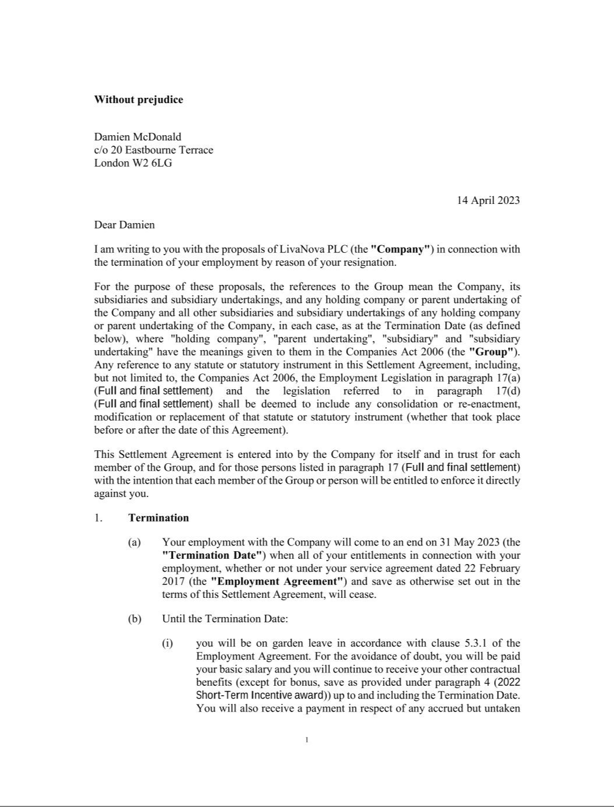

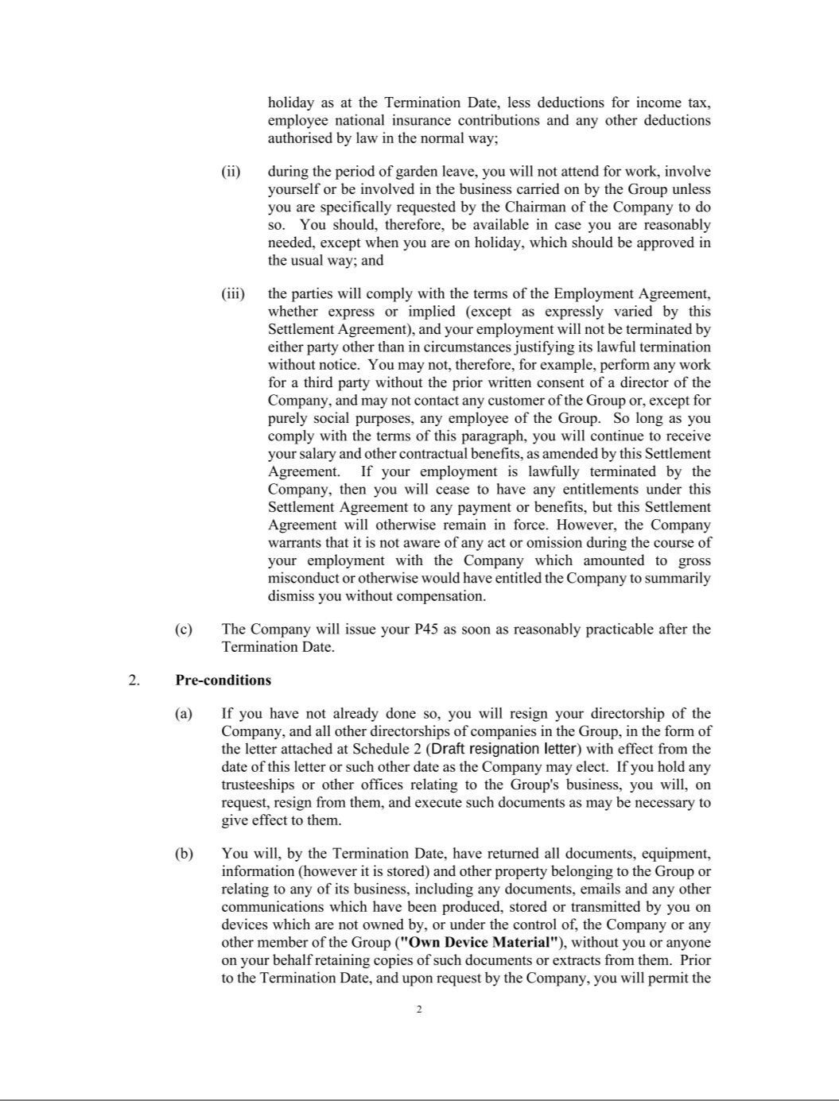

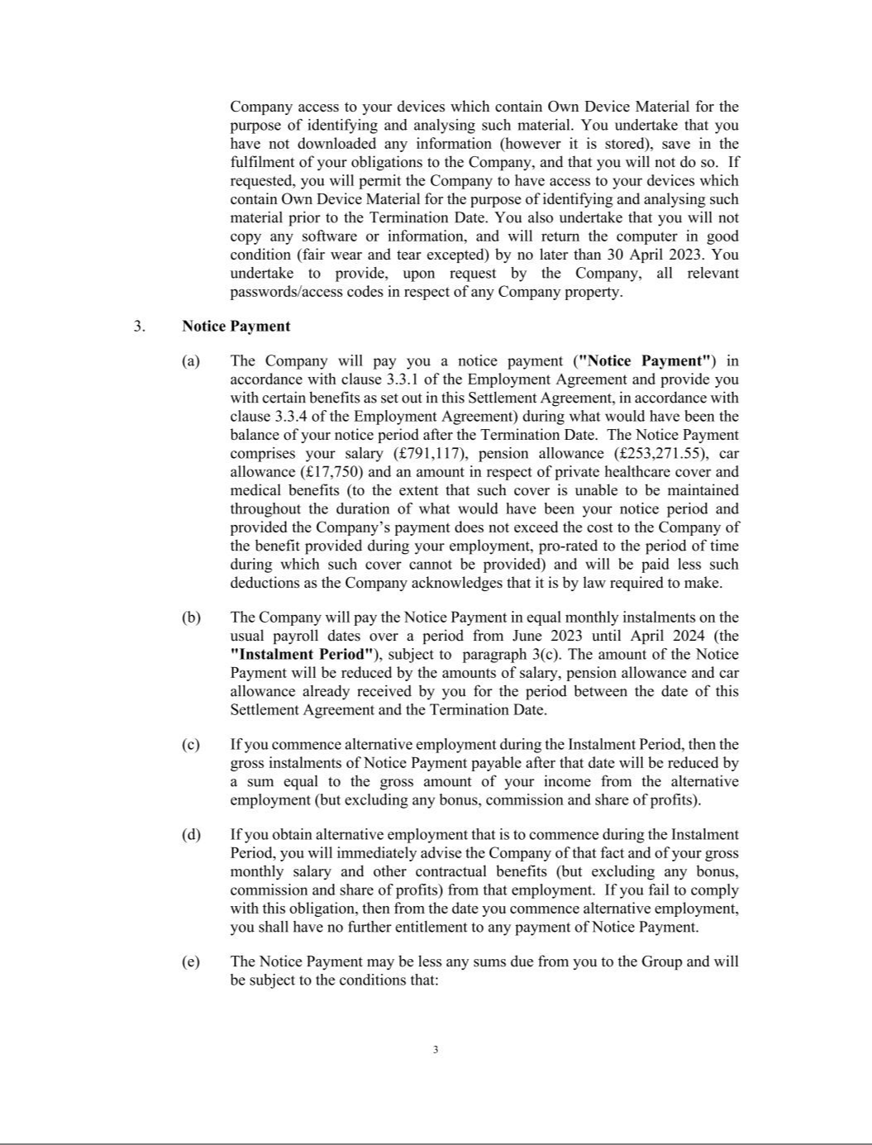

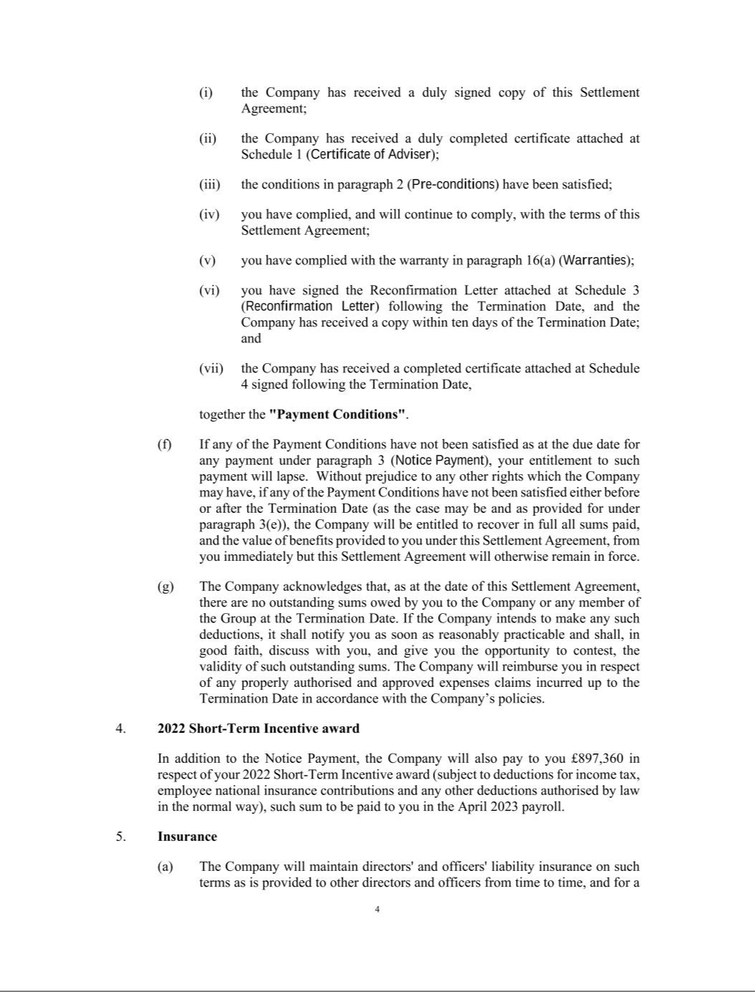

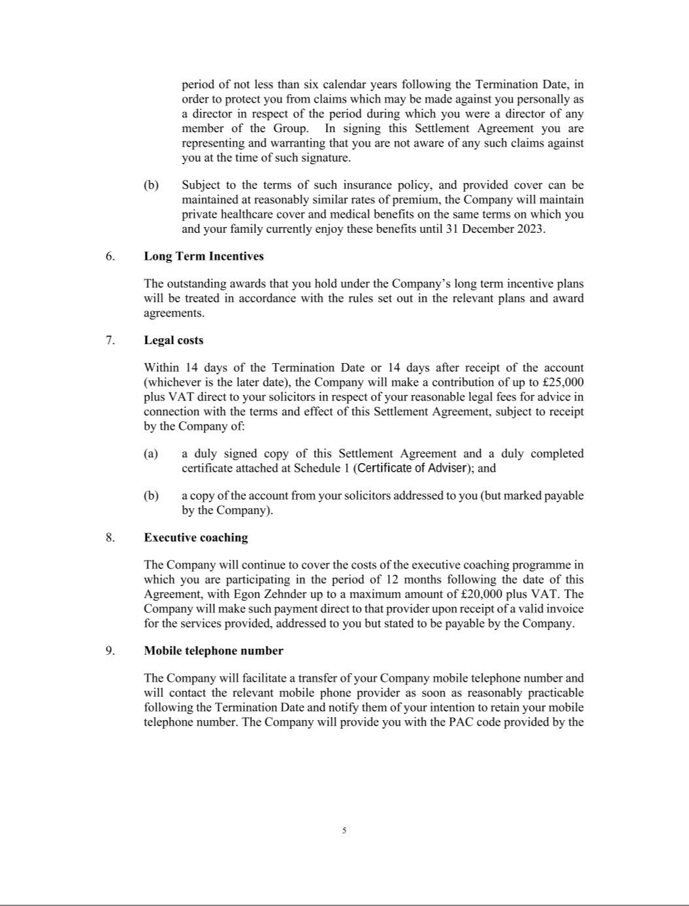

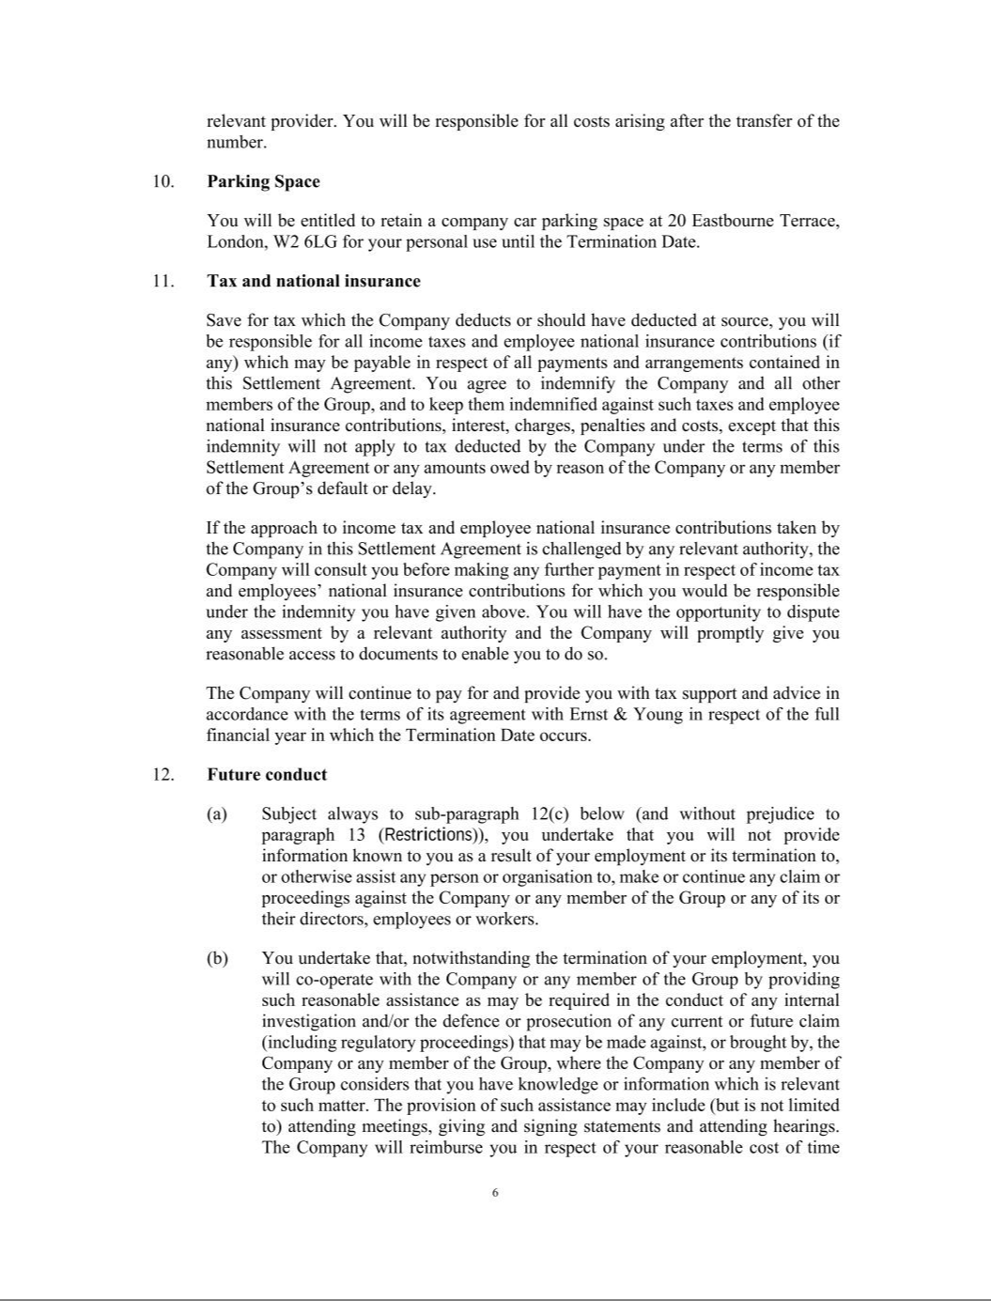

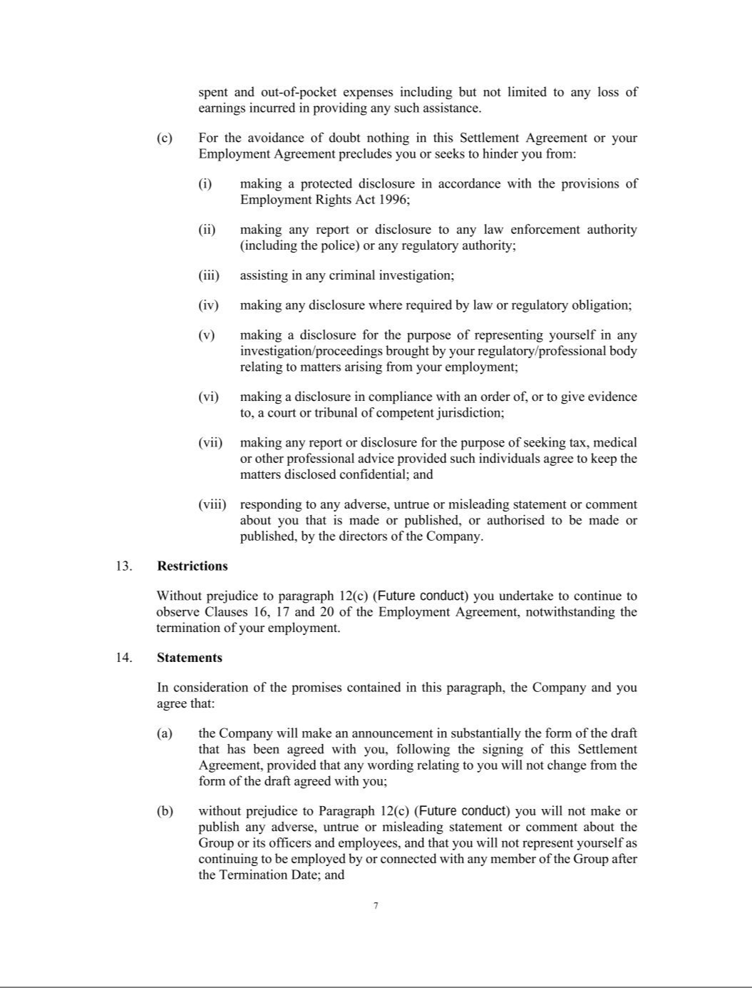

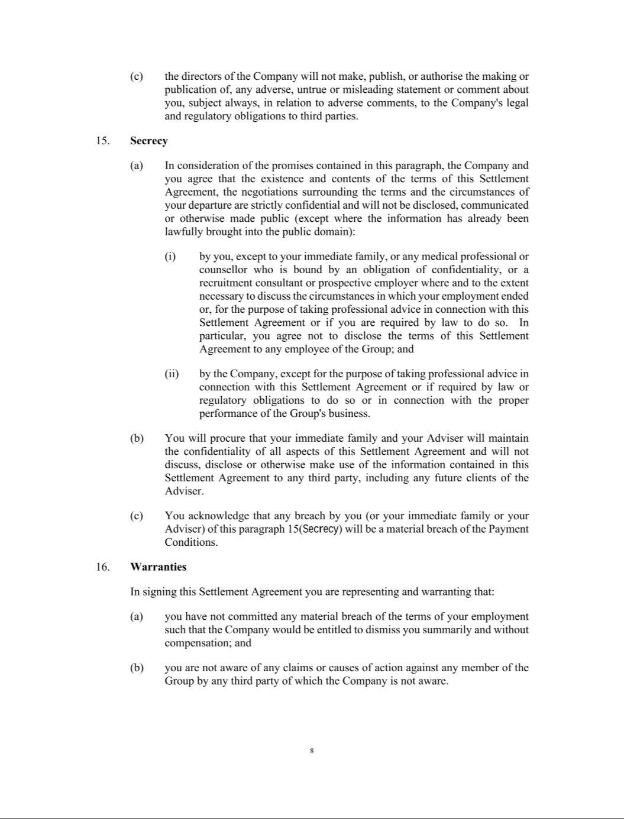

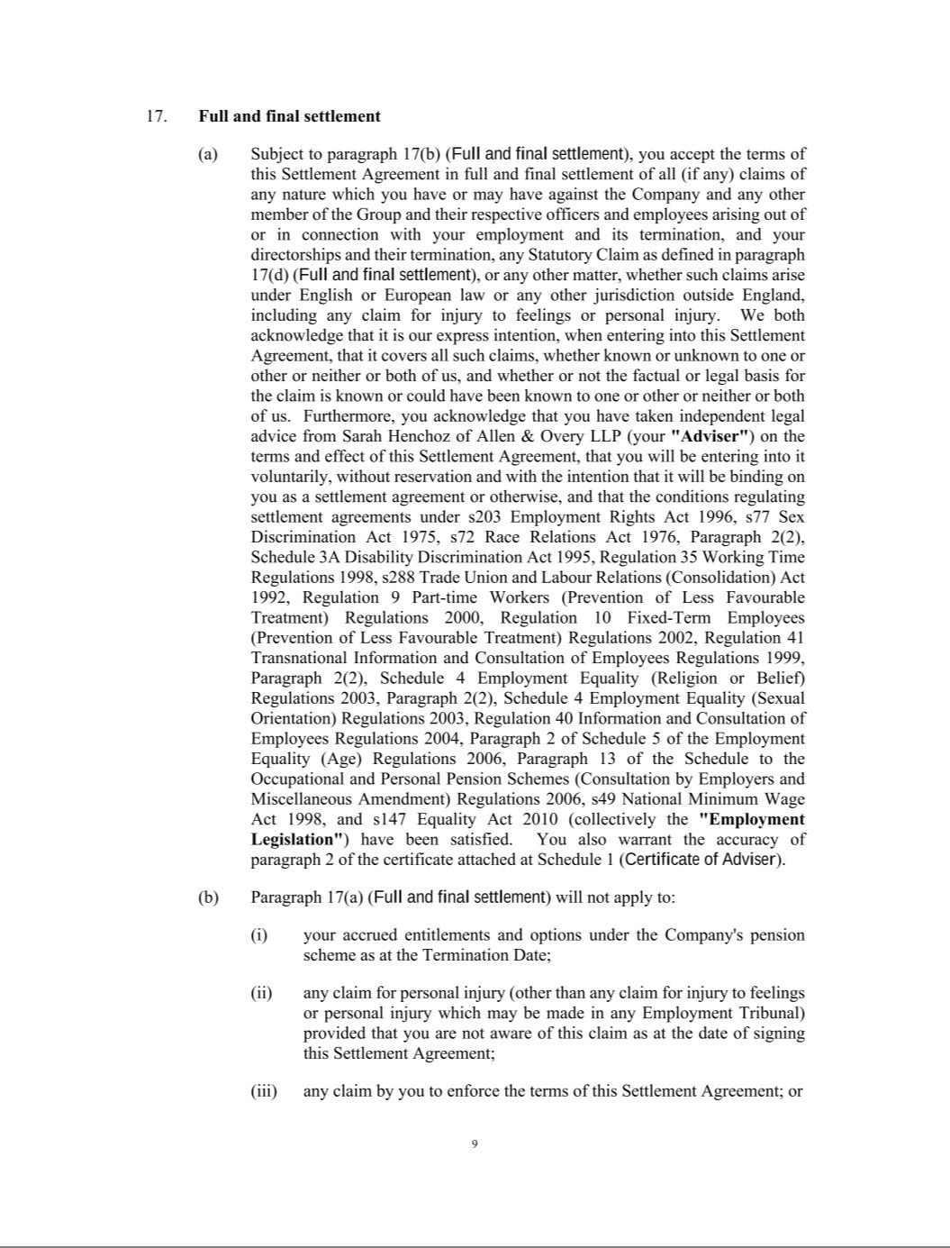

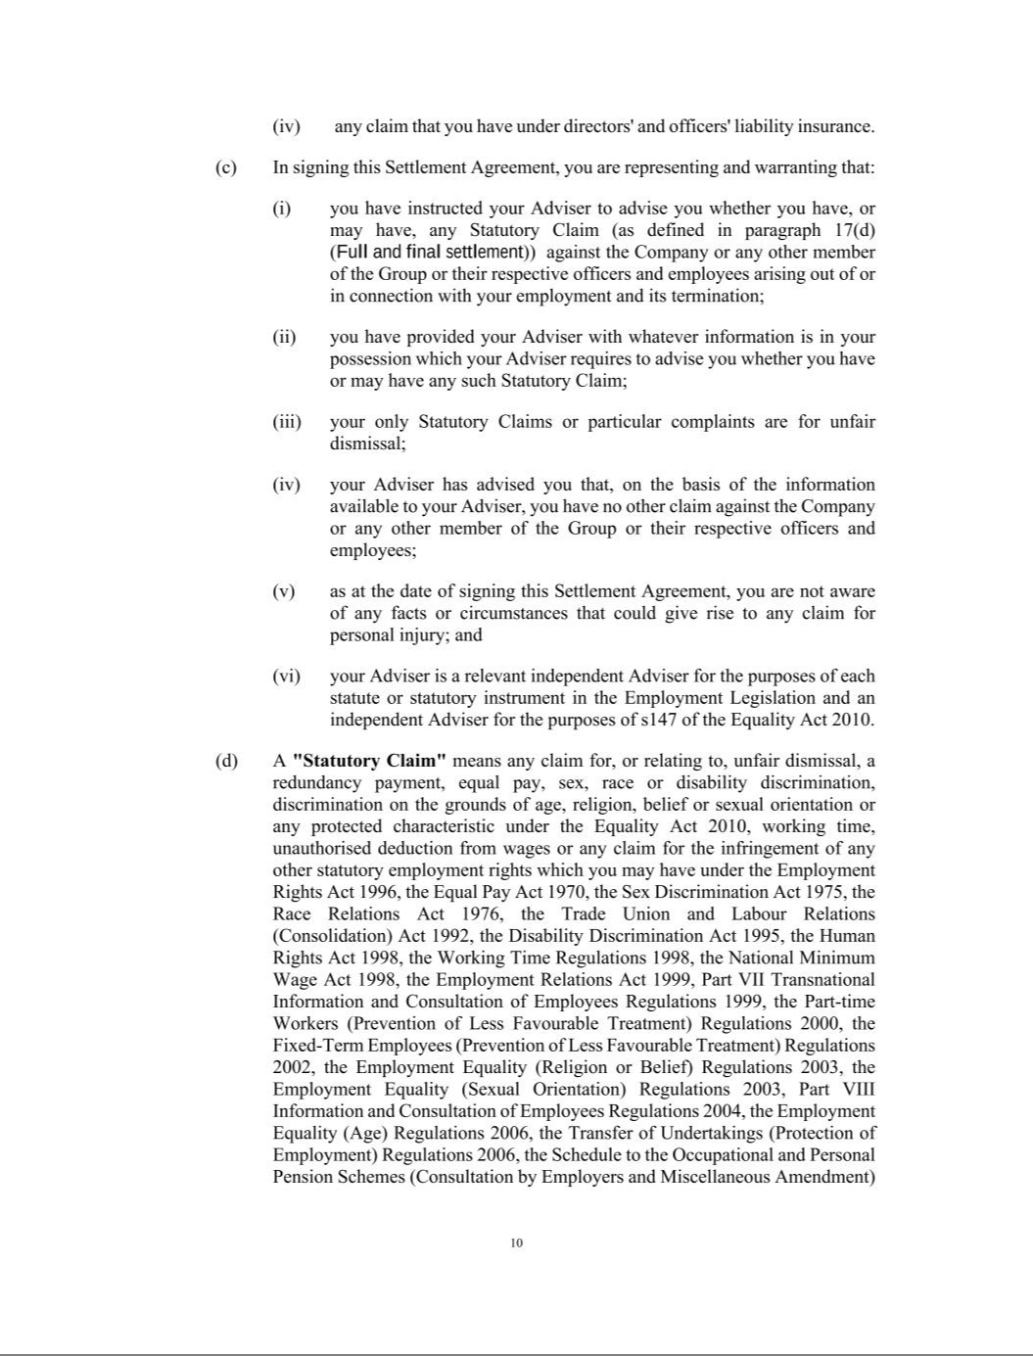

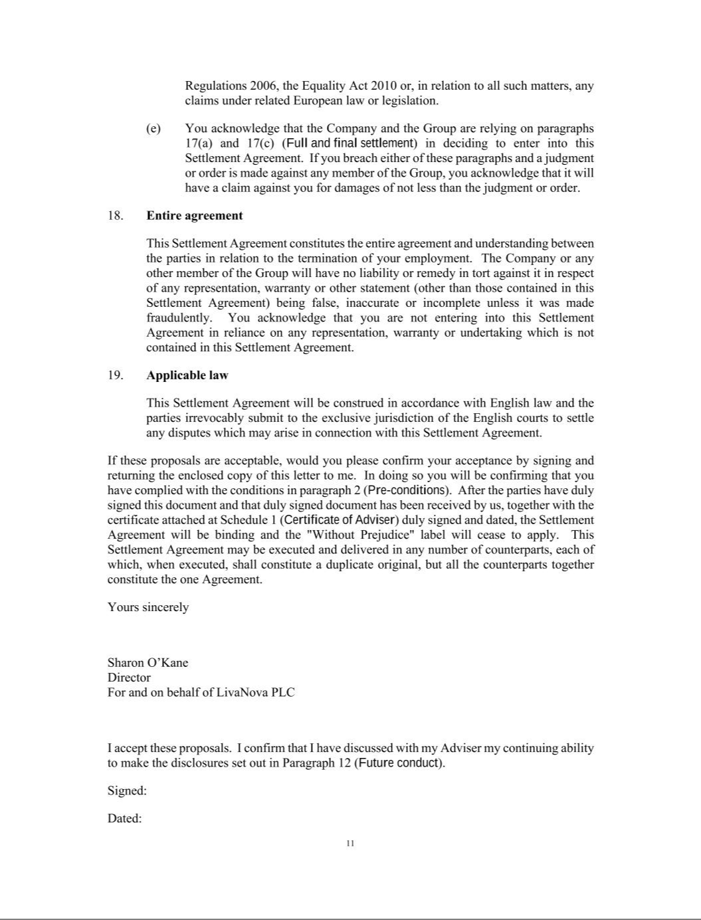

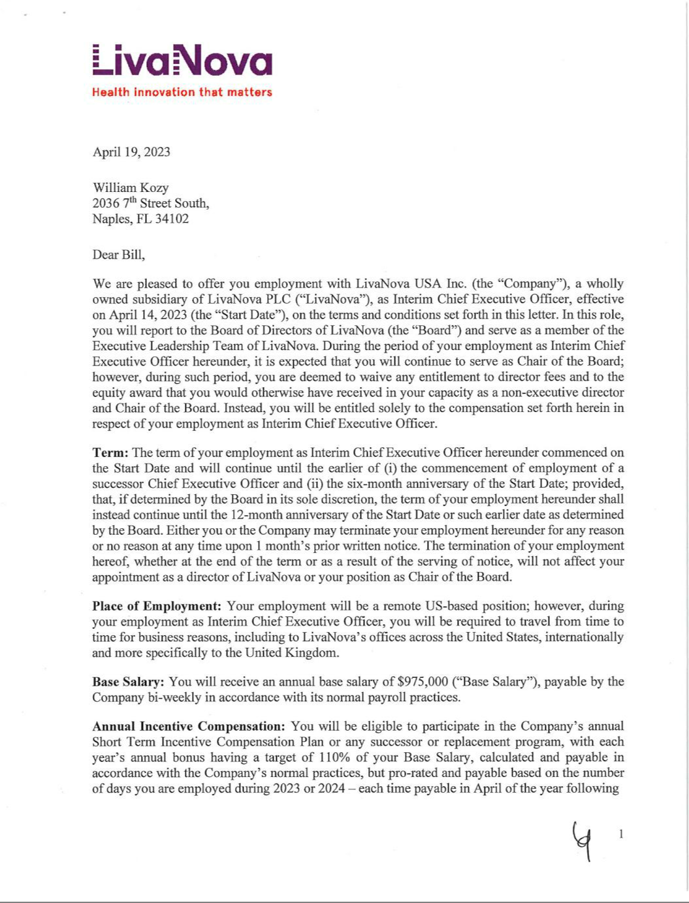

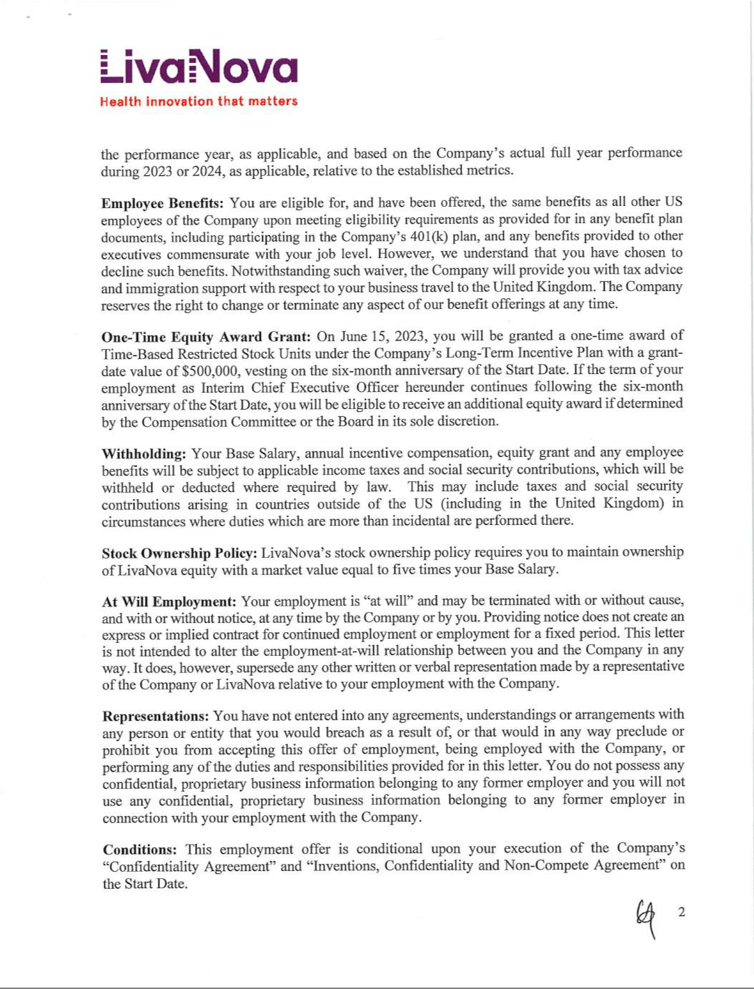

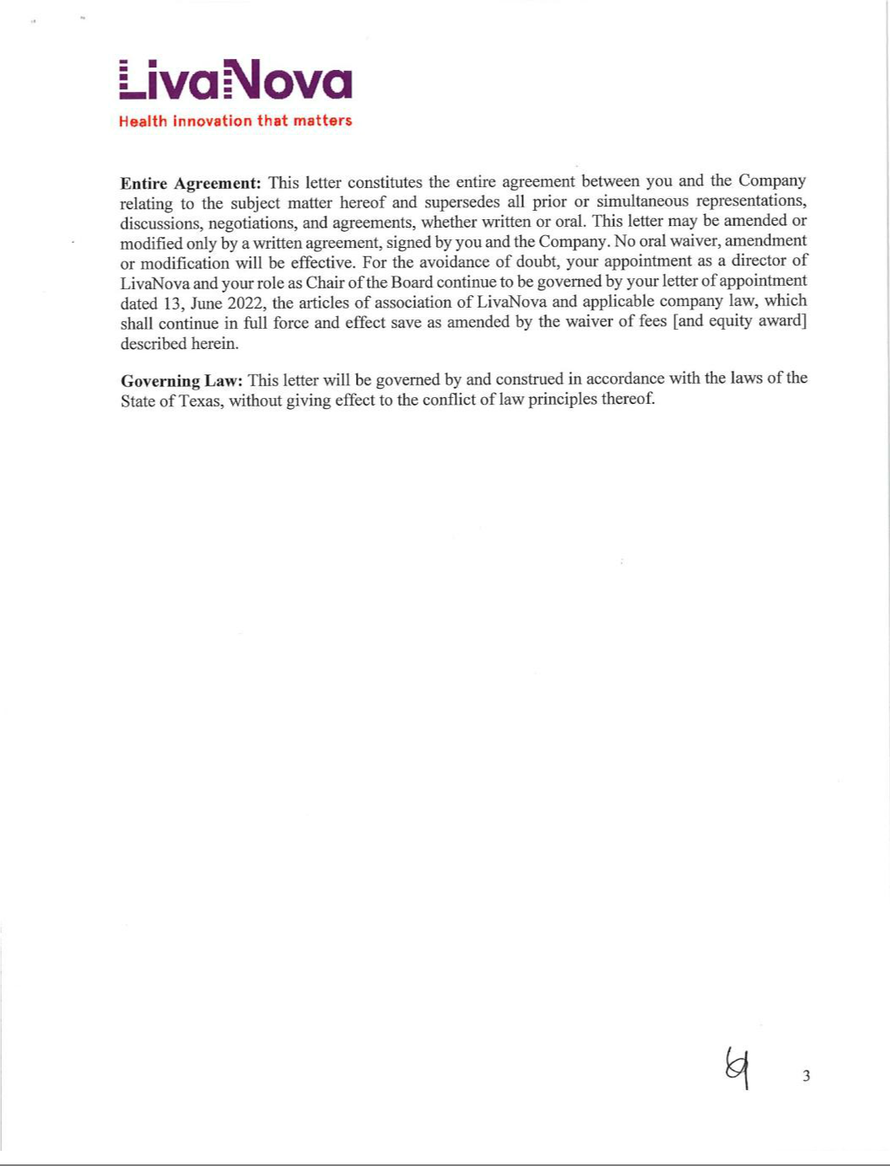

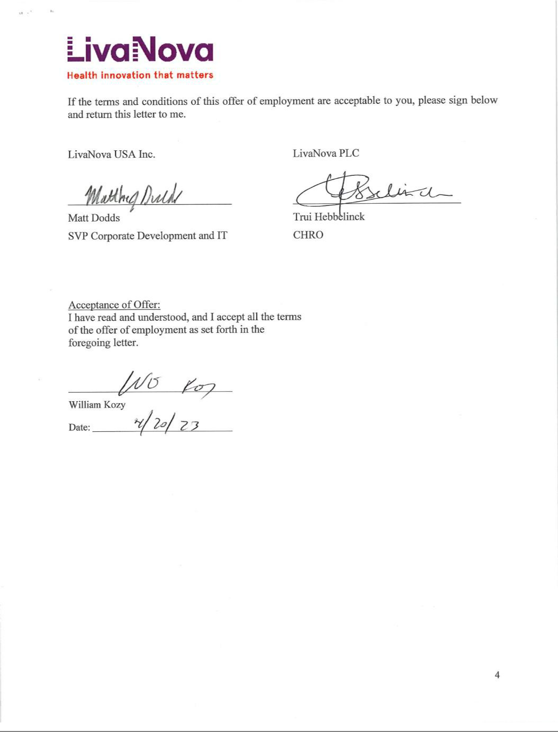

EXHIBIT 31.1

CERTIFICATION OF CHIEF EXECUTIVE OFFICER

PURSUANT TO SECTION 302 OF THE SARBANES-OXLEY ACT OF 2002

I, William A. Kozy, certify that:

- I have reviewed this Quarterly Report on Form 10-Q for the quarterly period ended June 30, 2023 of LivaNova PLC and its consolidated subsidiaries;

- Based on my knowledge, this report does not contain any untrue statement of a material fact or omit to state a material fact necessary to make the statements made, in light of the circumstances under which such statements were made, not misleading with respect to the period covered by this report;

- Based on my knowledge, the financial statements, and other financial information included in this report, fairly present in all material respects the financial condition, results of operations and cash flows of the registrant as of, and for, the periods presented in this report;

- The registrant’s other certifying officer and I are responsible for establishing and maintaining disclosure controls and procedures (as defined in Rules 13a-15(e) and 15d-15(e) of the Securities Exchange Act of 1934 (the "Exchange Act")) and internal control over financial reporting (as defined in Rules 13a-15(f) and 15d-15(f) of the Exchange Act) for the registrant and have:

- Designed such disclosure controls and procedures, or caused such disclosure controls and procedures to be designed under our supervision, to ensure that material information relating to the registrant, including its consolidated subsidiaries, is made known to us by others within those entities, particularly during the period in which this report is being prepared;

- Designed such internal control over financial reporting, or caused such internal control over financial reporting to be designed under our supervision, to provide reasonable assurance regarding the reliability of financial reporting and the preparation of financial statements for external purposes in accordance with generally accepted accounting principles;

- Evaluated the effectiveness of the registrant’s disclosure controls and procedures and presented in this report our conclusions about the effectiveness of the disclosure controls and procedures, as of the end of the period covered by this report based on such evaluation; and

- Disclosed in this report any change in the registrant’s internal control over financial reporting that occurred during the registrant’s most recent fiscal quarter (the registrant’s fourth fiscal quarter in the case of an annual report) that has materially affected, or is reasonably likely to materially affect, the registrant’s internal control over financial reporting; and

- The registrant’s other certifying officer and I have disclosed, based on our most recent evaluation of internal control over financial reporting, to the registrant’s auditors and the audit committee of the registrant’s board of directors (or persons performing the equivalent functions):

- All significant deficiencies and material weaknesses in the design or operation of internal control over financial reporting which are reasonably likely to adversely affect the registrant’s ability to record, process, summarize and report financial information; and

- Any fraud, whether or not material, that involves management or other employees who have a significant role in the registrant’s internal control over financial reporting.

Date: July 26, 2023

/s/ WILLIAM A. KOZY

William A. Kozy

Interim Chief Executive Officer and Chair of the Board

(Principal Executive Officer)

EXHIBIT 31.2

CERTIFICATION OF CHIEF FINANCIAL OFFICER

PURSUANT TO SECTION 302 OF THE SARBANES-OXLEY ACT OF 2002

I, Alex Shvartsburg, certify that:

- I have reviewed this Quarterly Report on Form 10-Q for the quarterly period ended June 30, 2023 of LivaNova PLC and its consolidated subsidiaries;

- Based on my knowledge, this report does not contain any untrue statement of a material fact or omit to state a material fact necessary to make the statements made, in light of the circumstances under which such statements were made, not misleading with respect to the period covered by this report;

- Based on my knowledge, the financial statements, and other financial information included in this report, fairly present in all material respects the financial condition, results of operations and cash flows of the registrant as of, and for, the periods presented in this report;

- The registrant’s other certifying officer and I are responsible for establishing and maintaining disclosure controls and procedures (as defined in Rules 13a-15(e) and 15d-15(e) of the Securities Exchange Act of 1934 (the "Exchange Act")) and internal control over financial reporting (as defined in Rules 13a-15(f) and 15d-15(f) of the Exchange Act) for the registrant and have:

- Designed such disclosure controls and procedures, or caused such disclosure controls and procedures to be designed under our supervision, to ensure that material information relating to the registrant, including its consolidated subsidiaries, is made known to us by others within those entities, particularly during the period in which this report is being prepared;

- Designed such internal control over financial reporting, or caused such internal control over financial reporting to be designed under our supervision, to provide reasonable assurance regarding the reliability of financial reporting and the preparation of financial statements for external purposes in accordance with generally accepted accounting principles;

- Evaluated the effectiveness of the registrant’s disclosure controls and procedures and presented in this report our conclusions about the effectiveness of the disclosure controls and procedures, as of the end of the period covered by this report based on such evaluation; and

- Disclosed in this report any change in the registrant’s internal control over financial reporting that occurred during the registrant’s most recent fiscal quarter (the registrant’s fourth fiscal quarter in the case of an annual report) that has materially affected, or is reasonably likely to materially affect, the registrant’s internal control over financial reporting; and

- The registrant’s other certifying officer and I have disclosed, based on our most recent evaluation of internal control over financial reporting, to the registrant’s auditors and the audit committee of the registrant’s board of directors (or persons performing the equivalent functions):

- All significant deficiencies and material weaknesses in the design or operation of internal control over financial reporting which are reasonably likely to adversely affect the registrant’s ability to record, process, summarize and report financial information; and

- Any fraud, whether or not material, that involves management or other employees who have a significant role in the registrant’s internal control over financial reporting.

Date: July 26, 2023

/s/ ALEX SHVARTSBURG

Alex Shvartsburg

Chief Financial Officer

(Principal Accounting and Financial Officer)

EXHIBIT 32.1

CERTIFICATION OF THE

CHIEF EXECUTIVE OFFICER AND

CHIEF FINANCIAL OFFICER

OF LIVANOVA PLC

PURSUANT TO 18 U.S.C. SECTION 1350

AS ADOPTED PURSUANT TO SECTION 906 OF THE SARBANES-OXLEY ACT OF 2002

Each of William A. Kozy, Interim Chief Executive Officer and Chair of the Board of LivaNova PLC (the “Company”), and Alex Shvartsburg, Chief Financial Officer of the Company, each hereby certifies pursuant to 18 U.S.C. Section 1350, as adopted pursuant to Section 906 of the Sarbanes-Oxley Act of 2002, that to the best of his knowledge:

- the Quarterly Report on Form 10-Q of the Company and its consolidated subsidiaries for the quarterly period ended June 30, 2023, as filed with the Securities and Exchange Commission on the date hereof (the “Report”) fully complies with the requirements of Section 13(a) or 15(d) of the Securities Exchange Act of 1934, as amended; and

- the information contained in the Report fairly presents, in all material respects, the financial condition and results of operations of the Company.

Date: July 26, 2023

/s/ WILLIAM A. KOZY

William A. Kozy

Interim Chief Executive Officer and Chair of the Board

(Principal Executive Officer)

/s/ ALEX SHVARTSBURG

Alex Shvartsburg

Chief Financial Officer

(Principal Accounting and Financial Officer)

A signed original of this written statement required by Section 906 has been provided to the Company and will be retained by the Company and furnished to the Securities and Exchange Commission or its staff upon request.

The foregoing certification is being furnished solely pursuant to 18 U.S.C. Section 1350 and is not being filed as a part of this report or on a separate disclosure document.

