UNITED STATES
SECURITIES AND EXCHANGE COMMISSION
Washington, D.C. 20549
_________________________

Form 10-Q

(Mark One)

- QUARTERLY REPORT PURSUANT TO SECTION 13 OR 15(d) OF THE SECURITIES EXCHANGE ACT OF 1934 For the quarterly period ended: March 31, 2024

or

- TRANSITION REPORT PURSUANT TO SECTION 13 OR 15(d) OF THE SECURITIES EXCHANGE ACT OF 1934 For the transition period from _______________ to _______________

Commission file number: 001-37599


LivaNova PLC

(Exact name of registrant as specified in its charter)

 |  |  | England and Wales ................... |  |  | 98-1268150
 |  |  | (State or other jurisdiction of .......... |  |  | (I.R.S. Employer
 |  |  | incorporation or organization) ........ |  |  | Identification No.)
 |  |  | 20 Eastbourne Terrace, London, United Kingdom, W2 6LG
 |  |  | (Address of principal executive offices) |  |  | ....................... (Zip Code)
 |  |  | Registrant’s telephone number, including area code: (44) (0) 203 325-0660
 |  |  | Securities registered pursuant to Section 12(b) of the Act:
 | Title of each class |  |  | Trading Symbol(s) |  |  | Name of each exchange on which registered
Ordinary Shares - £1.00 par value per share |  |  |  | LIVN |  |  | The NASDAQ Stock Market LLC

Indicate by check mark whether the registrant (1) has filed all reports required to be filed by Section 13 or 15(d) of the Securities Exchange Act of 1934 during the preceding 12 months (or for such shorter period that the registrant was required to file such reports), and (2) has been subject to such filing requirements for the past 90 days. Yes ☑ No ☐

Indicate by check mark whether the registrant has submitted electronically every Interactive Data File required to be submitted pursuant to Rule 405 of Regulation S-T (§232.405 of this chapter) during the preceding 12 months (or for such shorter period that the registrant was required to submit such files). Yes ☑ No ☐

Indicate by check mark whether the registrant is a large accelerated filer, an accelerated filer, a non-accelerated filer, a smaller reporting company or an emerging growth company. See the definitions of “large accelerated filer,” “accelerated filer,” “smaller reporting company” and “emerging growth company” in Rule 12b-2 of the Exchange Act.

Large accelerated filer | ☑ | Accelerated filer | ☐
Non-accelerated filer | ☐ | Smaller reporting company | ☐
Emerging growth company | ☐

If an emerging growth company, indicate by check mark if the registrant has elected not to use the extended transition period for complying with any new or revised financial accounting standards provided pursuant to Section 13(a) of the Exchange Act. ☐

Indicate by check mark whether the registrant is a shell company (as defined in Rule 12b-2 of the Act). Yes ☐ | No ☑
Class | Outstanding at April 26, 2024
Ordinary Shares - £1.00 par value per share | 54,151,745

LIVANOVA PLC

TABLE OF CONTENTS

 |  |  |  |  |  |  |  |  |  |  |  |  |  |  | PART I. FINANCIAL INFORMATION |  |  |  | PAGE NO.
 |  |  |  | Definitions |  |  |  |  |  |  |  |  |  |  |  |  |  |  |  | 3
 |  |  |  | Note About Forward-Looking Statements |  |  |  |  |  |  |  |  |  |  |  |  |  |  |  | 6
 | Item 1 |  |  | Condensed Consolidated Financial Statements |  |  |  |  |  |  |  |  |  |  |  |  |  |  | 7
 |  |  |  | Condensed Consolidated Statements of (Loss) Income |  |  |  |  |  |  |  |  |  |  |  |  |  |  |  | 7
 |  |  |  | Condensed Consolidated Statements of Comprehensive (Loss) Income |  |  |  |  |  |  |  |  |  |  |  |  |  |  |  | 8
 |  |  |  | Condensed Consolidated Balance Sheets |  |  |  |  |  |  |  |  |  |  |  |  |  |  | 9
 |  |  |  | Condensed Consolidated Statements of Cash Flows |  |  |  |  |  |  |  |  |  |  |  |  |  |  |  | 10
 |  |  |  | Notes to the Condensed Consolidated Financial Statements |  |  |  |  |  |  |  |  |  |  |  |  |  |  | 11
 | Item 2 |  |  | Management’s Discussion and Analysis of Financial Condition and Results of Operations |  |  |  |  |  |  |  |  |  |  |  |  |  |  | 31
 | Item 3 |  |  | Quantitative and Qualitative Disclosures About Market Risk |  |  |  |  |  |  |  |  |  |  |  |  |  |  | 38
 | Item 4 |  |  | Controls and Procedures |  |  |  |  |  |  |  |  |  |  |  |  |  |  | 38
 |  |  |  |  |  |  |  |  |  |  |  |  |  |  |  | PART II. OTHER INFORMATION
 | Item 1 |  |  | Legal Proceedings |  |  |  |  |  |  |  |  |  |  |  |  |  |  | 40
 | Item 1A |  |  | Risk Factors |  |  |  |  |  |  |  |  |  |  |  |  |  |  | 40
 | Item 2 |  |  | Unregistered Sales of Equity Securities and Use of Proceeds |  |  |  |  |  |  |  |  |  |  |  |  |  |  | 42
 | Item 3 |  |  | Defaults Upon Senior Securities |  |  |  |  |  |  |  |  |  |  |  |  |  |  | 42
 | Item 4 |  |  | Mine Safety Disclosures |  |  |  |  |  |  |  |  |  |  |  |  |  |  | 43
 | Item 5 |  |  | Other Information |  |  |  |  |  |  |  |  |  |  |  |  |  |  | 43
 | Item 6 |  |  | Exhibits |  |  |  |  |  |  |  |  |  |  |  |  |  |  | 44

2

DEFINITIONS

In this Quarterly Report on Form 10-Q for the quarter ended March 31, 2024, the following terms and abbreviations have the meanings listed below. “LivaNova” and “the Company” refer to LivaNova PLC and its consolidated subsidiaries.

 | Abbreviation |  | Definition
2021 | First Lien Credit Agreement |  | First Lien Credit Agreement for $125 million between LivaNova PLC and its wholly-owned subsidiary, Borrower, and Goldman Sachs Bank USA, as
 |  |  | First Lien Administrative Agent and First Lien Collateral Agent, entered into on August 13, 2021
2023 | Form 10-K |  | LivaNova PLC’s Annual Report on Form 10-K for the year ended December 31, 2023, filed with the SEC on February 29, 2024
2024 | Restructuring Plan |  | A plan, initiated during the first quarter of 2024, to enhance LivaNova’s focus on its core Cardiopulmonary and Neuromodulation segments
2025 | Capped Calls |  | Privately negotiated capped call transactions entered into with certain financial institutions
2025 | Notes |  | $287.5 million aggregate principal amount 3.00% unsecured cash exchangeable senior notes due 2025 by private placement to qualified institutional
 |  |  | buyers pursuant to Rule 144A under the Securities Act, issued by LivaNova USA on June 17, 2020
2025 | Notes Repurchase Transaction |  | Repurchase of $230.0 million aggregate principal amount of the 2025 Notes in privately-negotiated transactions from proceeds from the issuance of
 |  |  | the 2029 Notes
2029 | Capped Calls |  | Privately negotiated capped call transactions entered into with certain financial institutions
2029 | Notes |  | $345.0 million aggregate principal amount 2.5% unsecured convertible senior notes due 2029 by private placement to qualified institutional buyers
 |  |  | pursuant to Rule 144A under the Securities Act, issued by LivaNova PLC on March 8, 2024
ACS |  |  | Advanced Circulatory Support
ALung |  |  | ALung Technologies, Inc.
AOCI |  |  | Accumulated other comprehensive income
Barclays |  |  | Barclays Bank Ireland PLC
BEPS |  |  | Base Erosion and Profit Shifting
Borrower |  |  | LivaNova USA, Inc.
Capped Call Transactions |  |  | The 2025 Capped Calls and the 2029 Capped Calls
CEO |  |  | Chief Executive Officer
CFO |  |  | Chief Financial Officer
CODM |  |  | Chief Operating Decision Maker
Convertible Notes Measurement Period |  |  | Any specified ten consecutive trading day measurement period
Court of Appeal |  |  | Court of Appeal in Milan
CPB |  |  | Cardiopulmonary bypass
Delayed Draw Term Facility |  |  | $50 million delayed draw term facility under the 2021 First Lien Credit Agreement resulting from the Incremental Facility Amendment No. 2
DRE |  |  | Drug-resistant epilepsy
DTD |  |  | Difficult-to-treat depression
ECJ |  |  | European Court of Justice
EU |  |  | European Union
Exchange Act |  |  | U.S. Securities Exchange Act of 1934, as amended
FX |  |  | Foreign currency exchange rate
GAAP |  |  | Generally Accepted Accounting Principles
HLM |  |  | Heart-lung machine
ImThera |  |  | ImThera Medical, Inc., acquired by LivaNova in 2018, a company developing an implantable neurostimulation device system for the treatment of
 |  |  | obstructive sleep apnea
Incremental Facility Amendment No. 2 |  |  | An incremental facility amendment to the 2021 First Lien Credit Agreement, dated July 6, 2022
Incremental Facility Amendment No. 3 |  |  | An incremental facility amendment to the 2021 First Lien Credit Agreement, dated March 8, 2024
 |  |  | 3

Abbreviation |  | Definition
Initial Term Facility |  | $300 million term facility under the 2021 First Lien Credit Agreement resulting from the Incremental Facility Amendment No. 2
ISIN |  | National Inspectorate for Nuclear Safety and Radiation Protection, a sub-body of the Italian Ministry of Economic Development
LivaNova PLC |  | A public limited company organized under the laws of England and Wales on February 20, 2015
LivaNova USA |  | LivaNova USA, Inc.
LSM |  | LivaNova Site Management S.r.l.
MDL |  | Federal multi-district litigation in the U.S. District Court for the Middle District of Pennsylvania
Nasdaq |  | Nasdaq Global Market
OCI |  | Other comprehensive income (loss)
OECD |  | Organization for Economic Co-operation and Development
Option Counterparties |  | Certain financial institutions with whom LivaNova USA or LivaNova PLC, as applicable, has entered into the 2025 Capped Calls and 2029 Capped
 |  | Calls
Order |  | Administrative order from the Italian Ministry of the Environment received by LivaNova in 2021
OSA |  | Obstructive sleep apnea
OSPREY clinical trial |  | LivaNova’s clinical trial, “Treating Obstructive Sleep Apnea using Targeted Hypoglossal Neurostimulation”
Pillar Two |  | OECD BEPS Pillar Two
Public Administrations |  | The Italian Ministry of the Environment and other Italian government agencies
R&D |  | Research and Development
Report |  | This Quarterly Report on Form 10-Q
RSUs |  | Service-based restricted stock units
SARs |  | Service-based stock appreciation rights
SEC |  | U.S. Securities and Exchange Commission
Securities Act |  | U.S. Securities Act of 1933, as amended
SG&A |  | Selling, general and administrative expenses
SNIA |  | SNIA S.p.A.
SNIA Litigation Guarantee |  | A first demand bank guarantee of €270.0 million in connection with the SNIA litigation
Sorin spin-off |  | The spin-off of Sorin from SNIA in 2004
Term Facilities |  | The Initial Term Facility, together with the Delayed Draw Term Facility
UK |  | United Kingdom
UK Act |  | Finance (No.2) Act 2023
U.S. |  | United States of America
U.S. GAAP |  | Generally Accepted Accounting Principles in the U.S.
USD |  | U.S. dollar
UTPR |  | Undertaxed profits rule
VNS Therapy |  | LivaNova Vagus Nerve Stimulation Therapy

4

INTELLECTUAL PROPERTY, TRADEMARKS AND TRADE NAMES This report may contain references to LivaNova’s proprietary intellectual property, including among others:

- Trademarks for LivaNova’s Neuromodulation systems, the VNS Therapy™ System, the VITARIA™ System and LivaNova’s proprietary pulse generator products: Model 102 (Pulse™), Model 102R (Pulse Duo™), Model 103 (Demipulse™), Model 104 (Demipulse Duo™), Model 106 (AspireSR™), Model 1000 (SenTiva™), Model 1000-D (SenTiva™ Duo), Model 7103 (VITARIA™ and TitrationAssist™) and Model 8103 (Symmetry™).
- Trademarks for LivaNova’s Cardiopulmonary products and systems: Essenz™, S5™, S3™, S5 Pro™, B-Capta™, Inspire™, Heartlink™, XTRA™, 3T Heater-Cooler™, Connect™ and Revolution™.

- Trademarks for LivaNova’s advanced circulatory support systems: TandemLife™, TandemHeart™, TandemLung™, ProtekDuo™, LifeSPARC™, ALung™, Hemolung™, Respiratory Dialysis™ and ActivMix™.
- Trademarks for LivaNova’s obstructive sleep apnea system: ImThera™ and aura6000™.
These trademarks and trade names are the property of LivaNova or the property of LivaNova’s consolidated subsidiaries and are protected under applicable intellectual property laws. Solely for convenience, LivaNova’s trademarks and trade names referred to in this Report may appear without the ™ symbol, but such references are not intended to indicate in any way that the Company will
not assert, to the fullest extent under applicable law, LivaNova’s rights to these trademarks and trade names.

5

CAUTIONARY NOTE ABOUT FORWARD-LOOKING STATEMENTS

Certain statements in this Report, other than statements of historical or current fact, are “forward-looking statements” within the meaning of the Private Securities Litigation Reform Act of 1995, Section 27A of the Securities Act and Section 21E of the Exchange Act. These statements include, but are not limited to, LivaNova’s plans, objectives, strategies, financial performance and outlook, trends, the amount and timing of future cash distributions, prospects or future events and involve known and unknown risks that are difficult to predict. As a result, the Company’s actual financial results, performance, achievements or prospects may differ materially from those expressed or implied by these forward-looking statements. Generally, you can identify forward-looking statements by the use of words such as “may,” “could,” “seek,” “guidance,” “predict,” “potential,” “likely,” “believe,” “will,” “should,” “expect,” “anticipate,” “estimate,” “plan,” “intend,” “forecast,” “foresee” or variations of these terms and similar expressions, or the negative of these terms or similar expressions. Such forward-looking statements are necessarily based on estimates and assumptions that, while considered reasonable by LivaNova and its management based on their knowledge and understanding of the business and industry, are inherently uncertain. These statements are not guarantees of future performance, and stockholders should not place undue reliance on forward-looking statements. There are a number of risks, uncertainties and other important factors, many of which are beyond the Company’s control, that could cause the Company’s actual results to differ materially from the forward-looking statements contained in this Report, and include, but are not limited to, the following risks and uncertainties: volatility in the global market and worldwide economic conditions, including as caused by the invasion of Ukraine, the evolving instability in the Middle East, inflation, changing interest rates, foreign exchange fluctuations, changes to existing trade agreements and relationships between the U.S. and other countries including the implementation of sanctions; cyber-attacks or other disruptions to the Company’s information technology systems or those of third parties with which the Company interacts; costs of complying with privacy and security of personal information requirements and laws; risks relating to supply chain pressures; changes in technology, including the development of superior or alternative technology or devices by competitors and/or competition from providers of alternative medical therapies; failure to obtain approvals or reimbursement in relation to the Company’s products; failure to establish, expand or maintain market acceptance of the Company’s products for the treatment of the Company’s approved indications; failure to develop and commercialize new products and the rate and degree of market acceptance of such products; unfavorable results from clinical studies or failure to meet milestones; failure to comply with, or changes in, laws, regulations or administrative practices affecting government regulation of the Company’s products; risks relating to recalls, enforcement actions or product liability claims; changes or reduction in reimbursement for the Company’s products or failure to comply with rules relating to reimbursement of healthcare goods and services; failure to comply with anti-bribery laws; losses or costs from pending or future lawsuits and governmental investigations, including in the case of the Company’s 3T Heater-Cooler and SNIA litigations; risks associated with environmental laws and regulations as well as environmental liabilities, violations, protest voting and litigation; product liability, intellectual property, shareholder-related, environmental-related, income tax and other litigation, disputes, losses and costs; failure to retain key personnel, prevent labor shortages, or manage labor costs; the failure of the Company’s R&D efforts to keep up with the rapid pace of technological development in the medical device industry; the risks relating to the impact of climate change and the risk of ESG pressures from internal and external stakeholders; the risk of quality concerns and the impacts thereof; failure to protect the Company’s proprietary intellectual property; failure of new acquisitions to further the Company’s strategic objectives or strengthen the Company’s existing businesses; the potential for impairments of intangible assets, goodwill and other long-lived assets; risks relating to the Company’s indebtedness; effectiveness of the Company’s internal controls over financial reporting; changes in the Company’s profitability and/or failure to manage costs and expenses; fluctuations in future quarterly operating results and/or variations in revenue and operating expenses relative to estimates; changes in tax laws and regulations, including exposure to additional income tax liabilities; and other unknown or unpredictable factors that could harm the Company’s financial performance.

Other factors that could cause LivaNova’s actual results to differ from projected results are described in (1) “Part II, Item 1A. Risk Factors” and elsewhere in this and the Company’s other Quarterly Reports on Form 10-Q, (2) the Company’s 2023 Form 10-K, (3) the Company’s reports and registration statements filed and furnished from time to time with the SEC and (4) other announcements LivaNova makes from time to time.

Readers are cautioned not to place undue reliance on the Company’s forward-looking statements, which speak only as of the date hereof. The Company undertakes no obligation to update or revise any forward-looking statements after the date they are made, whether as a result of new information, future events or otherwise. You should read the following discussion and analysis in conjunction with the Company’s unaudited condensed consolidated financial statements and related notes included elsewhere in this report. Operating results for the three months ended March 31, 2024, are not necessarily indicative of future results, including the full fiscal year. You should also refer to the Company’s “Annual Consolidated Financial Statements,” “Notes” thereto, “Management’s Discussion and Analysis of Financial Condition and Results of Operations” and “Risk Factors” contained in LivaNova’s 2023 Form 10-K and in the Company’s Quarterly Reports on Form 10-Q.

Financial Information and Currency of Financial Statements

All of the financial information included in this quarterly report has been prepared in accordance with U.S. GAAP. The reporting currency of the Company’s condensed consolidated financial statements is USD.

6

PART I. FINANCIAL INFORMATION

Item 1. Financial Statements

LIVANOVA PLC AND SUBSIDIARIES

CONDENSED CONSOLIDATED STATEMENTS OF (LOSS) INCOME

(UNAUDITED)

(In thousands, except per share amounts)

 | Three Months Ended March 31,
 | 2024 |  |  | 2023
Net revenue | $ | 294,912 |  | $ | 263,418
Cost of sales |  | 87,522 |  |  | 89,335
Gross profit |  | 207,390 |  |  | 174,083
Operating expenses:
Selling, general and administrative |  | 129,863 |  |  | 124,129
Research and development |  | 45,664 |  |  | 49,986
Other operating expenses |  | 15,617 |  |  | 2,310
Operating income (loss) |  | 16,246 |  |  | (2,342)
Interest expense |  | (15,893) |  |  | (13,437)
Loss on debt extinguishment |  | (25,482) |  |  | —
Foreign exchange and other income/(expense) |  | (9,071) |  |  | 25,547
(Loss) income before tax |  | (34,200) |  |  | 9,768
Income tax expense |  | 7,717 |  |  | 2,371
Loss from equity method investments |  | (26) |  |  | (27)
Net (loss) income | $ | (41,943) |  | $ | 7,370
Basic (loss) income per share | $ | (0.78) |  | $ | 0.14
Diluted (loss) income per share | $ | (0.78) |  | $ | 0.14
Shares used in computing basic (loss) income per share |  | 54,008 |  |  | 53,617
Shares used in computing diluted (loss) income per share |  | 54,008 |  |  | 53,900

See accompanying notes to the condensed consolidated financial statements

7

LIVANOVA PLC AND SUBSIDIARIES

CONDENSED CONSOLIDATED STATEMENTS OF COMPREHENSIVE (LOSS) INCOME

(UNAUDITED)

(In thousands)

 | Three Months Ended March 31,
 | 2024 |  |  | 2023
Net (loss) income | $ | (41,943) |  | $ | 7,370
Other comprehensive income:
Net change in unrealized loss on derivatives |  | — |  |  | (966)
Tax effect |  | — |  |  | —
Net of tax |  | — |  |  | (966)
Foreign currency translation adjustment |  | (17,323) |  |  | 8,053
Total other comprehensive (loss) income |  | (17,323) |  |  | 7,087
Total comprehensive (loss) income | $ | (59,266) |  | $ | 14,457

See accompanying notes to the condensed consolidated financial statements

8

LIVANOVA PLC AND SUBSIDIARIES
CONDENSED CONSOLIDATED BALANCE SHEETS
(UNAUDITED)

(In thousands, except share amounts)

ASSETS |  | March 31, 2024 |  |  | December 31, 2023
Current Assets:
Cash and cash equivalents | $ | 309,191 |  | $ | 266,504
Restricted cash |  | 306,492 |  |  | 311,368
Accounts receivable, net of allowance of $11,026 at March 31, 2024 and $12,019 at December 31, 2023 |  | 209,431 |  |  | 215,072
Inventories |  | 153,176 |  |  | 147,887
Prepaid and refundable taxes |  | 22,543 |  |  | 20,145
Prepaid expenses and other current assets |  | 39,184 |  |  | 27,182
Total Current Assets |  | 1,040,017 |  |  | 988,158
Property, plant and equipment, net |  | 152,237 |  |  | 154,181
Goodwill |  | 771,817 |  |  | 782,941
Intangible assets, net |  | 253,927 |  |  | 261,178
Operating lease assets |  | 50,260 |  |  | 50,845
Investments |  | 22,675 |  |  | 22,843
Deferred tax assets |  | 113,687 |  |  | 118,858
Long-term derivative assets |  | 41,617 |  |  | 38,496
Other assets |  | 13,365 |  |  | 12,063
Total Assets | $ | 2,459,602 |  | $ | 2,429,563
LIABILITIES AND STOCKHOLDERS' EQUITY
Current Liabilities:
Current debt obligations | $ | 19,704 |  | $ | 18,111
Accounts payable |  | 75,944 |  |  | 80,845
Accrued liabilities and other |  | 94,029 |  |  | 107,301
Current litigation provision liability |  | 16,980 |  |  | 10,756
Taxes payable |  | 29,761 |  |  | 23,340
Accrued employee compensation and related benefits |  | 91,353 |  |  | 94,630
Total Current Liabilities |  | 327,771 |  |  | 334,983
Long-term debt obligations |  | 604,753 |  |  | 568,543
Contingent consideration |  | 80,769 |  |  | 80,902
Deferred tax liabilities |  | 10,974 |  |  | 11,567
Long-term operating lease liabilities |  | 43,724 |  |  | 45,388
Long-term employee compensation and related benefits |  | 17,062 |  |  | 17,254
Long-term derivative liabilities |  | 104,920 |  |  | 45,569
Other long-term liabilities |  | 48,092 |  |  | 47,729
Total Liabilities |  | 1,238,065 |  |  | 1,151,935
Commitments and contingencies (Note 6)
Stockholders’ Equity:
Ordinary Shares, £1.00 par value: unlimited shares authorized; 54,295,837 shares issued and 54,148,808 shares outstanding at March 31, |  | 82,975 |  |  | 82,533
2024; 53,942,151 shares issued and 53,918,222 shares outstanding at December 31, 2023 |  | 82,975 |  |  | 82,533
Additional paid-in capital |  | 2,192,676 |  |  | 2,189,517
Accumulated other comprehensive loss |  | (45,206) |  |  | (27,883)
Accumulated deficit |  | (1,008,427) |  |  | (966,484)
Treasury stock at cost, 147,029 ordinary shares at March 31, 2024; 23,929 ordinary shares at December 31, 2023 |  | (481) |  |  | (55)
Total Stockholders’ Equity |  | 1,221,537 |  |  | 1,277,628
Total Liabilities and Stockholders’ Equity | $ | 2,459,602 |  | $ | 2,429,563

See accompanying notes to the condensed consolidated financial statements

9

LIVANOVA PLC AND SUBSIDIARIES
CONDENSED CONSOLIDATED STATEMENTS OF CASH FLOWS
(UNAUDITED)
(In thousands)
 | Three Months Ended March 31,
Operating Activities: | 2024 |  |  | 2023
Net (loss) income | $ | (41,943) |  | $ | 7,370
Adjustments to reconcile net (loss) income to net cash provided by operating activities:
Loss on debt extinguishment |  | 25,482 |  |  | —
Remeasurement of derivative instruments |  | 11,598 |  |  | (26,281)
Stock-based compensation |  | 10,226 |  |  | 10,579
Depreciation |  | 6,266 |  |  | 5,956
Amortization of debt issuance costs |  | 4,900 |  |  | 5,019
Amortization of intangible assets |  | 4,329 |  |  | 6,355
Deferred income tax expense (benefit) |  | 4,800 |  |  | (76)
Amortization of operating lease assets |  | 2,544 |  |  | 2,642
Remeasurement of contingent consideration to fair value |  | (133) |  |  | 4,827
Other |  | (534) |  |  | (108)
Changes in operating assets and liabilities:
Accounts receivable, net |  | 1,991 |  |  | 7,558
Inventories |  | (8,146) |  |  | (11,342)
Other current and non-current assets |  | (8,945) |  |  | (3,838)
Accounts payable and accrued current and non-current liabilities |  | (15,576) |  |  | 21,378
Taxes payable |  | 6,887 |  |  | 972
Litigation provision liability |  | 6,235 |  |  | (10,254)
Net cash provided by operating activities |  | 9,981 |  |  | 20,757
Investing Activities:
Purchases of property, plant and equipment |  | (6,398) |  |  | (7,685)
Purchase of investments |  | — |  |  | (5,136)
Other |  | 35 |  |  | 1,337
Net cash used in investing activities |  | (6,363) |  |  | (11,484)
Financing Activities:
Proceeds from long-term debt obligations |  | 335,513 |  |  | —
Repayment of long-term debt obligations |  | (234,375) |  |  | (1,875)
Payment of debt extinguishment costs |  | (38,953) |  |  | —
Purchase of capped calls |  | (31,637) |  |  | —
Proceeds from unwind of capped calls |  | 22,523 |  |  | —
Payment of contingent consideration |  | (13,750) |  |  | —
Shares repurchased from employees for minimum tax withholding |  | (316) |  |  | (1,577)
Payment of debt issuance costs |  | (1,893) |  |  | —
Repayments of short-term borrowings (maturities greater than 90 days) |  | — |  |  | (1,974)
Other |  | 35 |  |  | 191
Net cash provided by (used in) financing activities |  | 37,147 |  |  | (5,235)
Effect of exchange rate changes on cash, cash equivalents and restricted cash |  | (2,954) |  |  | 3,302
Net increase in cash, cash equivalents and restricted cash |  | 37,811 |  |  | 7,340
Cash, cash equivalents and restricted cash at beginning of period |  | 577,872 |  |  | 515,618
Cash, cash equivalents and restricted cash at end of period | $ | 615,683 |  | $ | 522,958

See accompanying notes to the condensed consolidated financial statements

10

LIVANOVA PLC AND SUBSIDIARIES

NOTES TO THE CONDENSED CONSOLIDATED FINANCIAL STATEMENTS

(Unaudited)

Note 1. Unaudited Condensed Consolidated Financial Statements

Basis of Presentation

The accompanying condensed consolidated financial statements of LivaNova as of, and for the three months ended March 31, 2024 and 2023, have been prepared in accordance with U.S. GAAP for interim financial information and the instructions to Form 10-Q and Article 10 of Regulation S-X. The accompanying condensed consolidated balance sheet of LivaNova at December 31, 2023 has been derived from audited financial statements contained in LivaNova’s 2023 Form 10-K but does not include all of the information and footnotes required by U.S. GAAP for complete financial statements. In the opinion of management, the condensed consolidated financial statements reflect all adjustments considered necessary for a fair statement of the operating results of LivaNova and its subsidiaries for the three months ended March 31, 2024, and are not necessarily indicative of the results that may be expected for the year ending December 31, 2024. The financial information presented herein should be read in conjunction with the audited consolidated financial statements and notes thereto accompanying LivaNova’s 2023 Form 10-K.

Macroeconomic Environment

The current macroeconomic environment, including foreign exchange volatility, inflationary pressures, geopolitical instability, and supply chain challenges, has impacted and may continue to impact LivaNova’s business and profitability. Furthermore, LivaNova continues to experience logistical, capacity, and labor constraints, though, to date, the Company’s supply of raw materials and the production and distribution of finished products have not been materially affected. The Company continues to respond to such challenges, and while LivaNova has business continuity plans in place, the impact of the ongoing challenges the Company is navigating, along with their potential escalation, may adversely affect its business.

Cybersecurity Incident

As previously disclosed, in November 2023, LivaNova detected a cybersecurity incident that resulted in a disruption of portions of the Company’s information technology systems. Promptly after detecting the issue, LivaNova began an investigation with assistance from external cybersecurity experts and coordinated with law enforcement. The Company implemented remediation measures to mitigate the impact of the incident. The Company continues to assess the nature and scope of the affected data and analyze its legal notification obligations, and the Company is notifying affected individuals and regulators as required by applicable law. The Company believes it contained the cybersecurity threat, though its mitigation efforts are ongoing. At this time, all of LivaNova’s manufacturing sites worldwide are operating at normal levels. The Company continues to assess the full impact of the cybersecurity event on its business, results of operations, cash flows and financial condition.

Through March 31, 2024, LivaNova had incurred direct costs totaling $5.4 million in connection with this cybersecurity incident, including $2.8 million during the three months ended March 31, 2024. These costs primarily include external cybersecurity experts, legal counsel, and system restoration costs, and do not include business interruption or other non-direct costs. The Company expects to incur additional costs related to this incident in the future. LivaNova maintains insurance, including cyber insurance, which is subject to certain retentions and policy limitations that may serve to limit the amount that the insurers may pay the Company when a claim is submitted. LivaNova plans to file for reimbursement of covered costs related to this incident, but the Company’s insurance coverage may be insufficient to cover all costs and expenses related to this cybersecurity incident, and the insurance carrier may not cover all submitted costs and expenses related to this cybersecurity incident.

Significant Accounting Policies

LivaNova’s significant accounting policies are detailed below and in “Note 2. Basis of Presentation, Use of Accounting Estimates and Significant Accounting Policies” and “Note 3. Revenue Recognition” of LivaNova’s 2023 Form 10-K.

11

Note 2. Restructuring

From time to time, LivaNova initiates restructuring plans to leverage economies of scale, streamline distribution and logistics, and strengthen operational and administrative effectiveness in order to reduce overall costs.

On January 5, 2024, the Board of Directors of LivaNova PLC approved the 2024 Restructuring Plan to enhance the Company’s focus on its core Cardiopulmonary and Neuromodulation segments. The main component of this plan was to wind down the ACS segment, which the Company anticipates will be substantially complete by the end of 2024. LivaNova recognized restructuring expense under the 2024 Restructuring Plan of $9.2 million in other operating expenses on its condensed consolidated statements of (loss) income for the three months ended March 31, 2024.

In connection with the 2024 Restructuring Plan, LivaNova expects to incur pre-tax restructuring charges in the range of approximately $15 million to $20 million. The anticipated charges are comprised of approximately $10 million to $12 million in severance expenses and retention bonuses and approximately $5 million to $8 million in other expenses, including lease termination, facilities remediation, and asset disposal expenses. LivaNova expects the majority of the severance expenses to be incurred in the first half of 2024. Retention bonuses will be earned over the period of service, which is expected to be over the full year of 2024. All future cash payments related to these restructuring charges are expected to be substantially paid out during 2024. These estimates are subject to change.

The following table presents a reconciliation of the beginning and ending balance of the accruals and other reserves recorded in connection with LivaNova’s restructuring plans included in accounts payable, accrued liabilities and other, and accrued employee compensation and related benefits on the condensed consolidated balance sheets (in thousands):
 | Employee Severance and Other |  |  | Other |  |  | Total
 | Termination Costs |  |  | Other |  |  | Total
Balance at December 31, 2023 ⁽¹⁾ | $ | 911 |  | $ | — |  | $ | 911
Charges |  | 7,251 |  |  | 1,974 |  |  | 9,225
Cash payments |  | (2,092) |  |  | (1,218) |  |  | (3,310)
Balance at March 31, 2024 | $ | 6,070 |  | $ | 756 |  | $ | 6,826
(1) Represents restructuring plans initiated prior to 2024.
The following table presents restructuring expense by reportable segment (in thousands):
 |  |  |  | Three Months Ended March 31,
 |  |  |  | 2024 |  |  | 2023
Neuromodulation |  |  |  | $ | — |  | $ | 416
Other ⁽¹⁾ |  |  |  |  | 9,225 |  |  | 309
Total ⁽²⁾ |  |  |  | $ | 9,225 |  | $ | 725

- Other primarily includes restructuring expense not allocated to segments.

- Restructuring expense is included in other operating expenses on the condensed consolidated statements of (loss) income.

12

Note 3. Fair Value Measurements

LivaNova reviews its fair value hierarchy classification on a quarterly basis. Changes in the ability to observe valuation inputs may result in a reclassification of levels for certain securities in the fair value hierarchy. There were no transfers between Level 1, Level 2, or Level 3 during the three months ended March 31, 2024 and 2023.

Assets and Liabilities Measured at Fair Value on a Recurring Basis

The following tables provide information by level for assets and liabilities that are measured at fair value on a recurring basis (in thousands):

 | Fair Value as of March 31, |  |  |  | Fair Value Measurements Using Inputs Considered as:
Assets: |  | 2024 |  |  | Level 1 |  |  | Level 2 |  |  | Level 3
Derivative assets - freestanding instruments (FX) | $ | 1,295 |  | $ | — |  | $ | 1,295 |  | $ | —
Derivative assets - capped call derivatives (2025 Notes) |  | 8,010 |  |  | — |  |  | — |  |  | 8,010
Derivative assets - capped call derivatives (2029 Notes) |  | 33,607 |  |  | — |  |  | — |  |  | 33,607
Convertible notes receivable |  | 269 |  |  | — |  |  | — |  |  | 269
 | $ | 43,181 |  | $ | — |  | $ | 1,295 |  | $ | 41,886
Liabilities:
Derivative liabilities - embedded exchange feature (2025 Notes) | $ | 10,632 |  | $ | — |  | $ | — |  | $ | 10,632
Derivative liabilities - embedded conversion feature (2029 Notes) |  | 94,288 |  |  | — |  |  | — |  |  | 94,288
Contingent consideration arrangement |  | 80,769 |  |  | — |  |  | — |  |  | 80,769
 | $ | 185,689 |  | $ | — |  | $ | — |  | $ | 185,689

 |  | Fair Value as of December |  |  |  | Fair Value Measurements Using Inputs Considered as:
Assets: |  |  | 31, 2023 |  |  | Level 1 |  |  | Level 2 |  |  | Level 3
Derivative assets - capped call derivatives (2025 Notes) | $ |  | 38,496 |  | $ | — |  | $ | — |  | $ | 38,496
Convertible notes receivable |  |  | 275 |  |  | — |  |  | — |  |  | 275
 |  | $ | 38,771 |  | $ | — |  | $ | — |  | $ | 38,771
Liabilities:
Derivative liabilities - freestanding instruments (FX) | $ |  | 3,883 |  | $ | — |  | $ | 3,883 |  | $ | —
Derivative liabilities - embedded exchange feature (2025 Notes) |  |  | 45,569 |  |  | — |  |  | — |  |  | 45,569
Contingent consideration arrangements |  |  | 94,652 |  |  | — |  |  | — |  |  | 94,652
 |  | $ | 144,104 |  | $ | — |  | $ | 3,883 |  | $ | 140,221
 | 13

The following table provides a reconciliation of the beginning and ending balances of LivaNova’s recurring fair value measurements, using significant unobservable inputs (Level 3) (in thousands):

 |  | Capped Call |  |  | Capped Call |  |  |  |  | Embedded Exchange |  |  | Embedded Conversion |  |  |  | Contingent
 |  |  |  |  |  |  |  | Convertible Notes |  |  | Feature Derivative |  |  | Feature Derivative |  |  | Contingent
 |  | Derivative Assets |  |  | Derivative Assets |  |  |  |  |  | Liability |  |  | Liability |  | Consideration Liability
 |  | (2025 Notes) |  |  | (2029 Notes) |  |  | Receivable |  |  | (2025 Notes) |  |  | (2029 Notes) |  |  | Arrangements
As of December 31, 2023 | $ | 38,496 |  | $ | — |  | $ | 275 |  | $ | 45,569 |  | $ | — |  | $ | 94,652
Additions |  | — |  |  | 31,637 |  |  | — |  |  | — |  |  | 87,457 |  |  | —
Cash receipt |  | (22,524) |  |  | — |  |  | — |  |  | — |  |  | — |  |  | —
Payment |  | — |  |  | — |  |  | — |  |  | (36,915) |  |  | — |  |  | (13,750)
Changes in fair value |  | (7,962) |  |  | 1,970 |  |  | (6) |  |  | 1,978 |  |  | 6,831 |  |  | (133)
Total at March 31, 2024 - long-term | $ | 8,010 |  | $ | 33,607 |  | $ | 269 |  | $ | 10,632 |  | $ | 94,288 |  | $ | 80,769

Embedded Features and Capped Call Derivatives

In June 2020, the Company issued $287.5 million in notes due in 2025 and entered into related capped call transactions. In March 2024, the Company issued $345.0 million in notes due in 2029 and entered into related capped call transactions. The 2025 Notes include an embedded exchange feature that is bifurcated from the 2025 Notes and the 2029 Notes include an embedded conversion feature that is bifurcated from the 2029 Notes (we refer to such embedded features collectively as the “embedded derivative features”). In connection with the issuance of the 2029 Notes, the Company repurchased an aggregate principal amount of $230.0 million of the 2025 Notes and unwound a corresponding portion of the 2025 Capped Calls. Please refer to “Note 4. Financing Arrangements” for further details. The embedded derivative features are measured at fair value using a binomial lattice model and estimated discounted cash flows that utilize observable and unobservable market data. The Capped Call Transactions are measured at fair value using the Black-Scholes model utilizing observable and unobservable market data, including stock price, remaining contractual term, expected volatility, risk-free interest rate and expected dividend yield, as applicable.

The embedded derivative features and Capped Call Transactions are classified as Level 3 because the Company uses historical volatility and implied volatility from actual options traded to determine expected stock price volatility, an unobservable input that is significant to the valuation. In general, an increase in LivaNova’s stock price or stock price volatility would increase the fair value of the embedded derivative features and Capped Call Transactions which would result in an increase in net expense. As the remaining time to the expiration of the derivatives decreases, the fair value of the derivatives decreases. The future impact of the derivatives on net income depends on how significant inputs such as stock price, stock price volatility and time to the expiration of the derivatives change in relation to other inputs. Changes in the fair value of the embedded derivative features and capped call derivatives are recognized in foreign exchange and other income/(expense) in the condensed consolidated statements of (loss) income.

The following table presents the stock price volatility utilized in determining the fair value of LivaNova’s capped call derivative assets and embedded derivative liabilities as of March 31, 2024:

March 31, 2024 |  | Capped Call Derivative Assets |  | Capped Call Derivative Assets |  | Embedded Exchange Feature |  | Embedded Conversion Feature
 |  | (2025 Notes) |  | (2029 Notes) |  | Derivative Liability (2025 Notes) |  | Derivative Liability (2029 Notes)
Stock price volatility |  | 38 % |  | 36 % |  | 38 % |  | 36 %
 |  |  |  | 14

Contingent Consideration Arrangements

The following table provides the fair value of Level 3 contingent consideration arrangements by acquisition (in thousands):
 | March 31, 2024 |  |  |  | December 31, 2023
ImThera | $ | 80,769 |  | $ | 80,902
ALung |  | — |  |  | 13,750
 | $ | 80,769 |  | $ | 94,652

The ImThera business combination involved contingent consideration arrangements composed of potential cash payments upon the achievement of a certain regulatory milestone and a sales-based earnout associated with sales of products. The sales-based earnouts are valued using projected sales from LivaNova’s internal strategic plan. These arrangements are Level 3 fair value measurements and include the following significant unobservable inputs as of March 31, 2024:

ImThera Acquisition |  | Valuation Technique |  |  |  |  |  |  | Unobservable Input |  |  |  |  |  |  | Inputs
Regulatory milestone-based payment |  | Discounted cash flow |  |  |  |  |  | Discount rate |  |  |  |  |  | 8.2%
 |  |  |  |  |  |  |  | Probability of payment |  |  |  |  |  | 85%
 |  |  |  |  |  |  |  | Projected payment year |  |  |  |  |  | 2026
Sales-based earnout |  | Monte Carlo simulation |  |  |  |  |  | Risk-adjusted discount rate |  |  |  |  |  | 14.0% - 14.4%
 |  |  |  |  |  |  |  | Credit risk discount rate |  |  |  |  |  | 8.3% - 8.7%
 |  |  |  |  |  |  |  | Revenue volatility |  |  |  |  |  | 28.4%
 |  |  |  |  |  |  |  | Probability of payment |  |  |  |  |  | 85%
 |  |  |  |  |  |  |  | Projected years of earnout |  |  |  |  |  | 2026 - 2029
Note 4. Financing Arrangements
The outstanding principal amount of long-term debt as of March 31, 2024 and December 31, 2023 was as follows (in thousands, except interest rates):
 |  |  |  | March 31, 2024 |  |  | December 31, 2023 |  |  |  |  | Maturity |  |  |  | Interest Rate
Term Facilities |  |  | $ | 324,571 |  |  | $ |  | 328,459 |  |  | July 2027 |  |  |  | 8.93%
2029 Notes |  |  |  | 246,256 |  |  |  |  | — |  |  | March 2029 |  | 2.50%
2025 Notes |  |  |  | 51,015 |  |  |  |  | 255,500 |  |  | December 2025 |  | 3.00%
Bank of America, U.S. |  |  |  | 1,500 |  |  |  |  | 1,500 |  |  | January 2025 |  | 8.09%
Other |  |  |  | 478 |  |  |  |  | 568
Total long-term facilities |  |  |  | 623,820 |  |  |  |  | 586,027
Less current portion of long-term debt |  |  |  | 19,067 |  |  |  |  | 17,484
Total long-term debt obligations |  |  | $ | 604,753 |  |  | $ |  | 568,543

Revolving Credit & Term Facilities

The outstanding principal amount of LivaNova’s short-term unsecured revolving credit agreements and other agreements with various banks was $0.6 million as of each of March 31, 2024 and December 31, 2023 with an average interest rate of 4.94% and loan terms ranging from overnight to 364 days as of March 31, 2024.

On March 8, 2024, LivaNova and LivaNova USA entered into Incremental Facility Amendment No. 3, which provides for LivaNova USA to obtain revolving commitments in an aggregate principal amount of $225 million. The $225 million revolving facility is subject to the terms and conditions of the 2021 First Lien Credit Agreement, as amended thereof, and will replace entirely the existing $125 million revolving facility under the 2021 First Lien Credit Agreement. The new $225 million revolving facility is available for working capital and other general corporate purposes and, if drawn, can be repaid at any time without premium or penalty. The new $225 million revolving facility matures on March 8, 2029. There were no outstanding borrowings under the revolving facilities under the 2021 First Lien Credit Agreement as of March 31, 2024 and December 31, 2023.

15

The 2021 First Lien Credit Agreement, as amended, also contemplates the payment of certain commitment fees on the unused portion of the commitments, at a variable percentage based on the LivaNova’s Total Net Leverage Ratio. As of March 31, 2024 and December 31, 2023, the applicable commitment fee percentage was 0.5% per annum.

The 2021 First Lien Credit Agreement, as amended, contains customary representations, warranties and covenants, including the requirement to maintain a Senior Secured First Lien Net Leverage Ratio of not more than 3.50 to 1.00, calculated as the ratio of Consolidated Senior Secured First Lien Net Indebtedness to Consolidated EBITDA, as defined in the credit agreement, for the period of four consecutive fiscal quarters ended on the calculation date and an Interest Coverage Ratio of not less than 2.00 to 1.00, calculated as the ratio of Consolidated EBITDA to Consolidated Interest Expense, both as defined in the credit agreement, for the period of four consecutive fiscal quarters ended on the calculation date. As of March 31, 2024, the Company was in compliance with the financial covenants contained in the 2021 First Lien Credit Agreement.

Debt discounts and issuance costs related to the Initial Term Facility were $9.6 million. Amortization of debt discount and issuance costs for the Initial Term Facility was $0.5 million for the three months ended March 31, 2024 and is included in interest expense on the condensed consolidated statements of (loss) income. The unamortized discount and issuance costs related to the Initial Term Facility as of March 31, 2024 and December 31, 2023 were $6.3 million and $6.8 million, respectively. Issuance costs related to the Delayed Draw Term Facility were $1.6 million and were fully amortized as of December 31, 2023. Amortization of issuance costs for the Delayed Draw Term Facility was $0.5 million for the three months ended March 31, 2023 and is included in interest expense on the condensed consolidated statements of (loss) income.

2029 Notes Issuance and 2025 Notes Repurchase Transactions

On March 8, 2024, LivaNova issued $345.0 million aggregate principal amount of 2.50% notes due 2029 by private placement to qualified institutional buyers pursuant to Rule 144A under the Securities Act, which included exercise in full of the initial purchasers’ option to purchase up to an additional $45.0 million principal amount of the 2029 Notes. The 2029 Notes are senior unsecured obligations of the Company. The Company used part of the proceeds from the issuance of the 2029 Notes to repurchase $230.0 million aggregate principal amount of the 2025 Notes in privately-negotiated transactions for an aggregate cash repurchase consideration of $270.5 million.

The 2025 Notes Repurchase Transaction was treated as a debt extinguishment. The carrying value of the 2025 Notes which includes the unamortized debt issuance cost and discounts and the fair value of the embedded exchange feature were derecognized and the 2029 Notes issued were recognized at fair value. The difference between the consideration used to extinguish the 2025 Notes and the carrying value of the 2025 Notes (including unamortized debt discount and issuance cost) and fair value of the embedded exchange feature is recognized as an extinguishment loss of $25.5 million recorded through loss on debt extinguishment on LivaNova’s condensed consolidated statements of (loss) income. Any third-party costs incurred directly related to the 2025 Notes Repurchase Transaction were deferred and capitalized as additional debt issuance cost to be amortized on the 2029 Notes.

Contemporaneously with the 2025 Notes Repurchase Transaction, the Company and the financial institutions party to the 2025 Capped Calls agreed to terminate a portion of the 2025 Capped Calls in a notional amount corresponding to the amount of 2025 Notes repurchased. The Company received $22.5 million in cash consideration, the fair value of the terminated portion, upon settlement. The terms of the remaining 2025 Capped Calls remain unchanged and continue to be classified as long-term derivative assets.

2029 Notes

The sale of the 2029 Notes resulted in $332.1 million in net proceeds to the Company after deducting issuance costs. Interest is payable semiannually in arrears on March 15 and September 15. The effective interest rate of the 2029 Notes at March 31, 2024 was 9.78%. The 2029 Notes mature on March 15, 2029, unless earlier repurchased, redeemed or converted.

Debt discounts and issuance costs related to the 2029 Notes were $99.6 million, including $87.5 million of discount related to the embedded conversion feature (discussed below), and $12.1 million new debt issuance costs to the 2029 Notes. Amortization of debt discount and issuance cost for the 2029 Notes was $0.9 million for the three months ended March 31, 2024, and is included in interest expense on the condensed consolidated statements of (loss) income. The unamortized debt issuance cost and discount related to the 2029 Notes as of March 31, 2024 was $98.7 million.

Commencing after the calendar quarter ending on June 30, 2024 and prior to the close of business on the business day immediately preceding December 15, 2028, the 2029 Notes will be convertible only under the following circumstances:

- During any calendar quarter commencing after the calendar quarter ending on June 30, 2024 (and only during such calendar quarter), if the last reported sale price of ordinary shares of the Company for at least 20 trading days (whether or not consecutive) during a period of 30 consecutive trading days ending on, and including, the last trading

16

day of the immediately preceding calendar quarter is greater than or equal to 130% of the conversion price on each applicable trading day;

- At any time during the five day business period immediately after any ten consecutive trading day period, if the trading price per $1,000 principal amount of the 2029 Notes for each trading day of the Convertible Notes Measurement Period was less than 98% of the product of the last reported sale price of the ordinary shares on each such trading day and the conversion rate on each such trading day;

- If the Company calls any or all of the 2029 Notes for redemption, at any time prior to the close of business on the scheduled trading day immediately preceding December 15, 2028; or

- Upon the occurrence of specified corporate events (as set forth in the indenture governing the 2029 Notes).

On or after December 15, 2028, holders of the 2029 Notes may convert their 2029 Notes at their option at any time until the close of business on the second Scheduled Trading Day (as defined in the indenture governing the 2029 Notes) immediately preceding the maturity date.

There have been no changes to the initial conversion price of the 2029 Notes since issuance. During the three months ended March 31, 2024, the conditions for conversion were not met and, therefore, the 2029 Notes were not convertible during that period.

The Company may redeem the 2029 Notes in whole or in part at its option on or after March 22, 2027, for cash if the last reported sale price per ordinary share has been at least 130% of the conversion price then in effect for at least 20 trading days (whether or not consecutive) during any 30 consecutive trading day period (including the last trading day of such period) ending on, and including, the trading day immediately preceding the date on which the Company provides notice of redemption. Additionally, the Company may redeem the 2029 Notes at its option, in whole but not in part, in connection with certain tax-related events.

Holders of the 2029 Notes may require the Company to repurchase their 2029 Notes upon the occurrence of a Fundamental Change (as defined in the indenture governing the 2029 Notes) at a repurchase price equal to the principal amount thereof plus accrued and unpaid interest to, but excluding, the repurchase date. In addition, in connection with certain corporate events or if the Company issues a notice of redemption, the Company will, under certain circumstances, increase the conversion rate for holders who elect to convert their 2029 Notes in connection with such corporate event or during the relevant redemption period.

The indenture governing the 2029 Notes contains customary terms and covenants, including that upon certain events of default occurring and continuing, either the Trustee (as defined in the indenture governing the 2029 Notes) or holders of at least 25% in aggregate principal amount of the 2029 Notes then outstanding may declare the entire principal amount of all the 2029 Notes, and accrued and unpaid interest on such 2029 Notes, to be immediately due and payable. Upon events of default in connection with specified bankruptcy events involving the Company, the 2029 Notes will become due and payable immediately.

Embedded Conversion Feature

The embedded conversion feature of the 2029 Notes requires bifurcation from the 2029 Notes and is accounted for as a derivative liability. The fair value of the 2029 Notes embedded conversion feature at the time of issuance was $87.5 million and was recorded as debt discount on the 2029 Notes. This discount is amortized as interest expense using the effective interest method over the term of the 2029 Notes together with other debt issuance cost and discounts. The 2029 Notes embedded conversion feature derivative is carried on the condensed consolidated balance sheets at its estimated fair value and is adjusted at the end of each reporting period, with the unrealized gain or loss reflected in foreign exchange and other income/(expense) in the condensed consolidated statements of (loss) income. The fair value of the embedded conversion feature derivative liability was $94.3 million as of March 31, 2024.

2029 Capped Calls

In connection with pricing the 2029 Notes, the Company entered into privately negotiated capped call transactions with certain financial institutions. The 2029 Capped Calls have an initial strike price of $69.40, subject to certain adjustments, which corresponds to the initial conversion price of the 2029 Notes. The 2029 Capped Calls are subject to anti-dilution adjustments substantially similar to the 2029 Notes and cover the number of LivaNova’s ordinary shares underlying the 2029 Notes. The 2029 Capped Calls generally offset cash payments or the cash equivalent value of ordinary shares upon conversion if the market value per ordinary share is greater than the strike price, with such offset being subject to an initial cap price of $94.2840 per share. If the Company’s share price exceeds the cap price at the time of valuation in respect of a conversion, the proceeds under the 2029 Capped Calls would not fully offset the excess principal amount due to the holders of the 2029 Notes. The 2029 Capped Calls expire on March 15, 2029 and must be settled in cash. If the 2029 Capped Calls are early terminated, settlement occurs at their termination value, which is equal to their fair value at the time of the early termination. The 2029 Capped Calls are carried on the condensed consolidated balance sheets as a derivative asset at their estimated fair value and are adjusted at the

17

end of each reporting period, with unrealized gain or loss reflected in foreign exchange and other income/(expense) in the condensed consolidated statements of (loss) income. The fair value of the 2029 Capped Calls was $33.6 million as of March 31, 2024. As of March 31, 2024, the 2029 Capped Calls were classified as long-term assets.

2025 Notes

On June 17, 2020, LivaNova USA issued $287.5 million aggregate principal amount of 3.00% notes due 2025 by private placement to qualified institutional buyers pursuant to Rule 144A under the Securities Act. The 2025 Notes are senior unsecured obligations of the Company. The sale of the 2025 Notes resulted in $278.0 million in net proceeds to the Company after deducting issuance costs. Interest is payable semiannually in arrears on June 15 and December 15 of each year. On March 8, 2024, in connection with the issuance of the 2029 Notes, the Company used part of the net proceeds to repurchase $230.0 million aggregate principal amount of the 2025 Notes in privately negotiated transactions. Refer to the above section “2029 Notes Issuance and 2025 Notes Repurchase Transactions” for further information. The effective interest rate of the 2025 Notes at March 31, 2024 was 9.16%. The 2025 Notes mature on December 15, 2025 unless earlier exchanged, repurchased, or redeemed.

Debt discounts and issuance costs related to the 2025 Notes were $82.0 million and included $75.0 million of discount attributable to the embedded exchange feature, discussed below, and $7.0 million of allocated issuance costs to the 2025 Notes related to legal, bank and accounting fees. Upon the closing of the 2025 Notes Repurchase Transaction in March 2024, the remaining unamortized debt discounts and issuance costs related to the 2025 Notes were $5.8 million. Amortization of debt discount and issuance costs for the 2025 Notes was $3.4 million and $3.8 million for the three months ended March 31, 2024 and 2023, respectively, and is included in interest expense on the condensed consolidated statements of (loss) income. The unamortized discount related to the 2025 Notes as of March 31, 2024 and December 31, 2023 was $6.5 million and $32.0 million, respectively.

Holders of the 2025 Notes are entitled to exchange the 2025 Notes at any time during specified periods, at their option. This includes the right to exchange the 2025 Notes during any calendar quarter, if the last reported sale price of LivaNova’s ordinary shares, with a nominal value of £1.00 per share, is greater than or equal to 130% of the exchange price, or $79.27 per share for at least 20 trading days (whether or not consecutive) during a period of 30 consecutive trading days ending on, and including, the last trading day of the immediately preceding calendar quarter. The exchange condition was not satisfied on March 31, 2024. As a result, the Company has included its obligations from the 2025 Notes and the associated embedded exchange feature derivative as a long-term liability on the condensed consolidated balance sheet as of March 31, 2024. The 2025 Notes are exchangeable solely into cash and are not exchangeable into ordinary shares of LivaNova or any other security under any circumstances. The initial exchange rate for the 2025 Notes is 16.3980 ordinary shares per $1,000 principal amount of 2025 Notes (equivalent to an initial exchange price of $60.98 per share). The exchange rate is subject to adjustment in certain circumstances, as set forth in the indenture governing the 2025 Notes.

There have been no changes to the initial exchange price of the 2025 Notes since issuance. During the three months ended March 31, 2024, the conditions allowing holders of the 2025 Notes to exchange were not met. The 2025 Notes were therefore not exchangeable during the three months ended March 31, 2024.

The Company may redeem the 2025 Notes at its option on or after June 20, 2023 and prior to the 51st scheduled trading day immediately preceding the maturity date, in whole or in part, if the last reported sale price per ordinary share has been at least 130% of the exchange price then in effect for at least 20 trading days (whether or not consecutive), including the trading day immediately preceding the date on which the Company provides notice of redemption, during any 30 consecutive trading day period ending on, and including, the trading day immediately preceding the date on which the Company provides notice of redemption, at a redemption price equal to 100% of the principal amount of the 2025 Notes to be redeemed, plus accrued and unpaid interest to, but excluding, the redemption date. Additionally, the Company may redeem the 2025 Notes at its option, prior to their stated maturity, in whole but not in part, in connection with certain tax-related events.

Embedded Exchange Feature

The embedded exchange feature of the 2025 Notes requires bifurcation from the 2025 Notes and is accounted for as a derivative liability. The fair value of the 2025 Notes’ embedded exchange feature derivative at the time of issuance was $75.0 million and was recorded as debt discount on the 2025 Notes. This discount is amortized as interest expense using the effective interest method over the term of the 2025 Notes. The 2025 Notes’ embedded exchange feature derivative is carried on the condensed consolidated balance sheets at its estimated fair value and is adjusted at the end of each reporting period, with the unrealized gain or loss reflected in foreign exchange and other income/(expense) in the condensed consolidated statements of (loss) income. The fair value of the embedded exchange feature derivative liability was $10.6 million and $45.6 million as of March 31, 2024 and December 31, 2023, respectively.

18

2025 Capped Calls

In connection with the pricing of the 2025 Notes, the Company entered into privately negotiated capped call transactions with certain financial institutions. The 2025 Capped Calls cover, subject to anti-dilution adjustments substantially similar to those applicable to the 2025 Notes, the number of LivaNova’s ordinary shares underlying the 2025 Notes and are expected generally to offset any cash payments the Company is required to make upon exchange of the 2025 Notes in excess of the principal amount thereof in the event that the market value per ordinary share, as measured under the 2025 Capped Calls, is greater than the strike price of the 2025 Capped Calls, with such offset being subject to an initial cap price of $100.00 per share. If the Company’s share price exceeds the cap price at the time of valuation in respect of an exchange, the proceeds under the 2025 Capped Calls would not fully offset the excess principal amount due to the holders of the 2025 Notes. The 2025 Capped Calls expire on December 15, 2025 and must be settled in cash. If the 2025 Capped Calls are early terminated, settlement occurs at their termination value, which is equal to their fair value at the time of the early termination. The 2025 Capped Calls are carried on the condensed consolidated balance sheets as a derivative asset at their estimated fair value and are adjusted at the end of each reporting period, with unrealized gain or loss reflected in foreign exchange and other income/(expense) in the condensed consolidated statements of (loss) income. In connection with the issuance of the 2029 Notes, the Company repurchased an aggregate principal amount of $230.0 million of the 2025 Notes and unwound a corresponding portion of the 2025 Capped Calls at the fair value of such portion of the 2025 Capped Calls. The fair value of the 2025 Capped Calls then in existence was $8.0 million and $38.5 million as of March 31, 2024 and December 31, 2023, respectively. As of March 31, 2024, the 2025 Capped Calls were classified as long-term assets.

Note 5. Derivatives and Risk Management

Due to the global nature of LivaNova’s operations, the Company is exposed to FX fluctuations. Historically, LivaNova has entered into FX derivative contracts and interest rate swap contracts to reduce the impact of FX and interest rate fluctuations, respectively, on earnings and cash flow.

LivaNova is also exposed to equity price risk in connection with its 2025 Notes and 2029 Notes, including exchange/conversion and settlement provisions based on the price of its ordinary shares at exchange/conversion or maturity of the 2025 Notes and 2029 Notes. The Capped Call Transactions associated with the 2025 Notes and 2029 Notes also include settlement provisions that are based on the price of LivaNova’s ordinary shares, subject to a capped price per share. LivaNova does not enter into derivative contracts for speculative purposes.

LivaNova measures all outstanding derivatives each period end at fair value and reports the fair value as either financial assets or liabilities on the condensed consolidated balance sheets. At inception of the contract, the derivative is designated as either a freestanding derivative or a hedge. Derivatives that are not designated as hedging instruments are referred to as freestanding derivatives with changes in fair value included in earnings. These derivatives are intended to serve as economic hedges and follow the cash flows of the economic hedged item. The cash flows from these derivative contracts are reported as operating activities on LivaNova’s condensed consolidated statements of cash flows.

If the derivative qualifies for hedge accounting, changes in the fair value of the derivative will be recorded in AOCI until the hedged item is recognized in earnings upon settlement/termination. Interest rate swap gains and losses in AOCI are reclassified to interest expense on LivaNova’s condensed consolidated statements of (loss) income. LivaNova evaluates hedge effectiveness at inception. LivaNova had no designated hedging instruments as of March 31, 2024 and December 31, 2023.

Counterparty Credit Risk

LivaNova is exposed to credit risk in the event of non-performance by the counterparties to the Company’s derivatives.

The Option Counterparties are financial institutions. To limit LivaNova’s credit risk, the Company selected financial institutions with a minimum long-term investment grade credit rating. LivaNova’s exposure to the credit risk of the Option Counterparties is not secured by any collateral. If such an Option Counterparty becomes subject to insolvency proceedings, LivaNova will become an unsecured creditor in those proceedings, with a claim equal to the Company’s exposure at that time under the 2025 Capped Calls and/or 2029 Capped Calls, as applicable, with that Option Counterparty.

To manage credit risk with respect to LivaNova’s other derivatives, the Company selects and periodically reviews counterparties based on credit ratings, limits its exposure with respect to each counterparty, and monitors their respective market positions. However, if one or more of these counterparties were in a liability position to the Company and were unable to meet their obligations, any transactions with the counterparty could be subject to early termination, which could result in substantial losses for the Company.

19

Freestanding FX Derivative Contracts

The gross notional amount of FX derivative contracts not designated as hedging instruments outstanding as of March 31, 2024 and December 31, 2023 was $160.0 million and $223.4 million, respectively. These derivative contracts are designed to offset the FX effects in earnings of various intercompany loans and trade receivables. LivaNova recorded net gains for these freestanding derivatives of $3.2 million for the three months ended March 31, 2024 and net losses of $1.3 million for three months ended March 31, 2023. These gains and losses are included in foreign exchange and other income/(expense) on LivaNova’s condensed consolidated statements of (loss) income.

Cash Flow Hedges

Historically, LivaNova entered into interest rate swaps associated with the Initial Term Facility, which qualified for and were designated as cash flow hedges. The Company’s outstanding interest rate swaps expired on April 6, 2023. LivaNova elected not to renew the interest rate swaps as interest expense associated with the Initial Term Facility is principally offset by holding a significant portion of the Initial Term Facility in a depository account, which earns a floating rate of interest.

The pre-tax gains (losses) for derivative contracts designated as cash flow hedges recognized in OCI and the amount reclassified to earnings from AOCI were as follows (in thousands):

Three Months Ended March 31,

2023

Description of Derivative Contract |  | Location in Earnings of Reclassified Gain |  |  | Loss Recognized in OCI |  |  | Gain Reclassified from AOCI to
 |  | or Loss |  |  |  |  |  | Earnings
Interest rate swap contracts |  | Interest expense |  | $ | (433) |  | $ | 533

Balance Sheet Presentation

LivaNova offsets fair value amounts associated with its derivative instruments that are executed with the same counterparty under master netting arrangements on the Company’s consolidated balance sheets. Master netting arrangements include a right to set off or net together purchases and sales of similar products in the settlement process.

The following tables present the fair value and the location of derivative contracts reported on the condensed consolidated balance sheets as of March 31, 2024 and December 31, 2023 (in thousands):

 | Asset Derivatives |  |  |  |  | Liability Derivatives
March 31, 2024 | Balance Sheet Location |  |  | Fair Value ⁽¹⁾ |  | Balance Sheet Location |  | Fair Value ⁽¹⁾
Derivatives Not Designated as Hedging Instruments:
Capped call derivatives (2025 Notes) | Long-term derivative assets | $ |  | 8,010
Capped call derivatives (2029 Notes) | Long-term derivative assets |  |  | 33,607
Embedded exchange feature (2025 Notes) |  |  |  |  |  | Long-term derivative liabilities | $ | 10,632
Embedded exchange feature (2029 Notes) |  |  |  |  |  | Long-term derivative liabilities |  | 94,288
FX derivative contracts | Prepaid expenses and other current assets |  |  | 1,295
Total derivatives not designated as hedging |  |  |  | 42,912 |  |  |  | 104,920
instruments
Total derivatives |  |  | $ | 42,912 |  |  | $ | 104,920
 |  | 20

 | Asset Derivatives |  |  |  | Liability Derivatives
December 31, 2023 | Balance Sheet Location |  | Fair Value ⁽¹⁾ |  | Balance Sheet Location |  | Fair Value ⁽¹⁾
Derivatives Not Designated as Hedging Instruments:
Capped call derivatives (2025 Notes) | Long-term derivative assets | $ | 38,496
FX derivative contracts |  |  |  |  | Accrued liabilities and other | $ | 3,883
Embedded exchange feature (2025 Notes) |  |  |  |  | Long-term derivative liabilities |  | 45,569
Total derivatives not designated as hedging
instruments |  |  | 38,496 |  |  |  | 49,452
Total derivatives |  | $ | 38,496 |  |  | $ | 49,452

(1) For the classification of inputs used to evaluate the fair value of derivatives, refer to “Note 3. Fair Value Measurements.”

Note 6. Commitments and Contingencies

Saluggia Site Hazardous Substances

LSM, formerly a subsidiary of Sorin, one of the companies that merged into LivaNova PLC in 2015, manages site services for the campus in Saluggia, Italy. In addition to being a former LivaNova manufacturing facility, the Saluggia campus is also the location of manufacturing facilities of third parties, a cafeteria for workers, and storage facilities for hazardous substances and equipment previously used in a nuclear research center, later turned nuclear medicine business, between the 1960s and the late 1990s. Pursuant to authorization from the Italian government, LSM performs ordinary maintenance, secures the facilities, monitors air and water quality and files applicable reports with the competent environmental authorities.

In 2020, LSM received correspondence from ISIN requesting that, within five years, LSM demonstrate the financial capacity to meet its obligations under Italian law to clean and dismantle any contaminated buildings and equipment, as well as to deliver hazardous substances to a national repository. This repository will be built by the Italian government at a location and time yet to be determined. ISIN subsequently published Technical Guide n. 30, which identifies the technical criteria, and general safety and protection requirements for the design, construction, operation and dismantling of temporary storage facilities for the hazardous substances. In January 2021, a list of 67 potential sites for the national repository was published.

Although there is no legal obligation to begin any work or deliver the hazardous substances, as the performance of these obligations is contingent on the construction of the as-yet unbuilt national repository, based on the aforementioned factors, the Company concluded its obligation to clean, dismantle, and deliver any hazardous substances to a national repository is probable and reasonably estimable. The estimated liability as of March 31, 2024 was €35.7 million ($38.6 million), which represented the low end of the estimated range of loss of €35.7 million ($38.6 million) to €45.5 million ($49.2 million). The estimated liability as of December 31, 2023 was €35.8 million ($39.7 million).

SNIA Environmental Liability

Sorin was created as a result of a spin-off from SNIA in 2004, and in 2015, Sorin was merged into LivaNova. SNIA subsequently became insolvent, and the Public Administrations sought compensation from SNIA in an aggregate amount of approximately $3.7 billion for remediation costs relating to the environmental damage at chemical sites previously operated by SNIA’s other subsidiaries.

There are proceedings relating to the SNIA bankruptcy to which LivaNova is not a party in the Bankruptcy Court of Udine and the Bankruptcy Court of Milan. In 2011, the Bankruptcy Court of Udine held that the Public Administrations were not creditors of either SNIA or its subsidiaries in connection with their claims in the Italian insolvency proceedings. The Public Administrations appealed. In 2016, the Court of Udine rejected the appeal, and the Public Administrations appealed to the Supreme Court. Similarly, in 2014, the Bankruptcy Court of Milan held that the Public Administrations were not creditors of either SNIA or its subsidiaries. The Public Administrations appealed. In April 2022, Bankruptcy Court of Milan declared the Public Administrations to be a non-privileged creditor of SNIA for up to €454 million, and the Public Administrations appealed to the Supreme Court.

In 2012, SNIA filed a civil action against Sorin in the Civil Court of Milan asserting joint liability of a parent and a spun-off company; the Public Administrations entered voluntarily into the proceeding, asking Sorin, as jointly liable with SNIA, to pay compensation for SNIA’s environmental damages. In 2016, the Court of Milan dismissed all legal actions of SNIA and of the Public Administrations further requiring the Public Administrations to pay Sorin €292,000 ($315,403 as of March 31, 2024) for legal fees. The Public Administrations appealed the 2016 Decision to the Court of Appeal. On March 5, 2019, the Court of

21

Appeal issued a partial decision on the merits declaring Sorin/LivaNova jointly liable with SNIA for SNIA’s environmental liabilities in an amount up to the fair value of the net worth received by Sorin because of the Sorin spin-off, an estimated €572.1 million ($618.0 million as of March 31, 2024). LivaNova appealed the partial decision on liability to the Italian Supreme Court in August 2019.

In 2021, the Court of Appeal delivered the remainder of its decision, ordering LivaNova to pay damages of €453.6 million ($489.9 million as of March 31, 2024). LivaNova appealed the decision on damages in December 2021. On February 21, 2022, the Court of Appeal notified the Company that it granted the Company a suspension with respect to the payment of damages until a decision has been reached on the appeal to the Italian Supreme Court. This suspension was subject to LivaNova providing a first demand bank guarantee of €270.0 million ($291.6 million as of March 31, 2024) within 30 calendar days, and on March 21, 2022, LivaNova delivered the guarantee, thereby satisfying the condition. Refer to “Note 12. Supplemental Financial Information” for information on the financing of the guarantee.

In 2022, in response to one of a number of appeals asserted by LivaNova, the Supreme Court issued an ordinance, a procedural document, whereby the Supreme Court referred a question on interpretation of a European directive on demergers to the ECJ. Specifically, the ordinance asks the ECJ to provide a binding decision as to whether a company resulting from a demerger can be held jointly and severally liable not only for the established liabilities of the demerged company that were articulated at the time of demerger, but also for the environmental liabilities of the demerged company that materialized after the demerger which are derived from actions performed prior to the demerger. Following receipt of the binding decision from the ECJ, which is expected in 2024, the Supreme Court is expected to incorporate and issue a decision in response to all of the appeals of LivaNova and counter-appeals submitted by the Public Administrations. While the timing of the decisions by the ECJ and, subsequently, the Supreme Court are uncertain, the Company does not expect that the final decision from the Supreme Court will be issued until at least 2025. LivaNova has not recognized a liability in connection with this matter because any potential loss is not currently probable.

On a separate, but related matter, in 2011, Caffaro, a SNIA subsidiary, sold its Brescia chemical business to Caffaro Brescia, a third party belonging to the Todisco group, and as part of the acquisition, Caffaro Brescia agreed to secure hydraulic barriers at the site and maintain existing environmental security measures. In 2020, Caffaro Brescia declared it was withdrawing from its agreement to maintain the environmental measures. In 2021, LivaNova (in addition to Caffaro Brescia, and other non-LivaNova entities) received an administrative order from the Italian Ministry of the Environment requiring the Company to ensure the maintenance of the environmental measures and to guarantee that such works remain fully operational, the annual management and maintenance for which is estimated at approximately €1 million per year. The receipt of the Order appears to be based on the aforementioned Court of Appeal decision regarding LivaNova’s alleged joint liability with SNIA for SNIA’s environmental liabilities. In February 2021, LivaNova disputed the grounds upon which the Order was based and appealed the Order in the Administrative Court in Brescia. On April 30, 2024, the Company learned that the Administrative Court in Brescia had dismissed the case. As a result, the Company considers this matter closed.

Product Liability Litigation

The Company continues to be involved in litigation involving LivaNova’s 3T device. The litigation includes the cases remaining in the MDL, various U.S. state court cases, and in jurisdictions outside the U.S. As of May 3, 2024, the Company was aware of approximately 65 filed and unfiled claims worldwide. The complaints generally seek damages and other relief based on theories of strict liability, negligence, breach of express and implied warranties, failure to warn, design and manufacturing defect, fraudulent and negligent misrepresentation or concealment, unjust enrichment, and violations of various state consumer protection statutes.

During the three months ended March 31, 2024, LivaNova recorded an additional liability of $6.4 million, due to new information received about the nature of certain claims. At March 31, 2024 and December 31, 2023, the provision for these matters was $20.0 million and $13.9 million, respectively. While the amount accrued represents LivaNova’s best estimate for those filed and unfiled claims worldwide of which LivaNova is aware and believes are both probable and estimable at this time, the actual liability for resolution of these matters may vary from the Company’s provision. A provision for the remaining claims has not been recorded because a potential loss is not determined to be probable, or a potential loss or range of potential loss is not reasonably estimable at this time.

22

The following table presents the changes in the carrying amount of the litigation provision liability for the three months ended March 31, 2024 (in thousands):

Total litigation provision liability at December 31, 2023 | $ | 13,860
Payments |  | (157)
Adjustments ⁽¹⁾ |  | 6,392
FX and other |  | (80)
Total litigation provision liability at March 31, 2024 |  | 20,015
Less current portion of litigation provision liability at March 31, 2024 |  | 16,980
Long-term portion of litigation provision liability at March 31, 2024 ⁽²⁾ | $ | 3,035

- Adjustments to the litigation provision are included in other operating expenses on the condensed consolidated statements of (loss) income.

- Included in other long-term liabilities on the condensed consolidated balance

Italian MedTech Payback Measure

As previously disclosed, in 2015, the Italian Parliament introduced rules regarding public contracts with the National Healthcare System for the supply of goods and services. In particular, the law introduced a “payback” measure requiring companies selling medical devices in Italy to repay a percentage of the healthcare expenditures exceeding the regional maximum caps for medical devices. In the intervening years since the rules were first issued, there has been considerable uncertainty about how the law will operate and what the exact timeline is for finalization. In August 2022, a decree was published which provided guidance and timetables for the rule. In response, LivaNova filed an appeal at the Administrative Court against the Decree of the Ministry of Health assessing the amount payable and against the MedTech Payback Guidelines. LivaNova also filed appeals against the regions requesting payments. In August 2023, the Administrative Court upheld LivaNova’s request to suspend the effect of the requests for payment by the regions, pending the decision by the court on the merits of the case. In November 2023, the Administrative Court, in a separate matter, asked the Constitutional Court whether the payback law is compliant with the Italian Constitution and pending the decision by the Constitutional Court, all cases brought by medical device companies in this matter are suspended. The Company has accrued for the “payback” law since 2015 based on market and product information. As of March 31, 2024 and December 31, 2023, the total amount reserved for this matter was $8.4 million and $8.2 million, respectively; however, the actual liability could vary.

Other Matters

Additionally, LivaNova is the subject of various pending or threatened legal actions and proceedings that arise in the ordinary course of LivaNova’s business. These matters are subject to many uncertainties and outcomes that are not predictable and that may not be known for extended periods of time. Since the outcome of these matters cannot be predicted with certainty, the costs associated with them could have a material adverse effect on LivaNova’s consolidated net income, financial position or liquidity.

23

Note 7. Stockholders' Equity

The tables below present the condensed consolidated statements of stockholders’ equity as of and for the three months ended March 31, 2024 and 2023 (in thousands):

 | Ordinary Shares |  |  | Ordinary Shares - |  |  |  |  | Additional Paid-In |  |  |  |  | Treasury Stock |  |  |  |  |  | Accumulated Other |  |  | Accumulated Deficit |  |  |  | Total Stockholders'
 |  |  |  |  |  | Amount |  |  |  | Capital |  |  |  |  |  |  |  |  | Comprehensive Loss |  |  |  |  |  |  |  | Equity ⁽¹⁾
December 31, 2023 | 53,942 |  |  | $ |  | 82,533 |  | $ |  | 2,189,517 |  |  | $ |  | (55) |  |  | $ |  | (27,883) |  | $ |  | (966,484) |  | $ | 1,277,628
Issuance of shares |  | — |  |  |  | 440 |  |  |  | — |  |  |  |  | (440) |  |  |  |  | — |  |  |  | — |  |  | —
Stock-based compensation plans | 354 |  |  |  |  | 2 |  |  |  | 3,159 |  |  |  |  | 14 |  |  |  |  | — |  |  |  | — |  |  | 3,175
Net loss |  | — |  |  |  | — |  |  |  | — |  |  |  |  | — |  |  |  |  | — |  |  |  | (41,943) |  |  | (41,943)
Other comprehensive loss |  | — |  |  |  | — |  |  |  | — |  |  |  |  | — |  |  |  |  | (17,323) |  |  |  | — |  |  | (17,323)
March 31, 2024 | 54,296 |  |  | $ |  | 82,975 |  | $ |  | 2,192,676 |  |  | $ |  | (481) |  |  | $ |  | (45,206) |  | $ |  | (1,008,427) |  | $ | 1,221,537
 |  | Ordinary Shares |  |  | Ordinary Shares - |  |  |  |  | Additional Paid-In |  |  |  |  | Treasury Stock |  |  |  |  | Accumulated Other |  |  |  | Accumulated Deficit |  |  | Total Stockholders'
 |  |  |  |  |  | Amount |  |  |  | Capital |  |  |  |  |  |  |  |  |  | Comprehensive Loss |  |  |  |  |  |  | Equity (1)
December 31, 2022 |  | 53,852 |  |  | $ | 82,424 |  |  | $ | 2,157,724 |  |  |  | $ | (375) |  |  |  | $ | (48,119) |  |  | $ | (984,030) |  | $ | 1,207,624
Stock-based compensation plans | 2 |  |  |  |  | — |  |  |  | 5,204 |  |  |  |  | 56 |  |  |  |  | — |  |  |  | — |  |  | 5,260
Net income |  | — |  |  |  | — |  |  |  | — |  |  |  |  | — |  |  |  |  | — |  |  |  | 7,370 |  |  | 7,370
Other comprehensive income |  | — |  |  |  | — |  |  |  | — |  |  |  |  | — |  |  |  |  | 7,087 |  |  |  | — |  |  | 7,087
March 31, 2023 |  | 53,854 |  |  | $ | 82,424 |  |  | $ | 2,162,928 |  |  |  | $ | (319) |  |  |  | $ | (41,032) |  |  | $ | (976,660) |  | $ | 1,227,341

The following table presents the change in each component of AOCI, net of tax, and the reclassifications out of AOCI into net income for the three months ended March 31, 2024 and 2023 (in thousands):
 | Change in Unrealized Loss |  |  |  | Foreign Currency
 |  |  |  |  | Translation Adjustments |  |  | Total
 |  | on Derivatives |  |  | (Loss) Gain ⁽¹⁾ |  |  | Total
December 31, 2023 | $ | — |  | $ | (27,883) |  | $ | (27,883)
Other comprehensive loss before reclassifications, before tax |  | — |  |  | (17,323) |  |  | (17,323)
Tax benefit |  | — |  |  | — |  |  | —
Other comprehensive loss before reclassifications, net of tax |  | — |  |  | (17,323) |  |  | (17,323)
Net current-period other comprehensive loss, net of tax |  | — |  |  | (17,323) |  |  | (17,323)
March 31, 2024 | $ | — |  | $ | (45,206) |  | $ | (45,206)
December 31, 2022 | $ | 966 |  | $ | (49,085) |  | $ | (48,119)
Other comprehensive (loss) income before reclassifications, before tax |  | (433) |  |  | 8,053 |  |  | 7,620
Tax benefit |  | — |  |  | — |  |  | —
Other comprehensive (loss) income before reclassifications, net of tax |  | (433) |  |  | 8,053 |  |  | 7,620
Reclassification of gain from accumulated other comprehensive loss, before tax |  | (533) |  |  | — |  |  | (533)
Reclassification of tax benefit |  | — |  |  | — |  |  | —
Reclassification of gain from accumulated other comprehensive loss, after tax |  | (533) |  |  | — |  |  | (533)
Net current-period other comprehensive (loss) income, net of tax |  | (966) |  |  | 8,053 |  |  | 7,087
March 31, 2023 | $ | — |  | $ | (41,032) |  | $ | (41,032)

- Taxes were not provided for foreign currency translation adjustments as translation adjustments are related to earnings that are intended to be reinvested in the countries where earned.

24

Note 8. Stock-Based Incentive Plans

Stock-Based Plans

During the three months ended March 31, 2024, LivaNova issued stock-based compensatory awards with terms approved by the Compensation and Human Capital Management Committee of LivaNova’s Board of Directors. The awards with service conditions generally vest ratably over four years and are subject to forfeiture unless service conditions are met. The market performance-based awards that were issued cliff vest after three years subject to the rank of LivaNova’s total shareholder return for the three-year period ending December 31, 2026 relative to the total shareholder returns of the S&P Healthcare Equipment Select Constituents index. The adjusted free cash flow and return on invested capital operating performance-based awards that were issued, cliff vest after three years subject to the achievement of certain thresholds of cumulative results for the three-year period ending December 31, 2026. Compensation expense related to awards granted during 2024 for the three months ended March 31, 2024 was $0.1 million.

Stock-Based Compensation

Stock-based incentive plan compensation expense is as follows (in thousands):
 | Three Months Ended March 31,
 | 2024 |  |  | 2023
RSUs | $ | 5,074 |  | $ | 5,717
SARs |  | 3,283 |  |  | 3,121
Market performance-based restricted stock units |  | 1,059 |  |  | 881
Operating performance-based restricted stock units |  | 448 |  |  | 570
Employee share purchase plan |  | 362 |  |  | 290
Total stock-based compensation expense | $ | 10,226 |  | $ | 10,579

Stock-based compensation agreements issued during the three months ended March 31, 2024 representing potential shares and their weighted average grant date fair values by type is as follows (shares in thousands, fair value in dollars):
Three Months Ended March 31, 2024

 | Shares |  |  |  | Weighted Average Grant Date
 | Shares |  |  |  | Fair Value
Service-based SARs |  | 697,124 |  | $ | 26.38
Service-based RSUs |  | 336,423 |  | $ | 55.94
Market performance-based RSUs |  | 60,104 |  | $ | 75.13
Operating performance-based RSUs |  | 60,098 |  | $ | 55.94

Note 9. Income Taxes

LivaNova’s effective income tax rate for the three months ended March 31, 2024 was (22.6)% compared with 24.3% for the three months ended March 31, 2023. LivaNova’s effective income tax rate fluctuates based on, among other factors, changes in pretax income in countries with varying statutory tax rates, valuation allowances, tax credits and incentives.

LivaNova continually assesses the realizability of its worldwide deferred tax asset and valuation allowance positions, and when the need arises, the Company establishes or releases valuation allowances accordingly.

The decrease in the effective tax rate for the three months ended March 31, 2024, compared to the prior year period, was primarily attributable to changes in valuation allowances, year-over-year changes in income before tax in countries with varying statutory tax rates, and certain discrete tax items.

LivaNova operates in multiple jurisdictions throughout the world, and its tax returns are periodically audited or subjected to review by tax authorities. As a result, there is an uncertainty in income taxes recognized in LivaNova’s financial statements.

On July 11, 2023, the UK Act implemented the Pillar Two framework, providing a minimum effective tax rate of 15%, including both a multinational top-up tax and a domestic top-up tax for accounting periods beginning on or after December 31, 2023. The UK Act also included a transitional safe harbor election for accounting periods beginning on or before December 31, 2026. Draft UK legislation has also been published for a UTPR to be introduced, although not before accounting periods beginning on or after December 31, 2024. The UTPR is intended to ensure that amounts of multinational top-up tax that are not

25

collected under foreign global minimum tax rules can, in certain circumstances, be collected instead in the UK. This minimum tax is treated as a period cost beginning in 2024 and has not had a material impact on the Company's financial results of operations for the current period. LivaNova will continue to monitor related guidance in the UK and other jurisdictions that impact LivaNova’s operations. Any material change in tax laws, regulations or policies, or their interpretation and enforcement, including with respect to the Pillar Two framework, could result in a higher effective tax rate and have a material impact on our consolidated statements of (loss) income or financial condition.

Note 10. Earnings Per Share

The following table presents basic and diluted earnings per share for the three months ended March 31, 2024 and 2023:

Three Months Ended March 31,

2024 2023

Basic (loss) income per share | $ | (0.78) | $ | 0.14
Diluted (loss) income per share | $ | (0.78) | $ | 0.14

The following table presents the reconciliations of net (loss) income and weighted average shares outstanding used in the calculations of basic and diluted earnings per share for the three months ended March 31, 2024 and 2023 (in thousands):
 | Three Months Ended March 31,
Numerator ⁽¹⁾: | 2024 |  |  | 2023
Net (loss) income - basic and diluted | $ | (41,943) |  | $ | 7,370
Denominator ⁽¹⁾:
Weighted average shares outstanding - basic |  | 54,008 |  |  | 53,617
Add: Dilutive effect of share-based compensation and convertible debt instruments ⁽²⁾ |  | — |  |  | 283
Weighted average shares outstanding - diluted |  | 54,008 |  |  | 53,900

- For the three months ended March 31, 2024, the 2029 Notes were outstanding and potentially dilutive securities but were excluded from the computation of diluted earnings per share because their effect would have been anti-dilutive.
- Excluded from the computation of diluted earnings per share were stock options, SARs and restricted share units totaling 4.6 million and 3.2 million for the three months ended March 31, 2024 and 2023, respectively, because to include them would have been anti-dilutive under the treasury stock method.

Note 11. Geographic and Segment Information

Segment Information

LivaNova identifies operating segments based on how it manages, evaluates and internally reports its business activities to allocate resources, develop and execute its strategy and assess performance. Prior to the first quarter of 2024, LivaNova operated through three segments: Cardiopulmonary, Neuromodulation and ACS. During the first quarter of 2024, the Company reorganized its operating and reporting structure upon initiating the 2024 Restructuring Plan. This involved transitioning all ACS standalone cannulae and accessories, including ProtekDuo and transseptal (TandemHeart) cannulae, into its Cardiopulmonary segment. Operations for other ACS products, including LifeSPARC and Hemolung systems, will be discontinued by the end of 2024. For additional information, please refer to “Note 2. Restructuring.” This restructuring, along with changes in how the Company’s CODM regularly reviews information, allocates resources and assesses performance, resulted in modifications to LivaNova’s reportable segments. Specifically, the ACS segment is now included in “Other,” excluding the ACS standalone cannulae and accessories business, which is now included in the Cardiopulmonary reportable segment. As a result, LivaNova now has two reportable segments: Cardiopulmonary and Neuromodulation. Net revenue of the Company’s reportable segments includes revenues from the sale of products that each reportable segment develops and manufactures or distributes. The segment financial information presented herein reflects these changes for all periods presented.

LivaNova’s Cardiopulmonary segment is engaged in the design, development, manufacture, marketing and selling of cardiopulmonary products, including heart-lung machines, oxygenators, autotransfusion systems, perfusion tubing systems, cannulae and other related accessories.

26

LivaNova’s Neuromodulation segment is engaged in the design, development, manufacture, marketing and selling of devices that deliver neuromodulation therapy for treating DRE and DTD. Neuromodulation products include the VNS Therapy System, which consists of an implantable pulse generator, a lead that connects the generator to the vagus nerve, and other accessories. It also includes the development and management of clinical testing of LivaNova’s aura6000 System for treating OSA. LivaNova’s Neuromodulation segment also includes costs associated with the Company’s former heart failure program, which the Company began winding down during the first quarter of 2023 and substantially completed winding down during the fourth quarter of 2023.

LivaNova operates under three geographic regions: U.S., Europe, and Rest of World. The following table presents net revenue by operating segment and geographic region for the three months ended

March 31, 2024 and 2023 (in thousands):

 |  | Three Months Ended March 31,
Cardiopulmonary |  | 2024 |  |  | 2023
United States | $ | 50,577 |  | $ | 39,609
Europe ⁽¹⁾ |  | 40,926 |  |  | 36,385
Rest of World |  | 64,388 |  |  | 59,750
 |  | 155,891 |  |  | 135,744
Neuromodulation
United States |  | 105,929 |  |  | 94,489
Europe ⁽¹⁾ |  | 13,407 |  |  | 13,280
Rest of World |  | 14,536 |  |  | 12,954
 |  | 133,872 |  |  | 120,723
Other Revenue ⁽²⁾ |  | 5,149 |  |  | 6,951
Totals
United States |  | 160,620 |  |  | 140,267
Europe ⁽¹⁾ |  | 54,341 |  |  | 49,643
Rest of World |  | 79,951 |  |  | 73,508
Total ⁽³⁾ | $ | 294,912 |  | $ | 263,418

- Includes countries in Europe where the Company has a direct sales presence. Countries in Europe where sales are made through distributors are included in “Rest of World.”

- Other revenue primarily includes revenue from the Company’s former ACS reportable segment, as discussed above, and rental income not allocated to segments.

- No single customer represented over 10% of the Company’s consolidated net revenue. No country’s net revenue exceeded 10% of the Company’s consolidated revenue except for the U.S.

27

LivaNova defines segment income as operating income before merger and integration expense, restructuring expense, amortization of intangible assets, as well as other income and expense not allocated to segments. Other income and expense not allocated to segments primarily includes the results of LivaNova’s former ACS reportable segment, as discussed above, and corporate expenses. The following table presents a reconciliation of segment income to consolidated (loss) income before tax for the three months ended March 31, 2024 and 2023 (in thousands):

 | Three Months Ended March 31,
 | 2024 |  |  | 2023
Cardiopulmonary | $ | 14,711 |  | $ | 9,174
Neuromodulation |  | 46,678 |  |  | 27,006
Segment income |  | 61,389 |  |  | 36,180
Other income/(expense) ⁽¹⁾ |  | (45,143) |  |  | (38,522)
Operating income (loss) |  | 16,246 |  |  | (2,342)
Interest expense |  | (15,893) |  |  | (13,437)
Loss on debt extinguishment |  | (25,482) |  |  | —
Foreign exchange and other income/(expense) |  | (9,071) |  |  | 25,547
(Loss) income before tax | $ | (34,200) |  | $ | 9,768

(1) Other income/(expense) primarily includes non-allocated corporate expenses, amortization of intangible assets, rental income, and the results of LivaNova’s former ACS reportable segment, as discussed above.

The following table presents assets by reportable segment as of March 31, 2024 and December 31, 2023 (in thousands):
 |  | March 31, 2024 |  |  | December 31, 2023
Cardiopulmonary | $ | 943,405 |  | $ | 964,735
Neuromodulation |  | 651,863 |  |  | 647,391
Other assets ⁽¹⁾ |  | 864,334 |  |  | 817,437
Total | $ | 2,459,602 |  | $ | 2,429,563

(1) Other assets primarily includes corporate assets not allocated to segments and the assets of LivaNova’s former ACS reportable segment.

The following table presents capital expenditures by reportable segment for the three months ended March 31, 2024 and 2023 (in thousands):

 | Three Months Ended March 31,
 | 2024 |  |  | 2023
Cardiopulmonary | $ | 3,748 |  | $ | 4,798
Neuromodulation |  | 276 |  |  | 359
Other capital expenditures ⁽¹⁾ |  | 2,423 |  |  | 2,694
Total | $ | 6,447 |  | $ | 7,851

(1) Other capital expenditures primarily includes corporate capital expenditures not allocated to segments and capital expenditures of LivaNova’s former ACS reportable segment.

The following table presents changes in the carrying amount of goodwill by reportable segment for the three months ended March 31, 2024 (in thousands):

 |  | Cardiopulmonary |  |  | Neuromodulation |  |  | Total
December 31, 2023 | $ | 384,187 |  | $ | 398,754 |  | $ | 782,941
Foreign currency adjustments |  | (11,124) |  |  | — |  |  | (11,124)
March 31, 2024 | $ | 373,063 |  | $ | 398,754 |  | $ | 771,817
 |  | 28

Geographic Information

The following table presents property, plant and equipment, net by geographic region as of March 31, 2024 and December 31, 2023 (in thousands):
 |  | March 31, 2024 |  |  | December 31, 2023
United States | $ | 63,846 |  | $ | 62,701
Europe |  | 82,833 |  |  | 85,606
Rest of World |  | 5,558 |  |  | 5,874
Total | $ | 152,237 |  | $ | 154,181

Note 12. Supplemental Financial Information

The following table presents the components of inventories as of March 31, 2024 and December 31, 2023 (in thousands):
 |  | March 31, 2024 |  |  | December 31, 2023
Raw materials | $ | 76,782 |  | $ | 81,878
Work-in-process |  | 15,964 |  |  | 12,901
Finished goods |  | 60,430 |  |  | 53,108
 | $ | 153,176 |  | $ | 147,887

As of March 31, 2024 and December 31, 2023, inventories included adjustments totaling $25.0 million and $24.4 million, respectively, to record balances at lower of cost or net realizable value.

The following table presents the components of accrued liabilities and other as of March 31, 2024 and December 31, 2023 (in thousands):

 | March 31, 2024 |  |  |  | December 31, 2023
Legal and professional costs | $ | 19,961 |  | $ | 17,794
Operating lease liabilities |  | 8,578 |  |  | 8,362
Italian medical device payback law |  | 8,447 |  |  | 8,223
Contract liabilities |  | 8,113 |  |  | 10,725
Interest payable |  | 7,985 |  |  | 7,840
Provisions for agents, returns and other |  | 6,705 |  |  | 4,464
Restructuring liability |  | 4,601 |  |  | 911
Royalty accrual |  | 4,146 |  |  | 4,441
Research and development costs |  | 3,099 |  |  | 2,462
Contingent consideration |  | — |  |  | 13,750
Current derivative liabilities |  | — |  |  | 3,883
Other accrued expenses |  | 22,394 |  |  | 24,446
 | $ | 94,029 |  | $ | 107,301

As of March 31, 2024 and December 31, 2023, contract liabilities totaling $14.1 million and $15.3 million, respectively, were included in accrued liabilities and other long-term liabilities on the condensed consolidated balance sheets.

29

The following table presents the items included in foreign exchange and other income/(expense) on the condensed consolidated statements of (loss) income for the three months ended March 31, 2024 and 2023 (in thousands):
 | Three Months Ended March 31,
 | 2024 |  |  | 2023
2025 Notes fair value adjustment ⁽¹⁾ | $ | (1,978) |  | $ | 44,390
2029 Notes fair value adjustment ⁽¹⁾ |  | (6,831) |  |  | —
Capped call fair value adjustment (2025 Notes) ⁽¹⁾ |  | (7,962) |  |  | (23,379)
Capped call fair value adjustment (2029 Notes) ⁽¹⁾ |  | 1,970 |  |  | —
Foreign exchange rate fluctuations |  | (922) |  |  | 222
Interest income |  | 7,021 |  |  | 4,536
Other |  | (369) |  |  | (222)
Foreign exchange and other income/(expense) | $ | (9,071) |  | $ | 25,547

(1) Refer to “Note 3. Fair Value Measurements”

The following table presents a reconciliation of cash, cash equivalents and restricted cash reported on the condensed consolidated balance sheets that sum to the total of the amounts shown on the condensed consolidated statements of cash flows as of March 31, 2024 and December 31, 2023 (in thousands):
 |  | March 31, 2024 |  |  | December 31, 2023
Cash and cash equivalents | $ | 309,191 |  | $ | 266,504
Restricted cash ⁽¹⁾ |  | 306,492 |  |  | 311,368
Cash, cash equivalents and restricted cash | $ | 615,683 |  | $ | 577,872

- On March 18, 2022, LivaNova PLC, acting through its Italian branch, entered into an Indemnity Letter and an Account Pledge Agreement with Barclays, further to which Barclays issued the SNIA Litigation Guarantee. As security for the SNIA Litigation Guarantee, LivaNova is required to grant cash collateral to Barclays in USD in an amount equal to the USD equivalent of 105% of the amount of the SNIA Litigation Guarantee calibrated on a biweekly basis. Cash collateral classified as restricted cash on the condensed consolidated balance sheet was $306.5 million and $311.4 million as of March 31, 2024 and December 31, 2023, respectively. Refer to “Note 6. Commitments and Contingencies.”

Note 13. New Accounting Pronouncements

The following table provides a description of future adoptions of new accounting standards that may have an impact on LivaNova’s financial statements when adopted:

Issue Date & Standard |  | Description |  | Adoption |  | Assessment
November 2023 |  | This ASU expands public entities’ reportable segment disclosures by requiring |  | This ASU will be effective for annual |  | LivaNova is currently evaluating
ASU No. 2023-07, Segment |  | disclosure of significant segment expenses that are regularly provided to the |  | periods beginning after December 15, 2023 |  | the effect this standard will have on
Reporting (Topic 280): |  | CODM and included in each reported measure of segment profit or loss, the |  | and subsequent interim periods, on a |  | its consolidated financial
Improvements to Reportable |  | amount and description of other segment items, and the title and position of the |  | retrospective basis. |  | statements and related disclosures.
Segment Disclosures |  | Company’s CODM, as well as an explanation of how the CODM uses the
 |  | Company’s reported measures of segment profit or loss in assessing segment
 |  | performance and deciding how to allocate resources.

December 2023 ASU No. This ASU expands annual income tax disclosures primarily related to the rate
2023-09, Income Taxes (Topic reconciliation and income taxes paid.
740): Improvements to Income
Tax Disclosures

This ASU will be effective for annual LivaNova is currently evaluating
periods beginning after December 15, 2024, the effect this standard will have on on a prospective basis, with early adoption its consolidated financial

and retrospective application permitted. statements and related disclosures.

30

Item 2. Management’s Discussion and Analysis of Financial Condition and Results of Operations

The following discussion and analysis should be read in conjunction with the condensed consolidated financial statements and related notes, which appear elsewhere in this document, and with LivaNova’s 2023 Form 10-K. LivaNova’s discussion and analysis may contain forward-looking statements that involve risks and uncertainties. The Company’s actual results may differ materially from those anticipated in these forward-looking statements as a result of certain factors, including those set forth under “Risk Factors” in Part I, Item 1A. of LivaNova’s 2023 Form 10-K, as updated and supplemented by LivaNova’s Quarterly Reports on Form 10-Q, including in Part II, Item 1A. and elsewhere in this Report.

The capitalized terms used below have been defined in the notes to LivaNova’s condensed consolidated financial statements and the “Definitions” section of this Report.

Description of the Business

LivaNova PLC is a market-leading global medical technology company. The Company designs, develops, manufactures, markets and sells products and therapies that are consistent with LivaNova’s mission to provide hope for patients and their families through innovative medical technologies that deliver life-changing improvements. LivaNova is a public limited company organized under the laws of England and Wales and is headquartered in London, England. LivaNova’s ordinary shares are listed for trading on the Nasdaq under the symbol “LIVN.”

Macroeconomic Environment

The current macroeconomic environment, including foreign exchange volatility, inflationary pressures, geopolitical instability, and supply chain challenges, has impacted and may continue to impact LivaNova’s business and profitability. Furthermore, LivaNova continues to experience logistical, capacity, and labor constraints, though, to date, the Company’s supply of raw materials and the production and distribution of finished products have not been materially affected. The Company continues to respond to such challenges, and while LivaNova has business continuity plans in place, the impact of the ongoing challenges the Company is navigating, along with their potential escalation, may adversely affect its business.

Cybersecurity Incident

As previously disclosed, in November 2023, LivaNova detected a cybersecurity incident that resulted in a disruption of portions of the Company’s information technology systems. Promptly after detecting the issue, LivaNova began an investigation with assistance from external cybersecurity experts and coordinated with law enforcement. The Company implemented remediation measures to mitigate the impact of the incident. The Company continues to assess the nature and scope of the affected data and analyze its legal notification obligations, and the Company is notifying affected individuals and regulators as required by applicable law. The Company believes it contained the cybersecurity threat, though its mitigation efforts are ongoing. At this time, all of LivaNova’s manufacturing sites worldwide are operating at normal levels. The Company continues to assess the full impact of the cybersecurity event on its business, results of operations, cash flows and financial condition.

Through March 31, 2024, LivaNova had incurred direct costs totaling $5.4 million in connection with this cybersecurity incident, including $2.8 million during the three months ended March 31, 2024. These costs primarily include external cybersecurity experts, legal counsel, and system restoration costs, and do not include business interruption or other non-direct costs. The Company expects to incur additional costs related to this incident in the future. LivaNova maintains insurance, including cyber insurance, which is subject to certain retentions and policy limitations that may serve to limit the amount that the insurers may pay the Company when a claim is submitted. LivaNova plans to file for reimbursement of covered costs related to this incident, but the Company’s insurance coverage may be insufficient to cover all costs and expenses related to this cybersecurity incident, and the insurance carrier may not cover all submitted costs and expenses related to this cybersecurity incident.

31

Business Segments

Prior to the first quarter of 2024, LivaNova operated through three segments: Cardiopulmonary, Neuromodulation and ACS. During the first quarter of 2024, the Company reorganized its operating and reporting structure upon initiating the 2024 Restructuring Plan. This involved transitioning all ACS standalone cannulae and accessories, including ProtekDuo and transseptal (TandemHeart) cannulae, into its Cardiopulmonary segment. Operations for other ACS products, including LifeSPARC and Hemolung systems, will be discontinued by the end of 2024. For additional information, please refer to “Note 2. Restructuring” in the condensed consolidated financial statements in this Report. This restructuring, along with changes in how the Company’s CODM regularly reviews information, allocates resources and assesses performance, resulted in modifications to LivaNova’s reportable segments. Specifically, the ACS segment is now included in “Other,” excluding the ACS standalone cannulae and accessories business, which is now included in the Cardiopulmonary reportable segment. As a result, LivaNova now has two reportable segments: Cardiopulmonary and Neuromodulation. For further information regarding LivaNova’s reportable segments, historical financial information and its methodology for the presentation of financial results, please refer to the condensed consolidated financial statements and accompanying notes of this Report.

Cardiopulmonary

LivaNova’s Cardiopulmonary segment is engaged in the design, development, manufacture, marketing and selling of cardiopulmonary products, including HLMs, oxygenators, autotransfusion systems, perfusion tubing systems, cannulae and other related accessories. In particular, the Cardiopulmonary segment includes the Essenz Perfusion System, the Company’s next-generation HLM with an embedded patient monitor for tailored patient care strategies and sensing technology for data-driven decision making during CPB procedures.

Information on Cardiopulmonary that could potentially impact LivaNova’s condensed consolidated financial statements and related disclosures is incorporated by reference to Part I. Note 6.

Commitments and Contingencies: Product Liability Litigation.

Neuromodulation

LivaNova’s Neuromodulation segment is engaged in the design, development, manufacture, marketing and selling of devices that deliver neuromodulation therapy for treating DRE and DTD. LivaNova’s principal Neuromodulation product, the VNS Therapy System, consists of an implantable pulse generator and connective lead that stimulates the vagus nerve; surgical equipment to assist with the implant procedure; equipment and instruction manuals enabling a treating physician to set parameters for a patient’s pulse generator; and for epilepsy, magnets to manually suspend or induce nerve stimulation. The lead does not need to be removed to replace a generator with a depleted battery.

The Neuromodulation segment is also engaged in the development and management of clinical testing for LivaNova’s aura6000 System for treating OSA. The aura6000 device stimulates the hypoglossal nerve, which engages specific tongue and palate muscles to open the airway while a patient sleeps. LivaNova’s OSPREY clinical trial seeks to confirm the safety and effectiveness of the aura6000 System.

In March 2024, the Company announced that the OSPREY clinical study had achieved a positive predictive outcome and would conclude enrollment sooner than expected. This development signified that there is a greater than 97.5% probability that the OSPREY trial will successfully meet its primary endpoint.

LivaNova’s Neuromodulation segment also includes costs associated with the Company’s former heart failure program, which the Company began winding down during the first quarter of 2023 and substantially completed winding down during the fourth quarter of 2023.

Critical Accounting Estimates

For a discussion of LivaNova’s critical accounting estimates, see “Management’s Discussion and Analysis of Financial Condition and Results of Operations” included in the 2023 Form 10-K.

The accompanying unaudited condensed consolidated financial statements of LivaNova and its consolidated subsidiaries have been prepared in accordance with U.S. GAAP on an interim basis.

32

Results of Operations

The following table summarizes LivaNova’s condensed consolidated results of operations (in thousands):
 | Three Months Ended March 31,
 | 2024 |  |  | 2023
Net revenue | $ | 294,912 |  | $ | 263,418
Cost of sales |  | 87,522 |  |  | 89,335
Gross profit |  | 207,390 |  |  | 174,083
Operating expenses:
Selling, general and administrative |  | 129,863 |  |  | 124,129
Research and development |  | 45,664 |  |  | 49,986
Other operating expenses |  | 15,617 |  |  | 2,310
Operating income (loss) |  | 16,246 |  |  | (2,342)
Interest expense |  | (15,893) |  |  | (13,437)
Loss on debt extinguishment |  | (25,482) |  |  | —
Foreign exchange and other income/(expense) |  | (9,071) |  |  | 25,547
(Loss) income before tax |  | (34,200) |  |  | 9,768
Income tax expense |  | 7,717 |  |  | 2,371
Loss from equity method investments |  | (26) |  |  | (27)
Net (loss) income | $ | (41,943) |  | $ | 7,370
33

Net Revenue

The following table presents net revenue by operating segment and geographic region for the three months ended March 31, 2024 and 2023 (in thousands, except for percentages):

 |  |  |  | Three Months Ended March 31,
Cardiopulmonary |  | 2024 |  |  | 2023 |  | % Change
United States | $ | 50,577 |  | $ | 39,609 |  | 27.7 %
Europe ⁽¹⁾ |  | 40,926 |  |  | 36,385 |  | 12.5 %
Rest of World |  | 64,388 |  |  | 59,750 |  | 7.8 %
 |  | 155,891 |  |  | 135,744 |  | 14.8 %
Neuromodulation
United States |  | 105,929 |  |  | 94,489 |  | 12.1 %
Europe ⁽¹⁾ |  | 13,407 |  |  | 13,280 |  | 1.0 %
Rest of World |  | 14,536 |  |  | 12,954 |  | 12.2 %
 |  | 133,872 |  |  | 120,723 |  | 10.9 %
Other Revenue ⁽²⁾ |  | 5,149 |  |  | 6,951 |  | (25.9)%
Totals
United States |  | 160,620 |  |  | 140,267 |  | 14.5 %
Europe ⁽¹⁾ |  | 54,341 |  |  | 49,643 |  | 9.5 %
Rest of World |  | 79,951 |  |  | 73,508 |  | 8.8 %
Total | $ | 294,912 |  | $ | 263,418 |  | 12.0 %

- Includes countries in Europe where the Company has a direct sales presence. Countries in Europe where sales are made through distributors are included in “Rest of World.”

- Other revenue primarily includes revenue from the Company’s former ACS reportable segment, as discussed above, and rental income not allocated to segments.

34

The following table presents segment income for the three months ended March 31, 2024 and 2023 (in thousands, except for percentages):

 |  |  |  | Three Months Ended March 31,
 | 2024 |  |  |  | 2023 |  | % Change
Cardiopulmonary | $ | 14,711 |  | $ | 9,174 |  | 60.4 %
Neuromodulation |  | 46,678 |  |  | 27,006 |  | 72.8 %
Segment income ⁽¹⁾ | $ | 61,389 |  | $ | 36,180 |  | 69.7 %

(1) For a reconciliation of segment income to consolidated (loss) income before tax refer to “Note 11. Geographic and Segment Information” in the condensed consolidated financial statements in this Report.

Cardiopulmonary

Cardiopulmonary net revenue for the three months ended March 31, 2024 increased 14.8% to $155.9 million compared to the three months ended March 31, 2023, with growth across all regions, driven by Essenz Perfusion System sales in the U.S. and Europe, and strong consumables demand worldwide.

Cardiopulmonary segment income for the three months ended March 31, 2024 was $14.7 million, compared to $9.2 million for the three months ended March 31, 2023. The increase in segment income was primarily due to the increase in net revenue, as described above, partially offset by an increase in the litigation provision related to LivaNova’s 3T Heater-Cooler device of $5.1 million.

Neuromodulation

Neuromodulation net revenue for the three months ended March 31, 2024 increased 10.9% to $133.9 million compared to the three months ended March 31, 2023, with double-digit growth in the U.S. and Rest of World regions.

Neuromodulation segment income for the three months ended March 31, 2024 was $46.7 million, compared to $27.0 million for the three months ended March 31, 2023. The increase in segment income was primarily due to the increase in net revenue, as described above, as well as $3.8 million from the net favorable change in fair value of the sales-based and milestone-based contingent consideration arrangement associated with the acquisition of ImThera.

Cost of Sales and Expenses

The following table presents costs and expenses as a percentage of net revenue for the three months ended March 31, 2024 and 2023:

 |  |  |  | Three Months Ended March 31,
 | 2024 |  |  | 2023 |  | Change
Cost of sales |  | 29.7 % |  | 33.9 % |  | (4.2)%
Selling, general and administrative |  | 44.0 % |  | 47.1 % |  | (3.1)%
Research and development |  | 15.5 % |  | 19.0 % |  | (3.5)%
Other operating expenses |  | 5.3 % |  | 0.9 % |  | 4.4 %

Cost of Sales

Cost of sales consists primarily of direct labor, allocated manufacturing overhead, and the acquisition of raw materials, and components.

Cost of sales as a percentage of net revenue was 29.7% for the three months ended March 31, 2024, a decrease of 4.2 percentage points compared to the three months ended March 31, 2023. The decrease was primarily due to favorable product mix from the wind down of the ACS segment resulting from the 2024 Restructuring Plan, as well as the net impact of the change in fair value of sales-based contingent consideration arrangements totaling $3.2 million.

Selling, General and Administrative Expense

SG&A expenses are comprised of sales, marketing, general, and administrative activities.

SG&A expense as a percentage of net revenue was 44.0% for the three months ended March 31, 2024, a decrease of 3.1 percentage points compared to the three months ended March 31, 2023. The decrease was primarily due to a decrease in sales and marketing expenses driven by the wind down of the ACS segment, partially offset by $2.8 million in costs associated with the November 2023 cybersecurity incident, as described above.

35

Research and Development Expense

R&D expenses consist of product design and development efforts, clinical study programs and regulatory activities.

R&D expense as a percentage of net revenue was 15.5% for the three months ended March 31, 2024, a decrease of 3.5 percentage points compared to the three months ended March 31, 2023. The decrease was primarily due to an $8.7 million decrease in costs associated with winding down the Company’s heart failure program, which was substantially completed during the fourth quarter of 2023.

Other Operating Expenses

Other operating expenses primarily consists of the provision for litigation involving LivaNova’s 3T Heater-Cooler device, and restructuring expense.

Other operating expenses as a percentage of net revenue was 5.3% for the three months ended March 31, 2024, an increase of 4.4 percentage points compared to the three months ended March 31, 2023. The increase was primarily due to an $8.5 million increase in restructuring costs resulting from the 2024 Restructuring Plan, as well as a $5.1 million increase in the amount recorded for the litigation provision related to LivaNova’s 3T Heater-Cooler device. For additional information, please refer to “Note 2. Restructuring,” and “Note 6. Commitments and Contingencies,” respectively, in the condensed consolidated financial statements in this Report.

Interest Expense

Interest expense for the three months ended March 31, 2024 increased to $15.9 million, compared to $13.4 million for the three months ended March 31, 2023, primarily due to increases in interest rates, average borrowings, and amortization of debt issuance costs. For further details, refer to “Note 4. Financing Arrangements” in the condensed consolidated financial statements in this Report.

Loss on Debt Extinguishment

In connection with the 2025 Notes Repurchase Transaction, during the three months ended March 31, 2024, LivaNova incurred a loss on debt extinguishment of $25.5 million. For additional information, please refer to “Note 4. Financing Arrangements” in the condensed consolidated financial statements in this Report.

Foreign Exchange and Other Income/(Expense)

Foreign exchange and other income/(expense) consists primarily of gains and losses arising from transactions denominated in a currency different from an entity’s functional currency, FX derivative gains and losses, and changes in the fair value of embedded and capped call derivatives.

Foreign exchange and other income/(expense) was expense of $9.1 million for the three months ended March 31, 2024, compared to income of $25.5 million for the three months ended March 31, 2023. For further details, refer to “Note 12. Supplemental Financial Information” in the condensed consolidated financial statements in this Report.

Income Taxes

LivaNova PLC is resident in the UK for tax purposes. LivaNova’s subsidiaries conduct operations and earn income in numerous countries and are subject to the laws of, and varying income tax rates imposed by, the taxing jurisdictions in those countries. LivaNova’s effective income tax rate fluctuates based on, among other factors, changes in pretax income in countries with varying statutory tax rates, valuation allowances, tax credits and incentives and unrecognized tax benefits associated with uncertain tax positions.

LivaNova’s effective income tax rate for the three months ended March 31, 2024 was (22.6)%, compared with 24.3% for the three months ended March 31, 2023. The decrease in the effective tax rate for the three months ended March 31, 2024, compared to the prior year period, was primarily attributable to changes in valuation allowances, year-over-year changes in income before tax in countries with varying statutory tax rates, and certain discrete tax items.

On July 11, 2023, the UK Act implemented the Pillar Two framework, providing a minimum effective tax rate of 15%, including both a multinational top-up tax and a domestic top-up tax for accounting periods beginning on or after December 31, 2023. The UK Act also included a transitional safe harbor election for accounting periods beginning on or before December 31, 2026. Draft UK legislation has also been published for a UTPR to be introduced, although not before accounting periods beginning on or after December 31, 2024. The UTPR is intended to ensure that amounts of multinational top-up tax that are not collected under foreign global minimum tax rules can, in certain circumstances, be collected instead in the UK. This minimum tax is treated as a period cost beginning in 2024 and has not had a material impact on the Company's financial results of

36

operations for the current period. LivaNova will continue to monitor related guidance in the UK and other jurisdictions that impact LivaNova’s operations. Any material change in tax laws, regulations or policies, or their interpretation and enforcement, including with respect to the Pillar Two framework, could result in a higher effective tax rate and have a material impact on our consolidated statements of (loss) income or financial condition.

Liquidity and Capital Resources

Based on LivaNova’s current business plan, the Company believes that its sources of liquidity, which primarily consist of cash and cash equivalents, future cash generated from operations, and available borrowings under its revolving credit facility, will be sufficient to fund its uses of liquidity, primarily consisting of day-to-day operating expenses, working capital, capital expenditures, acquisition earn-outs and debt service requirements over the twelve-month period beginning from the issuance date of this Report. From time to time, LivaNova may access debt and/or equity markets to optimize its capital structure, raise additional capital, or increase liquidity as necessary. LivaNova’s liquidity could be adversely affected by the factors affecting future operating results, including those referred to in “Part I, Item 1A. Risk Factors” in the 2023 Form 10-K as well as “Note 6. Commitments and Contingencies” in the condensed consolidated financial statements in this Report.

LivaNova’s operating and working capital obligations primarily consist of liabilities arising from the normal course of business including inventory supply contracts, the future settlement of derivative instruments, and future payments of operating leases, as well as contingent consideration arrangements resulting from acquisitions and obligations associated with legal and other accruals.

The following table presents selected financial information related to LivaNova’s liquidity as of March 31, 2024 and December 31, 2023 (in thousands):

Available Short-term Liquidity |  | March 31, 2024 |  |  | December 31, 2023
Cash and cash equivalents | $ | 309,191 |  | $ | 266,504
Availability under the 2021 First Lien Credit Agreement ⁽¹⁾ |  | 225,000 |  |  | 125,000
 | $ | 534,191 |  | $ | 391,504
Working Capital
Current assets | $ | 1,040,017 |  | $ | 988,158
Current liabilities |  | 327,771 |  |  | 334,983
 | $ | 712,246 |  | $ | 653,175
Debt Obligations
Current portion of long-term debt | $ | 19,067 |  | $ | 17,484
Short-term unsecured borrowing arrangements |  | 637 |  |  | 627
Current debt obligations |  | 19,704 |  |  | 18,111
Long-term debt obligations |  | 604,753 |  |  | 568,543
Total debt obligations | $ | 624,457 |  | $ | 586,654

- On March 8, 2024, LivaNova and LivaNova USA entered into Incremental Facility Amendment No. 3, which provides for LivaNova USA to obtain revolving commitments in an aggregate principal amount of $225 million. For additional information, refer to “Note 4. Financing Arrangements” in the condensed consolidated financial statements in this Report.

On March 8, 2024, LivaNova issued $345.0 million aggregate principal amount of 2.50% notes due 2029. The 2029 Notes are senior unsecured obligations of the Company. In connection with pricing the 2029 Notes, the Company entered into privately negotiated capped call transactions with certain financial institutions. The Company used part of the proceeds from the issuance of the 2029 Notes to repurchase $230.0 million aggregate principal amount of the 2025 Notes in privately-negotiated transactions for an aggregate cash repurchase consideration of $270.5 million. Contemporaneously with the 2025 Notes Repurchase Transaction, the Company and the financial institutions party to the 2025 Capped Calls agreed to terminate a portion of the 2025 Capped Calls in a notional amount corresponding to the amount of 2025 Notes repurchased. For additional information on LivaNova’s debt obligations and Capped Call Transactions, refer to “Note 4. Financing Arrangements” in the condensed consolidated financial statements in this Report.

37

Cash Flows

The following table presents net cash and cash equivalents provided by (used in) operating, investing and financing activities and the net increase in the balance of cash and cash equivalents and restricted cash for the three months ended March 31, 2024 and 2023 (in thousands):
 | Three Months Ended March 31,
 | 2024 |  |  | 2023
Operating activities | $ | 9,981 |  | $ | 20,757
Investing activities |  | (6,363) |  |  | (11,484)
Financing activities |  | 37,147 |  |  | (5,235)
Effect of exchange rate changes on cash, cash equivalents and restricted cash |  | (2,954) |  |  | 3,302
Net increase in cash, cash equivalents and restricted cash | $ | 37,811 |  | $ | 7,340

Operating Activities

Cash provided by operating activities during the three months ended March 31, 2024 decreased by $10.8 million compared to the same prior year period primarily due to changes in operating assets and liabilities totaling $38.5 million, partially offset by an increase in net income adjusted for non-cash items of $11.3 million, a decrease in 3T Heater-Cooler litigation settlement payments of $11.4 million, and an increase in adjustments to the 3T Heater-Cooler litigation provision of $5.1 million.

Investing Activities

Cash used in investing activities during the three months ended March 31, 2024 decreased $5.1 million compared to the same prior year period primarily due to a decrease in purchases of equity investments of $5.1 million.

Financing Activities

Cash provided by financing activities during the three months ended March 31, 2024 increased $42.4 million compared to the same prior year period, primarily due to net proceeds during the three months ended March 31, 2024 of $46.8 million from debt and derivative transactions associated with the 2029 Notes, 2025 Notes, 2029 Capped Calls and 2025 Capped Calls, as discussed in “Note 4. Financing Arrangements” in the condensed consolidated financial statements in this Report, partially offset by payment of the ALung contingent consideration arrangement of $13.8 million during the three months ended March 31, 2024.

Item 3. Quantitative and Qualitative Disclosures About Market Risk

LivaNova is exposed to certain market risks as part of its ongoing business operations, including risks from foreign currency exchange rates, equity price risk, interest rate risks and concentration of procurement suppliers that could adversely affect LivaNova’s consolidated financial position, results of operations or cash flows. The Company manages these risks through regular operating and financing activities and, at certain times, derivative financial instruments. Quantitative and qualitative disclosures about these risks are included in this Report in “Part I, Note 5. Derivatives and Risk Management,” “Part I, Item 2. Management’s Discussion and Analysis of Financial Conditions and Results of Operations” and “Part II, Item 1A. Risk Factors” and in LivaNova’s 2023 Form 10-K in “Part II, Item 7. Management’s Discussion and Analysis of Financial Condition and Results of Operations” and “Part I, Item 1A. Risk Factors.”

Item 4. Controls and Procedures

Disclosure Controls and Procedures

- Evaluation of Disclosure Controls and Procedures

LivaNova maintains a system of disclosure controls and procedures, as defined in Rules 13a-15(e) and 15d-15(e) of the Exchange Act, that is designed to ensure that information required to be disclosed in the Company’s reports filed under the Exchange Act is recorded, processed, summarized and reported within the time periods specified in the SEC’s rules and forms. This information is also accumulated and communicated to management, including LivaNova’s CEO and CFO, as appropriate, to allow timely decisions regarding required disclosure. LivaNova’s management, under the supervision and with the participation of its CEO and CFO, evaluated the effectiveness of the design and operation of the Company’s disclosure controls and procedures as of the end of the most recent fiscal quarter reported herein. Based on that evaluation, LivaNova’s CEO and CFO concluded that the Company’s disclosure controls and procedures were effective as of March 31, 2024.

38

- Changes in Internal Control Over Financial Reporting

There have been no changes in LivaNova’s internal control over financial reporting (as defined in Rules 13a-15(f) and 15d-5(f) under the Exchange Act) during the quarter ended March 31, 2024 that have materially affected, or are reasonably likely to materially affect, LivaNova’s internal control over financial reporting.

39

PART II. OTHER INFORMATION

Item 1. Legal Proceedings

For a description of LivaNova’s material pending legal and regulatory proceedings and settlements, refer to “Note 6. Commitments and Contingencies” in the Company’s condensed consolidated financial statements included in this Report.

Item 1A. Risk Factors

Other than as described below, there have been no material changes in our risk factors from those disclosed in in Part I, Item 1A of the Company’s 2023 Annual Report on Form 10-K.

Risks Related to LivaNova’s Indebtedness

Paying amounts due with respect to LivaNova’s outstanding 2025 Notes and 2029 Notes on interest payment dates, at maturity and upon exchange or conversion thereof, as applicable, will require a cash payment. LivaNova may not have sufficient cash flow from its business operations to pay when due or be able to raise the funds necessary to pay when due, amounts owed with respect to the 2025 Notes and 2029 Notes and/or any amounts owed under the Company’s revolving credit facility and term facilities, which could adversely affect LivaNova’s business and results of operations.

On June 17, 2020, LivaNova’s wholly-owned subsidiary, LivaNova USA, issued the 2025 Notes, and on March 8, 2024, LivaNova issued the 2029 Notes. The ability to make scheduled payments of interest on, and principal of, to satisfy exchanges for cash or conversions, as applicable, in respect of, and/or to refinance LivaNova’s outstanding Notes or other indebtedness (including any indebtedness under LivaNova’s revolving credit facility or term facilities) depends on the Company’s future performance, which is subject to economic, financial, competitive and other factors beyond its control. For further information on LivaNova’s term facilities, please refer to “Part I, Item 2. Management’s Discussion and Analysis of Financial Condition and Results of Operations” of this Report under the section entitled “Liquidity and Capital Resources.” If LivaNova is unable to generate enough cash flow to make payments on the 2025 Notes, the 2029 Notes or other indebtedness when due, the Company may be required to adopt one or more alternatives, such as selling assets or obtaining additional debt financing or equity capital on terms that may be onerous or highly dilutive. LivaNova’s ability to refinance the 2025 Notes, the 2029 Notes or other indebtedness, which the Company may need to do in order to satisfy its obligations thereunder, will depend on the capital markets and LivaNova’s financial condition at such time. LivaNova may not be able to engage in these activities on desirable terms or at all, which could result in a default on the 2025 Notes and 2029 Notes and/or LivaNova’s revolving credit facility and term facilities.

The holders of the 2025 Notes and 2029 Notes have the right to require LivaNova to repurchase the aforementioned notes upon the occurrence of a fundamental change (as defined in the indentures) at a repurchase price equal to 100% of the principal amount of the 2025 Notes and 2029 Notes to be repurchased, plus accrued and unpaid interest, if any. Upon repurchase of the 2025 Notes and 2029 Notes, LivaNova will be required to make cash payments as required by the indentures. LivaNova may not have enough available cash or be able to obtain financing at the time the Company is required to make repurchases of, or exchange or convert, as applicable, the 2025 Notes and 2029 Notes. LivaNova’s failure to repurchase the 2025 Notes and 2029 Notes or exchange or convert the 2025 Notes and 2029 Notes, as applicable, at a time when the repurchase or exchange or conversion is required by the applicable indentures would constitute a default under such indentures.

In addition, LivaNova’s indebtedness including under the 2025 Notes and 2029 Notes, combined with the Company’s other financial obligations and contractual commitments including those under

LivaNova’s revolving credit facility or term facilities, could have other important consequences. For example, it could:

- Make LivaNova more vulnerable to adverse changes in government regulations and in the global economy, healthcare and competitive environment;

- Limit the Company’s flexibility in planning for, or reacting to, changes in LivaNova’s business and its markets;

- Place the Company at a disadvantage compared to LivaNova’s competitors who have less debt;

- Limit LivaNova’s ability to borrow additional amounts for working capital, to fund acquisitions and for other general corporate purposes; and

- Make a sale of the Company less attractive to buyers or more difficult to complete.

Any of these factors could harm LivaNova’s business, results of operations, cash flows and financial condition. In addition, if LivaNova incurs additional indebtedness under the revolving credit facility or term facilities, the risks related to LivaNova’s business and its ability to repay the Company’s indebtedness, including under the 2025 Notes and 2029 Notes, would increase.

40

For additional information, please refer to “Note 4. Financing Arrangements” in LivaNova’s condensed consolidated financial statements included in this Report.

The conditional exchange or conversion features of the 2025 Notes and 2029 Notes, as applicable, if triggered, may adversely affect LivaNova’s liquidity and operating results.

If the conditional exchange feature of the 2025 Notes is triggered, holders of the 2025 Notes are entitled to exchange the 2025 Notes at any time during specified periods, at their option. Holders of the 2025 Notes for example, are entitled to exchange the 2025 Notes during the current calendar quarter if the closing price of LivaNova’s ordinary shares for at least 20 trading days (whether or not consecutive) during the last 30 consecutive trading days of the immediately preceding calendar quarter is greater than or equal to 130% of the exchange price – the exchange price being $60.98 per share and the “conversion trigger” (subject to other conditions per the indenture governing the 2025 Notes) being $79.27 per share – on each applicable trading day. The exchange condition was not satisfied on December 31, 2023, and therefore, exchangeability was not an option from January 1, 2024, through March 31, 2024. If holders elect to exchange their 2025 Notes during future periods following the satisfaction of an exchange condition as laid out in the indenture governing the 2025 Notes, LivaNova would be required to settle its exchange obligation through the payment of cash, which could adversely affect the Company’s liquidity.

Holders of the 2029 Notes may convert their 2029 Notes at their option at any time prior to the close of business on the business day immediately preceding December 15, 2028 only under the following circumstances: (1) during any calendar quarter commencing after the calendar quarter ending on June 30, 2024 (and only during such calendar quarter), if the last reported sale price of LivaNova’s ordinary shares for at least 20 trading days (whether or not consecutive) during a period of 30 consecutive trading days ending on, and including, the last trading day of the immediately preceding calendar quarter is greater than or equal to 130% of the conversion price on each applicable trading day; (2) during the five business day period after any ten consecutive trading day period in which the trading price per $1,000 principal amount of notes for each trading day of the Convertible Notes Measurement Period was less than 98% of the product of the last reported sale price of LivaNova’s ordinary shares and the conversion rate on each such trading day; (3) if LivaNova calls such 2029 Notes for redemption, at any time prior to the close of business on the second scheduled trading day immediately preceding the redemption date, but only with respect to the 2029 Notes called (or deemed called) for redemption; or (4) upon the occurrence of specified corporate events. On or after December 15, 2028 until the close of business on the second scheduled trading day immediately preceding the maturity date, holders may convert their 2029 Notes at any time, regardless of the foregoing circumstances. Upon conversion of the 2029 Notes, LivaNova will pay cash up to the aggregate principal amount of the 2029 Notes to be converted and pay or deliver, as the case may be, cash, LivaNova’s ordinary shares, or a combination of cash and LivaNova’s ordinary shares, at LivaNova’s election, in respect of the remainder, if any, of LivaNova’s conversion obligation in excess of the aggregate principal amount of the 2029 Notes being converted. Such settlement of a conversion for cash could adversely affect the Company’s liquidity.

The effective interest rate and related interest expense reported in LivaNova’s consolidated financial statement of operations is significantly greater than the stated interest rate of the 2025 Notes and 2029 Notes and may result in volatility to the Company’s reported financial results, which could adversely affect the price at which LivaNova’s ordinary shares trade.

LivaNova will settle exchanges of the 2025 Notes entirely in cash. Additionally, upon conversion of the 2029 Notes, LivaNova will pay cash up to the aggregate principal amount of the 2029 Notes to be converted and pay or deliver, as the case may be, cash, LivaNova’s ordinary shares, or a combination of cash and LivaNova’s ordinary shares, at LivaNova’s election, in respect of the remainder, if any, of LivaNova’s conversion obligation in excess of the aggregate principal amount of the 2029 Notes being converted. Accordingly, the exchange or conversion feature, as applicable, that is part of the 2025 Notes and 2029 Notes is accounted for as a derivative pursuant to accounting standards relating to derivative instruments. This resulted in an initial accounting valuation of the exchange or conversion feature, as applicable, which was bifurcated from the debt component of the 2025 Notes and 2029 Notes, resulting in an original issue discount. The original issue discount is amortized and recognized as a component of interest expense over the term of the 2025 Notes and 2029 Notes, which results in an effective interest rate reported in LivaNova’s consolidated statements of operations in excess of the stated interest rate of the 2025 Notes and 2029 Notes. Although this accounting treatment does not affect the amount of cash interest paid to holders of the 2025 Notes and 2029 Notes or LivaNova’s cash flows, it reduces the Company’s earnings and could adversely affect the price at which its ordinary shares trade.

Additionally, for each financial statement period after issuance of the 2025 Notes and 2029 Notes, a derivative gain or loss is and will be reported in LivaNova’s consolidated statements of (loss) income to the extent the valuations of the exchange feature and conversion feature, as applicable, changes from the previous period. The 2025 Capped Calls and 2029 Capped Calls described below and elsewhere in this Report are also accounted for as derivative instruments. The valuation of the exchange feature of the 2025 Notes and 2025 Capped Calls utilizes significant observable and unobservable market inputs, including

41

stock price, stock price volatility, risk-free interest rate, and time to expiration of the 2025 Notes. The valuation of the conversion feature of the 2029 Notes and 2029 Capped Calls similarly utilizes significant observable and unobservable market inputs, including stock price, expected volatility, risk-free interest rate, expected dividend yield, and time to expiration of the 2029 Notes. The change in input values at the current period end compared to the previous period end may result in a material change in the respective valuations and the gain or loss resulting from the exchange feature of the 2025 Notes and 2025 Capped Calls and the conversion feature of the 2029 Notes and 2029 Capped Calls, as applicable, and may not completely offset each other. As such, there may be a material net impact on LivaNova’s consolidated statements of operations, which could adversely affect the price at which its ordinary shares trade.

The arbitrage or hedging strategy by purchasers of the 2025 Notes and 2029 Notes and Option Counterparties in connection with LivaNova’s 2025 Capped Calls and 2029 Capped Calls may affect the value of LivaNova’s ordinary shares.

LivaNova expects that many investors in, and potential purchasers of, the 2025 Notes and 2029 Notes will employ, or seek to employ, an arbitrage strategy with respect to the 2025 Notes and 2029 Notes. Investors would typically implement such a strategy by selling short LivaNova’s ordinary shares underlying the 2025 Notes and 2029 Notes and dynamically adjusting their short position while continuing to hold the 2025 Notes and 2029 Notes. Investors may also implement this type of strategy by entering into swaps or options on LivaNova’s ordinary shares in lieu of or in addition to selling short the Company’s ordinary shares. This activity could decrease, or reduce the size of any increase in, the market price of LivaNova’s ordinary shares at that time.

In connection with the pricing of the 2025 Notes and 2029 Notes, LivaNova entered into the 2025 Capped Calls and 2029 Capped Calls, respectively. The 2025 Capped Calls and 2029 Capped Calls are expected generally to offset cash payments due upon exchange of the 2025 Notes and to compensate (through the payment of cash to LivaNova) for potential dilution to the Company’s ordinary shares, or to offset cash payments due, upon conversion of the 2029 Notes in excess of the principal amount thereof in the event that the market price per ordinary share of the Company at the time of exchange of the 2025 Notes or conversion of the 2029 Notes, respectively, is greater than the strike price under the 2025 Capped Calls or 2029 Capped Calls, respectively, with such offset subject to a cap based on the respective cap prices. It is LivaNova’s understanding that the Option Counterparties, or their respective affiliates, in connection with establishing their initial hedges of the 2025 Capped Calls and 2029 Capped Calls, purchased LivaNova’s ordinary shares and/or entered into various derivative transactions with respect to the Company’s ordinary shares concurrently with or shortly after the pricing of the 2025 Notes and 2029 Notes. The Option Counterparties or their respective affiliates may modify these initial hedge positions by entering into or unwinding various derivatives with respect to LivaNova’s ordinary shares and/or purchasing or selling its ordinary shares or other of LivaNova securities in secondary market transactions prior to the maturity of the 2025 Notes and 2029 Notes (and are likely to do so during any observation period related to an exchange of the 2025 Notes or upon a repurchase or redemption of the 2025 Notes or related to a conversion of the 2029 Notes or upon a repurchase of the 2029 Notes by LivaNova, if LivaNova unwinds a corresponding portion of the 2025 Capped Calls or 2029 Capped Calls). This activity could cause or avoid an increase or decrease in the market price of LivaNova’s ordinary shares at that time.

LivaNova is subject to counterparty risk with respect to the 2025 Capped Calls and 2029 Capped Calls.

The Option Counterparties are financial institutions, and LivaNova is subject to the risk that they might default under the 2025 Capped Calls and 2029 Capped Calls. LivaNova’s exposure to the credit risk of the Option Counterparties is not secured by any collateral.

If an Option Counterparty becomes subject to insolvency proceedings, LivaNova will become an unsecured creditor in those proceedings, with a claim equal to the Company’s exposure at that time under the 2025 Capped Calls and/or 2029 Capped Calls with that Option Counterparty. LivaNova’s exposure will depend on many factors but generally an increase in the Company’s exposure will be correlated to an increase in the market price and in the volatility of its ordinary shares. In addition, upon a default by an Option Counterparty, LivaNova may suffer adverse tax consequences and may, on a net basis, have to pay more cash than the Company currently anticipates to settle exchanges or conversions of the 2025 Notes, and to pay more cash or suffer more dilution than the Company currently anticipates with respect to the ordinary shares upon conversions of the 2029 Notes, and the effect of which would not be compensated for by the Company. LivaNova can provide no assurances as to the financial stability or viability of the Option Counterparties.

Item 2. Unregistered Sales of Equity Securities and Use of Proceeds

None.

Item 3. Defaults Upon Senior Securities

None.

42

Item 4. Mine Safety Disclosures

Not applicable.

Item 5. Other Information

During the three months ended March 31, 2024, none of the Company’s directors or officers (as defined in Rule 16a-1(f) of the Securities Exchange Act of 1934) adopted, terminated or modified a Rule 10b5-1 trading arrangement or non-Rule 10b5-1 trading arrangement (as such terms are defined in Item 408 of Regulation S-K of the Securities Act of 1933).

Disclosure Pursuant to Section 13(r) of the Exchange Act of 1934

Section 13(r) of the Exchange Act requires issuers to disclose in their quarterly reports, among other things, certain types of dealings with Iran and other entities, including transactions or dealings with government-owned entities, even when those activities are lawful and do not involve U.S. persons. Two of LivaNova’s non-U.S. subsidiaries currently sells medical devices, including cardiopulmonary and neuromodulation products, to distributors and a non-governmental organization in Iran to support patient care in that country. LivaNova has limited visibility into the identity of the customers of these distributors’ and non-governmental organizations in Iran. It is possible that their customers include entities, such as government-owned hospitals or sub-distributors, that are owned or controlled directly or indirectly by the Iranian government. However, to the best of its knowledge at this time, LivaNova does not have any contracts or commercial arrangements with the Iranian government or other relevant entities.

LivaNova’s gross revenue and net profits attributable to the above-mentioned Iranian activities were $3.7 million and $1.9 million, respectively, for the three months ended March 31, 2024.

LivaNova believes its activities are consistent with applicable law, including U.S., UK, EU, and other applicable sanctions laws, though such laws are complex and continue to evolve rapidly. The Company intends to continue its business in Iran.

43

Item 6. Exhibits

The exhibits marked with the asterisk symbol (*) are filed or furnished (in the case of Exhibit 32.1) with this Report. Exhibits marked with the cross symbol (†), if any, are management contracts or compensatory plans or arrangements filed pursuant to Item 601(b)(10)(iii) of Regulation S-K.

 |  | Exhibit |  | Document Description
 |  | Number |  | Document Description
4.1 |  |  |  | Indenture, dated as of March 8, 2024 between LivaNova PLC and Citibank, N.A., as trustee, incorporated by reference to Exhibit 4.1 of the Company’s current Report on Form 8-K,
 |  |  |  | filed on March 8, 2024
4.2 |  |  |  | Form of Global Note, representing LivaNova’s 2.50% convertible senior notes due 2029 (included in Exhibit 4.1 of the Company’s current Report on Form 8-K, filed on March 8,
 |  |  |  | 2024)
 | 10.1*† |  |  | Vladimir Makatsaria Employment Agreement, dated February 1, 2024
10.2 |  |  |  | Form of Confirmation for Capped Call Transactions, incorporated by reference to Exhibit 10.1 of the Company’s current Report on Form 8-K, filed on March 8, 2024.
10.3 |  |  |  | Incremental Facility Amendment No. 3 to Credit Agreement, dated as of March 8, 2024, by and among LivaNova Plc, LivaNova USA, Inc., the Third Incremental Amendment
 |  |  |  | Revolving Lenders, Goldman Sachs Bank USA, the Term Lenders parties hereto, the Issuing Banks, the Swingline Lenders and, for purposes of Sections 7 and 9 only, the other Loan
 |  |  |  | Parties as of the date hereof., incorporated by reference to Exhibit 10.2 of the Company’s current Report on Form 8-K filed on March 8, 2024.
31.1* |  |  |  | Certification of the Chief Executive Officer of LivaNova PLC pursuant to Section 302 of the Sarbanes-Oxley Act of 2002
31.2* |  |  |  | Certification of the Chief Financial Officer of LivaNova PLC pursuant to Section 302 of the Sarbanes-Oxley Act of 2002
32.1* |  |  |  | Certification of the Chief Executive Officer and Chief Financial Officer of LivaNova PLC pursuant to Section 906 of the Sarbanes-Oxley Act of 2002
101* |  |  |  | Interactive Data Files Pursuant to Rule 405 of Regulation S-T formatted in Inline XBRL: (i) the Condensed Consolidated Statements of (Loss) Income for the three months ended
 |  |  |  | March 31, 2024 and 2023, (ii) the Condensed Consolidated Statements of Comprehensive (Loss) Income for the three months ended March 31, 2024 and 2023, (iii) the Condensed
 |  |  |  | Consolidated Balance Sheet as of March 31, 2024 and December 31, 2023, (iv) the Condensed Consolidated Statements of Cash Flows for the three months ended March 31, 2024 and
 |  |  |  | 2023, and (vi) the Notes to the Condensed Consolidated Financial Statements
104* |  |  |  | Cover Page Interactive Data File (formatted as Inline XBRL and contained in Exhibit 101)
 |  |  |  | 44

SIGNATURE

Pursuant to the requirements of the Securities Exchange Act of 1934, the registrant has duly caused this report to be signed on its behalf by the undersigned thereunto duly authorized.

LIVANOVA PLC

Date: May 3, 2024 By: /s/ VLADIMIR MAKATSARIA

Vladimir Makatsaria

Chief Executive Officer

(Principal Executive Officer)

LIVANOVA PLC

Date: May 3, 2024 By: /s/ ALEX SHVARTSBURG

Alex Shvartsburg

Chief Financial Officer

(Principal Accounting and Financial Officer)

45

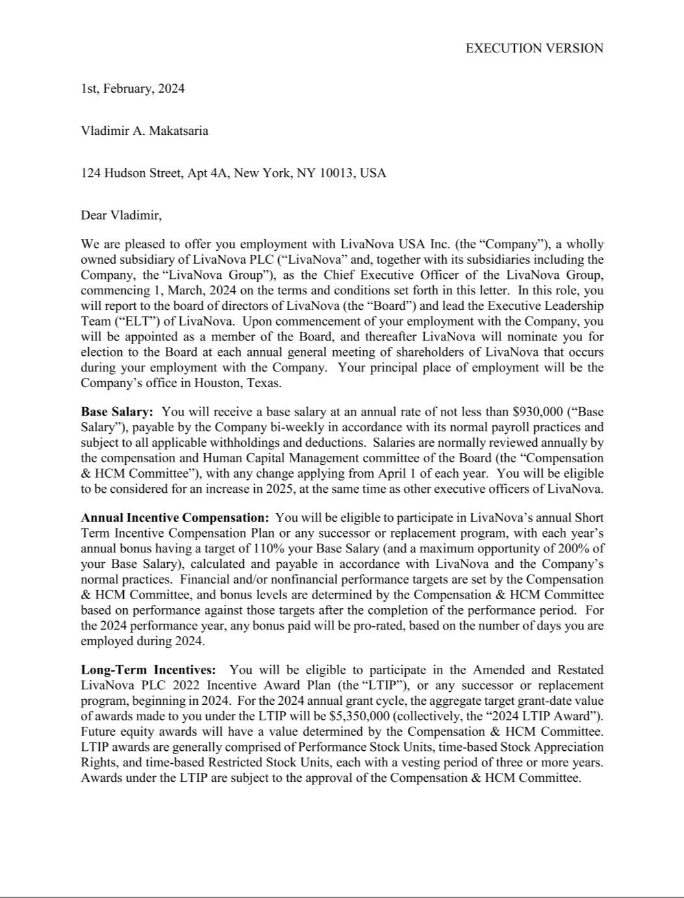

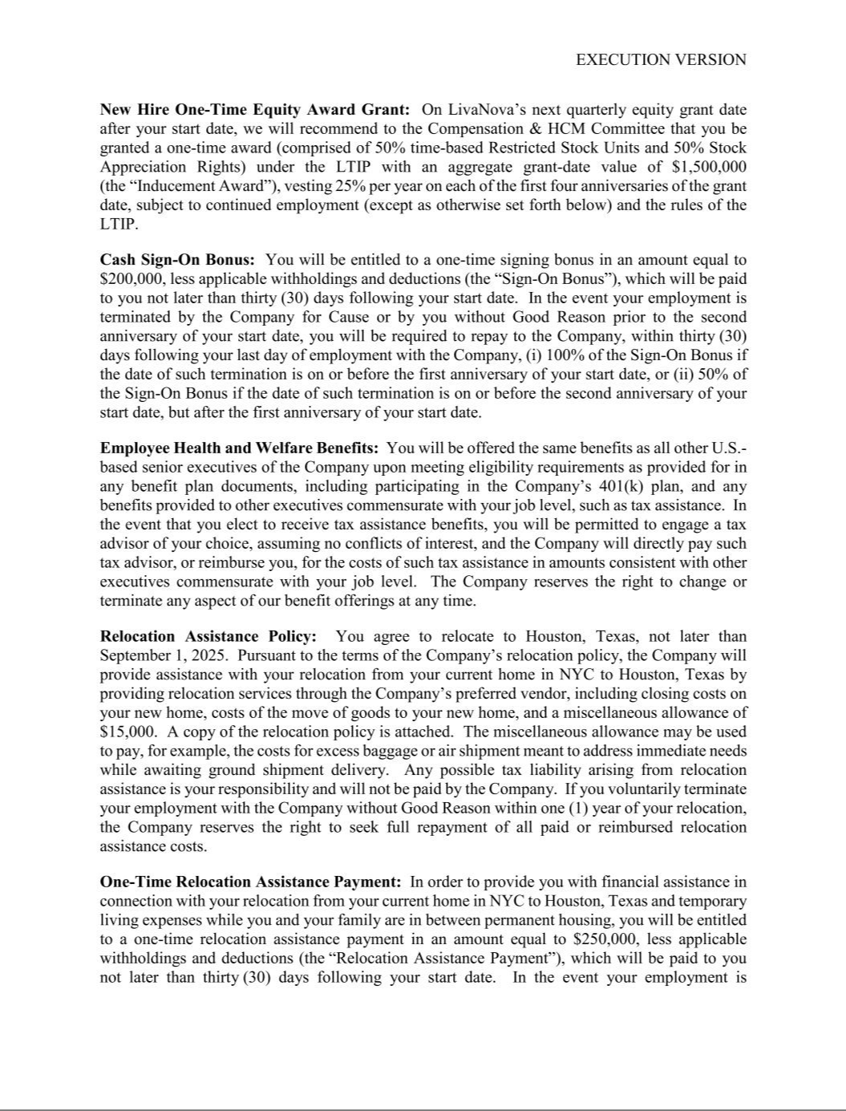

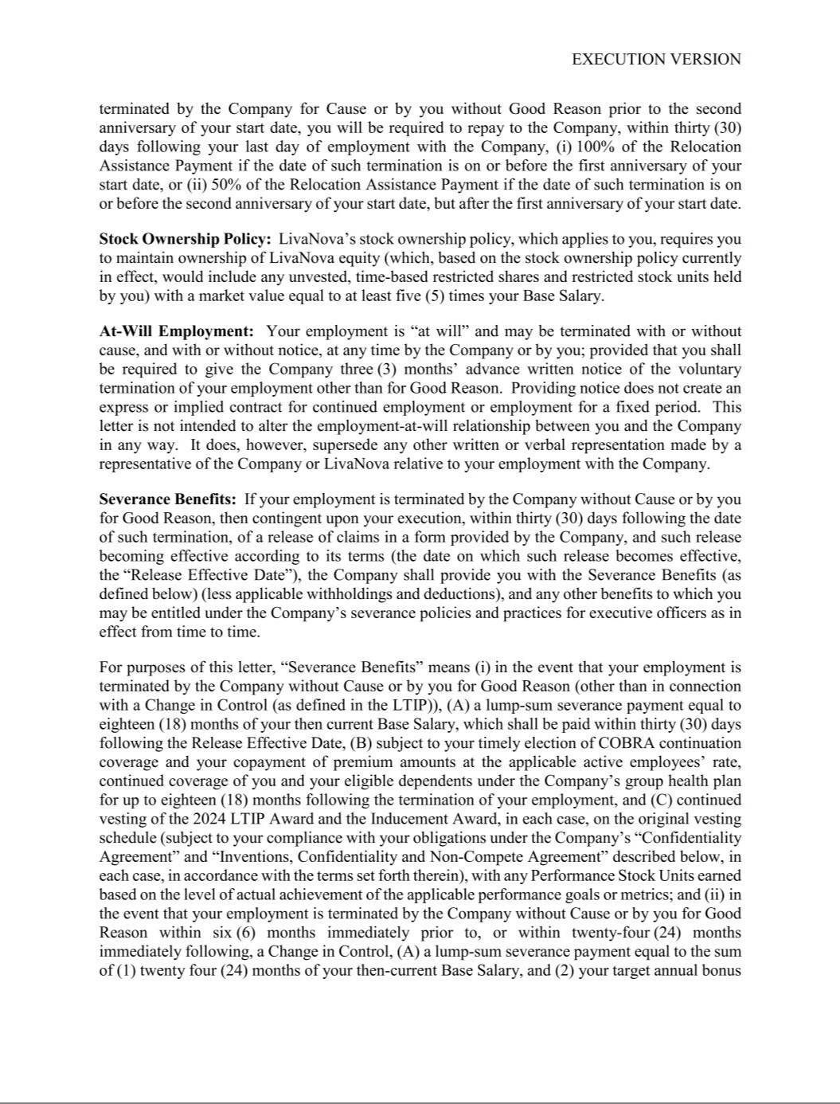

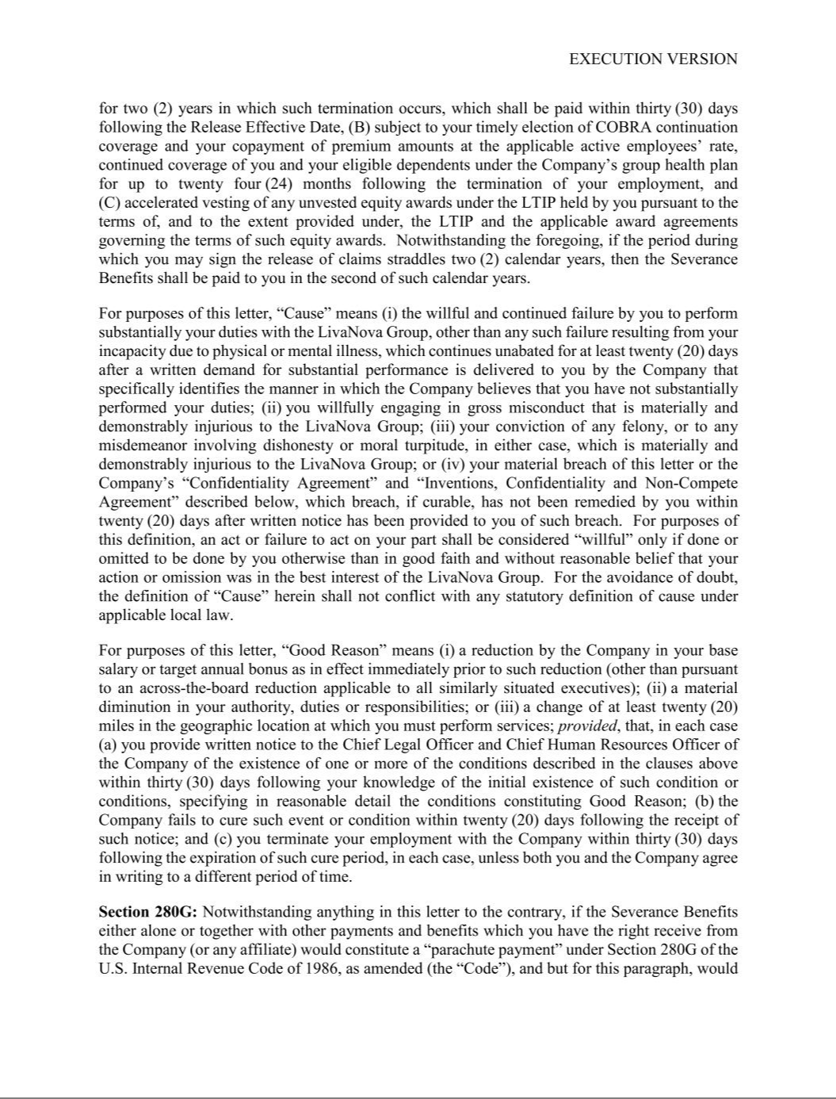

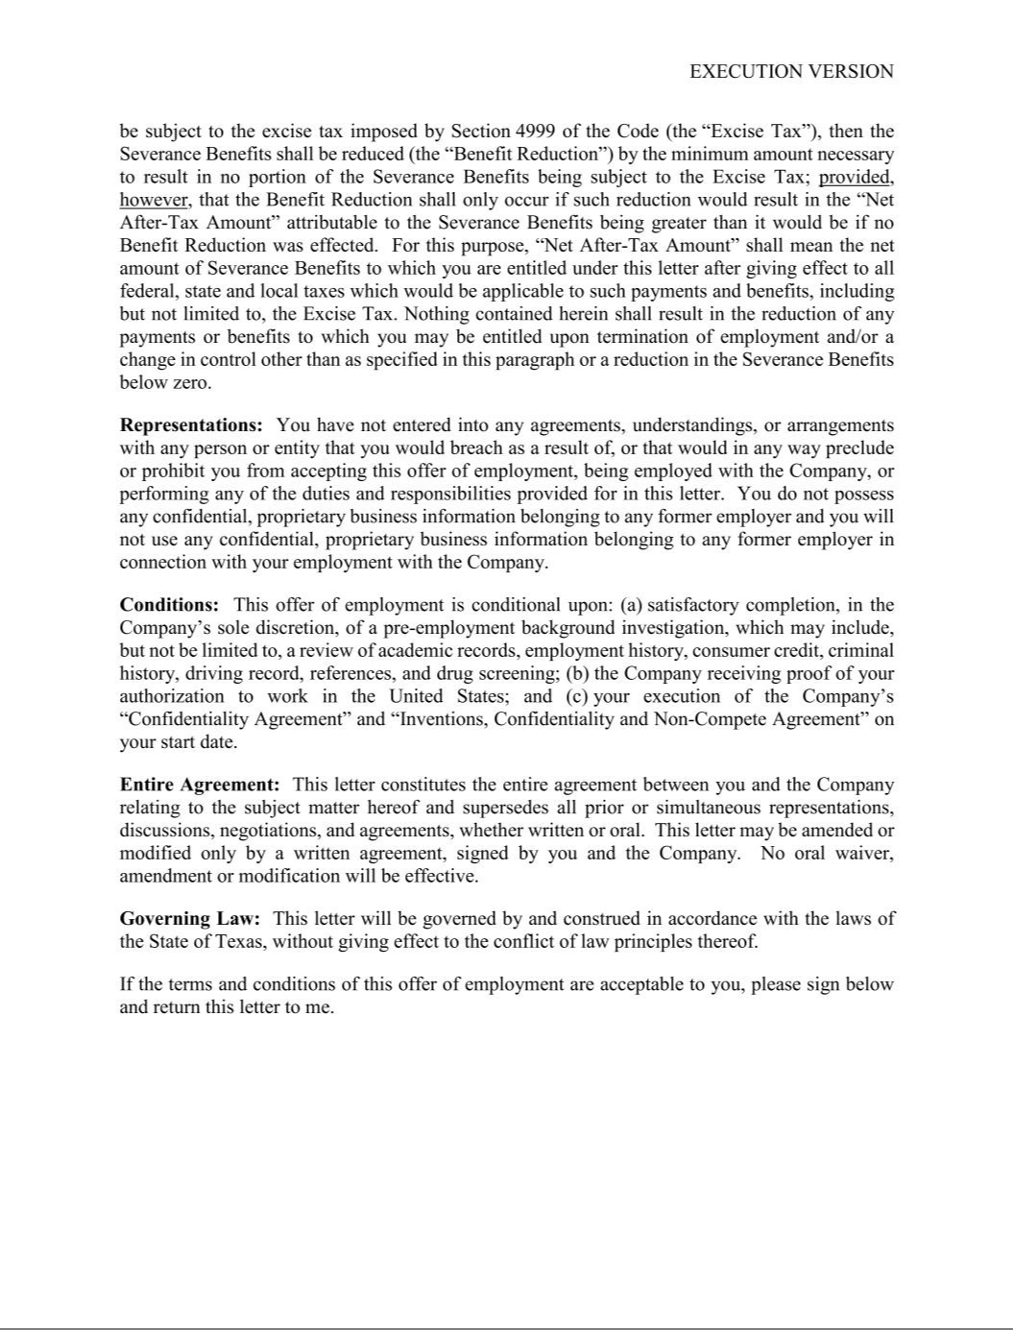

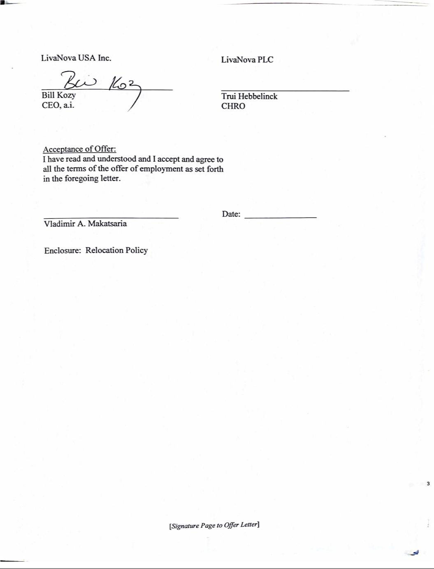

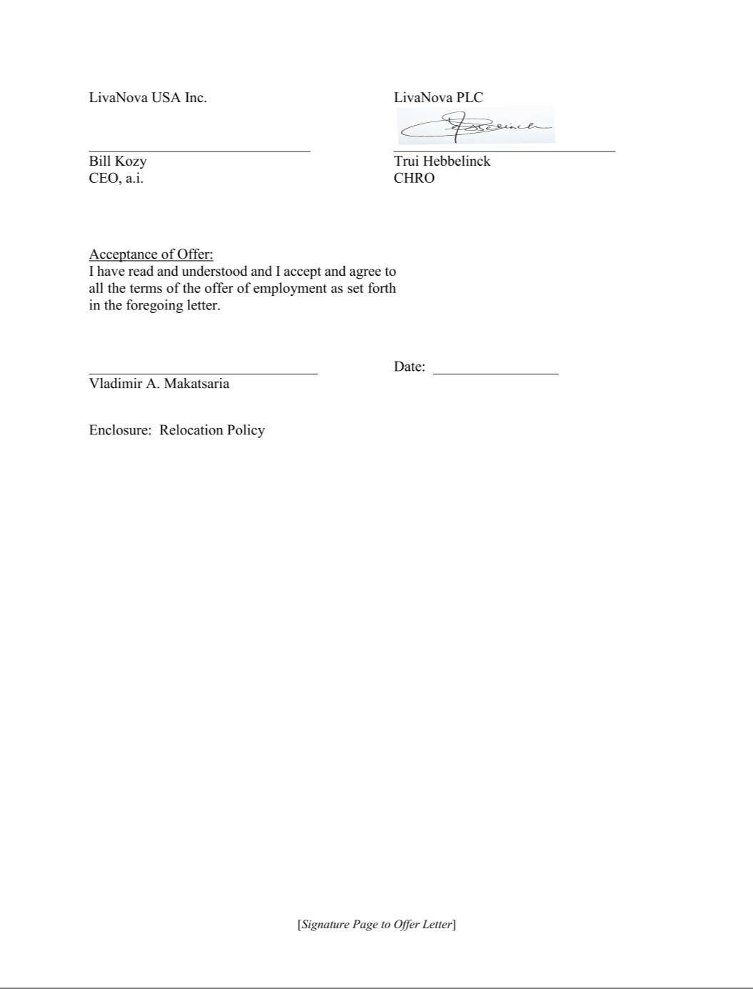

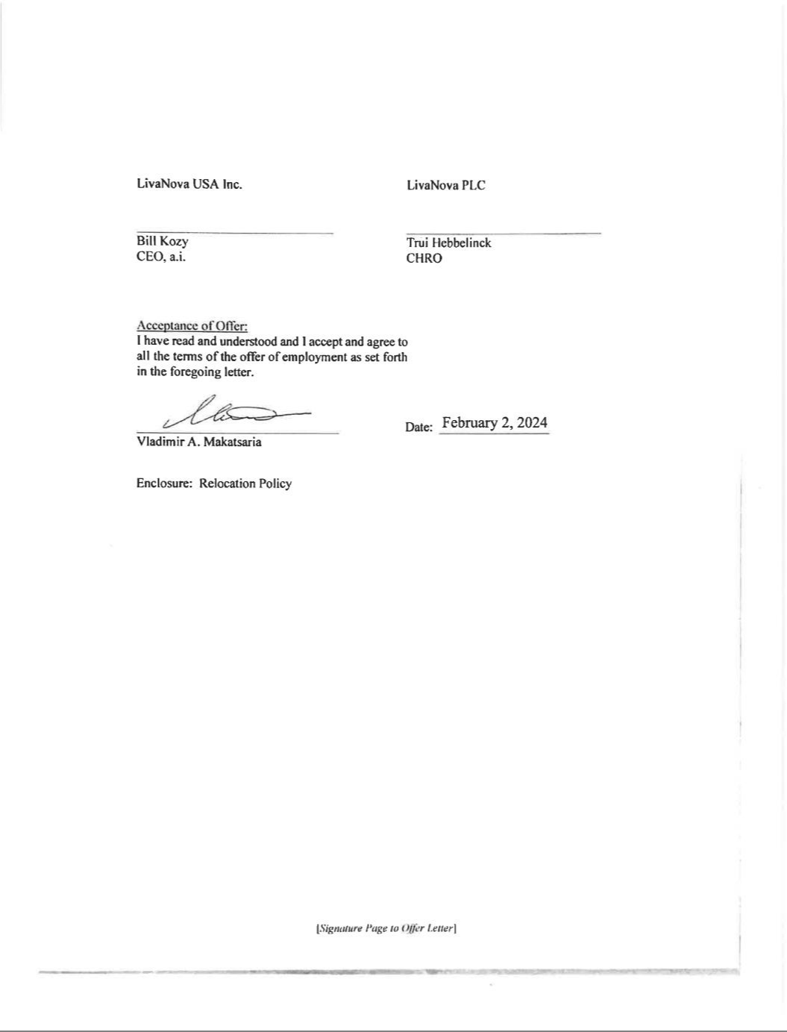

EXHIBIT 31.1

CERTIFICATION OF CHIEF EXECUTIVE OFFICER

PURSUANT TO SECTION 302 OF THE SARBANES-OXLEY ACT OF 2002

I, Vladimir Makatsaria, certify that:

- I have reviewed this Quarterly Report on Form 10-Q for the quarterly period ended March 31, 2024 of LivaNova PLC and its consolidated subsidiaries;

- Based on my knowledge, this report does not contain any untrue statement of a material fact or omit to state a material fact necessary to make the statements made, in light of the circumstances under which such statements were made, not misleading with respect to the period covered by this report;

- Based on my knowledge, the financial statements, and other financial information included in this report, fairly present in all material respects the financial condition, results of operations and cash flows of the registrant as of, and for, the periods presented in this report;

- The registrant’s other certifying officer and I are responsible for establishing and maintaining disclosure controls and procedures (as defined in Rules 13a-15(e) and 15d-15(e) of the Securities Exchange Act of 1934 (the "Exchange Act")) and internal control over financial reporting (as defined in Rules 13a-15(f) and 15d-15(f) of the Exchange Act) for the registrant and have:

- Designed such disclosure controls and procedures, or caused such disclosure controls and procedures to be designed under our supervision, to ensure that material information relating to the registrant, including its consolidated subsidiaries, is made known to us by others within those entities, particularly during the period in which this report is being prepared;

- Designed such internal control over financial reporting, or caused such internal control over financial reporting to be designed under our supervision, to provide reasonable assurance regarding the reliability of financial reporting and the preparation of financial statements for external purposes in accordance with generally accepted accounting principles;

- Evaluated the effectiveness of the registrant’s disclosure controls and procedures and presented in this report our conclusions about the effectiveness of the disclosure controls and procedures, as of the end of the period covered by this report based on such evaluation; and

- Disclosed in this report any change in the registrant’s internal control over financial reporting that occurred during the registrant’s most recent fiscal quarter (the registrant’s fourth fiscal quarter in the case of an annual report) that has materially affected, or is reasonably likely to materially affect, the registrant’s internal control over financial reporting; and

- The registrant’s other certifying officer and I have disclosed, based on our most recent evaluation of internal control over financial reporting, to the registrant’s auditors and the audit committee of the registrant’s board of directors (or persons performing the equivalent functions):

- All significant deficiencies and material weaknesses in the design or operation of internal control over financial reporting which are reasonably likely to adversely affect the registrant’s ability to record, process, summarize and report financial information; and

- Any fraud, whether or not material, that involves management or other employees who have a significant role in the registrant’s internal control over financial reporting.

Date: May 3, 2024

/s/ VLADIMIR MAKATSARIA

Vladimir Makatsaria

Chief Executive Officer

(Principal Executive Officer)

EXHIBIT 31.2

CERTIFICATION OF CHIEF FINANCIAL OFFICER

PURSUANT TO SECTION 302 OF THE SARBANES-OXLEY ACT OF 2002

I, Alex Shvartsburg, certify that:

- I have reviewed this Quarterly Report on Form 10-Q for the quarterly period ended March 31, 2024 of LivaNova PLC and its consolidated subsidiaries;

- Based on my knowledge, this report does not contain any untrue statement of a material fact or omit to state a material fact necessary to make the statements made, in light of the circumstances under which such statements were made, not misleading with respect to the period covered by this report;

- Based on my knowledge, the financial statements, and other financial information included in this report, fairly present in all material respects the financial condition, results of operations and cash flows of the registrant as of, and for, the periods presented in this report;

- The registrant’s other certifying officer and I are responsible for establishing and maintaining disclosure controls and procedures (as defined in Rules 13a-15(e) and 15d-15(e) of the Securities Exchange Act of 1934 (the "Exchange Act")) and internal control over financial reporting (as defined in Rules 13a-15(f) and 15d-15(f) of the Exchange Act) for the registrant and have:

- Designed such disclosure controls and procedures, or caused such disclosure controls and procedures to be designed under our supervision, to ensure that material information relating to the registrant, including its consolidated subsidiaries, is made known to us by others within those entities, particularly during the period in which this report is being prepared;

- Designed such internal control over financial reporting, or caused such internal control over financial reporting to be designed under our supervision, to provide reasonable assurance regarding the reliability of financial reporting and the preparation of financial statements for external purposes in accordance with generally accepted accounting principles;

- Evaluated the effectiveness of the registrant’s disclosure controls and procedures and presented in this report our conclusions about the effectiveness of the disclosure controls and procedures, as of the end of the period covered by this report based on such evaluation; and

- Disclosed in this report any change in the registrant’s internal control over financial reporting that occurred during the registrant’s most recent fiscal quarter (the registrant’s fourth fiscal quarter in the case of an annual report) that has materially affected, or is reasonably likely to materially affect, the registrant’s internal control over financial reporting; and

- The registrant’s other certifying officer and I have disclosed, based on our most recent evaluation of internal control over financial reporting, to the registrant’s auditors and the audit committee of the registrant’s board of directors (or persons performing the equivalent functions):

- All significant deficiencies and material weaknesses in the design or operation of internal control over financial reporting which are reasonably likely to adversely affect the registrant’s ability to record, process, summarize and report financial information; and

- Any fraud, whether or not material, that involves management or other employees who have a significant role in the registrant’s internal control over financial reporting.

Date: May 3, 2024

/s/ ALEX SHVARTSBURG

Alex Shvartsburg

Chief Financial Officer

(Principal Accounting and Financial Officer)

EXHIBIT 32.1

CERTIFICATION OF THE

CHIEF EXECUTIVE OFFICER AND

CHIEF FINANCIAL OFFICER

OF LIVANOVA PLC

PURSUANT TO 18 U.S.C. SECTION 1350

AS ADOPTED PURSUANT TO SECTION 906 OF THE SARBANES-OXLEY ACT OF 2002

Each of Vladimir Makatsaria, Chief Executive Officer of LivaNova PLC (the “Company”), and Alex Shvartsburg, Chief Financial Officer of the Company, each hereby certifies pursuant to 18

U.S.C. Section 1350, as adopted pursuant to Section 906 of the Sarbanes-Oxley Act of 2002, that to the best of his knowledge:

- the Quarterly Report on Form 10-Q of the Company and its consolidated subsidiaries for the quarterly period ended March 31, 2024, as filed with the Securities and Exchange Commission on the date hereof (the “Report”) fully complies with the requirements of Section 13(a) or 15(d) of the Securities Exchange Act of 1934, as amended; and

- the information contained in the Report fairly presents, in all material respects, the financial condition and results of operations of the Company.

Date: May 3, 2024

/s/ VLADIMIR MAKATSARIA

Vladimir Makatsaria

Chief Executive Officer

(Principal Executive Officer)

/s/ ALEX SHVARTSBURG

Alex Shvartsburg

Chief Financial Officer

(Principal Accounting and Financial Officer)

A signed original of this written statement required by Section 906 has been provided to the Company and will be retained by the Company and furnished to the Securities and Exchange Commission or its staff upon request.

The foregoing certification is being furnished solely pursuant to 18 U.S.C. Section 1350 and is not being filed as a part of this report or on a separate disclosure document.

