UNITED STATES
SECURITIES AND EXCHANGE COMMISSION
Washington, D.C. 20549
_________________________

Form 10-Q

(Mark One)

- QUARTERLY REPORT PURSUANT TO SECTION 13 OR 15(d) OF THE SECURITIES EXCHANGE ACT OF 1934 For the quarterly period ended: September 30, 2024

or

- TRANSITION REPORT PURSUANT TO SECTION 13 OR 15(d) OF THE SECURITIES EXCHANGE ACT OF 1934 For the transition period from _______________ to _______________

Commission file number: 001-37599


LivaNova PLC

(Exact name of registrant as specified in its charter)

 |  |  | England and Wales ................... |  |  | 98-1268150
 |  |  | (State or other jurisdiction of .......... |  |  | (I.R.S. Employer
 |  |  | incorporation or organization) ........ |  |  | Identification No.)
 |  |  | 20 Eastbourne Terrace, London, United Kingdom, W2 6LG
 |  |  | (Address of principal executive offices) |  |  | ....................... (Zip Code)
 |  |  | Registrant’s telephone number, including area code: (44) (0) 203 325-0660
 |  |  | Securities registered pursuant to Section 12(b) of the Act:
 | Title of each class |  |  | Trading Symbol(s) |  |  | Name of each exchange on which registered
Ordinary Shares - £1.00 par value per share |  |  |  | LIVN |  |  | The Nasdaq Stock Market LLC

Indicate by check mark whether the registrant (1) has filed all reports required to be filed by Section 13 or 15(d) of the Securities Exchange Act of 1934 during the preceding 12 months (or for such shorter period that the registrant was required to file such reports), and (2) has been subject to such filing requirements for the past 90 days. Yes ☑ No ☐

Indicate by check mark whether the registrant has submitted electronically every Interactive Data File required to be submitted pursuant to Rule 405 of Regulation S-T (§232.405 of this chapter) during the preceding 12 months (or for such shorter period that the registrant was required to submit such files). Yes ☑ No ☐

Indicate by check mark whether the registrant is a large accelerated filer, an accelerated filer, a non-accelerated filer, a smaller reporting company or an emerging growth company. See the definitions of “large accelerated filer,” “accelerated filer,” “smaller reporting company,” and “emerging growth company” in Rule 12b-2 of the Exchange Act.

Large accelerated filer | ☑ | Accelerated filer | ☐
Non-accelerated filer | ☐ | Smaller reporting company | ☐
Emerging growth company | ☐

If an emerging growth company, indicate by check mark if the registrant has elected not to use the extended transition period for complying with any new or revised financial accounting standards provided pursuant to Section 13(a) of the Exchange Act. ☐

Indicate by check mark whether the registrant is a shell company (as defined in Rule 12b-2 of the Act). Yes ☐ | No ☑
Class | Outstanding at October 25, 2024
Ordinary Shares - £1.00 par value per share | 54,300,835

 |  | LIVANOVA PLC
 |  | TABLE OF CONTENTS
Item |  | Description |  | Page
 |  | Definitions |  | 1
 |  | Intellectual Property, Trademarks, and Trade Names | 3
 |  | Cautionary Note About Forward-Looking Statements | 4
 |  | PART I. FINANCIAL INFORMATION
1. |  | Financial Statements (unaudited) | 5
2. |  | Management's Discussion and Analysis of Financial Condition and Results of Operations | 29
3. |  | Quantitative and Qualitative Disclosures About Market Risk | 36
4. |  | Controls and Procedures | 36
 |  | PART II. OTHER INFORMATION
1. |  | Legal Proceedings | 36
1A. |  | Risk Factors | 37
2. |  | Unregistered Sales of Equity Securities and Use of Proceeds | 37
3. |  | Defaults Upon Senior Securities | 37
4. |  | Mine Safety Disclosures | 37
5. |  | Other Information | 37
6. |  | Exhibits | 38
 |  | Signatures | 39

DEFINITIONS

In this Quarterly Report on Form 10-Q for the quarter ended September 30, 2024, the following terms and abbreviations have the meanings listed below. “LivaNova” and the “Company” refer to LivaNova PLC and its consolidated subsidiaries.

 | Abbreviation |  | Definition
2015 | Plan |  | LivaNova PLC 2015 Incentive Award Plan
2015 | Plan Amendment |  | Amendment No. 2 to the LivaNova PLC 2015 Incentive Award Plan
2021 | First Lien Credit Agreement |  | First Lien Credit Agreement between LivaNova PLC and its wholly-owned subsidiary, LivaNova USA, Inc., and Goldman Sachs Bank USA, as First
 |  |  | Lien Administrative Agent and First Lien Collateral Agent, entered into on August 13, 2021
2023 | Form 10-K |  | LivaNova PLC’s Annual Report on Form 10-K for the year ended December 31, 2023, filed with the SEC on February 29, 2024
2024 | Restructuring Plan |  | A plan, initiated during the first quarter of 2024, to enhance LivaNova’s focus on its core Cardiopulmonary and Neuromodulation segments
2025 | Capped Calls |  | Privately-negotiated capped call transactions entered into with certain financial institutions
2025 | Notes |  | $287.5 million aggregate principal amount 3.00% unsecured cash exchangeable senior notes due 2025 by private placement to qualified institutional
 |  |  | buyers pursuant to Rule 144A under the Securities Act, issued by LivaNova USA on June 17, 2020
2025 | Notes Repurchase Transaction |  | Repurchase of $230.0 million aggregate principal amount of the 2025 Notes in privately-negotiated transactions from proceeds from the issuance of
 |  |  | the 2029 Notes
2029 | Capped Calls |  | Privately-negotiated capped call transactions entered into with certain financial institutions
2029 | Notes |  | $345.0 million aggregate principal amount 2.50% unsecured convertible senior notes due 2029 by private placement to qualified institutional buyers
 |  |  | pursuant to Rule 144A under the Securities Act, issued by LivaNova PLC on March 8, 2024
A&R 2022 Plan |  |  | Amended and Restated LivaNova PLC 2022 Incentive Award Plan
A&R 2022 Plan Amendment |  |  | Amendment No. 1 to the Amended and Restated LivaNova PLC 2022 Incentive Award Plan
ACS |  |  | Advanced Circulatory Support
ALung |  |  | ALung Technologies, Inc.
AOCI |  |  | Accumulated other comprehensive income (loss)
Barclays |  |  | Barclays Bank Ireland PLC
Capped Call Transactions |  |  | The 2025 Capped Calls and the 2029 Capped Calls
CEO |  |  | Chief Executive Officer
CFO |  |  | Chief Financial Officer
CMS |  |  | The U.S. Centers for Medicare & Medicaid Services
CODM |  |  | Chief Operating Decision Maker
Court of Appeal |  |  | Court of Appeal in Milan
Delayed Draw Term Facility |  |  | $50.0 million delayed draw term facility under the 2021 First Lien Credit Agreement resulting from the Incremental Facility Amendment No. 2
DRE |  |  | Drug-resistant epilepsy
DTD |  |  | Difficult-to-treat depression
ECJ |  |  | European Court of Justice
Embedded Derivatives |  |  | The bifurcated embedded derivatives associated with the 2025 Notes and 2029 Notes, collectively
Exchange Act |  |  | U.S. Securities Exchange Act of 1934, as amended
FX |  |  | Foreign currency exchange rate
HLM |  |  | Heart-lung machine
ImThera |  |  | ImThera Medical, Inc., acquired by LivaNova in 2018, a company developing an implantable neurostimulation device system for the treatment of
 |  |  | obstructive sleep apnea
Incremental Facility Amendment No. 2 |  |  | An incremental facility amendment to the 2021 First Lien Credit Agreement, dated July 6, 2022
 |  |  | 1

Abbreviation |  | Definition
Incremental Facility Amendment No. 3 |  | An incremental facility amendment to the 2021 First Lien Credit Agreement, dated March 8, 2024
Initial Term Facility |  | $300.0 million term facility under the 2021 First Lien Credit Agreement, resulting from the Incremental Facility Amendment No. 2
ISIN |  | National Inspectorate for Nuclear Safety and Radiation Protection, a sub-body of the Italian Ministry of Economic Development
LivaNova PLC |  | A public limited company organized under the laws of England and Wales on February 20, 2015
LivaNova USA |  | LivaNova USA, Inc.
LSM |  | LivaNova Site Management S.r.l.
MDL |  | Federal multi-district litigation in the U.S. District Court for the Middle District of Pennsylvania
MedTech |  | Medical technology
Nasdaq |  | Nasdaq Global Select Market
OCI |  | Other comprehensive income (loss)
Option Counterparties |  | Certain financial institutions with whom LivaNova USA or LivaNova PLC, as applicable, has entered into the 2025 Capped Calls and 2029 Capped
 |  | Calls
OSA |  | Obstructive sleep apnea
OSPREY clinical trial |  | LivaNova’s clinical trial, “Treating Obstructive Sleep Apnea using Targeted Hypoglossal Neurostimulation”
Pillar Two |  | Organisation for Economic Co-operation and Development Global Anti-Base Erosion Model Rules (Pillar Two)
Public Administrations |  | The Italian Ministry of the Environment and other Italian government agencies
R&D |  | Research and Development
Report |  | This Quarterly Report on Form 10-Q
RSUs |  | Restricted stock units
SARs |  | Stock appreciation rights
SEC |  | U.S. Securities and Exchange Commission
Securities Act |  | U.S. Securities Act of 1933, as amended
SG&A |  | Selling, general, and administrative expenses
ShiraTronics |  | ShiraTronics, Inc., a company developing an implantable neuromodulation therapy device for the treatment of chronic migraine attacks
SNIA |  | SNIA S.p.A.
SNIA Litigation Guarantee |  | A first demand bank guarantee of €270.0 million in connection with the SNIA environmental litigation
Sorin |  | Sorin S.p.A.
Term Facilities |  | The Initial Term Facility, together with the Delayed Draw Term Facility
U.S. |  | United States of America
U.S. GAAP |  | Generally Accepted Accounting Principles in the U.S.
UK |  | United Kingdom
UK Act |  | Finance (No. 2) Act 2023
USD |  | U.S. dollar
VNS Therapy |  | LivaNova Vagus Nerve Stimulation Therapy
 |  | 2

INTELLECTUAL PROPERTY, TRADEMARKS, AND TRADE NAMES

This report may contain references to LivaNova’s proprietary intellectual property, including among others:

- Trademarks for LivaNova’s Neuromodulation systems, the VNS Therapy™ System, and LivaNova’s proprietary pulse generator products: Model 102 (Pulse™), Model 102R (Pulse Duo™), Model 103 (Demipulse™), Model 104 (Demipulse Duo™), Model 106 (AspireSR™), Model 1000 (SenTiva™), Model 1000-D (SenTiva™ Duo), and Model 8103 (Symmetry™).
- Trademarks for LivaNova’s Cardiopulmonary products and systems: Essenz™, S5™, S5 Pro™, B-Capta™, Inspire™, Heartlink™, XTRA™, 3T Heater-Cooler™, Connect™, and Revolution™.

- Trademarks for LivaNova’s advanced circulatory support systems: TandemLife™, TandemHeart™, TandemLung™, ProtekDuo™, LifeSPARC™, ALung™, Hemolung™, Respiratory Dialysis™, and ActivMix™.
- Trademarks for LivaNova’s obstructive sleep apnea system: ImThera™ and aura6000™.
These trademarks and trade names are the property of LivaNova or the property of LivaNova’s consolidated subsidiaries and are protected under applicable intellectual property laws. Solely for convenience, LivaNova’s trademarks and trade names referred to in this Report may appear without the ™ symbol, but such references are not intended to indicate in any way that the Company will
not assert, to the fullest extent under applicable law, LivaNova’s rights to these trademarks and trade names.

3

CAUTIONARY NOTE ABOUT FORWARD-LOOKING STATEMENTS

Certain statements in this Report, other than statements of historical or current fact, are “forward-looking statements” within the meaning of the Private Securities Litigation Reform Act of 1995, Section 27A of the Securities Act, and Section 21E of the Exchange Act. These statements include, but are not limited to, LivaNova’s plans, objectives, strategies, financial performance and outlook, trends, the amount and timing of future cash distributions, prospects or future events, and involve known and unknown risks that are difficult to predict. As a result, the Company’s actual financial results, performance, achievements, or prospects may differ materially from those expressed or implied by these forward-looking statements. Generally, forward-looking statements can be identified by the use of words such as “may,” “could,” “seek,” “guidance,” “predict,” “potential,” “likely,” “believe,” “will,” “should,” “expect,” “anticipate,” “estimate,” “plan,” “intend,” “forecast,” “foresee,” or variations of these terms and similar expressions, or the negative of these terms or similar expressions. Such forward-looking statements are necessarily based on estimates and assumptions that, while considered reasonable by LivaNova and its management based on their knowledge and understanding of the business and industry, are inherently uncertain. These statements are not guarantees of future performance, and stockholders should not place undue reliance on forward-looking statements. There are a number of risks, uncertainties, and other important factors, many of which are beyond the Company’s control, that could cause the Company’s actual results to differ materially from the forward-looking statements contained in this Report, and include, but are not limited to, the following risks and uncertainties: volatility in the global market and worldwide economic conditions, including as caused by the invasion of Ukraine, the evolving instability in the Middle East, inflation, changing interest rates, foreign exchange fluctuations, changes to existing trade agreements and relationships between the U.S. and other countries, including the implementation of sanctions; cyber-attacks or other disruptions to the Company’s information technology systems or those of third parties with which the Company interacts; costs of complying with privacy and security of personal information requirements and laws; risks relating to supply chain pressures; changes in technology, including the development of superior or alternative technology or devices by competitors and/or competition from providers of alternative medical therapies; failure to obtain approvals or reimbursement in relation to the Company’s products; failure to establish, expand, or maintain market acceptance of the Company’s products for the treatment of the Company’s approved indications; failure to develop and commercialize new products and the rate and degree of market acceptance of such products; unfavorable results from clinical studies or failure to meet milestones; failure to comply with, or changes in, laws, regulations, or administrative practices affecting government regulation of the Company’s products; the risk of quality issues and the impacts thereof; risks relating to recalls, replacement of inventory, enforcement actions, or product liability claims; changes or reduction in reimbursement for the Company’s products or failure to comply with rules relating to reimbursement of healthcare goods and services; failure to comply with anti-bribery laws; losses or costs from pending or future lawsuits and governmental investigations, including in the case of the Company’s 3T Heater-Cooler and SNIA environmental litigations; risks associated with environmental laws and regulations as well as environmental liabilities, violations, protest voting, and litigation; product liability, intellectual property, shareholder-related, environmental-related, income tax, and other litigation, disputes, losses, and costs; failure to retain key personnel, prevent labor shortages, or manage labor costs; the failure of the Company’s R&D efforts to keep up with the rapid pace of technological development in the medical device industry; the risks relating to the impact of climate change and the risk of environmental, social, and governance pressures from internal and external stakeholders; failure to protect the Company’s proprietary intellectual property; failure of new acquisitions to further the Company’s strategic objectives or strengthen the Company’s existing businesses; the potential for impairments of intangible assets, goodwill, and other long-lived assets; risks relating to the Company’s indebtedness; effectiveness of the Company’s internal controls over financial reporting; changes in the Company’s profitability and/or failure to manage costs and expenses; fluctuations in future quarterly operating results and/or variations in revenue and operating expenses relative to estimates; changes in tax laws and regulations, including exposure to additional income tax liabilities; and other unknown or unpredictable factors that could harm the Company’s financial performance.

Other factors that could cause LivaNova’s actual results to differ from projected results are described in: (1) “Part II, Item 1A. Risk Factors” and elsewhere in this and the Company’s other Quarterly Reports on Form 10-Q, (2) the Company’s 2023 Form 10-K, (3) the Company’s reports and registration statements filed and furnished from time to time with the SEC, and (4) other announcements LivaNova makes from time to time.

Readers are cautioned not to place undue reliance on the Company’s forward-looking statements, which speak only as of the date hereof. The Company undertakes no obligation to update or revise any forward-looking statements after the date they are made, whether as a result of new information, future events, or otherwise. The following discussion and analysis should be read in conjunction with the Company’s unaudited condensed consolidated financial statements and related notes included elsewhere in this Report. Operating results for the nine months ended September 30, 2024 are not necessarily indicative of future results, including the full fiscal year. Please also refer to the Company’s “Annual Consolidated Financial Statements,” “Notes” thereto, “Management’s Discussion and Analysis of Financial Condition and Results of Operations,” and “Risk Factors” contained in LivaNova’s 2023 Form 10-K and in the Company’s Quarterly Reports on Form 10-Q.

FINANCIAL INFORMATION AND CURRENCY OF FINANCIAL STATEMENTS

All of the financial information included in this Report has been prepared in accordance with U.S. GAAP. The reporting currency of the Company’s condensed consolidated financial statements is USD.

4

PART I. FINANCIAL INFORMATION

ITEM 1. FINANCIAL STATEMENTS

LIVANOVA PLC AND SUBSIDIARIES

CONDENSED CONSOLIDATED STATEMENTS OF INCOME (LOSS)

(UNAUDITED)

 | (In thousands, except per share amounts)
 |  |  | Three Months Ended September 30, |  |  |  |  |  | Nine Months Ended September 30,
 |  |  | 2024 |  |  | 2023 |  |  | 2024 |  |  | 2023
Net revenue |  | $ | 318,120 |  | $ | 286,113 |  | $ | 931,607 |  | $ | 843,413
Cost of sales |  |  | 92,856 |  |  | 84,310 |  |  | 280,088 |  |  | 262,330
Gross profit |  |  | 225,264 |  |  | 201,803 |  |  | 651,519 |  |  | 581,083
Operating expenses:
Selling, general, and administrative |  |  | 131,661 |  |  | 134,794 |  |  | 390,642 |  |  | 384,795
Research and development |  |  | 48,805 |  |  | 46,541 |  |  | 139,206 |  |  | 147,651
Other operating expenses |  |  | 9,180 |  |  | 16,010 |  |  | 29,641 |  |  | 29,145
Operating income |  |  | 35,618 |  |  | 4,458 |  |  | 92,030 |  |  | 19,492
Interest expense |  |  | (15,878) |  |  | (14,986) |  |  | (47,303) |  |  | (43,232)
Loss on debt extinguishment |  |  | — |  |  | — |  |  | (25,482) |  |  | —
Foreign exchange and other income/(expense) |  |  | 24,701 |  |  | 8,550 |  |  | 12,585 |  |  | 36,810
Income (loss) before tax |  |  | 44,441 |  |  | (1,978) |  |  | 31,830 |  |  | 13,070
Income tax expense |  |  | 11,525 |  |  | 5,308 |  |  | 24,469 |  |  | 11,776
Income (loss) from equity method investments |  |  | 37 |  |  | (32) |  |  | (18) |  |  | (87)
Net income (loss) |  | $ | 32,953 |  | $ | (7,318) |  | $ | 7,343 |  | $ | 1,207
Basic income (loss) per share | $ |  | 0.61 |  | $ | (0.14) |  | $ | 0.14 |  | $ | 0.02
Diluted income (loss) per share | $ |  | 0.60 |  | $ | (0.14) |  | $ | 0.13 |  | $ | 0.02
Shares used in computing basic income (loss) per share |  |  | 54,352 |  |  | 53,989 |  |  | 54,194 |  |  | 53,837
Shares used in computing diluted income (loss) per share |  |  | 54,585 |  |  | 53,989 |  |  | 54,526 |  |  | 54,107

See accompanying notes to the condensed consolidated financial statements.

5

LIVANOVA PLC AND SUBSIDIARIES

CONDENSED CONSOLIDATED STATEMENTS OF COMPREHENSIVE INCOME (LOSS)

(UNAUDITED)

(In thousands)

 | Three Months Ended September 30, |  |  |  |  |  |  | Nine Months Ended September 30,
 | 2024 |  |  |  | 2023 |  |  | 2024 |  |  | 2023
Net income (loss) | $ | 32,953 |  | $ | (7,318) |  | $ | 7,343 |  | $ | 1,207
Other comprehensive income (loss):
Unrealized loss on cash flow hedges |  | — |  |  | — |  |  | — |  |  | (966)
Tax effect |  | — |  |  | — |  |  | — |  |  | —
Net of tax |  | — |  |  | — |  |  | — |  |  | (966)
Foreign currency translation adjustment |  | 26,116 |  |  | (19,222) |  |  | 1,180 |  |  | (5,716)
Other comprehensive income (loss), net of tax |  | 26,116 |  |  | (19,222) |  |  | 1,180 |  |  | (6,682)
Comprehensive income (loss) | $ | 59,069 |  | $ | (26,540) |  | $ | 8,523 |  | $ | (5,475)

See accompanying notes to the condensed consolidated financial statements.

6

LIVANOVA PLC AND SUBSIDIARIES

CONDENSED CONSOLIDATED BALANCE SHEETS

(UNAUDITED)

(In thousands, except share amounts)

ASSETS |  | September 30, 2024 |  |  | December 31, 2023
Current Assets:
Cash and cash equivalents | $ | 346,366 |  | $ | 266,504
Restricted cash |  | 320,210 |  |  | 311,368
Accounts receivable, net of allowance of $12,129 at September 30, 2024 and $12,019 at December 31, 2023 |  | 197,162 |  |  | 215,072
Inventories |  | 162,264 |  |  | 147,887
Prepaid and refundable taxes |  | 23,858 |  |  | 20,145
Prepaid expenses and other current assets |  | 43,253 |  |  | 27,182
Total Current Assets |  | 1,093,113 |  |  | 988,158
Property, plant, and equipment, net |  | 169,317 |  |  | 154,181
Goodwill |  | 781,553 |  |  | 782,941
Intangible assets, net |  | 248,545 |  |  | 261,178
Operating lease assets |  | 51,599 |  |  | 50,845
Investments |  | 18,097 |  |  | 22,843
Deferred tax assets |  | 109,992 |  |  | 118,858
Long-term derivative assets |  | 35,368 |  |  | 38,496
Other assets |  | 14,374 |  |  | 12,063
Total Assets | $ | 2,521,958 |  | $ | 2,429,563
LIABILITIES AND STOCKHOLDERS' EQUITY
Current Liabilities:
Current debt obligations | $ | 21,951 |  | $ | 18,111
Accounts payable |  | 77,893 |  |  | 80,845
Accrued liabilities and other |  | 104,523 |  |  | 107,301
Current litigation provision liability |  | 16,098 |  |  | 10,756
Taxes payable |  | 26,507 |  |  | 23,340
Accrued employee compensation and related benefits |  | 77,430 |  |  | 94,630
Total Current Liabilities |  | 324,402 |  |  | 334,983
Long-term debt obligations |  | 604,287 |  |  | 568,543
Contingent consideration |  | 81,240 |  |  | 80,902
Deferred tax liabilities |  | 11,843 |  |  | 11,567
Long-term operating lease liabilities |  | 44,078 |  |  | 45,388
Long-term employee compensation and related benefits |  | 14,867 |  |  | 17,254
Long-term derivative liabilities |  | 84,157 |  |  | 45,569
Other long-term liabilities |  | 47,040 |  |  | 47,729
Total Liabilities |  | 1,211,914 |  |  | 1,151,935
Commitments and contingencies (Note 6)
Stockholders’ Equity:
Ordinary Shares, £1.00 par value: unlimited shares authorized; 54,405,751 shares issued and 54,300,048 shares outstanding at |  | 83,112 |  |  | 82,533
September 30, 2024; 53,942,151 shares issued and 53,918,222 shares outstanding at December 31, 2023 |  | 83,112 |  |  | 82,533
Additional paid-in capital |  | 2,212,932 |  |  | 2,189,517
Accumulated other comprehensive loss |  | (26,703) |  |  | (27,883)
Accumulated deficit |  | (959,141) |  |  | (966,484)
Treasury stock at cost, 105,703 ordinary shares at September 30, 2024; 23,929 ordinary shares at December 31, 2023 |  | (156) |  |  | (55)
Total Stockholders’ Equity |  | 1,310,044 |  |  | 1,277,628
Total Liabilities and Stockholders’ Equity | $ | 2,521,958 |  | $ | 2,429,563

See accompanying notes to the condensed consolidated financial statements.

7

LIVANOVA PLC AND SUBSIDIARIES

CONDENSED CONSOLIDATED STATEMENTS OF CASH FLOWS

(UNAUDITED)

 | (In thousands)
 |  | Nine Months Ended September 30,
Operating Activities: |  | 2024 |  |  | 2023
Net income | $ |  | 7,343 |  | $ | 1,207
Adjustments to reconcile net income to net cash provided by operating activities:
Stock-based compensation |  |  | 26,984 |  |  | 28,069
Loss on debt extinguishment |  |  | 25,482 |  |  | —
Depreciation |  |  | 18,683 |  |  | 18,582
Amortization of debt issuance costs |  |  | 15,692 |  |  | 14,246
Amortization of intangible assets |  |  | 12,960 |  |  | 19,129
Deferred income tax expense |  |  | 9,093 |  |  | 1,908
Amortization of operating lease assets |  |  | 6,918 |  |  | 7,270
Impairment of investments |  |  | 5,768 |  |  | —
Remeasurement of derivative instruments |  |  | 400 |  |  | (25,730)
Remeasurement of contingent consideration to fair value |  |  | 338 |  |  | 4,516
Other |  |  | 1,453 |  |  | 605
Changes in operating assets and liabilities:
Accounts receivable, net |  |  | 17,425 |  |  | (8,239)
Inventories |  |  | (13,895) |  |  | (33,024)
Other current and non-current assets |  |  | (14,841) |  |  | (2,981)
Accounts payable and accrued current and non-current liabilities |  |  | (23,383) |  |  | (8,084)
Taxes payable |  |  | 2,628 |  |  | 6,347
Litigation provision liability |  |  | 5,283 |  |  | (2,865)
Net cash provided by operating activities |  |  | 104,331 |  |  | 20,956
Investing Activities:
Purchases of property, plant, and equipment |  |  | (36,701) |  |  | (22,062)
Purchase of investments |  |  | (846) |  |  | (6,570)
Other |  |  | 95 |  |  | 439
Net cash used in investing activities |  |  | (37,452) |  |  | (28,193)
Financing Activities:
Proceeds from long-term debt obligations |  |  | 335,513 |  |  | 50,000
Repayment of long-term debt obligations |  |  | (243,174) |  |  | (16,061)
Payment of debt extinguishment costs |  |  | (38,953) |  |  | —
Purchase of capped calls |  |  | (31,637) |  |  | —
Proceeds from unwind of capped calls |  |  | 22,523 |  |  | —
Payment of contingent consideration |  |  | (13,750) |  |  | —
Shares repurchased from employees for minimum tax withholding |  |  | (8,071) |  |  | (6,995)
Payment of debt issuance costs |  |  | (5,931) |  |  | —
Proceeds from exercise of stock options |  |  | 5,028 |  |  | 19
Repayments of short-term borrowings (maturities greater than 90 days) |  |  | — |  |  | (1,901)
Other |  |  | 447 |  |  | 1,440
Net cash provided by financing activities |  |  | 21,995 |  |  | 26,502
Effect of exchange rate changes on cash, cash equivalents, and restricted cash |  |  | (170) |  |  | (2,161)
Net increase in cash, cash equivalents, and restricted cash |  |  | 88,704 |  |  | 17,104
Cash, cash equivalents, and restricted cash at beginning of period |  |  | 577,872 |  |  | 515,618
Cash, cash equivalents, and restricted cash at end of period |  | $ | 666,576 |  | $ | 532,722

See accompanying notes to the condensed consolidated financial statements.

8

LIVANOVA PLC AND SUBSIDIARIES

NOTES TO THE CONDENSED CONSOLIDATED FINANCIAL STATEMENTS

(Unaudited)

Note 1. Unaudited Condensed Consolidated Financial Statements

Basis of Presentation

The accompanying unaudited condensed consolidated financial statements of LivaNova and the notes thereto as of and for the three and nine months ended September 30, 2024 and 2023 have been prepared in accordance with U.S. GAAP for interim financial information and the instructions to Form 10-Q and Article 10 of Regulation S-X. The accompanying condensed consolidated balance sheet of LivaNova at December 31, 2023 has been derived from audited consolidated financial statements contained in LivaNova’s 2023 Form 10-K, but does not include all of the information and footnotes required by U.S. GAAP for complete financial statements. In the opinion of management, the condensed consolidated financial statements reflect all adjustments considered necessary for a fair statement of the operating results of LivaNova and its subsidiaries for the three and nine months ended September 30, 2024 and are not necessarily indicative of the results that may be expected for the year ending December 31, 2024. The financial information presented herein should be read in conjunction with the audited consolidated financial statements and notes thereto accompanying LivaNova’s 2023 Form 10-K.

Cybersecurity Incident

As previously disclosed, in November 2023, LivaNova detected a cybersecurity incident that resulted in a disruption of portions of the Company’s information technology systems. Promptly after detecting the issue, LivaNova began an investigation with assistance from external cybersecurity experts and coordinated with law enforcement. The Company quickly implemented remediation measures to mitigate the impact of the incident. The Company also assessed the nature and scope of the affected data, analyzed its legal notification obligations, and notified affected individuals and regulators as required by applicable law. The Company believes the incident is contained and mitigation efforts are complete.

Through September 30, 2024, LivaNova incurred direct costs totaling $10.8 million in connection with this cybersecurity incident, including $2.5 million and $8.2 million during the three and nine months ended September 30, 2024, respectively. These costs primarily include external cybersecurity expert and legal fees, system restoration costs, and a $1.2 million provision related to the class action settlement, as discussed in “Note 6. Commitments and Contingencies,” and do not include business interruption losses. The Company expects to incur additional costs related to this incident in the future. LivaNova maintains insurance, including cyber insurance, which is subject to certain retentions and policy limitations that will likely limit the amount that the insurers may pay the Company. LivaNova has filed claims for insurance reimbursement of covered costs and business interruption losses related to this incident and has submitted additional claims and supplemental requests for reimbursement as new costs have been incurred. LivaNova has not yet received reimbursement or recognized a receivable. The Company’s insurance coverage will likely be insufficient to cover all costs and expenses related to this cybersecurity incident or may be unavailable to cover all costs and expenses related to this cybersecurity incident.

Significant Accounting Policies

LivaNova’s significant accounting policies are included within “Note 2. Basis of Presentation, Use of Accounting Estimates and Significant Accounting Policies” and “Note 3. Revenue Recognition” of LivaNova’s 2023 Form 10-K.

Note 2. Restructuring

From time to time, LivaNova initiates restructuring plans to leverage economies of scale, streamline distribution and logistics, and strengthen operational and administrative effectiveness to reduce overall costs.

On January 5, 2024, the Board of Directors of LivaNova approved the 2024 Restructuring Plan to enhance the Company’s focus on its core Cardiopulmonary and Neuromodulation segments. The main component of the 2024 Restructuring Plan was to wind down the ACS segment, which the Company anticipates will be substantially complete by the end of 2024. In connection with the 2024 Restructuring Plan, LivaNova expects to incur pre-tax restructuring charges in the range of $15.0 million to $20.0 million. The anticipated charges are comprised of $10.0 million to $12.0 million in severance expenses and retention bonuses and $5.0 million to $8.0 million in other expenses, including lease termination, facilities remediation, and asset disposal expenses. Retention bonuses will be earned over the period of service, which is expected to be over the full year of 2024. All future cash payments related to these restructuring charges are expected to be substantially paid out during 2024. These estimates are subject to change. LivaNova recognized restructuring expense under the 2024 Restructuring Plan of $1.5 million and $12.8 million in other operating expenses on its condensed consolidated statements of income (loss) for the three and nine months ended September 30, 2024, respectively.

9

The following table presents a reconciliation of the beginning and ending balance of the accruals and other reserves recorded in connection with LivaNova’s restructuring plans included in accounts payable and accrued liabilities and other on the condensed consolidated balance sheets (in thousands):
 |  |  | Employee Severance and Other |  |  |  |  | Other |  |  |  |  |  |  |  | Total
 |  |  | Termination Costs |  |  |  |  |  |  |  |  |  |  |  |  | Total
Balance at December 31, 2023 ⁽¹⁾ |  | $ |  |  | 911 |  |  | $ |  |  | — |  | $ |  |  | 911
Charges |  |  |  |  | 10,377 |  |  |  |  |  | 2,466 |  |  |  |  | 12,843
Cash payments |  |  |  |  | (7,868) |  |  |  |  |  | (2,006) |  |  |  |  | (9,874)
Balance at September 30, 2024 |  | $ |  |  | 3,420 |  |  | $ |  |  | 460 |  | $ |  |  | 3,880
(1) | Represents restructuring plans initiated prior to 2024.
The following table presents restructuring expense by reportable segment (in thousands):
 |  |  | Three Months Ended September 30, |  |  |  |  |  |  |  | Nine Months Ended September 30,
 |  |  | 2024 |  |  |  |  | 2023 |  |  | 2024 |  |  |  |  | 2023
Neuromodulation |  |  | $ | — |  | $ |  | (6) |  | $ |  |  | — |  | $ | 554
Other ⁽¹⁾ |  |  |  | 1,479 |  |  |  | 130 |  |  |  | 12,843 |  |  |  | 501
 |  |  | $ | 1,479 |  | $ |  | 124 |  | $ |  | 12,843 |  |  | $ | 1,055

- Other primarily includes restructuring expense not allocated to segments.

Note 3. Derivatives and Risk Management

Due to the global nature of LivaNova’s operations, the Company is exposed to FX fluctuations. LivaNova enters into FX derivative contracts to reduce the impact of FX fluctuations on earnings and cash flow.

LivaNova is also exposed to equity price risk in connection with its 2025 Notes and 2029 Notes, including exchange/conversion and settlement provisions based on the price of its ordinary shares at exchange/conversion or maturity of the 2025 Notes and 2029 Notes. The Capped Call Transactions associated with the 2025 Notes and 2029 Notes also include settlement provisions that are based on the price of LivaNova’s ordinary shares, subject to a capped price per share. LivaNova does not enter into derivative contracts for speculative purposes.

LivaNova measures all outstanding derivatives each period end at fair value and reports the fair value as either financial assets or liabilities on the condensed consolidated balance sheets. At inception of the contract, the derivative is designated as either a freestanding derivative or a hedge. Derivatives that are not designated as hedging instruments are referred to as freestanding derivatives with changes in fair value included in earnings. These derivatives are intended to serve as economic hedges and follow the cash flows of the economic hedged item. The cash flows from these derivative contracts are reported as operating activities on LivaNova’s condensed consolidated statements of cash flows.

If the derivative qualifies for hedge accounting, changes in the fair value of the derivative will be recorded in AOCI until the hedged item is recognized in earnings upon settlement/termination. Interest rate swap gains and losses in AOCI are reclassified to interest expense on LivaNova’s condensed consolidated statements of income (loss). LivaNova evaluates hedge effectiveness at inception. LivaNova had no designated hedging instruments as of September 30, 2024 and December 31, 2023.

Freestanding FX Derivatives

The gross notional amount of freestanding FX derivative contracts not designated as hedging instruments outstanding as of September 30, 2024 and December 31, 2023 was $158.9 million and $223.4 million, respectively. These derivative contracts are designed to offset the FX effects in earnings of various intercompany loans and trade receivables. LivaNova recorded net losses of $5.0 million and net gains of $5.0 million for these freestanding derivatives for the three months ended September 30, 2024 and 2023, respectively, and net losses of $0.1 million and net gains of $4.1 million for the nine months ended September 30, 2024 and 2023, respectively. These gains and losses are included in foreign exchange and other income/(expense) on LivaNova’s condensed consolidated statements of income (loss).

10

Capped Call Derivatives

The Capped Call Transactions are carried on the condensed consolidated balance sheets as a derivative asset at their estimated fair value and are adjusted at the end of each reporting period, with unrealized gain or loss reflected in foreign exchange and other income/(expense) in the condensed consolidated statements of income (loss). The Capped Call Transactions are measured at fair value using the Black-Scholes model utilizing observable and unobservable market data, including stock price, remaining contractual term, expected volatility, risk-free interest rate, and expected dividend yield, as applicable. For additional information, refer to “Note 5. Financing Arrangements.”

2025 Capped Calls

In June 2020, LivaNova issued the 2025 Notes. In connection with the pricing of the 2025 Notes, the Company entered into related privately-negotiated capped call transactions with certain financial institutions. Under the 2025 Capped Calls, the Company purchased a capped call option with an initial strike price of $60.98 and an initial cap price of $100.00 per share. The strike price, which is subject to certain adjustments, corresponds to the initial exchange price of the 2025 Notes. The 2025 Capped Calls are intended to offset any cash payments upon exchange of the 2025 Notes in excess of the principal amount; however, the proceeds are limited to the initial cap price in the event the Company’s share price exceeds the cap price at the time of an exchange. The 2025 Capped Calls expire on December 15, 2025, and must be settled in cash. The 2025 Capped Calls are subject to anti-dilution adjustments substantially similar to those applicable to the 2025 Notes and cover the number of LivaNova’s ordinary shares underlying the 2025 Notes. If the 2025 Capped Calls are terminated early, settlement occurs at their termination value, which is equal to their fair value at the time of the early termination. In connection with the issuance of the 2029 Notes, the Company repurchased an aggregate principal amount of $230.0 million of the 2025 Notes and unwound a corresponding portion of the 2025 Capped Calls at the fair value of such portion of the 2025 Capped Calls. The Company received $22.5 million in cash consideration, the fair value of the terminated portion, upon settlement. The terms of the remaining 2025 Capped Calls remain unchanged and continue to be classified as long-term derivative assets.

2029 Capped Calls

In March 2024, LivaNova issued the 2029 Notes. In connection with the pricing of the 2029 Notes, the Company entered into related privately-negotiated capped call transactions with certain financial institutions. Under the 2029 Capped Calls, the Company purchased a capped call option with an initial strike price of $69.40 and an initial cap price of $94.28 per share. The strike price, which is subject to certain adjustments, corresponds to the initial conversion price of the 2029 Notes. The 2029 Capped Calls are intended to offset any cash payments and/or cash equivalent value of ordinary shares upon conversion of the 2029 Notes if the market value per ordinary share is greater than the strike price, with such offsets being subject to the initial cap price of $94.28 per share. However, the proceeds under the 2029 Capped Calls are limited to the initial cap price in the event the Company’s share price exceeds the cap price at the time of conversion. The 2029 Capped Calls expire on March 15, 2029, and must be settled in cash. The 2029 Capped Calls are subject to anti-dilution adjustments substantially similar to those applicable to the 2029 Notes and cover the number of LivaNova’s ordinary shares underlying the 2029 Notes. If the 2029 Capped Calls are terminated early, settlement occurs at their termination value, which is equal to their fair value at the time of the early termination. For transaction costs associated with entering into the 2029 Capped Calls, refer to “Additions” in the “Reconciliation of Level 3 Assets and Liabilities” table within “Note 4. Fair Value Measurements.”

Embedded Derivatives

The 2025 Notes and 2029 Notes each include terms resulting in a bifurcated embedded derivative. The Embedded Derivatives are measured at fair value using a binomial lattice model and estimated discounted cash flows that utilize observable and unobservable market data and are adjusted at the end of each reporting period, with the unrealized gain or loss reflected in foreign exchange and other income/(expense) in the condensed consolidated statements of income (loss). For additional information, refer to “Note 5. Financing Arrangements.”

Counterparty Credit Risk

LivaNova is exposed to credit risk in the event of non-performance by the counterparties to the Company’s derivatives.

The Option Counterparties are financial institutions. To limit LivaNova’s credit risk, the Company selected financial institutions with a minimum long-term investment grade credit rating. LivaNova’s exposure to the credit risk of the Option Counterparties is not secured by any collateral. If such an Option Counterparty becomes subject to insolvency proceedings, LivaNova will become an unsecured creditor in those proceedings, with a claim equal to the Company’s exposure at that time under the 2025 Capped Calls and/or 2029 Capped Calls, as applicable, with that Option Counterparty.

To manage credit risk with respect to LivaNova’s other derivatives, the Company selects and periodically reviews counterparties based on credit ratings, limits its exposure with respect to each counterparty, and monitors their respective

11

market positions. However, if one or more of these counterparties were in a liability position to the Company and were unable to meet their obligations, any transactions with the counterparty could be subject to early termination, which could result in substantial losses for the Company.

Cash Flow Hedges

Historically, LivaNova entered into interest rate swaps associated with the Initial Term Facility, which qualified for and were designated as cash flow hedges. The Company’s outstanding interest rate swaps expired on April 6, 2023. LivaNova elected not to renew the interest rate swaps. Interest expense associated with the Initial Term Facility is principally offset by holding a significant portion of the Term Facilities in a depository account, which earns a floating rate of interest.

The pre-tax gains (losses) for derivative contracts designated as cash flow hedges recognized in OCI and the amount reclassified to earnings from AOCI were as follows (in thousands):

 |  |  |  |  | Nine Months Ended September 30, 2023
Description of Derivative Contract |  | Location in Earnings of Reclassified Gain |  |  | Loss Recognized in OCI |  |  | Gain Reclassified from AOCI to
 |  | or Loss |  |  |  |  |  | Earnings
Interest rate swap contracts |  | Interest expense |  | $ | (433) |  | $ | 533

Balance Sheet Presentation

LivaNova offsets fair value amounts associated with its derivative instruments that are executed with the same counterparty under master netting arrangements on the Company’s condensed consolidated balance sheets. Master netting arrangements include a right to set off or net together purchases and sales of similar products in the settlement process.

The following tables present the fair value and the location of derivative contracts reported on the condensed consolidated balance sheets (in thousands):

 | Derivative Assets |  |  |  | Derivative Liabilities
September 30, 2024 | Balance Sheet Location |  | Fair Value ⁽¹⁾ |  | Balance Sheet Location |  | Fair Value ⁽¹⁾
Derivatives Not Designated as Hedging Instruments:
Capped call derivatives (2025 Notes) | Long-term derivative assets | $ | 5,771
Capped call derivatives (2029 Notes) | Long-term derivative assets |  | 29,597
Embedded derivative (2025 Notes) |  |  |  |  | Long-term derivative liabilities | $ | 7,188
Embedded derivative (2029 Notes) |  |  |  |  | Long-term derivative liabilities |  | 76,969
FX derivative contracts | Prepaid expenses and other current assets |  | — |  | Accrued liabilities and other |  | 2,245
Total derivatives not designated as hedging |  | $ | 35,368 |  |  | $ | 86,402
instruments |  | $ | 35,368 |  |  | $ | 86,402
 | Derivative Assets |  |  |  | Derivative Liabilities
December 31, 2023 | Balance Sheet Location |  | Fair Value ⁽¹⁾ |  | Balance Sheet Location |  | Fair Value ⁽¹⁾
Derivatives Not Designated as Hedging Instruments:
Capped call derivatives (2025 Notes) | Long-term derivative assets | $ | 38,496
Embedded derivative (2025 Notes) |  |  |  |  | Long-term derivative liabilities | $ | 45,569
FX derivative contracts |  |  |  |  | Accrued liabilities and other |  | 3,883
Total derivatives not designated as hedging |  | $ | 38,496 |  |  | $ | 49,452
instruments |  | $ | 38,496 |  |  | $ | 49,452

- For the classification of inputs used to evaluate the fair value of LivaNova’s derivatives, refer to “Note 4. Fair Value Measurements.”

12

Note 4. Fair Value Measurements

LivaNova reviews its fair value hierarchy classification on a quarterly basis. Changes in the ability to observe valuation inputs may result in a reclassification of levels for certain securities in the fair value hierarchy. There were no transfers between Level 1, Level 2, or Level 3 during the nine months ended September 30, 2024 and 2023.

Assets and Liabilities Measured at Fair Value on a Recurring Basis

The following tables present the level in the fair value hierarchy at which the Company’s assets and liabilities are measured on a recurring basis (in thousands):

 |  |  |  |  |  |  | Fair Value Measurements Using Inputs
 |  |  |  |  |  |  |  |  | Considered as:
Assets: | Balance Sheet Location |  |  | September 30, 2024 |  |  | Level 1 |  |  | Level 2 |  |  | Level 3
Derivative assets - capped call derivatives (2025 Notes) | Long-term derivative assets |  | $ | 5,771 |  | $ | — |  | $ | — |  | $ | 5,771
Derivative assets - capped call derivatives (2029 Notes) | Long-term derivative assets |  |  | 29,597 |  |  | — |  |  | — |  |  | 29,597
 |  |  | $ | 35,368 |  | $ | — |  | $ | — |  | $ | 35,368
Liabilities:
Derivative liabilities - freestanding instruments (FX) | Accrued liabilities and other |  | $ | 2,245 |  | $ | — |  | $ | 2,245 |  | $ | —
Derivative liabilities - embedded derivative (2025 Notes) | Long-term derivative liabilities |  |  | 7,188 |  |  | — |  |  | — |  |  | 7,188
Derivative liabilities - embedded derivative (2029 Notes) | Long-term derivative liabilities |  |  | 76,969 |  |  | — |  |  | — |  |  | 76,969
Contingent consideration arrangement | Contingent consideration |  |  | 81,240 |  |  | — |  |  | — |  |  | 81,240
 |  |  | $ | 167,642 |  | $ | — |  | $ | 2,245 |  | $ | 165,397

 |  |  |  |  |  |  | Fair Value Measurements Using Inputs
 |  |  |  |  |  |  |  |  | Considered as:
Assets: | Balance Sheet Location |  |  | December 31, 2023 |  |  | Level 1 |  |  | Level 2 |  |  | Level 3
Derivative assets - capped call derivatives (2025 Notes) | Long-term derivative assets |  | $ | 38,496 |  | $ | — |  | $ | — |  | $ | 38,496
Convertible notes receivable | Other assets |  |  | 275 |  |  | — |  |  | — |  |  | 275
 |  |  | $ | 38,771 |  | $ | — |  | $ | — |  | $ | 38,771
Liabilities:
Derivative liabilities - freestanding instruments (FX) | Accrued liabilities and other |  | $ | 3,883 |  | $ | — |  | $ | 3,883 |  | $ | —
Derivative liabilities - embedded derivative (2025 Notes) | Long-term derivative liabilities |  |  | 45,569 |  |  | — |  |  | — |  |  | 45,569
Contingent consideration arrangement | Contingent consideration |  |  | 80,902 |  |  | — |  |  | — |  |  | 80,902
Contingent consideration arrangement | Accrued liabilities and other |  |  | 13,750 |  |  | — |  |  | — |  |  | 13,750
 |  |  | $ | 144,104 |  | $ | — |  | $ | 3,883 |  | $ | 140,221
 | 13

Reconciliation of Level 3 Assets and Liabilities

The following tables present reconciliations of recurring fair value measurements that use significant unobservable inputs (Level 3) (in thousands):
 |  |  |  |  |  |  |  |  | Three Months Ended September 30, 2024
 |  | Capped Call |  |  | Capped Call |  | Convertible Notes |  |  |  | Embedded Derivative |  |  |  |  |  |  | Embedded Derivative |  |  |  | Contingent
 |  | Derivative Assets |  |  | Derivative Assets |  |  |  |  |  |  |  |  | Liability |  |  |  |  | Liability |  | Consideration Liability
 |  | (2025 Notes) |  |  | (2029 Notes) |  |  |  | Receivable |  |  |  |  | (2025 Notes) |  |  |  |  | (2029 Notes) |  |  | Arrangement
June 30, 2024 | $ | 7,439 |  | $ | 32,114 |  | $ |  | 275 |  | $ |  |  | 10,017 |  |  |  | $ | 95,392 |  | $ | 81,174
Changes in fair value |  | (1,668) |  |  | (2,517) |  |  |  | (275) |  |  |  |  | (2,829) |  |  |  |  | (18,423) |  |  | 66
September 30, 2024 | $ | 5,771 |  | $ | 29,597 |  | $ |  | — |  | $ |  |  | 7,188 |  |  |  | $ | 76,969 |  | $ | 81,240
 |  |  |  |  |  |  |  |  |  |  |  |  |  | Three Months Ended September 30, 2023
 |  |  |  |  |  |  |  |  | Capped Call |  |  |  |  | Convertible Notes |  |  |  | Embedded Derivative |  |  |  | Contingent
 |  |  |  |  |  |  |  |  | Derivative Assets |  |  |  |  |  |  |  |  |  | Liability |  | Consideration Liability
 |  |  |  |  |  |  |  |  | (2025 Notes) |  |  |  |  | Receivable |  |  |  |  | (2025 Notes) |  |  | Arrangements
June 30, 2023 |  |  |  |  |  |  |  | $ | 42,034 |  |  |  | $ | 275 |  |  |  | $ | 53,705 |  | $ | 92,626
Changes in fair value |  |  |  |  |  |  |  |  | 1,635 |  |  |  |  | — |  |  |  |  | (402) |  |  | (2,818)
September 30, 2023 |  |  |  |  |  |  |  | $ | 43,669 |  |  |  | $ | 275 |  |  |  | $ | 53,303 |  | $ | 89,808
 |  |  |  |  |  |  |  |  | Nine Months Ended September 30, 2024
 |  | Capped Call |  |  | Capped Call |  | Convertible Notes |  |  |  | Embedded Derivative |  |  |  |  |  |  | Embedded Derivative |  |  |  | Contingent
 |  | Derivative Assets |  |  | Derivative Assets |  |  |  |  |  |  |  |  | Liability |  |  |  |  | Liability |  | Consideration Liability
 |  | (2025 Notes) |  |  | (2029 Notes) |  |  |  | Receivable |  |  |  |  | (2025 Notes) |  |  |  |  | (2029 Notes) |  |  | Arrangements
December 31, 2023 | $ | 38,496 |  | $ | — |  | $ |  | 275 |  | $ |  |  | 45,569 |  |  |  | $ | — |  | $ | 94,652
Additions |  | — |  |  | 31,637 |  |  |  | — |  |  |  |  | — |  |  |  |  | 87,457 |  |  | —
Cash receipt |  | (22,524) |  |  | — |  |  |  | — |  |  |  |  | — |  |  |  |  | — |  |  | —
Payment |  | — |  |  | — |  |  |  | — |  |  |  |  | (36,915) |  |  |  |  | — |  |  | (13,750)
Changes in fair value |  | (10,201) |  |  | (2,040) |  |  |  | (275) |  |  |  |  | (1,466) |  |  |  |  | (10,488) |  |  | 338
September 30, 2024 | $ | 5,771 |  | $ | 29,597 |  | $ |  | — |  | $ |  |  | 7,188 |  |  |  | $ | 76,969 |  | $ | 81,240
 |  |  |  |  |  |  |  |  |  |  |  |  |  | Nine Months Ended September 30, 2023
 |  |  |  |  |  |  |  |  | Capped Call |  |  |  |  | Convertible Notes |  |  |  | Embedded Derivative |  |  |  | Contingent
 |  |  |  |  |  |  |  |  | Derivative Assets |  |  |  |  |  |  |  |  |  | Liability |  | Consideration Liability
 |  |  |  |  |  |  |  |  | (2025 Notes) |  |  |  |  | Receivable |  |  |  |  | (2025 Notes) |  |  | Arrangements
December 31, 2022 |  |  |  |  |  |  |  | $ | 54,393 |  |  |  | $ | 285 |  |  |  | $ | 85,675 |  | $ | 85,292
Changes in fair value |  |  |  |  |  |  |  |  | (10,724) |  |  |  |  | (10) |  |  |  |  | (32,372) |  |  | 4,516
September 30, 2023 |  |  |  |  |  |  |  | $ | 43,669 |  |  |  | $ | 275 |  |  |  | $ | 53,303 |  | $ | 89,808

Stock Price Volatility

The following table presents the stock price volatility utilized in determining the fair value of LivaNova’s capped call derivative assets and embedded derivative liabilities:

September 30, 2024 |  | Capped Call Derivative Assets |  | Capped Call Derivative Assets |  | Embedded Derivative Liability |  | Embedded Derivative Liability
 |  | (2025 Notes) |  | (2029 Notes) |  | (2025 Notes) |  | (2029 Notes)
Stock price volatility ⁽¹⁾ |  | 40 % |  | 37 % |  | 40 % |  | 37 %

- The Embedded Derivatives and Capped Call Transactions are classified as Level 3 because the Company uses historical volatility and implied volatility from actual options traded to determine expected stock price volatility, an unobservable input that is significant to the valuation. In general, an increase in LivaNova’s stock price or stock price volatility would increase the fair value of the Embedded Derivatives and Capped Call Transactions which would result in an increase in net expense. As the remaining time

14

to the expiration of the derivatives decreases, the fair value of the derivatives decreases. The future impact of the derivatives on net income depends on how significant inputs such as stock price, stock price volatility, and time to the expiration of the derivatives change in relation to other inputs.

Contingent Consideration Arrangements

The following table presents the fair value of LivaNova’s Level 3 contingent consideration arrangements by acquisition (in thousands):

 |  | September 30, 2024 |  |  | December 31, 2023
ImThera | $ | 81,240 |  | $ | 80,902
ALung |  | — |  |  | 13,750
 | $ | 81,240 |  | $ | 94,652

The ImThera business combination involved contingent consideration arrangements comprised of potential cash payments upon the achievement of a certain regulatory milestone and a sales-based earnout associated with sales of products. The sales-based earnouts are valued using projected sales from LivaNova’s internal strategic plan. These arrangements are Level 3 fair value measurements and included the following significant unobservable inputs as of September 30, 2024:

ImThera Acquisition |  | Valuation Technique |  | Unobservable Input |  | Inputs
Regulatory milestone-based payment |  | Discounted cash flow |  | Discount rate |  | 7.7%
 |  |  |  | Probability of payment |  | 85%
 |  |  |  | Projected payment year |  | 2026
Sales-based earnout |  | Monte-Carlo simulation |  | Risk-adjusted discount rate |  | 14.6% | - 14.7%
 |  |  |  | Credit risk discount rate |  | 7.8% | - 8.2%
 |  |  |  | Revenue volatility |  | 27.1%
 |  |  |  | Probability of payment |  | 85%
 |  |  |  | Projected years of earnout |  | 2027 | - 2030

Note 5. Financing Arrangements

The following table presents a summary of LivaNova’s long-term debt obligations (in thousands, except interest rates):

 |  | September 30, 2024 |  |  | December 31, 2023 |  | Maturity |  | Interest Rate
Term Facilities | $ | 316,803 |  | $ | 328,459 |  | July 2027 |  | 8.66%
2029 Notes |  | 253,863 |  |  | — |  | March 2029 |  | 2.50%
2025 Notes |  | 52,919 |  |  | 255,500 |  | December 2025 |  | 3.00%
Bank of America, U.S. |  | 1,500 |  |  | 1,500 |  | January 2025 |  | 8.19%
Other |  | 455 |  |  | 568
Total long-term facilities |  | 625,540 |  |  | 586,027
Less: Current portion of long-term debt |  | 21,253 |  |  | 17,484
Total long-term debt obligations | $ | 604,287 |  | $ | 568,543

Revolving Credit and Term Facilities

The outstanding principal amount of LivaNova’s short-term unsecured revolving credit agreements and other agreements with various banks was $0.7 million at September 30, 2024 and $0.6 million at December 31, 2023, with an average interest rate of 4.94% and loan terms ranging from overnight to 364 days as of September 30, 2024.

On March 8, 2024, LivaNova and LivaNova USA entered into Incremental Facility Amendment No. 3, which provides for LivaNova USA to obtain revolving commitments in an aggregate principal amount of $225.0 million. The $225.0 million revolving facility is subject to the terms and conditions of the 2021 First Lien Credit Agreement, as amended thereof, and replaced the previously existing $125.0 million revolving facility under the 2021 First Lien Credit Agreement. The $225.0 million revolving facility is available for working capital and other general corporate purposes and, if drawn, can be repaid at any time without premium or penalty. The $225.0 million revolving facility matures on March 8, 2029. There were no

15

outstanding borrowings under the revolving facilities under the 2021 First Lien Credit Agreement as of September 30, 2024 and December 31, 2023.

The 2021 First Lien Credit Agreement, as amended, also requires the payment of certain commitment fees on the unused portion of the commitments, at a variable percentage based on LivaNova’s Total Net Leverage Ratio. As of September 30, 2024 and December 31, 2023, the applicable commitment fee percentage was 0.5% per annum.

The 2021 First Lien Credit Agreement, as amended, contains customary representations, warranties, and covenants, including the requirement to maintain a Senior Secured First Lien Net Leverage Ratio of not more than 3.50 to 1.00, calculated as the ratio of Consolidated Senior Secured First Lien Net Indebtedness to Consolidated EBITDA, as defined in the credit agreement, for the period of four consecutive fiscal quarters ended on the calculation date and an Interest Coverage Ratio of not less than 2.00 to 1.00, calculated as the ratio of Consolidated EBITDA to Consolidated Interest Expense, both as defined in the credit agreement, for the period of four consecutive fiscal quarters ended on the calculation date. As of September 30, 2024, the Company was in compliance with the financial covenants contained in the 2021 First Lien Credit Agreement.

Debt discount and issuance costs related to the Initial Term Facility were $9.6 million. The unamortized debt discount and issuance costs related to the Initial Term Facility were $5.4 million and $6.8 million as of September 30, 2024 and December 31, 2023, respectively.

2029 Notes Issuance and 2025 Notes Repurchase Transactions

On March 8, 2024, LivaNova issued $345.0 million aggregate principal amount of 2.50% notes due 2029 by private placement to qualified institutional buyers pursuant to Rule 144A under the Securities Act, which included exercise in full of the initial purchasers’ option to purchase up to an additional $45.0 million principal amount of the 2029 Notes. The 2029 Notes are senior unsecured obligations of the Company. The Company used part of the proceeds from the issuance of the 2029 Notes to repurchase $230.0 million aggregate principal amount of the 2025 Notes in privately-negotiated transactions for an aggregate cash repurchase consideration of $270.5 million.

The 2025 Notes Repurchase Transaction was treated as a debt extinguishment. The carrying value of the related 2025 Notes, which included the unamortized debt discount and issuance costs and the fair value of the embedded derivative, was derecognized, and the 2029 Notes issued were recognized at fair value. The difference between the consideration used to extinguish the 2025 Notes, the carrying value of the 2025 Notes, and the fair value of the embedded derivative was recognized as a loss on debt extinguishment of $25.5 million on LivaNova’s condensed consolidated statements of income (loss) during the nine months ended September 30, 2024. Third-party costs incurred directly related to the 2025 Notes Repurchase Transaction were deferred and capitalized as additional debt issuance costs to be amortized on the 2029 Notes.

Contemporaneously with the 2025 Notes Repurchase Transaction, the Company and the financial institutions party to the 2025 Capped Calls agreed to terminate a portion of the 2025 Capped Calls in a notional amount corresponding to the amount of 2025 Notes repurchased. The Company received $22.5 million in cash consideration, the fair value of the terminated portion, upon settlement. The terms of the remaining 2025 Capped Calls remain unchanged and continue to be classified as long-term derivative assets. For additional information on LivaNova’s capped call and embedded derivatives, refer to “Note 3. Derivatives and Risk Management.”

2029 Notes

The sale of the 2029 Notes resulted in $332.1 million in net proceeds to the Company after deducting issuance costs. Interest is payable semiannually in arrears on March 15 and September 15 of each year. The effective interest rate of the 2029 Notes was 9.79% as of September 30, 2024. The 2029 Notes mature on March 15, 2029, unless earlier repurchased, redeemed or converted.

Debt discount and issuance costs related to the 2029 Notes were $99.6 million, including $87.5 million of discount attributable to the embedded derivative and $12.1 million of new debt issuance costs related to the 2029 Notes. The debt discount and issuance costs are amortized as interest expense using the effective interest method over the term of the 2029 Notes. The unamortized debt discount and issuance costs related to the 2029 Notes as of September 30, 2024 were $91.1 million.

Holders are entitled to convert the 2029 Notes at any time during specified periods, at their option, subject to certain conditions. This includes the right to convert the 2029 Notes during any calendar quarter if the last reported sale price of LivaNova’s ordinary shares is greater than or equal to 130% of the conversion price, or $90.22 per share, for at least 20 trading days (whether or not consecutive) during a period of 30 consecutive trading days ending on, and including, the last trading day of the immediately preceding calendar quarter. The initial conversion rate for the 2029 Notes is 14.4085 ordinary shares per $1,000 principal amount of 2029 Notes (equivalent to an initial conversion price of $69.40 per share). The conversion rate is subject to adjustment in certain circumstances, as set forth in the indenture governing the 2029 Notes.

16

As of September 30, 2024, the conditions for conversion were not met. As a result, the Company included its obligations from the 2029 Notes and the associated embedded derivative as long-term liabilities on the condensed consolidated balance sheet as of September 30, 2024, and the 2029 Notes are not convertible during the three months ending December 31, 2024.

Upon any conversion of the 2029 Notes, LivaNova will be required to pay cash up to the aggregate principal amount of the 2029 Notes to be converted and may elect to settle the conversion obligation in excess of the aggregate principal amount of the 2029 Notes being converted in cash, shares, or a combination of the two.

On or after December 15, 2028, holders may convert their 2029 Notes at their option at any time until the close of business on the second Scheduled Trading Day (as defined in the indenture governing the 2029 Notes) immediately preceding the maturity date.

The Company may redeem the 2029 Notes, in whole or in part, at its option on or after March 22, 2027 for cash if the last reported sale price of LivaNova’s ordinary share has been at least 130% of the conversion price, or $90.22 per share, then in effect for at least 20 trading days (whether or not consecutive) during any 30 consecutive trading day period (including the last trading day of such period) ending on, and including, the trading day immediately preceding the date on which the Company provides notice of redemption. Additionally, the Company may redeem the 2029 Notes at its option, prior to the stated maturity, in whole but not in part, in connection with certain tax-related events.

Holders may require the Company to repurchase their 2029 Notes upon the occurrence of a Fundamental Change (as defined in the indenture governing the 2029 Notes) at a repurchase price equal to the principal amount thereof plus accrued and unpaid interest to, but excluding, the repurchase date. In addition, in connection with certain corporate events or if the Company issues a notice of redemption, the Company will, under certain circumstances, increase the conversion rate for holders who elect to convert their 2029 Notes in connection with such corporate event or during the relevant redemption period.

The indenture governing the 2029 Notes contains customary terms and covenants, including that upon certain events of default occurring and continuing, either the Trustee (as defined in the indenture governing the 2029 Notes) or holders of at least 25% in aggregate principal amount of the 2029 Notes then outstanding may declare the entire principal amount of all the 2029 Notes, and accrued and unpaid interest on such 2029 Notes, to be immediately due and payable. Upon events of default in connection with specified bankruptcy events involving the Company, the 2029 Notes will become due and payable immediately.

2025 Notes

On June 17, 2020, LivaNova USA issued $287.5 million aggregate principal amount of 3.00% notes due 2025 by private placement to qualified institutional buyers pursuant to Rule 144A under the Securities Act. The 2025 Notes are senior unsecured obligations of the Company. The sale of the 2025 Notes resulted in $278.0 million in net proceeds to the Company after deducting issuance costs. Interest is payable semiannually in arrears on June 15 and December 15 of each year. On March 8, 2024, in connection with the issuance of the 2029 Notes, the Company used part of the net proceeds to repurchase $230.0 million aggregate principal amount of the 2025 Notes in privately-negotiated transactions. For additional information, refer to “2029 Notes Issuance and 2025 Notes Repurchase Transactions” above. The effective interest rate of the 2025 Notes was 9.16% as of September 30, 2024. The 2025 Notes mature on December 15, 2025, unless earlier exchanged, repurchased, or redeemed.

Debt discount and issuance costs related to the 2025 Notes were $82.0 million, including $75.0 million of discount attributable to the embedded derivative and $7.0 million of allocated issuance costs to the 2025 Notes related to legal, bank, and accounting fees. The debt discount and issuance costs are amortized as interest expense using the effective interest method over the term of the 2025 Notes. Upon the closing of the 2025 Notes Repurchase Transaction in March 2024, the remaining unamortized debt discount and issuance costs related to the 2025 Notes were $5.8 million. The unamortized debt discount and issuance costs related to the 2025 Notes as of September 30, 2024 and December 31, 2023 were $4.6 million and $32.0 million, respectively.

Holders are entitled to exchange the 2025 Notes at any time during specified periods, at their option, subject to certain conditions. This includes the right to exchange the 2025 Notes during any calendar quarter if the last reported sale price of LivaNova’s ordinary shares is greater than or equal to 130% of the exchange price, or $79.27 per share, for at least 20 trading days (whether or not consecutive) during a period of 30 consecutive trading days ending on, and including, the last trading day of the immediately preceding calendar quarter. The 2025 Notes are exchangeable solely into cash and are not exchangeable into ordinary shares of LivaNova or any other security under any circumstances. The initial exchange rate for the 2025 Notes is 16.3980 ordinary shares per $1,000 principal amount of 2025 Notes (equivalent to an initial exchange price of $60.98 per share). The exchange rate is subject to adjustment in certain circumstances, as set forth in the indenture governing the 2025 Notes.

17

As of September 30, 2024, the conditions for exchange were not met. As a result, the Company included its obligations from the 2025 Notes and the associated embedded derivative as long-term liabilities on the condensed consolidated balance sheet as of September 30, 2024, and the 2025 Notes are not exchangeable during the three months ending December 31, 2024.

On or after September 15, 2025, holders may exchange their 2025 Notes at their option at any time until the close of business on the second Scheduled Trading Day (as defined in the indenture governing the 2025 Notes) immediately preceding the maturity date.

The Company may redeem the 2025 Notes, in whole or in part, at its option prior to the 51st scheduled trading day immediately preceding the maturity date if the last reported sale price per ordinary share has been at least 130% of the exchange price, or $79.27 per share, then in effect for at least 20 trading days (whether or not consecutive) during any 30 consecutive trading day period (including the last trading day of such period) ending on, and including, the trading day immediately preceding the date on which the Company provides notice of redemption, at a redemption price equal to 100% of the principal amount of the 2025 Notes to be redeemed, plus accrued and unpaid interest to, but excluding, the redemption date. Additionally, the Company may redeem the 2025 Notes at its option, prior to the stated maturity, in whole but not in part, in connection with certain tax-related events.

Note 6. Commitments and Contingencies

Saluggia Site Hazardous Substances

LSM, formerly a subsidiary of Sorin, one of the companies that merged into LivaNova PLC in 2015, manages site services for the campus in Saluggia, Italy. In addition to being a former LivaNova manufacturing facility, the Saluggia campus is also the location of manufacturing facilities of third parties, a cafeteria for workers, and storage facilities for hazardous substances and equipment previously used in a nuclear research center, later turned nuclear medicine business, between the 1960s and the late 1990s. Pursuant to authorization from the Italian government, LSM performs ordinary maintenance, secures the facilities, monitors air and water quality, and files applicable reports with the competent environmental authorities.

In 2020, LSM received correspondence from ISIN requesting that, within five years, LSM demonstrate the financial capacity to meet its obligations under Italian law to clean and dismantle any contaminated buildings and equipment, as well as to deliver hazardous substances to a national repository. This repository will be built by the Italian government at a location and time yet to be determined. ISIN subsequently published Technical Guide n. 30, which identifies the technical criteria, and general safety and protection requirements for the design, construction, operation, and dismantling of temporary storage facilities for the hazardous substances. In January 2021, a list of 67 potential sites for the national repository was published.

Although there is no legal obligation to begin any work or deliver the hazardous substances, as the performance of these obligations is contingent on the construction of the as-yet unbuilt national repository, based on the aforementioned factors, the Company concluded its obligation to clean, dismantle, and deliver any hazardous substances to a national repository is probable and reasonably estimable. The estimated liability as of September 30, 2024 was €35.5 million ($39.6 million), which represented the low end of the estimated range of loss of €35.5 million ($39.6 million) to €45.3 million ($50.6 million). The estimated liability as of December 31, 2023 was €35.8 million ($39.7 million).

SNIA Environmental Litigation

Sorin was created as a result of a spin-off from SNIA in 2004 and in 2015, Sorin was merged into LivaNova. SNIA subsequently became insolvent, and the Public Administrations sought compensation from SNIA in an aggregate amount of approximately $3.8 billion for remediation costs relating to the environmental damage at chemical sites previously operated by SNIA’s other subsidiaries.

There are proceedings relating to the SNIA bankruptcy to which LivaNova is not a party in the Bankruptcy Court of Udine and the Bankruptcy Court of Milan. In 2011, the Bankruptcy Court of Udine held that the Public Administrations were not creditors of either SNIA or its subsidiaries in connection with their claims in the Italian insolvency proceedings. The Public Administrations appealed. In 2016, the Court of Udine rejected the appeal, and the Public Administrations appealed to the Italian Supreme Court. Similarly, in 2014, the Bankruptcy Court of Milan held that the Public Administrations were not creditors of either SNIA or its subsidiaries. The Public Administrations appealed. In April 2022, the Bankruptcy Court of Milan declared the Public Administrations to be a non-privileged creditor of SNIA for up to €454.0 million, and the Public Administrations appealed to the Italian Supreme Court.

In 2012, SNIA filed a civil action against Sorin in the Civil Court of Milan asserting joint liability of a parent and a spun-off company; the Public Administrations entered voluntarily into the proceeding, asking Sorin, as jointly liable with SNIA, to pay compensation for SNIA’s environmental damages. In 2016, the Court of Milan dismissed all legal actions of SNIA and of the Public Administrations further requiring the Public Administrations to pay Sorin €292,000 ($326,191 as of September 30,

18

2024) for legal fees. The Public Administrations appealed the 2016 Decision to the Court of Appeal. On March 5, 2019, the Court of Appeal issued a partial decision on the merits declaring Sorin/LivaNova jointly liable with SNIA for SNIA’s environmental liabilities in an amount up to the fair value of the net worth received by Sorin because of the spin-off of Sorin from SNIA in 2004, an estimated €572.1 million ($639.1 million as of September 30, 2024). LivaNova appealed the partial decision on liability to the Italian Supreme Court in August 2019.

In 2021, the Court of Appeal delivered the remainder of its decision, ordering LivaNova to pay damages of €453.6 million ($506.7 million as of September 30, 2024). LivaNova appealed the decision on damages in December 2021. On February 21, 2022, the Court of Appeal notified the Company that it granted the Company a suspension with respect to the payment of damages until a decision has been reached on the appeal to the Italian Supreme Court. This suspension was subject to LivaNova providing a first demand bank guarantee of €270.0 million ($301.6 million as of September 30, 2024) within 30 calendar days, and on March 21, 2022, LivaNova delivered the guarantee, thereby satisfying the condition. For additional information on the financing of the guarantee, refer to “Note 12. Supplemental Financial Information.”

In 2022, in response to one of a number of appeals asserted by LivaNova, the Italian Supreme Court issued an ordinance, a procedural document, whereby the Italian Supreme Court referred a question on interpretation of a European directive on demergers to the ECJ. Specifically, the ordinance asked the ECJ to provide a binding decision as to whether a company resulting from a demerger can be held jointly and severally liable not only for the established liabilities of the demerged company that were articulated at the time of demerger, but also for the environmental liabilities of the demerged company that materialized after the demerger which are derived from actions performed prior to the demerger. On July 29, 2024, the ECJ issued a judgment in response to the ordinance. The ECJ judgment states that a demerged company can be held responsible for liabilities not established prior to a demerger as long as the liabilities derive from the conduct of a demerged company prior to the demerger. The ECJ judgment also states that national law should determine whether liability for damages stemming from conduct after a demerger can be assigned to a demerged company. The Italian Supreme Court is expected to issue a decision in response to all of the appeals of LivaNova, and counter-appeals submitted by the Public Administrations. While the timing of the decision by the Italian Supreme Court is uncertain, the Company does not expect that a decision will be issued until at least 2025. LivaNova has not recognized a liability in connection with this matter because any potential loss is not currently probable.

Product Liability Litigation

The Company continues to be involved in litigation involving LivaNova’s 3T device. The litigation includes the cases remaining in the MDL, various U.S. state court cases, and claims in jurisdictions outside the U.S. As of October 30, 2024, the Company was aware of approximately 65 filed and unfiled claims worldwide. The complaints generally seek damages and other relief based on theories of strict liability, negligence, breach of express and implied warranties, failure to warn, design and manufacturing defect, fraudulent and negligent misrepresentation or concealment, unjust enrichment, and violations of various state consumer protection statutes.

During the three and nine months ended September 30, 2024, LivaNova recorded an additional liability of $7.7 million and $16.8 million, respectively, due to new information received about the nature of certain claims. As of September 30, 2024 and December 31, 2023, the provision for these matters was $19.2 million and $13.9 million, respectively. While the amount accrued represents LivaNova’s best estimate for those filed and unfiled claims worldwide of which LivaNova is aware and believes are both probable and estimable at this time, the actual liability for resolution of these matters may vary from the Company’s provision. A provision for the remaining claims has not been recorded, because a potential loss is not determined to be probable, or a potential loss or range of potential loss is not reasonably estimable at this time.

The following table presents the changes in the litigation provision liability for the nine months ended September 30, 2024 (in thousands):
Total litigation provision liability at December 31, 2023 | $ | 13,860
Payments |  | (11,515)
Adjustments ⁽¹⁾ |  | 16,798
FX and other |  | 86
Total litigation provision liability at September 30, 2024 |  | 19,229
Less: Current portion of litigation provision liability at September 30, 2024 |  | 16,098
Long-term portion of litigation provision liability at September 30, 2024 ⁽²⁾ | $ | 3,131

(1) | Adjustments to the litigation provision are included in other operating expenses on the condensed consolidated statements of income (loss).

19

- Included in other long-term liabilities on the condensed consolidated balance sheets.

Italian MedTech Payback Measure

As previously disclosed, in 2015, the Italian Parliament introduced rules regarding public contracts with the National Healthcare System for the supply of goods and services. In particular, the law introduced a payback measure requiring companies selling medical devices in Italy to repay a percentage of the healthcare expenditures exceeding the regional maximum caps for medical devices. In the intervening years since the rules were first issued, there has been considerable uncertainty about how the law will operate and what the exact timeline is for finalization. In August 2022, a decree was published which provided guidance and timetables for the rule. In response, LivaNova filed an appeal at the Administrative Court against the Decree of the Ministry of Health, assessing the amount payable and against the payback law. LivaNova also filed appeals against the regions requesting payments. In August 2023, the Administrative Court upheld LivaNova’s request to suspend the effect of the requests for payment by the regions, pending the decision by the Administrative Court on the merits of the case. In November 2023, the Administrative Court, in a separate matter, asked the Constitutional Court whether the payback law was compliant with the Italian Constitution and pending the decision by the Constitutional Court, all cases brought by medical device companies in this matter were suspended. On July 22, 2024, the Constitutional Court determined that the payback law is compliant with the Italian Constitution and that companies may reduce their payment obligations between 2015-2018 to 48% of the amount originally charged to companies. Based on market and product information, as previously disclosed, and the recent ruling by the Constitutional Court, the amount reserved for this matter was $16.8 million and $8.2 million as of September 30, 2024 and December 31, 2023, respectively, and is included in accrued liabilities and other in the condensed consolidated balance sheets. However, the actual liability could vary. Amounts recognized associated with the Italian MedTech payback measure are recorded as a reduction to net revenue in the condensed consolidated statements of income (loss).

Cyber Litigation

In connection with the cybersecurity incident initially reported on November 20, 2023, LivaNova USA was named as a defendant in six putative class action lawsuits filed in the United States District Court for the Southern District of Texas in June and July 2024. Those cases were consolidated in a single action, and the plaintiffs filed against LivaNova USA a consolidated class action complaint, which asserted claims of negligence, breach of contract, and violation of various state consumer protection laws. The plaintiffs sought damages, equitable/injunctive relief, and attorney’s fees, costs, and expenses, among other relief. The parties entered into mediation and have agreed to a settlement, for which the Company recorded an accrual of $1.2 million during the quarter ended September 30, 2024. The settlement is currently being memorialized and will be subject to court approval.

Other Matters

Additionally, LivaNova is the subject of various pending or threatened legal actions and proceedings that arise in the ordinary course of LivaNova’s business. These matters are subject to many uncertainties and outcomes that are not predictable and that may not be known for extended periods of time. Since the outcome of these matters cannot be predicted with certainty, the costs associated with them could have a material adverse effect on LivaNova’s consolidated results of operations, financial position, or liquidity.

20

Note 7. Stockholders' Equity

The tables below present the condensed consolidated statements of stockholders’ equity as of and for the three and nine months ended September 30, 2024 and 2023 (in thousands):

 | Ordinary Shares |  |  | Ordinary Shares - |  |  |  |  | Additional Paid-In |  |  |  |  | Treasury Stock |  |  |  |  |  | Accumulated Other |  |  | Accumulated Deficit |  |  |  | Total Stockholders'
 |  |  |  |  |  | Amount |  |  |  | Capital |  |  |  |  |  |  |  |  | Comprehensive Loss |  |  |  |  |  |  |  | Equity
June 30, 2024 | 54,404 |  |  | $ |  | 83,070 |  | $ |  | 2,204,580 |  |  | $ |  | (195) |  |  | $ |  | (52,819) |  | $ |  | (992,094) |  | $ | 1,242,542
Stock-based compensation plans | 2 |  |  |  |  | 42 |  |  |  | 8,352 |  |  |  |  | 39 |  |  |  |  | — |  |  |  | — |  |  | 8,433
Net income |  | — |  |  |  | — |  |  |  | — |  |  |  |  | — |  |  |  |  | — |  |  |  | 32,953 |  |  | 32,953
Other comprehensive income |  | — |  |  |  | — |  |  |  | — |  |  |  |  | — |  |  |  |  | 26,116 |  |  |  | — |  |  | 26,116
September 30, 2024 | 54,406 |  |  | $ |  | 83,112 |  | $ |  | 2,212,932 |  |  | $ |  | (156) |  |  | $ |  | (26,703) |  | $ |  | (959,141) |  | $ | 1,310,044
June 30, 2023 | 53,904 |  |  | $ |  | 82,441 |  | $ |  | 2,169,346 |  |  | $ |  | (95) |  |  | $ |  | (35,579) |  | $ |  | (975,505) |  | $ | 1,240,608
Stock-based compensation plans |  | — |  |  |  | 50 |  |  |  | 11,315 |  |  |  |  | 39 |  |  |  |  | — |  |  |  | — |  |  | 11,404
Net loss |  | — |  |  |  | — |  |  |  | — |  |  |  |  | — |  |  |  |  | — |  |  |  | (7,318) |  |  | (7,318)
Other comprehensive loss |  | — |  |  |  | — |  |  |  | — |  |  |  |  | — |  |  |  |  | (19,222) |  |  |  | — |  |  | (19,222)
September 30, 2023 | 53,904 |  |  | $ |  | 82,491 |  | $ |  | 2,180,661 |  |  | $ |  | (56) |  |  | $ |  | (54,801) |  | $ |  | (982,823) |  | $ | 1,225,472
 |  | Ordinary Shares |  |  | Ordinary Shares - |  |  |  |  | Additional Paid-In |  |  |  |  | Treasury Stock |  |  |  |  | Accumulated Other |  |  |  | Accumulated Deficit |  |  | Total Stockholders'
 |  |  |  |  |  | Amount |  |  |  | Capital |  |  |  |  |  |  |  |  |  | Comprehensive Loss |  |  |  |  |  |  | Equity
December 31, 2023 |  | 53,942 |  |  | $ | 82,533 |  |  | $ | 2,189,517 |  |  |  | $ | (55) |  |  |  | $ | (27,883) |  |  | $ | (966,484) |  | $ | 1,277,628
Issuance of shares |  | — |  |  |  | 440 |  |  |  | — |  |  |  |  | (440) |  |  |  |  | — |  |  |  | — |  |  | —
Stock-based compensation plans | 464 |  |  |  |  | 139 |  |  |  | 23,415 |  |  |  |  | 339 |  |  |  |  | — |  |  |  | — |  |  | 23,893
Net income |  | — |  |  |  | — |  |  |  | — |  |  |  |  | — |  |  |  |  | — |  |  |  | 7,343 |  |  | 7,343
Other comprehensive income |  | — |  |  |  | — |  |  |  | — |  |  |  |  | — |  |  |  |  | 1,180 |  |  |  | — |  |  | 1,180
September 30, 2024 |  | 54,406 |  |  | $ | 83,112 |  |  | $ | 2,212,932 |  |  |  | $ | (156) |  |  |  | $ | (26,703) |  |  | $ | (959,141) |  | $ | 1,310,044
December 31, 2022 | 53,852 |  |  | $ |  | 82,424 |  |  | $ | 2,157,724 |  |  |  | $ | (375) |  |  |  | $ | (48,119) |  |  | $ | (984,030) |  | $ | 1,207,624
Stock-based compensation plans | 52 |  |  |  |  | 67 |  |  |  | 22,937 |  |  |  |  | 319 |  |  |  |  | — |  |  |  | — |  |  | 23,323
Net income |  | — |  |  |  | — |  |  |  | — |  |  |  |  | — |  |  |  |  | — |  |  |  | 1,207 |  |  | 1,207
Other comprehensive loss |  | — |  |  |  | — |  |  |  | — |  |  |  |  | — |  |  |  |  | (6,682) |  |  |  | — |  |  | (6,682)
September 30, 2023 |  | 53,904 |  |  | $ | 82,491 |  |  | $ | 2,180,661 |  |  |  | $ | (56) |  |  |  | $ | (54,801) |  |  | $ | (982,823) |  | $ | 1,225,472
 |  |  |  |  |  |  |  |  |  | 21

The tables below present the change in each component of AOCI, net of tax, and the reclassifications out of AOCI into net income for the nine months ended September 30, 2024 and 2023 (in thousands):
 |  |  |  |  |  |  |  | Foreign Currency
 |  |  |  |  |  |  | Translation Adjustments ⁽¹⁾
December 31, 2023 |  |  |  |  |  |  | $ | (27,883)
Other comprehensive income before reclassifications, before tax |  |  |  |  |  |  |  | 1,180
Tax expense |  |  |  |  |  |  |  | —
Other comprehensive income net of reclassifications, before tax |  |  |  |  |  |  |  | 1,180
Net current-period other comprehensive income, net of tax |  |  |  |  |  |  |  | 1,180
September 30, 2024 |  |  |  |  |  |  | $ | (26,703)
 | Change in Unrealized Gain |  |  |  | Foreign Currency
 |  |  |  |  |  |  |  | Total
 |  | on Cash Flow Hedges |  | Translation Adjustments ⁽¹⁾ |  |  |  | Total
December 31, 2022 | $ | 966 |  | $ | (49,085) |  | $ | (48,119)
Other comprehensive loss before reclassifications, before tax |  | (433) |  |  | (5,716) |  |  | (6,149)
Tax expense |  | — |  |  | — |  |  | —
Other comprehensive loss before reclassifications, net of tax |  | (433) |  |  | (5,716) |  |  | (6,149)
Reclassification of gain from accumulated other comprehensive loss, before tax |  | (533) |  |  | — |  |  | (533)
Reclassification of tax expense |  | — |  |  | — |  |  | —
Reclassification of gain from accumulated other comprehensive loss, after tax |  | (533) |  |  | — |  |  | (533)
Net current-period other comprehensive loss, net of tax |  | (966) |  |  | (5,716) |  |  | (6,682)
September 30, 2023 | $ | — |  | $ | (54,801) |  | $ | (54,801)

- Taxes were not provided for foreign currency translation adjustments as translation adjustments are related to earnings that are intended to be reinvested in the countries where earned.

Note 8. Stock-Based Incentive Plans

Stock-Based Plans

During the nine months ended September 30, 2024, LivaNova issued stock-based compensatory awards with terms approved by the Compensation and Human Capital Management Committee of LivaNova’s Board of Directors. The awards with service conditions generally vest ratably over four years and are subject to forfeiture unless service conditions are met. The market performance-based awards that were issued cliff vest after three years, subject to the rank of LivaNova’s total shareholder return for the three-year period ending December 31, 2026, relative to the total shareholder returns of the S&P Healthcare Equipment Select Constituents index. The adjusted free cash flow and return on invested capital operating performance-based awards that were issued cliff vest after three years, subject to the achievement of certain thresholds of cumulative results for the three-year period ending December 31, 2026. Compensation expense related to awards granted during 2024 for the three and nine months ended September 30, 2024 was $3.4 million and $6.0 million, respectively.

Stock-based awards may be granted under the 2015 Plan and the A&R 2022 Plan in the form of stock options, SARs, RSUs, and other stock-based and cash-based awards. As of September 30, 2024, under the 2015 Plan, there were 90,081 shares available for future grants to LivaNova’s non-executive directors and under the A&R 2022 Plan, there were 1,496,770 shares pursuant to stock options or SARs and 948,029 shares pursuant to other types of awards available for future grants to LivaNova’s employees. In June 2024, the Company’s shareholders approved amendments to the 2015 Plan and the A&R 2022 Plan. The 2015 Plan Amendment increased the number of shares that can be issued from 50,000 to 150,000. The A&R 2022 Plan Amendment increased the number of shares that can be issued pursuant to options or SARs from 2,250,000 to 2,950,000, and the number of shares that can be issued pursuant to other types of awards from 1,500,000 to 2,000,000.

22

Stock-Based Compensation

Stock-based incentive plan compensation expense is as follows (in thousands):
 | Three Months Ended September 30, |  |  |  |  |  |  | Nine Months Ended September 30,
 | 2024 |  |  |  | 2023 |  |  | 2024 |  |  | 2023
Service-based RSUs | $ | 4,288 |  | $ | 5,690 |  | $ | 13,662 |  | $ | 16,103
Service-based SARs |  | 3,480 |  |  | 3,886 |  |  | 10,003 |  |  | 10,713
Market performance-based RSUs |  | 257 |  |  | 1,071 |  |  | 1,303 |  |  | 392
Operating performance-based RSUs |  | 255 |  |  | 866 |  |  | 1,119 |  |  | 7
Employee share purchase plan |  | 279 |  |  | 266 |  |  | 897 |  |  | 854
 | $ | 8,559 |  | $ | 11,779 |  | $ | 26,984 |  | $ | 28,069

Stock-based compensation agreements issued during the nine months ended September 30, 2024, representing potential shares and their weighted average grant date fair values by type, is as follows (shares in thousands, fair value in dollars):
Nine Months Ended September 30, 2024

 | Shares |  |  |  | Weighted Average Grant Date
 | Shares |  |  |  | Fair Value
Service-based SARs |  | 729,482 |  | $ | 26.28
Service-based RSUs |  | 411,799 |  | $ | 55.15
Market performance-based RSUs |  | 69,797 |  | $ | 74.32
Operating performance-based RSUs |  | 69,790 |  | $ | 55.33

Note 9. Income Taxes

LivaNova PLC is a resident in the UK. LivaNova’s effective income tax rate fluctuates based on, among other factors, changes in pre-tax income in countries with varying statutory tax rates, valuation allowances, tax credits and incentives, and unrecognized tax benefits associated with uncertain tax positions. LivaNova’s tax returns are periodically audited or subjected to review by tax authorities. The Company operates in multiple jurisdictions worldwide and assesses the recoverability of its deferred tax assets for each period and jurisdiction by considering whether it is more likely than not that all or a portion of the deferred tax assets will not be realized. The Company considers all available evidence (both positive and negative) in determining whether a valuation allowance is required. Depending on operating results in the future, a release of a valuation allowance could occur within the next 12 months. The timing and amount of the valuation allowance release could vary based on the Company’s assessment of all available evidence.

LivaNova’s effective income tax rate for the three and nine months ended September 30, 2024 was 25.9% and 76.9%, respectively, compared to (268.4)% and 90.1% for the three and nine months ended September 30, 2023, respectively. The change in the effective tax rate for both the three and nine months ended September 30, 2024, compared to the prior year periods, was primarily attributable to changes in valuation allowances, year-over-year changes in income before tax in countries with varying statutory tax rates, and certain discrete tax items.

On July 11, 2023, the UK Act implemented the Pillar Two framework, providing a minimum effective tax rate of 15.0%, including both a multinational top-up tax and a domestic top-up tax for accounting periods beginning on or after December 31, 2023. The UK Act also included a transitional safe harbor election for accounting periods beginning on or before December 31, 2026. This minimum tax is treated as a period cost beginning in 2024 and has not had a material impact on the Company's consolidated results of operations for the current period. LivaNova will continue to monitor related guidance in the UK and other jurisdictions that impact LivaNova’s operations.

23

Note 10. Earnings Per Share

The following table presents basic and diluted earnings per share:
 |  | Three Months Ended September 30, |  |  |  |  |  | Nine Months Ended September 30,
 |  | 2024 |  |  | 2023 |  |  | 2024 |  |  | 2023
Basic income (loss) per share | $ | 0.61 |  | $ | (0.14) |  | $ | 0.14 |  | $ | 0.02
Diluted income (loss) per share | $ | 0.60 |  | $ | (0.14) |  | $ | 0.13 |  | $ | 0.02

The following table presents the reconciliations of net income (loss) and weighted average shares outstanding used in the calculations of basic and diluted earnings per share (in thousands):

 | Three Months Ended September 30, |  |  |  |  |  |  | Nine Months Ended September 30,
Numerator ⁽¹⁾: | 2024 |  |  |  | 2023 |  |  | 2024 |  |  | 2023
Net income (loss) - basic and diluted | $ | 32,953 |  | $ | (7,318) |  | $ | 7,343 |  | $ | 1,207
Denominator:
Weighted average shares outstanding - basic |  | 54,352 |  |  | 53,989 |  |  | 54,194 |  |  | 53,837
Add: Dilutive effect of share-based compensation and convertible debt instruments ⁽¹⁾ ⁽²⁾ |  | 233 |  |  | — |  |  | 332 |  |  | 270
Weighted average shares outstanding - diluted |  | 54,585 |  |  | 53,989 |  |  | 54,526 |  |  | 54,107

- For the three and nine months ended September 30, 2024, the 2029 Notes were outstanding and potentially dilutive securities, but were excluded from the computation of diluted earnings per share, because their effect would have been anti-dilutive.

- Excluded from the computation of diluted earnings per share were stock options, SARs, and RSUs totaling 3.1 million and 4.0 million for the three months ended September 30, 2024 and 2023, respectively, and 2.8 million and 3.1 million for the nine months ended September 30, 2024 and 2023, respectively, because to include them would have been anti-dilutive under the treasury stock method.

Note 11. Geographic and Segment Information

Segment Information

LivaNova identifies operating segments based on how it manages, evaluates, and internally reports its business activities to develop and execute its strategy, allocate resources, and assess performance. Prior to the first quarter of 2024, LivaNova operated through three segments: Cardiopulmonary, Neuromodulation, and ACS. During the first quarter of 2024, the Company reorganized its operating and reporting structure upon initiating the 2024 Restructuring Plan. This involved transitioning all ACS standalone cannulae and accessories, including ProtekDuo and transseptal (TandemHeart) cannulae, into its Cardiopulmonary segment. Operations for other ACS products, including LifeSPARC and Hemolung systems, will be discontinued by the end of 2024. For additional information, refer to “Note 2. Restructuring.” This restructuring, along with changes in how the Company’s CODM regularly reviews information, allocates resources, and assesses performance, resulted in modifications to LivaNova’s reportable segments. Specifically, LivaNova’s former ACS segment is now included in “Other,” excluding the ACS standalone cannulae and accessories business, which is now included in the Cardiopulmonary reportable segment. As a result, LivaNova now has two reportable segments: Cardiopulmonary and Neuromodulation. Net revenue of the Company’s reportable segments includes revenues from the sale of products that each reportable segment develops and manufactures or distributes. The segment financial information presented herein reflects these changes for all periods presented.

LivaNova’s Cardiopulmonary segment is engaged in the design, development, manufacture, marketing, and selling of cardiopulmonary products, including heart-lung machines, oxygenators, autotransfusion systems, perfusion tubing systems, cannulae, and other related accessories.

LivaNova’s Neuromodulation segment is engaged in the design, development, manufacture, marketing, and selling of devices that deliver neuromodulation therapy for treating DRE and DTD. Neuromodulation products include the VNS Therapy System, which consists of an implantable pulse generator, a lead that connects the generator to the vagus nerve, and other accessories. It also includes the development and management of clinical testing of LivaNova’s aura6000 System for treating OSA. LivaNova’s Neuromodulation segment also includes costs associated with the Company’s former heart failure program, which the Company wound down during 2023.

24

LivaNova operates under three geographic regions: U.S., Europe, and Rest of World. The following table presents net revenue by operating segment and geographic region (in thousands):

 |  | Three Months Ended September 30, |  |  |  |  |  | Nine Months Ended September 30,
Cardiopulmonary |  | 2024 |  |  | 2023 |  |  | 2024 |  |  | 2023
United States | $ | 62,504 |  | $ | 52,281 |  | $ | 177,954 |  | $ | 141,891
Europe ⁽¹⁾ |  | 40,894 |  |  | 35,484 |  |  | 120,387 |  |  | 111,208
Rest of World |  | 68,841 |  |  | 61,190 |  |  | 203,503 |  |  | 185,713
 |  | 172,239 |  |  | 148,955 |  |  | 501,844 |  |  | 438,812
Neuromodulation
United States |  | 112,906 |  |  | 102,475 |  |  | 330,518 |  |  | 301,029
Europe ⁽¹⁾ |  | 11,922 |  |  | 12,661 |  |  | 40,919 |  |  | 41,066
Rest of World |  | 15,033 |  |  | 13,744 |  |  | 45,172 |  |  | 40,689
 |  | 139,861 |  |  | 128,880 |  |  | 416,609 |  |  | 382,784
Other Revenue ⁽²⁾ |  | 6,020 |  |  | 8,278 |  |  | 13,154 |  |  | 21,817
Totals ⁽³⁾
United States |  | 179,828 |  |  | 161,583 |  |  | 519,985 |  |  | 461,823
Europe ⁽¹⁾ |  | 52,815 |  |  | 48,129 |  |  | 158,414 |  |  | 152,231
Rest of World |  | 85,477 |  |  | 76,401 |  |  | 253,208 |  |  | 229,359
 | $ | 318,120 |  | $ | 286,113 |  | $ | 931,607 |  | $ | 843,413

- Includes countries in Europe where the Company has a direct sales presence. Countries in Europe where sales are made through distributors are included in “Rest of World.”

- “Other Revenue” includes revenue from the Company’s former ACS reportable segment, as discussed above, as well as rental and site services income not allocated to segments.

- No single customer represented over 10% of the Company’s consolidated net revenue. No country’s net revenue exceeded 10% of the Company’s consolidated net revenue except for the U.S.

LivaNova defines segment income as operating income before restructuring expense, amortization of intangible assets, merger and integration expense, and other income and expense not allocated to segments. Other income and expense not allocated to segments primarily includes corporate expense, rental income, and the results of LivaNova’s former ACS reportable segment, as discussed above. The following table presents a reconciliation of segment income to consolidated income (loss) before tax (in thousands):

 | Three Months Ended September 30, |  |  |  |  |  |  | Nine Months Ended September 30,
 | 2024 |  |  |  | 2023 |  |  | 2024 |  |  | 2023
Cardiopulmonary | $ | 21,669 |  | $ | (2,192) |  | $ | 56,007 |  | $ | 19,794
Neuromodulation |  | 49,533 |  |  | 41,930 |  |  | 151,023 |  |  | 107,084
Segment income |  | 71,202 |  |  | 39,738 |  |  | 207,030 |  |  | 126,878
Other income/(expense) |  | (35,584) |  |  | (35,280) |  |  | (115,000) |  |  | (107,386)
Operating income |  | 35,618 |  |  | 4,458 |  |  | 92,030 |  |  | 19,492
Interest expense ⁽¹⁾ |  | (15,878) |  |  | (14,986) |  |  | (47,303) |  |  | (43,232)
Loss on debt extinguishment |  | — |  |  | — |  |  | (25,482) |  |  | —
Foreign exchange and other income/(expense) |  | 24,701 |  |  | 8,550 |  |  | 12,585 |  |  | 36,810
Income (loss) before tax | $ | 44,441 |  | $ | (1,978) |  | $ | 31,830 |  | $ | 13,070

- “Interest expense” includes contractual interest expense associated with LivaNova’s short and long-term financing arrangements and the amortization of debt discount and issuance costs of $5.5 million and $15.7 million for the three and nine months ended September 30, 2024, respectively, and $4.7 million and $14.2 million for the three and nine months ended September 30, 2023, respectively.

25

The following table presents assets by reportable segment (in thousands):
 |  | September 30, 2024 |  |  | December 31, 2023
Cardiopulmonary | $ | 966,769 |  | $ | 964,735
Neuromodulation |  | 635,272 |  |  | 647,391
Other assets ⁽¹⁾ |  | 919,917 |  |  | 817,437
 | $ | 2,521,958 |  | $ | 2,429,563

- “Other assets” primarily includes corporate assets not allocated to segments and the assets of LivaNova’s former ACS reportable segment.

The following table presents capital expenditures by reportable segment (in thousands):
 | Three Months Ended September 30, |  |  |  |  |  |  | Nine Months Ended September 30,
 | 2024 |  |  | 2023 |  |  |  | 2024 |  |  | 2023
Cardiopulmonary | $ | 7,383 |  | $ | 4,144 |  | $ | 18,657 |  | $ | 11,485
Neuromodulation |  | 1,379 |  |  | 597 |  |  | 2,380 |  |  | 1,089
Other capital expenditures ⁽¹⁾ |  | 5,318 |  |  | 3,441 |  |  | 13,241 |  |  | 9,514
 | $ | 14,080 |  | $ | 8,182 |  | $ | 34,278 |  | $ | 22,088

- “Other capital expenditures” primarily includes corporate capital expenditures not allocated to segments and capital expenditures of LivaNova’s former ACS reportable segment.

The following table presents changes in the carrying amount of goodwill by reportable segment for the nine months ended September 30, 2024 (in thousands):
 |  | Cardiopulmonary |  |  | Neuromodulation |  |  | Total
December 31, 2023 | $ | 384,187 |  | $ | 398,754 |  | $ | 782,941
Foreign currency adjustments |  | (1,388) |  |  | — |  |  | (1,388)
September 30, 2024 | $ | 382,799 |  | $ | 398,754 |  | $ | 781,553

Geographic Information

The following table presents property, plant, and equipment, net by geographic region (in thousands):
 |  | September 30, 2024 |  |  | December 31, 2023
United States | $ | 73,323 |  | $ | 62,701
Europe |  | 89,226 |  |  | 85,606
Rest of World |  | 6,768 |  |  | 5,874
 | $ | 169,317 |  | $ | 154,181

Note 12. Supplemental Financial Information

The following table presents the components of inventories (in thousands):
 |  | September 30, 2024 |  |  | December 31, 2023
Raw materials | $ | 74,339 |  | $ | 81,878
Work-in-process |  | 17,617 |  |  | 12,901
Finished goods |  | 70,308 |  |  | 53,108
 | $ | 162,264 |  | $ | 147,887

As of September 30, 2024 and December 31, 2023, inventories included adjustments totaling $21.1 million and $24.4 million, respectively, to record balances at lower of cost or net realizable value.

26

The following table presents the components of accrued liabilities and other (in thousands):
 |  | September 30, 2024 |  |  | December 31, 2023
Legal and professional costs | $ | 19,075 |  | $ | 17,794
Italian MedTech payback measure |  | 16,756 |  |  | 8,223
Contract liabilities |  | 10,279 |  |  | 10,725
Operating lease liabilities |  | 9,477 |  |  | 8,362
Interest payable |  | 7,359 |  |  | 7,840
Research and development costs |  | 6,232 |  |  | 2,462
Provisions for agents, returns, and other |  | 4,570 |  |  | 4,464
Royalty accrual |  | 4,400 |  |  | 4,441
Restructuring liability |  | 3,384 |  |  | 911
Current derivative liabilities |  | 2,245 |  |  | 3,883
Contingent consideration |  | — |  |  | 13,750
Other accrued expenses |  | 20,746 |  |  | 24,446
 | $ | 104,523 |  | $ | 107,301

As of September 30, 2024 and December 31, 2023, contract liabilities totaling $13.7 million and $15.3 million, respectively, were included in accrued liabilities and other long-term liabilities on the condensed consolidated balance sheets.

The following table presents the items included in foreign exchange and other income/(expense) on the condensed consolidated statements of income (loss) (in thousands):

 | Three Months Ended September 30, |  |  |  |  |  |  | Nine Months Ended September 30,
 | 2024 |  |  | 2023 |  |  |  | 2024 |  |  | 2023
Embedded derivative fair value adjustment (2025 Notes) ⁽¹⁾ | $ | 2,829 |  | $ | 402 |  | $ | 1,466 |  | $ | 32,372
Embedded derivative fair value adjustment (2029 Notes) ⁽¹⁾ |  | 18,423 |  |  | — |  |  | 10,488 |  |  | —
Capped call fair value adjustment (2025 Notes) ⁽¹⁾ |  | (1,668) |  |  | 1,635 |  |  | (10,201) |  |  | (10,724)
Capped call fair value adjustment (2029 Notes) ⁽¹⁾ |  | (2,517) |  |  | — |  |  | (2,040) |  |  | —
Impairment of investment in ShiraTronics ⁽²⁾ |  | — |  |  | — |  |  | (5,750) |  |  | —
Foreign exchange rate fluctuations |  | 220 |  |  | 420 |  |  | (2,885) |  |  | (588)
Interest income |  | 7,139 |  |  | 5,921 |  |  | 21,497 |  |  | 15,985
Other |  | 275 |  |  | 172 |  |  | 10 |  |  | (235)
 | $ | 24,701 |  | $ | 8,550 |  | $ | 12,585 |  | $ | 36,810

- Refer to “Note 4. Fair Value Measurements.”

- Impairment of equity investment related to LivaNova’s preferred share ownership converting into common stock during the second quarter of 2024.

The following table presents a reconciliation of cash, cash equivalents, and restricted cash reported on the condensed consolidated balance sheets that sum to the total of the amounts shown on the condensed consolidated statements of cash flows (in thousands):
 |  | September 30, 2024 |  |  | December 31, 2023
Cash and cash equivalents | $ | 346,366 |  | $ | 266,504
Restricted cash ⁽¹⁾ |  | 320,210 |  |  | 311,368
 | $ | 666,576 |  | $ | 577,872

- On March 18, 2022, LivaNova PLC, acting through its Italian branch, entered into an Indemnity Letter and an Account Pledge Agreement with Barclays, further to which Barclays issued the SNIA Litigation Guarantee. As security for the SNIA Litigation Guarantee, LivaNova is required to grant cash collateral to Barclays in USD in an amount equal to the USD equivalent of 105% of the amount of the SNIA Litigation Guarantee calibrated on a biweekly basis, which is presented as restricted cash on the condensed consolidated balance sheet. For additional information, refer to “Note 6. Commitments and Contingencies.”

27

Note 13. New Accounting Pronouncements

The following table presents a description of future adoptions of new accounting standards that may have an impact on LivaNova’s consolidated financial statements when adopted:

Issue Date & Standard |  | Description |  | Adoption |  | Assessment
November 2023 |  | This ASU expands public entities’ reportable segment disclosures by requiring |  | This ASU will be effective for annual |  | LivaNova is currently evaluating
ASU No. 2023-07, Segment |  | disclosure of significant segment expenses that are regularly provided to the |  | periods beginning after December 15, 2023 |  | the effect this standard will have on
Reporting (Topic 280): |  | CODM and included in each reported measure of segment profit or loss, the |  | and interim periods within fiscal years |  | its consolidated financial
Improvements to Reportable |  | amount and description of other segment items, and the title and position of the |  | beginning after December 15, 2024, on a |  | statements and related disclosures.
Segment Disclosures |  | Company’s CODM, as well as an explanation of how the CODM uses the |  | retrospective basis.
 |  | Company’s reported measures of segment profit or loss in assessing segment
 |  | performance and deciding how to allocate resources.

December 2023 ASU No. This ASU expands annual income tax disclosures primarily related to the rate
2023-09, Income Taxes (Topic reconciliation and income taxes paid.
740): Improvements to Income
Tax Disclosures

This ASU will be effective for annual LivaNova is currently evaluating
periods beginning after December 15, 2024, the effect this standard will have on on a prospective basis, with early adoption its consolidated financial

and retrospective application permitted. statements and related disclosures.

28

ITEM 2. MANAGEMENT’S DISCUSSION AND ANALYSIS OF FINANCIAL CONDITION AND RESULTS OF OPERATIONS

The following discussion and analysis should be read in conjunction with the condensed consolidated financial statements and related notes, which appear elsewhere in this Report, and with LivaNova’s 2023 Form 10-K. LivaNova’s discussion and analysis may contain forward-looking statements that involve risks and uncertainties. The Company’s actual results may differ materially from those anticipated in these forward-looking statements as a result of certain factors, including those set forth under “Risk Factors” in Part I, Item 1A. of LivaNova’s 2023 Form 10-K, as updated and supplemented by LivaNova’s Quarterly Reports on Form 10-Q, including in Part II, Item 1A. and elsewhere in this Report. The accompanying unaudited condensed consolidated financial statements of LivaNova and its consolidated subsidiaries have been prepared in accordance with U.S. GAAP on an interim basis. The capitalized terms used below have been defined in the “Definitions” section and in the notes to LivaNova’s condensed consolidated financial statements of this Report.

Description of the Business

LivaNova PLC is a market-leading global medical technology company. The Company designs, develops, manufactures, markets, and sells products and therapies that are consistent with LivaNova’s mission to provide hope for patients and their families through medical technologies, delivering life-changing solutions in select neurological and cardiac conditions. LivaNova is a public limited company organized under the laws of England and Wales and is headquartered in London, England. LivaNova’s ordinary shares are listed for trading on the Nasdaq under the symbol “LIVN.”

Macroeconomic Environment

The current macroeconomic environment, including inflationary pressures, geopolitical instability, and supply chain challenges, has impacted and may continue to impact LivaNova’s business and profitability. Furthermore, LivaNova continues to experience logistical, capacity, and labor constraints. However, to date, the Company’s supply of raw materials and the production and distribution of finished products have not been materially affected. The Company continues to respond to such challenges, and while LivaNova has business continuity plans in place, the impact of the ongoing challenges the Company is navigating, along with their potential escalation, may adversely affect its business.

Cybersecurity Incident

As previously disclosed, in November 2023, LivaNova detected a cybersecurity incident that resulted in a disruption of portions of the Company’s information technology systems. Promptly after detecting the issue, LivaNova began an investigation with assistance from external cybersecurity experts and coordinated with law enforcement. The Company quickly implemented remediation measures to mitigate the impact of the incident. The Company also assessed the nature and scope of the affected data, analyzed its legal notification obligations, and notified affected individuals and regulators as required by applicable law. The Company believes the incident is contained and mitigation efforts are complete.

Through September 30, 2024, LivaNova incurred direct costs totaling $10.8 million in connection with this cybersecurity incident, including $2.5 million and $8.2 million during the three and nine months ended September 30, 2024, respectively. These costs primarily include external cybersecurity expert and legal fees, system restoration costs, and a $1.2 million provision related to the class action settlement, as discussed in “Note 6. Commitments and Contingencies” in the condensed consolidated financial statements in this Report, and do not include business interruption losses. The Company expects to incur additional costs related to this incident in the future. LivaNova maintains insurance, including cyber insurance, which is subject to certain retentions and policy limitations that will likely limit the amount that the insurers may pay the Company. LivaNova has filed claims for insurance reimbursement of covered costs and business interruption losses related to this incident and has submitted additional claims and supplemental requests for reimbursement as new costs have been incurred. LivaNova has not yet received reimbursement or recognized a receivable. The Company’s insurance coverage will likely be insufficient to cover all costs and expenses related to this cybersecurity incident or may be unavailable to cover all costs and expenses related to this cybersecurity incident.

Business Segments

Prior to the first quarter of 2024, LivaNova operated through three segments: Cardiopulmonary, Neuromodulation, and ACS. During the first quarter of 2024, the Company reorganized its operating and reporting structure upon initiating the 2024 Restructuring Plan. This involved transitioning all ACS standalone cannulae and accessories, including ProtekDuo and transseptal (TandemHeart) cannulae, into its Cardiopulmonary segment. Operations for other ACS products, including LifeSPARC and Hemolung systems, will be discontinued by the end of 2024. For additional information, refer to “Note 2. Restructuring” in the condensed consolidated financial statements in this Report. This restructuring, along with changes in how the Company’s CODM regularly reviews information, allocates resources, and assesses performance, resulted in modifications

29

to LivaNova’s reportable segments. Specifically, LivaNova’s former ACS segment is now included in “Other,” excluding the ACS standalone cannulae and accessories business, which is now included in the Cardiopulmonary reportable segment. As a result, LivaNova now has two reportable segments: Cardiopulmonary and Neuromodulation. The segment financial information presented herein reflects these changes for all periods presented. For additional information regarding LivaNova’s reportable segments, historical financial information, and its methodology for the presentation of financial results, refer to the condensed consolidated financial statements and accompanying notes of this Report.

Cardiopulmonary

LivaNova’s Cardiopulmonary segment is engaged in the design, development, manufacture, marketing, and selling of cardiopulmonary products, including HLMs, oxygenators, autotransfusion systems, perfusion tubing systems, cannulae, and other related accessories. In particular, the Cardiopulmonary segment includes the Essenz Perfusion System, the Company’s next-generation HLM with an embedded patient monitor for tailored patient care strategies and sensing technology for data-driven decision making during cardiopulmonary bypass procedures.

Information on the Cardiopulmonary segment that could potentially impact LivaNova’s condensed consolidated financial statements and related disclosures is incorporated by reference to Part I. “Note 6. Commitments and Contingencies: Product Liability Litigation.”

Neuromodulation

LivaNova’s Neuromodulation segment is engaged in the design, development, manufacture, marketing, and selling of devices that deliver neuromodulation therapy for treating DRE and DTD. LivaNova’s principal Neuromodulation product, the VNS Therapy System, consists of an implantable pulse generator and connective lead that stimulates the vagus nerve; surgical equipment to assist with the implant procedure; equipment and instruction manuals enabling a treating physician to set parameters for a patient’s pulse generator; and for epilepsy, magnets to manually suspend or induce nerve stimulation. The lead does not need to be removed to replace a generator with a depleted battery.

Obstructive Sleep Apnea

The Neuromodulation segment is also engaged in the development and management of clinical testing for LivaNova’s aura6000 System for treating OSA. The aura6000 device stimulates the hypoglossal nerve, which engages specific tongue and palate muscles to open the airway while a patient sleeps. LivaNova’s OSPREY clinical trial seeks to confirm the safety and effectiveness of the aura6000 System.

In March 2024, the Company announced that the OSPREY clinical study had achieved a positive predictive outcome, and as a result, enrollment concluded early. This development signified that there is a greater than 97.5% probability that the OSPREY trial will successfully meet its primary endpoint.

Depression

The Neuromodulation segment also includes the VNS Therapy System for the adjunctive treatment of chronic or recurrent depression for patients 18 years or older who are experiencing a major depressive episode and have not had an adequate response to four or more antidepressant treatments. LivaNova initiated the RECOVER clinical study, a CMS-approved, double-blind, randomized, placebo-controlled trial, in connection with its request that CMS reconsider its previous non-coverage determination.

In June 2024, the Company announced the preliminary results for the unipolar patient cohort of the RECOVER clinical study, assessing the use of VNS Therapy in treatment-resistant depression. The study did not meet its primary endpoint for the unipolar cohort; however, statistical significance was achieved in select secondary endpoints. The Company expects to publish two manuscripts on the unipolar cohort data, including details on the primary endpoint and secondary endpoints, in peer-reviewed journals in the fourth quarter of 2024. The Company intends to continue pursuing coverage for VNS Therapy while reducing investment in the DTD program in 2025.

Heart Failure

LivaNova’s Neuromodulation segment also includes costs associated with the Company’s former heart failure program, which the Company wound down during 2023.

30

Critical Accounting Estimates

For a discussion of LivaNova’s critical accounting estimates, see “Management’s Discussion and Analysis of Financial Condition and Results of Operations” included in the 2023 Form 10-K. During the nine months ended September 30, 2024, there were no material changes to the application of critical accounting policies and estimates previously disclosed in LivaNova’s 2023 Form 10-K.

Results of Operations

The following table presents LivaNova’s condensed consolidated results of operations (in thousands):

 | Three Months Ended September 30, |  |  |  |  |  |  | Nine Months Ended September 30,
 | 2024 |  |  |  | 2023 |  |  | 2024 |  |  | 2023
Net revenue | $ | 318,120 |  | $ | 286,113 |  | $ | 931,607 |  | $ | 843,413
Cost of sales |  | 92,856 |  |  | 84,310 |  |  | 280,088 |  |  | 262,330
Gross profit |  | 225,264 |  |  | 201,803 |  |  | 651,519 |  |  | 581,083
Operating expenses:
Selling, general, and administrative |  | 131,661 |  |  | 134,794 |  |  | 390,642 |  |  | 384,795
Research and development |  | 48,805 |  |  | 46,541 |  |  | 139,206 |  |  | 147,651
Other operating expenses |  | 9,180 |  |  | 16,010 |  |  | 29,641 |  |  | 29,145
Operating income |  | 35,618 |  |  | 4,458 |  |  | 92,030 |  |  | 19,492
Interest expense |  | (15,878) |  |  | (14,986) |  |  | (47,303) |  |  | (43,232)
Loss on debt extinguishment |  | — |  |  | — |  |  | (25,482) |  |  | —
Foreign exchange and other income/(expense) |  | 24,701 |  |  | 8,550 |  |  | 12,585 |  |  | 36,810
Income (loss) before tax |  | 44,441 |  |  | (1,978) |  |  | 31,830 |  |  | 13,070
Income tax expense |  | 11,525 |  |  | 5,308 |  |  | 24,469 |  |  | 11,776
Income (loss) from equity method investments |  | 37 |  |  | (32) |  |  | (18) |  |  | (87)
Net income (loss) | $ | 32,953 |  | $ | (7,318) |  | $ | 7,343 |  | $ | 1,207
 | 31

Net Revenue

The following table presents net revenue by operating segment and geographic region (in thousands, except for percentages):
 |  | Three Months Ended September 30, |  |  |  |  |  |  |  | Nine Months Ended September 30,
Cardiopulmonary |  | 2024 |  |  | 2023 |  | % Change |  |  | 2024 |  |  | 2023 |  | % Change
United States | $ | 62,504 |  | $ | 52,281 | 19.6 % |  |  | $ | 177,954 |  | $ | 141,891 | 25.4 %
Europe ⁽¹⁾ |  | 40,894 |  |  | 35,484 | 15.2 % |  |  |  | 120,387 |  |  | 111,208 | 8.3 %
Rest of World |  | 68,841 |  |  | 61,190 | 12.5 % |  |  |  | 203,503 |  |  | 185,713 | 9.6 %
 |  | 172,239 |  |  | 148,955 | 15.6 % |  |  |  | 501,844 |  |  | 438,812 | 14.4 %
Neuromodulation
United States |  | 112,906 |  |  | 102,475 | 10.2 % |  |  |  | 330,518 |  |  | 301,029 | 9.8 %
Europe ⁽¹⁾ |  | 11,922 |  |  | 12,661 | (5.8)% |  |  |  | 40,919 |  |  | 41,066 | (0.4)%
Rest of World |  | 15,033 |  |  | 13,744 | 9.4 % |  |  |  | 45,172 |  |  | 40,689 | 11.0 %
 |  | 139,861 |  |  | 128,880 | 8.5 % |  |  |  | 416,609 |  |  | 382,784 | 8.8 %
Other Revenue ⁽²⁾ |  | 6,020 |  |  | 8,278 | (27.3)% |  |  |  | 13,154 |  |  | 21,817 | (39.7)%
Totals
United States |  | 179,828 |  |  | 161,583 | 11.3 % |  |  |  | 519,985 |  |  | 461,823 | 12.6 %
Europe ⁽¹⁾ |  | 52,815 |  |  | 48,129 | 9.7 % |  |  |  | 158,414 |  |  | 152,231 | 4.1 %
Rest of World |  | 85,477 |  |  | 76,401 | 11.9 % |  |  |  | 253,208 |  |  | 229,359 | 10.4 %
 | $ | 318,120 |  | $ | 286,113 | 11.2 % |  |  | $ | 931,607 |  | $ | 843,413 | 10.5 %

- Includes countries in Europe where the Company has a direct sales presence. Countries in Europe where sales are made through distributors are included in “Rest of World.”

- “Other Revenue” includes revenue from the Company’s former ACS reportable segment, as discussed above, as well as rental and site services income not allocated to segments.

The following table presents segment income ⁽¹⁾ (in thousands, except for percentages):

 |  | Three Months Ended September 30, |  |  |  |  |  |  |  |  | Nine Months Ended September 30,
 | 2024 |  |  |  | 2023 |  |  | % Change |  |  | 2024 |  |  | 2023 |  |  | % Change
Cardiopulmonary | $ | 21,669 |  | $ | (2,192) |  |  | NM |  | $ | 56,007 |  | $ | 19,794 |  |  | 182.9 %
Neuromodulation |  | 49,533 |  |  | 41,930 |  |  | 18.1 % |  |  | 151,023 |  |  | 107,084 |  |  | 41.0 %
 | $ | 71,202 |  | $ | 39,738 |  |  | 79.2 % |  | $ | 207,030 |  | $ | 126,878 |  |  | 63.2 %

- For a reconciliation of segment income to consolidated income (loss) before tax, refer to “Note 11. Geographic and Segment Information” in the condensed consolidated financial statements in this Report. NM - Indicates that variance as a percentage is not meaningful.

Cardiopulmonary

Cardiopulmonary net revenue for the three and nine months ended September 30, 2024 increased 15.6% to $172.2 million and 14.4% to $501.8 million, respectively, compared to the three and nine months ended September 30, 2023, with growth across all regions, driven by Essenz Perfusion System sales and strong consumables demand.

Cardiopulmonary segment income for the three and nine months ended September 30, 2024 was $21.7 million and $56.0 million, respectively, compared to segment loss of $2.2 million and segment income of $19.8 million for the three and nine months ended September 30, 2023, respectively. These increases in segment income were primarily due to increases in net revenue, as described above, as well as decreases in the litigation provision related to LivaNova’s 3T Heater-Cooler device of $5.9 million and $8.9 million, for the three- and nine-month comparative periods, respectively.

Neuromodulation

Neuromodulation net revenue for the three and nine months ended September 30, 2024 increased 8.5% to $139.9 million and 8.8% to $416.6 million, respectively, compared to the three and nine months ended September 30, 2023, with growth in the U.S. and Rest of World regions, partially offset by a decline in Europe.

32

Neuromodulation segment income for the three and nine months ended September 30, 2024 was $49.5 million and $151.0 million, respectively, compared to $41.9 million and $107.1 million for the three and nine months ended September 30, 2023, respectively. These increases in segment income were primarily due to increases in net revenue, as described above. Segment income for the nine-month comparative period also increased due to a net decrease in R&D expenses, primarily associated with the winding down of the Company’s heart failure program of $21.7 million, partially offset by an increase in R&D expenses associated with the Company’s DTD program of $6.5 million. For the three-month comparative period, the increase in segment income was partially offset by a net increase in R&D expenses, primarily associated with the Company’s DTD program of $6.0 million, partially offset by a decrease in R&D expenses associated with the winding down of the Company’s heart failure program of $4.9 million.

Cost of Sales and Expenses

The following table presents costs and expenses as a percentage of net revenue:

 |  | Three Months Ended September 30, |  |  |  |  |  |  |  | Nine Months Ended September 30,
 | 2024 |  |  | 2023 |  |  | Change |  | 2024 |  |  | 2023 |  |  | Change
Cost of sales |  | 29.2 % |  | 29.5 % |  |  | (0.3)% |  |  | 30.1 % |  | 31.1 % |  |  | (1.0)%
Selling, general, and administrative |  | 41.4 % |  | 47.1 % |  |  | (5.7)% |  |  | 41.9 % |  | 45.6 % |  |  | (3.7)%
Research and development |  | 15.3 % |  | 16.3 % |  |  | (1.0)% |  |  | 14.9 % |  | 17.5 % |  |  | (2.6)%
Other operating expenses |  | 2.9 % |  | 5.6 % |  |  | (2.7)% |  |  | 3.2 % |  | 3.5 % |  |  | (0.3)%

Cost of Sales

Cost of sales consists primarily of direct labor, allocated manufacturing overhead, and the acquisition of raw materials and components.

Cost of sales as a percentage of net revenue was 29.2% and 30.1% for the three and nine months ended September 30, 2024, respectively, down 0.3 and 1.0 percentage points compared to the three and nine months ended September 30, 2023, respectively. For the nine-month comparative period, cost of sales as a percentage of net revenue decreased primarily due to a decrease in amortization resulting from the impairment of the ACS segment’s developed technology intangible asset in 2023.

Selling, General, and Administrative Expense

SG&A expenses are comprised of sales, marketing, general, and administrative activities.

SG&A expense as a percentage of net revenue was 41.4% and 41.9% for the three and nine months ended September 30, 2024, respectively, down 5.7 and 3.7 percentage points compared to the three and nine months ended September 30, 2023, respectively. These decreases were primarily due to a decrease in sales and marketing expenses driven by the winding down of the ACS segment, as described above, as well as an increase in net revenue, partially offset by $2.5 million and $8.2 million in costs during the three and nine months ended September 30, 2024, respectively, associated with the November 2023 cybersecurity incident, as described above.

Research and Development Expense

R&D expenses consist of product design and development efforts, clinical study programs, and regulatory activities.

R&D expense as a percentage of net revenue was 15.3% and 14.9% for the three and nine months ended September 30, 2024, respectively, down 1.0 and 2.6 percentage points compared to both the three and nine months ended September 30, 2023, respectively. These decreases were primarily due to R&D expense declines of $4.9 million and $21.7 million for the three- and nine-month comparative periods, respectively, associated with winding down the Company’s heart failure program, which was completed during the fourth quarter of 2023, and R&D expense declines of $1.7 million and $4.4 million for the three- and nine-month comparative periods, respectively, associated with winding down the Company’s ACS segment, as described above. These decreases were partially offset by increases of $6.0 million and $6.5 million for the three- and nine-month comparative periods, respectively, associated with the Company’s DTD program.

Other Operating Expenses

Other operating expenses primarily consists of the litigation provision related to LivaNova’s 3T Heater-Cooler device as well as restructuring expense.

Other operating expenses as a percentage of net revenue was 2.9% and 3.2% for the three and nine months ended September 30, 2024, respectively, decreases of 2.7 and 0.3 percentage points compared to the three and nine months ended September 30, 2023, respectively. The decreases were primarily due to declines of $5.9 million and $8.9 million in the amount recorded for the

33

litigation provision related to LivaNova’s 3T Heater-Cooler device for the three- and nine-month comparative periods, respectively, and a decrease in the Saluggia decommissioning provision of $2.3 million recorded during the three and nine months ended September 30, 2023. These decreases were partially offset by increases in restructuring expense of $1.4 million and $11.8 million for the three- and nine-month comparative periods, respectively, resulting from the 2024 Restructuring Plan. For additional information, refer to “Note 2. Restructuring” and “Note 6. Commitments and Contingencies” in the condensed consolidated financial statements in this Report.

Interest Expense

Interest expense increased to $15.9 million and $47.3 million for the three and nine months ended September 30, 2024, respectively, compared to $15.0 million and $43.2 million for the three and nine months ended September 30, 2023, respectively, primarily due to increases in average borrowings and the amortization of debt issuance costs. Additionally, interest expense for the nine-month comparative period increased due to an increase in interest rates. For additional information, refer to “Note 5. Financing Arrangements” in the condensed consolidated financial statements in this Report.

Loss on Debt Extinguishment

In connection with the 2025 Notes Repurchase Transaction, during the nine months ended September 30, 2024, LivaNova incurred a loss on debt extinguishment of $25.5 million. For additional information, refer to “Note 5. Financing Arrangements” in the condensed consolidated financial statements in this Report.

Foreign Exchange and Other Income/(Expense)

Foreign exchange and other income/(expense) consists primarily of gains and losses arising from transactions denominated in a currency different from an entity’s functional currency, FX derivative gains and losses, interest income, changes in the fair value of embedded and capped call derivatives, and an impairment of LivaNova’s investment in ShiraTronics.

Foreign exchange and other income/(expense) was income of $24.7 million and $12.6 million for the three and nine months ended September 30, 2024, respectively, compared to income of $8.6 million and $36.8 million for the three and nine months ended September 30, 2023, respectively. For additional information, refer to “Note 12. Supplemental Financial Information” in the condensed consolidated financial statements in this Report.

Income Taxes

LivaNova PLC is a resident in the UK. LivaNova’s effective income tax rate fluctuates based on, among other factors, changes in pre-tax income in countries with varying statutory tax rates, valuation allowances, tax credits and incentives, and unrecognized tax benefits associated with uncertain tax positions. LivaNova’s tax returns are periodically audited or subjected to review by tax authorities. The Company operates in multiple jurisdictions worldwide and assesses the recoverability of its deferred tax assets for each period and jurisdiction by considering whether it is more likely than not that all or a portion of the deferred tax assets will not be realized. The Company considers all available evidence (both positive and negative) in determining whether a valuation allowance is required. Depending on operating results in the future, a release of a valuation allowance could occur within the next 12 months. The timing and amount of the valuation allowance release could vary based on the Company’s assessment of all available evidence.

LivaNova’s effective income tax rate for the three and nine months ended September 30, 2024 was 25.9% and 76.9%, respectively, compared to (268.4)% and 90.1% for the three and nine months ended September 30, 2023, respectively. The change in the effective tax rate for both the three and nine months ended September 30, 2024, compared to the prior year periods, was primarily attributable to changes in valuation allowances, year-over-year changes in income before tax in countries with varying statutory tax rates, and certain discrete tax items.

On July 11, 2023, the UK Act implemented the Pillar Two framework, providing a minimum effective tax rate of 15.0%, including both a multinational top-up tax and a domestic top-up tax for accounting periods beginning on or after December 31, 2023. The UK Act also included a transitional safe harbor election for accounting periods beginning on or before December 31, 2026. This minimum tax is treated as a period cost beginning in 2024 and has not had a material impact on the Company's consolidated results of operations for the current period. LivaNova will continue to monitor related guidance in the UK and other jurisdictions that impact LivaNova’s operations.

Liquidity and Capital Resources

Based on LivaNova’s current business plan, the Company believes that its sources of liquidity, which primarily consist of cash and cash equivalents, future cash generated from operations, and available borrowings under its revolving credit facility, will be sufficient to fund its uses of liquidity, primarily consisting of day-to-day operating expenses, working capital, capital expenditures, acquisition earn-outs, and debt service requirements over the twelve-month period beginning from the issuance

34

date of this Report. From time to time, LivaNova may access debt and/or equity markets to optimize its capital structure, raise additional capital, or increase liquidity as necessary. LivaNova’s liquidity could be adversely affected by the factors affecting future operating results, including those referred to in “Part I, Item 1A. Risk Factors” in the 2023 Form 10-K, as well as “Note 6. Commitments and Contingencies” in the condensed consolidated financial statements in this Report.

LivaNova’s operating and working capital obligations primarily consist of liabilities arising from the normal course of business, including inventory supply contracts, the future settlement of derivative instruments, and future payments of operating leases, as well as contingent consideration arrangements resulting from acquisitions and obligations associated with legal and other accruals.

The following table presents selected financial information related to LivaNova’s liquidity (in thousands):
Available Short-term Liquidity |  | September 30, 2024 |  |  | December 31, 2023
Cash and cash equivalents | $ | 346,366 |  | $ | 266,504
Availability under the 2021 First Lien Credit Agreement |  | 225,000 |  |  | 125,000
 | $ | 571,366 |  | $ | 391,504
Working Capital
Current assets | $ | 1,093,113 |  | $ | 988,158
Current liabilities |  | 324,402 |  |  | 334,983
 | $ | 768,711 |  | $ | 653,175
Debt Obligations
Current portion of long-term debt | $ | 21,253 |  | $ | 17,484
Short-term unsecured borrowing arrangements |  | 698 |  |  | 627
Current debt obligations |  | 21,951 |  |  | 18,111
Long-term debt obligations |  | 604,287 |  |  | 568,543
 | $ | 626,238 |  | $ | 586,654

On March 8, 2024, LivaNova and LivaNova USA entered into Incremental Facility Amendment No. 3, which provides for LivaNova USA to obtain revolving commitments in an aggregate principal amount of $225.0 million. For additional information, refer to “Note 5. Financing Arrangements” in the condensed consolidated financial statements in this Report.

On March 8, 2024, LivaNova issued $345.0 million aggregate principal amount of 2.50% notes due 2029. The 2029 Notes are senior unsecured obligations of the Company. In connection with pricing the 2029 Notes, the Company entered into privately-negotiated capped call transactions with certain financial institutions. The Company used part of the proceeds from the issuance of the 2029 Notes to repurchase $230.0 million aggregate principal amount of the 2025 Notes in privately-negotiated transactions for an aggregate cash repurchase consideration of $270.5 million. Contemporaneously with the 2025 Notes Repurchase Transaction, the Company and the financial institutions party to the 2025 Capped Calls agreed to terminate a portion of the 2025 Capped Calls in a notional amount corresponding to the amount of 2025 Notes repurchased. For additional information on LivaNova’s debt obligations and Capped Call Transactions, refer to “Note 3. Derivatives and Risk Management” and “Note 5. Financing Arrangements” in the condensed consolidated financial statements in this Report.

Cash Flows

The following table presents net cash, cash equivalents, and restricted cash provided by (used in) operating, investing, and financing activities and the net increase in the balance of cash, cash equivalents, and restricted cash (in thousands):
 |  | Nine Months Ended September 30,
 |  | 2024 |  |  | 2023
Operating activities |  | $ | 104,331 |  | $ | 20,956
Investing activities |  |  | (37,452) |  |  | (28,193)
Financing activities |  |  | 21,995 |  |  | 26,502
Effect of exchange rate changes on cash, cash equivalents, and restricted cash |  |  | (170) |  |  | (2,161)
Net increase in cash, cash equivalents, and restricted cash |  | $ | 88,704 |  | $ | 17,104
 | 35

Operating Activities

Cash provided by operating activities during the nine months ended September 30, 2024 increased $83.4 million, compared to the same prior year period, primarily due to (i) an increase in net income adjusted for non-cash items of $61.3 million, (ii) an increase in customer collections, (iii) reduced cash outflows for inventories, and (iv) a decrease in 3T Heater-Cooler litigation settlement payments of $17.1 million.

Investing Activities

Cash used in investing activities during the nine months ended September 30, 2024 increased $9.3 million, compared to the same prior year period, primarily due to an increase in purchases of property, plant, and equipment of $14.6 million, primarily related to purchases and development of internal-use software, partially offset by a decrease in purchases of equity investments of $5.7 million.

Financing Activities

Cash provided by financing activities during the nine months ended September 30, 2024 decreased $4.5 million, compared to the same prior year period, primarily due to payment of the ALung contingent consideration arrangement of $13.8 million during the nine months ended September 30, 2024, partially offset by an increase in proceeds associated with net debt borrowings and repayments of $6.5 million.

ITEM 3. QUANTITATIVE AND QUALITATIVE DISCLOSURES ABOUT MARKET RISK

LivaNova is exposed to certain market risks as part of its ongoing business operations, including risks from foreign currency exchange rates, equity price risk, interest rate risks, and concentration of procurement suppliers that could adversely affect LivaNova’s consolidated financial position, results of operations, or cash flows. The Company manages these risks through regular operating and financing activities and, at certain times, derivative financial instruments. Quantitative and qualitative disclosures about these risks are included in this Report in “Part I, Item 1. Financial Statements, Note 3. Derivatives and Risk Management,” “Part I, Item 2. Management’s Discussion and Analysis of Financial Condition and Results of Operations,” and “Part II, Item 1A. Risk Factors” and in LivaNova’s 2023 Form 10-K in “Part II, Item 7. Management’s Discussion and Analysis of Financial Condition and Results of Operations” and “Part I, Item 1A. Risk Factors.”

ITEM 4. CONTROLS AND PROCEDURES

Disclosure Controls and Procedures

LivaNova maintains a system of disclosure controls and procedures, as defined in Rules 13a-15(e) and 15d-15(e) of the Exchange Act. The disclosure controls and procedures are designed to ensure that information required to be disclosed in the Company’s reports filed under the Exchange Act is (1) recorded, processed, summarized, and reported within the time periods specified in the SEC’s rules and forms and (2) accumulated and communicated to management, including LivaNova’s CEO and CFO, as appropriate, to allow timely decisions regarding required disclosure.

Applicable SEC rules require an evaluation of the effectiveness of the Company’s disclosure controls and procedures. LivaNova’s management, under the supervision and with the participation of its CEO and CFO, evaluated the effectiveness of the design and operation of the Company’s disclosure controls and procedures as of the end of the most recent fiscal quarter reported herein. Based on that evaluation, LivaNova’s CEO and CFO concluded that the Company’s disclosure controls and procedures were effective as of September 30, 2024.

Changes in Internal Control Over Financial Reporting

There have been no changes in LivaNova’s internal control over financial reporting (as defined in Rules 13a-15(f) and 15d-5(f) under the Exchange Act) during the quarter ended September 30, 2024 that have materially affected, or are reasonably likely to materially affect, LivaNova’s internal control over financial reporting.

PART II. OTHER INFORMATION

ITEM 1. LEGAL PROCEEDINGS

For a description of LivaNova’s material pending legal and regulatory proceedings and settlements, refer to “Note 6. Commitments and Contingencies” in the Company’s condensed consolidated financial statements included in this Report.

36

ITEM 1A. RISK FACTORS

There have been no material changes in LivaNova’s risk factors from those disclosed in Part I, Item 1A of the Company’s 2023 Annual Report on Form 10-K and Part II, Item 1A of the Company’s 10-Q for the quarter ended March 31, 2024.

ITEM 2. UNREGISTERED SALES OF EQUITY SECURITIES AND USE OF PROCEEDS

None.

ITEM 3. DEFAULTS UPON SENIOR SECURITIES

None.

ITEM 4. MINE SAFETY DISCLOSURES

Not applicable.

ITEM 5. OTHER INFORMATION

During the three months ended September 30, 2024, none of the Company’s directors or officers (as defined in Rule 16a-1(f) of the Exchange Act) adopted, terminated, or modified a Rule 10b5-1 trading arrangement or non-Rule 10b5-1 trading arrangement (as such terms are defined in Item 408 of Regulation S-K of the Securities Act).

Disclosure Pursuant to Section 13(r) of the Exchange Act of 1934

Section 13(r) of the Exchange Act requires issuers to disclose in quarterly reports, among other things, certain types of dealings with Iran and other entities, including transactions or dealings with government-owned entities, even when those activities are lawful and do not involve U.S. persons. Two of LivaNova’s non-U.S. subsidiaries currently sell medical devices, including cardiopulmonary and neuromodulation products, to distributors and a non-governmental organization in Iran to support patient care in that country. LivaNova has limited visibility into the identity of the customers of these distributors and non-governmental organizations in Iran. It is possible that their customers include entities, such as government-owned hospitals or sub-distributors that are owned or controlled directly or indirectly by the Iranian government. However, to the best of its knowledge at this time, LivaNova does not have any contracts or commercial arrangements with the Iranian government or other relevant entities.

LivaNova’s gross revenue and net profits attributable to the above-mentioned Iranian activities were $1.4 million and $0.7 million for the three months ended September 30, 2024, respectively, and $6.7 million and $3.3 million for the nine months ended September 30, 2024, respectively.

LivaNova believes its activities are consistent with applicable law, including U.S., UK, European Union, and other applicable sanctions laws, though such laws are complex and continue to evolve rapidly. The Company intends to continue its business in Iran.

37

ITEM 6. EXHIBITS

The exhibits marked with the asterisk symbol (*) are filed or furnished (for example, in the case of Exhibit 32.1) with this Report. Exhibits marked with the cross symbol (†), if any, are management contracts or compensatory plans or arrangements filed pursuant to Item 601(b)(10)(iii) of Regulation S-K.

Exhibit |  | Description
Number |  | Description
10.1*† |  | Trui Hebbelinck Settlement Agreement, dated September 7, 2024
31.1* |  | Certification of the Chief Executive Officer of LivaNova PLC pursuant to Section 302 of the Sarbanes-Oxley Act of 2002
31.2* |  | Certification of the Chief Financial Officer of LivaNova PLC pursuant to Section 302 of the Sarbanes-Oxley Act of 2002
32.1* |  | Certification of the Chief Executive Officer and Chief Financial Officer of LivaNova PLC pursuant to Section 906 of the Sarbanes-Oxley Act of 2002
101* |  | Interactive Data Files Pursuant to Rule 405 of Regulation S-T formatted in Inline XBRL: (i) the Condensed Consolidated Statements of Income (Loss) for the three and nine
 |  | months ended September 30, 2024 and 2023, (ii) the Condensed Consolidated Statements of Comprehensive Income (Loss) for the three and nine months ended September 30,
 |  | 2024 and 2023, (iii) the Condensed Consolidated Balance Sheet as of September 30, 2024 and December 31, 2023, (iv) the Condensed Consolidated Statements of Cash Flows
 |  | for the nine months ended September 30, 2024 and 2023, and (v) the Notes to the Condensed Consolidated Financial Statements
104* |  | Cover Page Interactive Data File (formatted as Inline XBRL and contained in Exhibit 101)
 |  | 38

SIGNATURES

Pursuant to the requirements of the Securities Exchange Act of 1934, the registrant has duly caused this report to be signed on its behalf by the undersigned thereunto duly authorized.

 | LIVANOVA PLC
Date: October 30, 2024 | By: | /s/ VLADIMIR MAKATSARIA
 |  | Vladimir Makatsaria
 |  | Chief Executive Officer
 |  | (Principal Executive Officer)
 | LIVANOVA PLC
Date: October 30, 2024 | By: | /s/ ALEX SHVARTSBURG
 |  | Alex Shvartsburg
 |  | Chief Financial Officer

(Principal Accounting and Financial Officer)

39

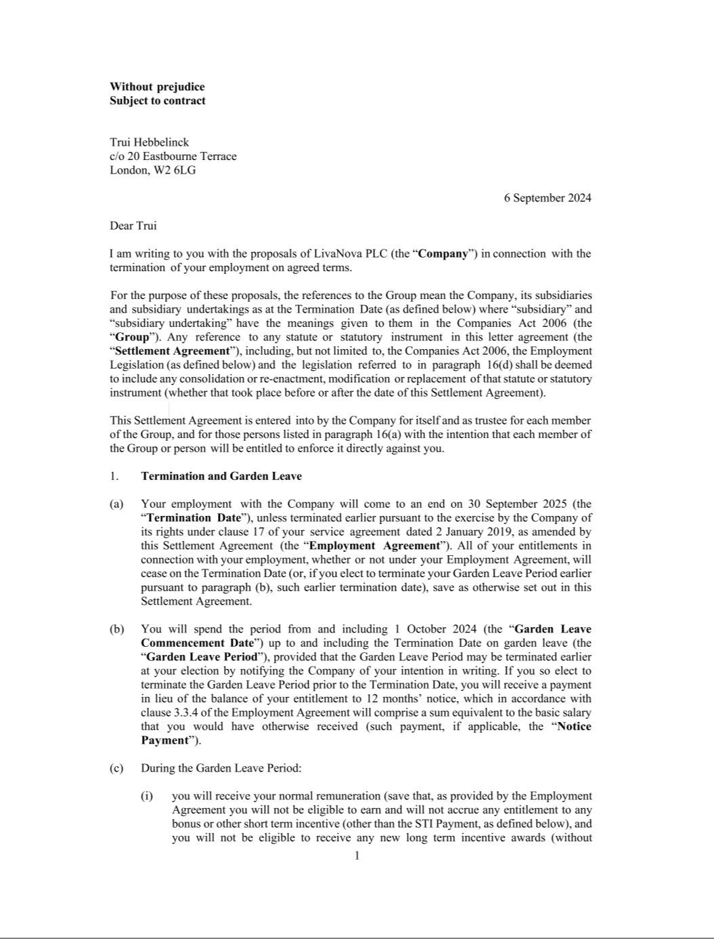

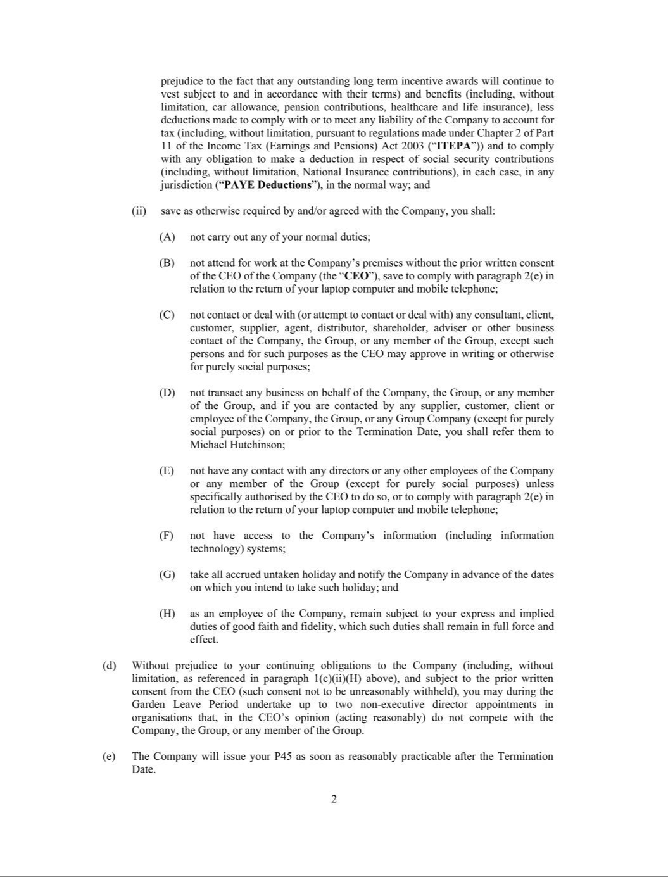

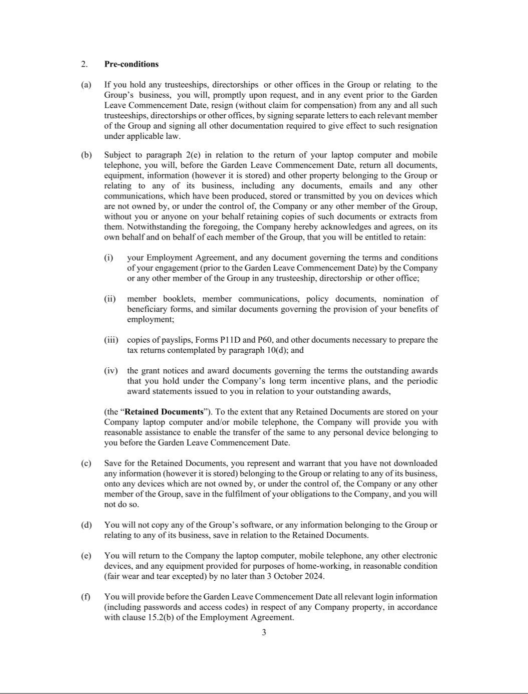

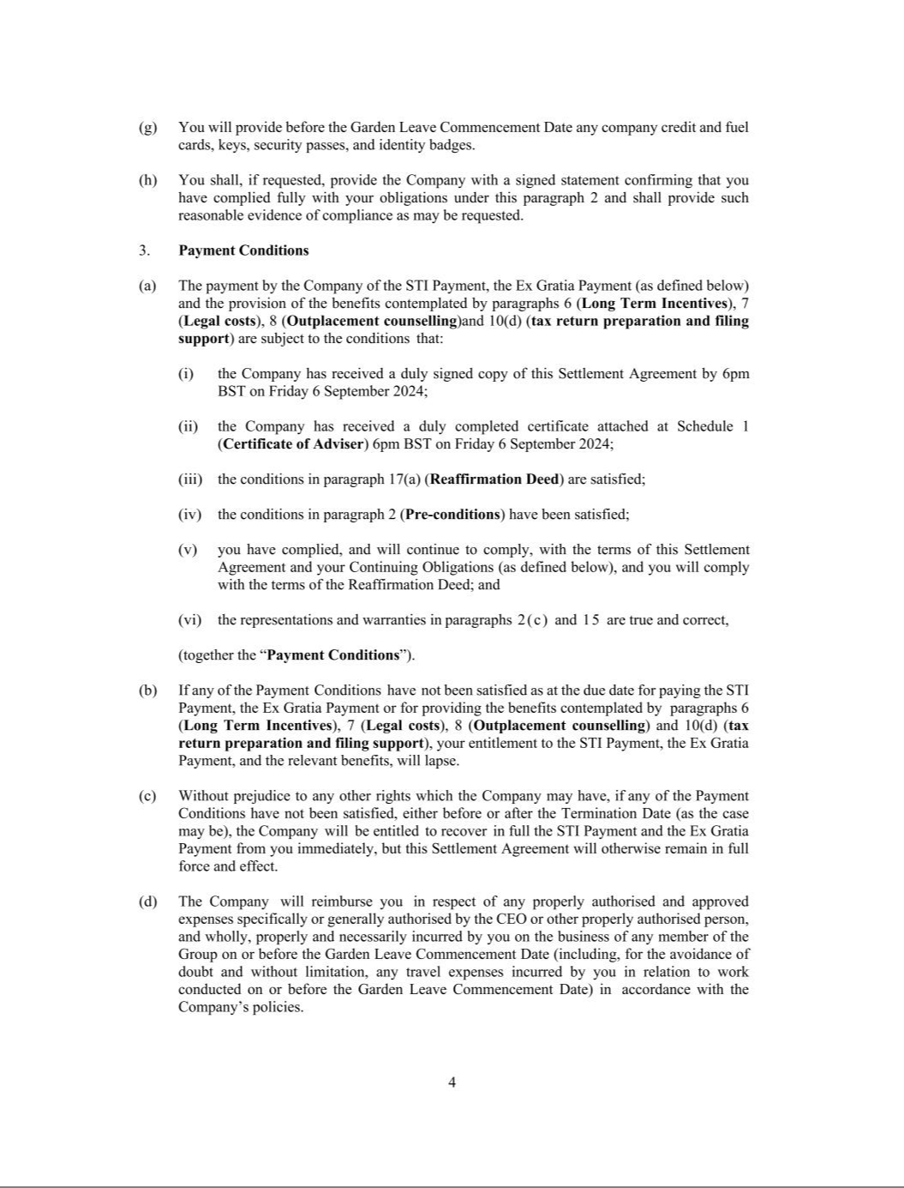

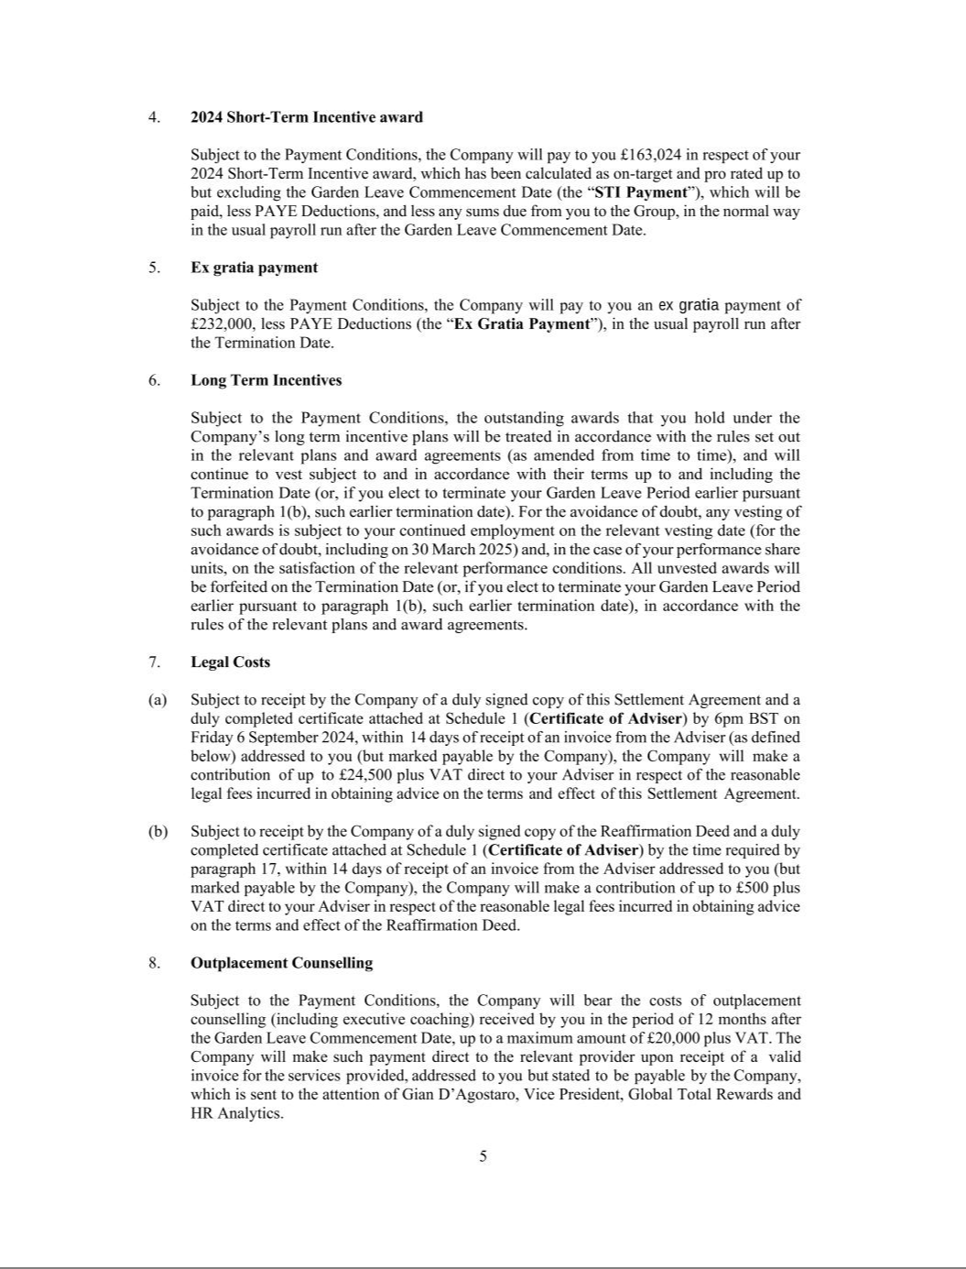

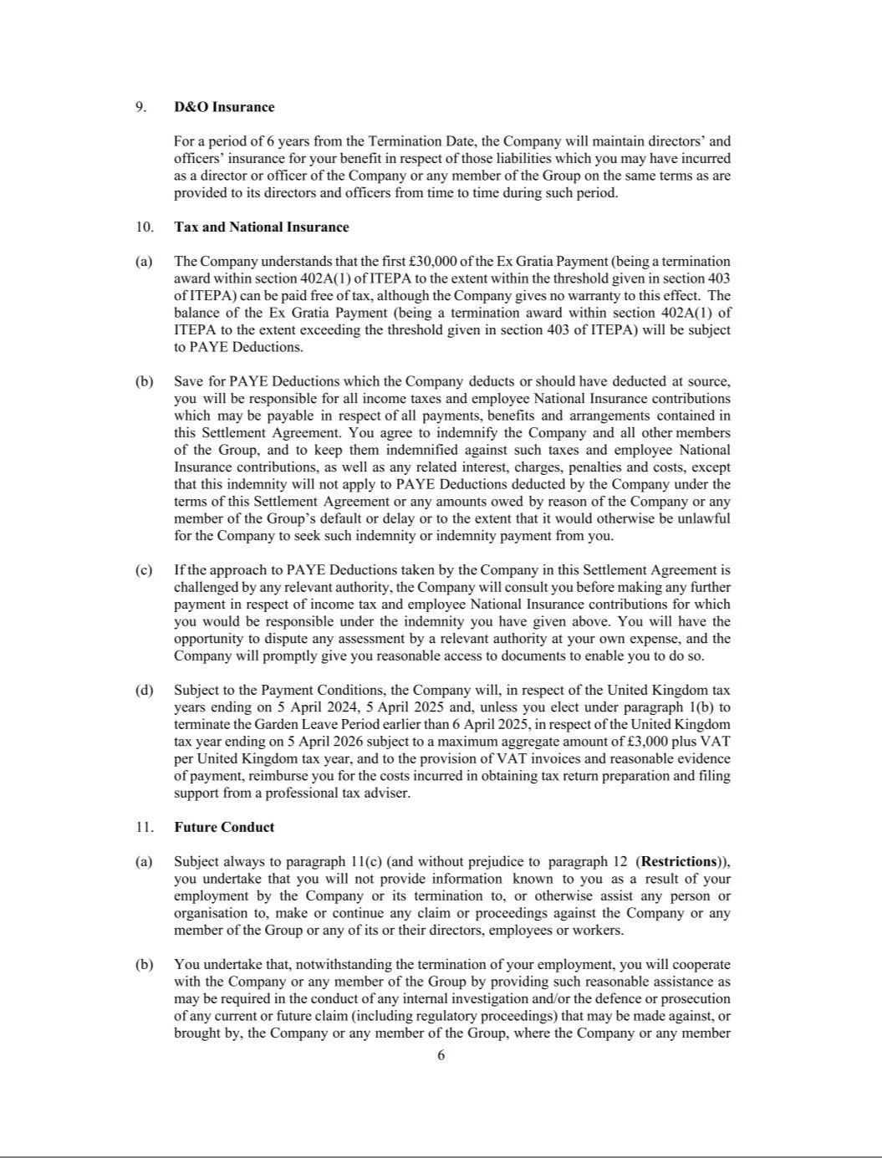

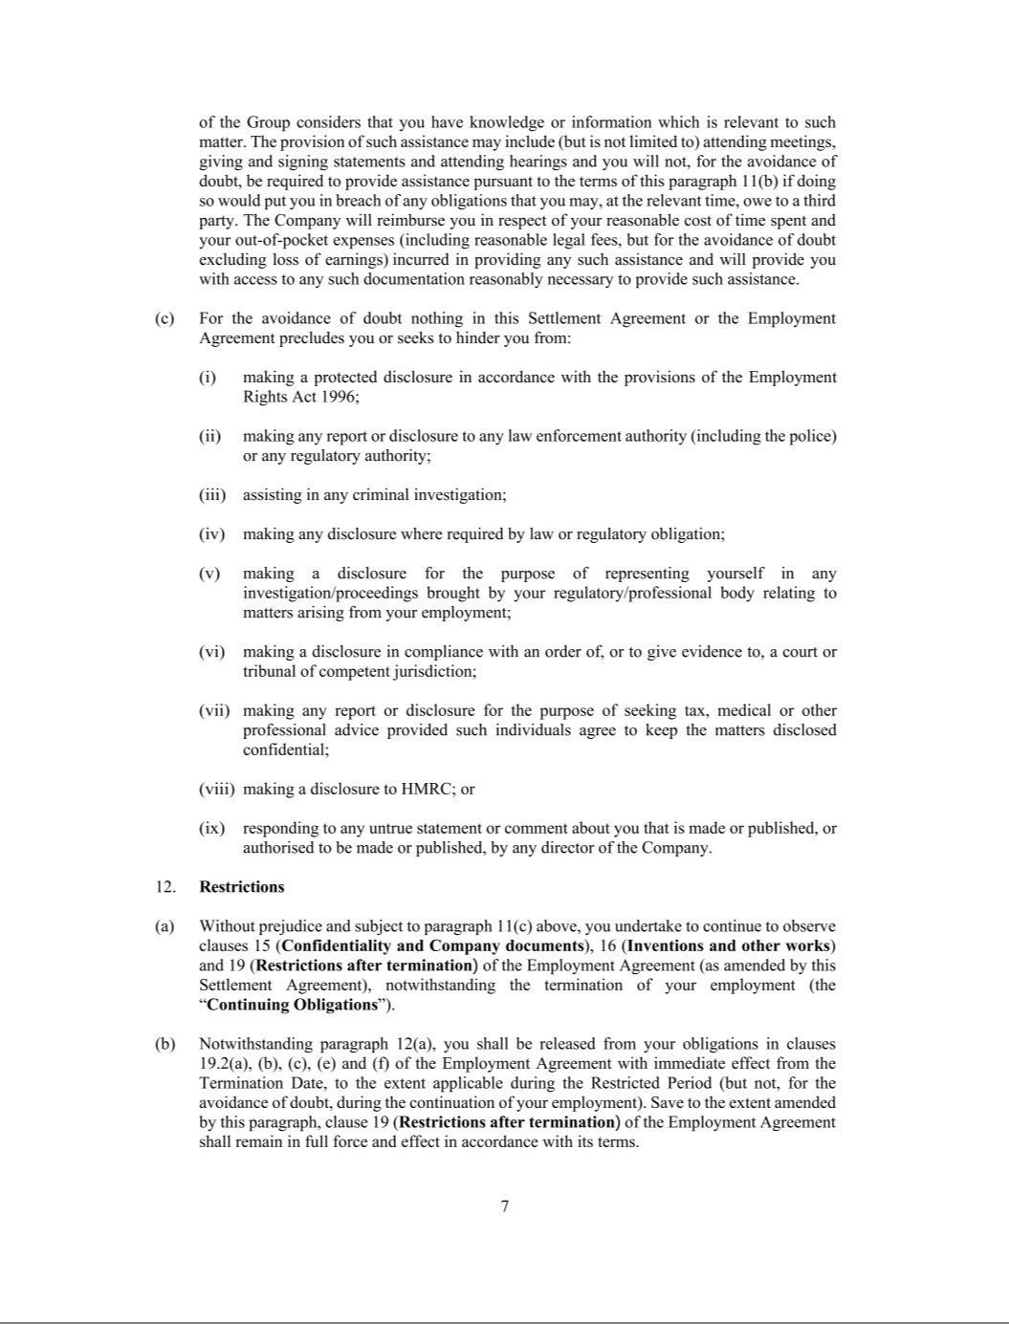

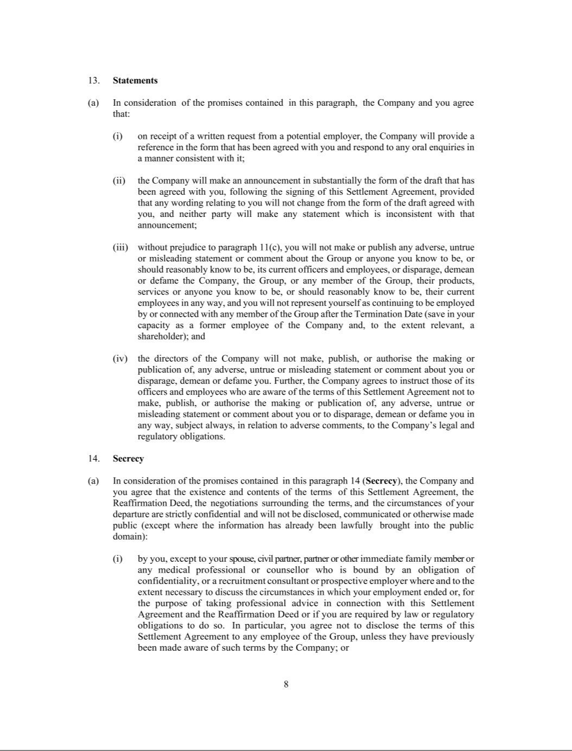

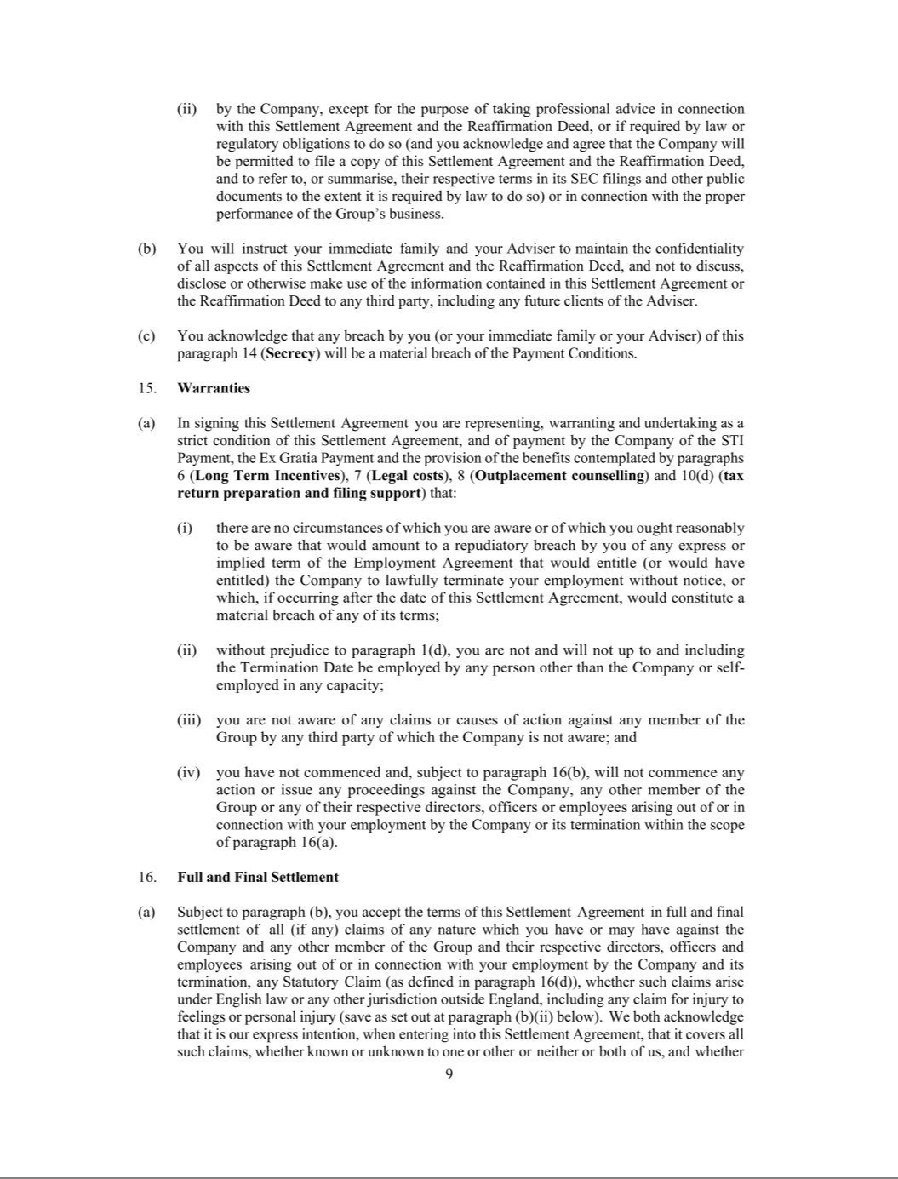

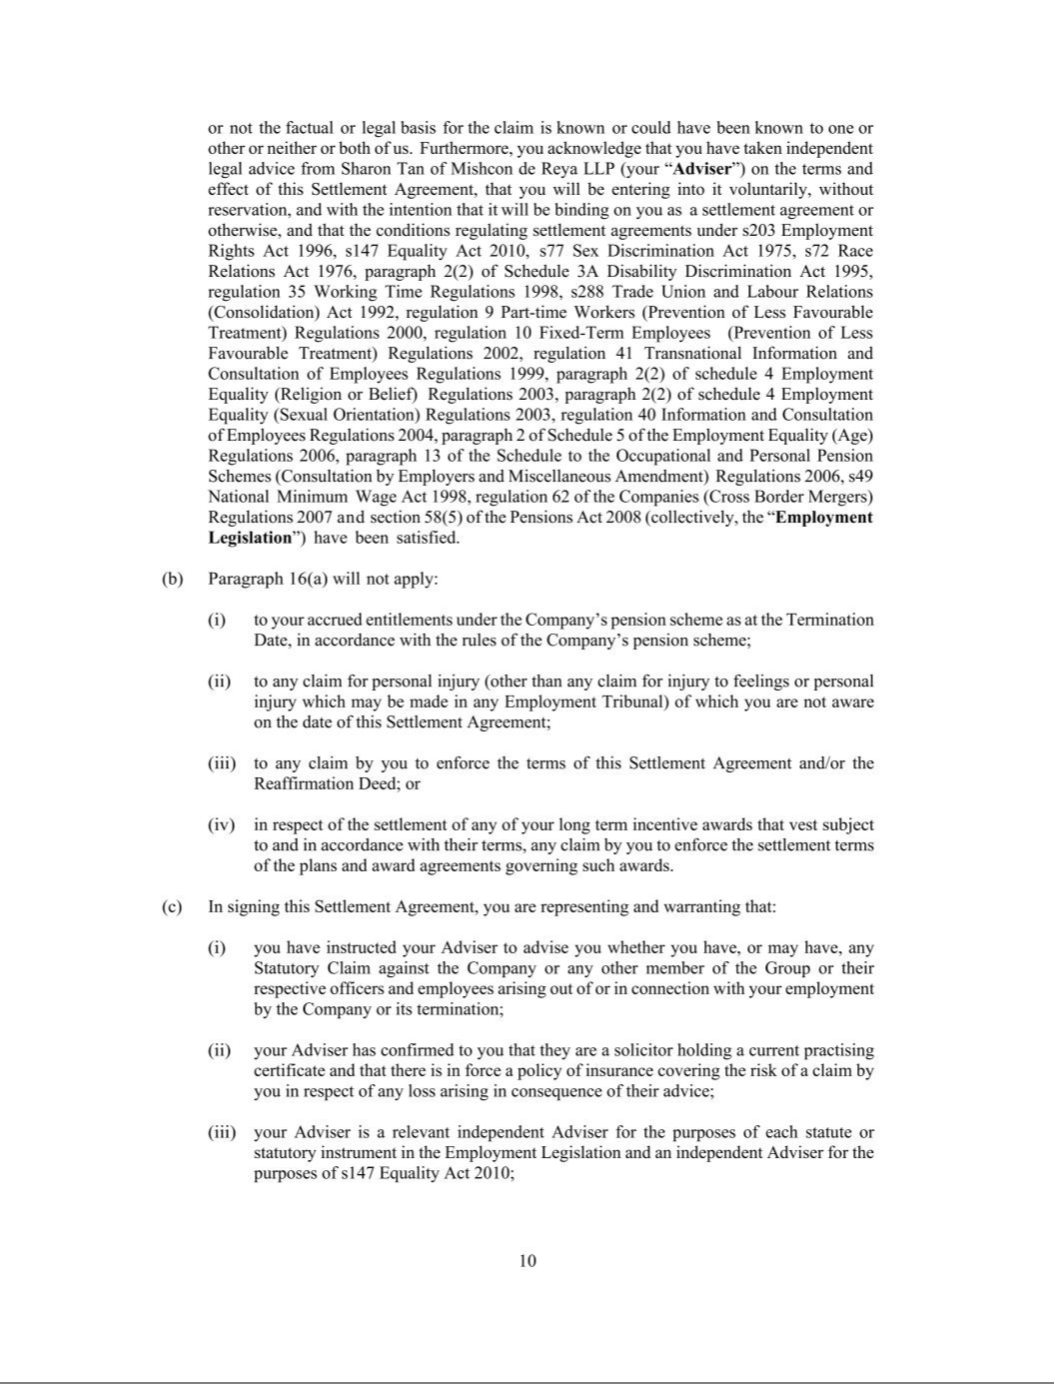

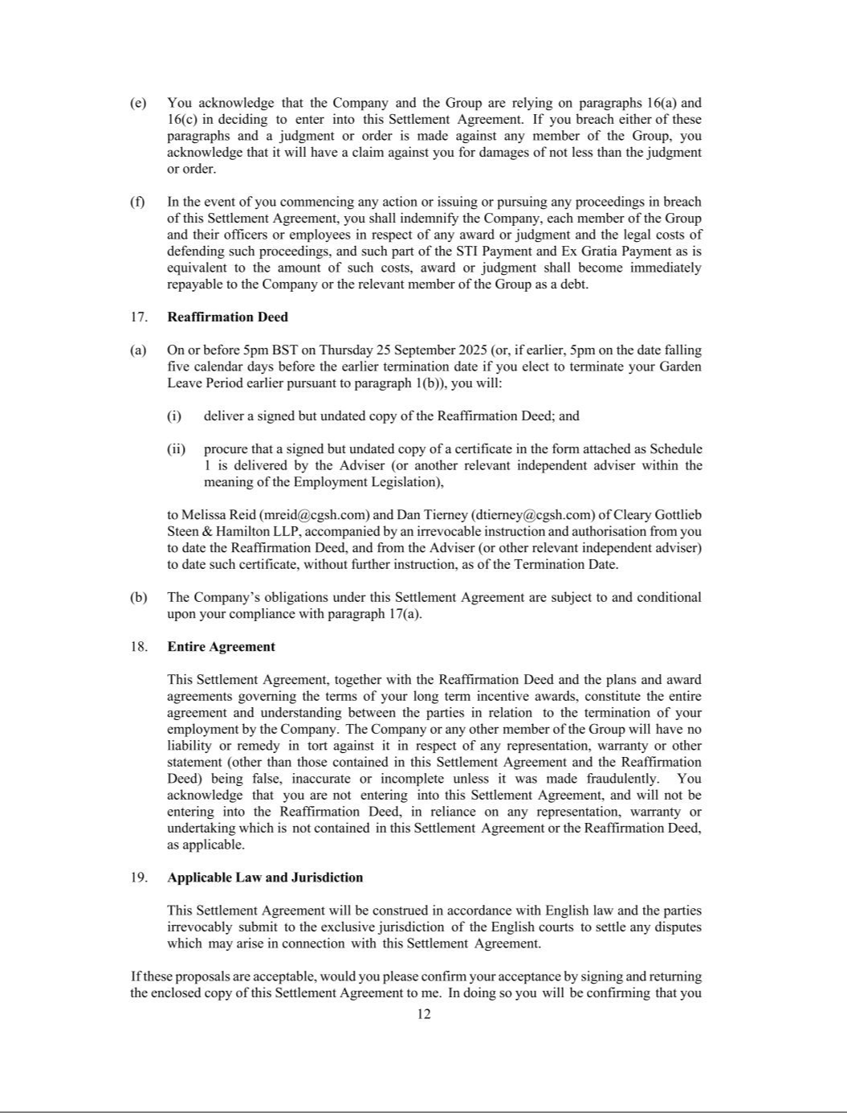

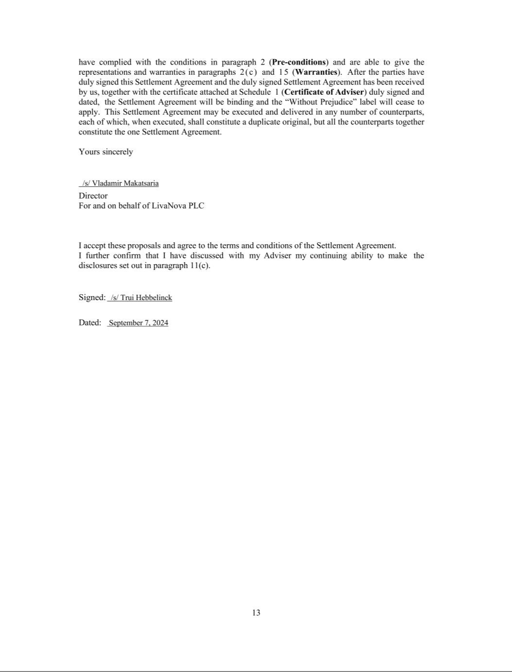

EXHIBIT 31.1

CERTIFICATION OF CHIEF EXECUTIVE OFFICER

PURSUANT TO SECTION 302 OF THE SARBANES-OXLEY ACT OF 2002

I, Vladimir Makatsaria, certify that:

- I have reviewed this Quarterly Report on Form 10-Q for the quarterly period ended September 30, 2024 of LivaNova PLC and its consolidated subsidiaries;

- Based on my knowledge, this report does not contain any untrue statement of a material fact or omit to state a material fact necessary to make the statements made, in light of the circumstances under which such statements were made, not misleading with respect to the period covered by this report;

- Based on my knowledge, the financial statements, and other financial information included in this report, fairly present in all material respects the financial condition, results of operations and cash flows of the registrant as of, and for, the periods presented in this report;

- The registrant’s other certifying officer(s) and I are responsible for establishing and maintaining disclosure controls and procedures (as defined in Exchange Act Rules 13a-15(e) and 15d-15(e)) and internal control over financial reporting (as defined in Exchange Act Rules 13a-15(f) and 15d-15(f)) for the registrant and have:

- Designed such disclosure controls and procedures, or caused such disclosure controls and procedures to be designed under our supervision, to ensure that material information relating to the registrant, including its consolidated subsidiaries, is made known to us by others within those entities, particularly during the period in which this report is being prepared;

- Designed such internal control over financial reporting, or caused such internal control over financial reporting to be designed under our supervision, to provide reasonable assurance regarding the reliability of financial reporting and the preparation of financial statements for external purposes in accordance with generally accepted accounting principles;

- Evaluated the effectiveness of the registrant’s disclosure controls and procedures and presented in this report our conclusions about the effectiveness of the disclosure controls and procedures, as of the end of the period covered by this report based on such evaluation; and

- Disclosed in this report any change in the registrant’s internal control over financial reporting that occurred during the registrant’s most recent fiscal quarter (the registrant’s fourth fiscal quarter in the case of an annual report) that has materially affected, or is reasonably likely to materially affect, the registrant’s internal control over financial reporting; and

- The registrant’s other certifying officer and I have disclosed, based on our most recent evaluation of internal control over financial reporting, to the registrant’s auditors and the audit committee of the registrant’s board of directors (or persons performing the equivalent functions):

- All significant deficiencies and material weaknesses in the design or operation of internal control over financial reporting which are reasonably likely to adversely affect the registrant’s ability to record, process, summarize and report financial information; and

- Any fraud, whether or not material, that involves management or other employees who have a significant role in the registrant’s internal control over financial reporting.

Date: October 30, 2024

/s/ VLADIMIR MAKATSARIA

Vladimir Makatsaria

Chief Executive Officer

(Principal Executive Officer)

EXHIBIT 31.2

CERTIFICATION OF CHIEF FINANCIAL OFFICER

PURSUANT TO SECTION 302 OF THE SARBANES-OXLEY ACT OF 2002

I, Alex Shvartsburg, certify that:

- I have reviewed this Quarterly Report on Form 10-Q for the quarterly period ended September 30, 2024 of LivaNova PLC and its consolidated subsidiaries;

- Based on my knowledge, this report does not contain any untrue statement of a material fact or omit to state a material fact necessary to make the statements made, in light of the circumstances under which such statements were made, not misleading with respect to the period covered by this report;

- Based on my knowledge, the financial statements, and other financial information included in this report, fairly present in all material respects the financial condition, results of operations and cash flows of the registrant as of, and for, the periods presented in this report;

- The registrant’s other certifying officer(s) and I are responsible for establishing and maintaining disclosure controls and procedures (as defined in Exchange Act Rules 13a-15(e) and 15d-15(e)) and internal control over financial reporting (as defined in Exchange Act Rules 13a-15(f) and 15d-15(f)) for the registrant and have:

- Designed such disclosure controls and procedures, or caused such disclosure controls and procedures to be designed under our supervision, to ensure that material information relating to the registrant, including its consolidated subsidiaries, is made known to us by others within those entities, particularly during the period in which this report is being prepared;

- Designed such internal control over financial reporting, or caused such internal control over financial reporting to be designed under our supervision, to provide reasonable assurance regarding the reliability of financial reporting and the preparation of financial statements for external purposes in accordance with generally accepted accounting principles;

- Evaluated the effectiveness of the registrant’s disclosure controls and procedures and presented in this report our conclusions about the effectiveness of the disclosure controls and procedures, as of the end of the period covered by this report based on such evaluation; and

- Disclosed in this report any change in the registrant’s internal control over financial reporting that occurred during the registrant’s most recent fiscal quarter (the registrant’s fourth fiscal quarter in the case of an annual report) that has materially affected, or is reasonably likely to materially affect, the registrant’s internal control over financial reporting; and

- The registrant’s other certifying officer and I have disclosed, based on our most recent evaluation of internal control over financial reporting, to the registrant’s auditors and the audit committee of the registrant’s board of directors (or persons performing the equivalent functions):

- All significant deficiencies and material weaknesses in the design or operation of internal control over financial reporting which are reasonably likely to adversely affect the registrant’s ability to record, process, summarize and report financial information; and

- Any fraud, whether or not material, that involves management or other employees who have a significant role in the registrant’s internal control over financial reporting.

Date: October 30, 2024

/s/ ALEX SHVARTSBURG

Alex Shvartsburg

Chief Financial Officer

(Principal Accounting and Financial Officer)

EXHIBIT 32.1

CERTIFICATION OF THE

CHIEF EXECUTIVE OFFICER AND

CHIEF FINANCIAL OFFICER

OF LIVANOVA PLC

PURSUANT TO 18 U.S.C. SECTION 1350

AS ADOPTED PURSUANT TO SECTION 906 OF THE SARBANES-OXLEY ACT OF 2002

Each of Vladimir Makatsaria, Chief Executive Officer of LivaNova PLC (the “Company”), and Alex Shvartsburg, Chief Financial Officer of the Company, each hereby certifies pursuant to 18

U.S.C. Section 1350, as adopted pursuant to Section 906 of the Sarbanes-Oxley Act of 2002, that to the best of his knowledge:

- the Quarterly Report on Form 10-Q of the Company and its consolidated subsidiaries for the quarterly period ended September 30, 2024, as filed with the Securities and Exchange Commission on the date hereof (the “Report”) fully complies with the requirements of Section 13(a) or 15(d) of the Securities Exchange Act of 1934, as amended; and

- the information contained in the Report fairly presents, in all material respects, the financial condition and results of operations of the Company.

Date: October 30, 2024

/s/ VLADIMIR MAKATSARIA

Vladimir Makatsaria

Chief Executive Officer

(Principal Executive Officer)

/s/ ALEX SHVARTSBURG

Alex Shvartsburg

Chief Financial Officer

(Principal Accounting and Financial Officer)

A signed original of this written statement required by Section 906 has been provided to the Company and will be retained by the Company and furnished to the Securities and Exchange Commission or its staff upon request.

The foregoing certification is being furnished solely pursuant to 18 U.S.C. Section 1350 and is not being filed as a part of this report or on a separate disclosure document.

