UNITED STATES
SECURITIES AND EXCHANGE COMMISSION
Washington, D.C. 20549
_________________________

Form 10-Q

(Mark One)

  - QUARTERLY REPORT PURSUANT TO SECTION 13 OR 15(d) OF THE SECURITIES EXCHANGE ACT OF 1934 For the quarterly period ended: June 30, 2021

or

- TRANSITION REPORT PURSUANT TO SECTION 13 OR 15(d) OF THE SECURITIES EXCHANGE ACT OF 1934 For the transition period from _______________ to _______________

Commission file number: 001-37599


LivaNova PLC

(Exact name of registrant as specified in its charter)

 |  |  | England and Wales ................... |  | 98-1268150
 |  |  | (State or other jurisdiction of .......... |  | (I.R.S. Employer
 |  |  | incorporation or organization) ........ |  | Identification No.)
 |  | 20 Eastbourne Terrace, London, United Kingdom, W2 6LG
 |  | (Address of principal executive offices) ....................... |  |  |  | (Zip Code)
 |  | Registrant’s telephone number, including area code: (44) (0) 203 325-0660
 |  |  | Securities registered pursuant to Section 12(b) of the Act
 | Title of each class |  | Trading Symbol(s) |  |  |  | Name of each exchange on which registered
Ordinary Shares - £1.00 par value per share |  |  |  | LIVN |  |  | NASDAQ Global Market

Indicate by check mark whether the registrant (1) has filed all reports required to be filed by Section 13 or 15(d) of the Securities Exchange Act of 1934 during the preceding 12 months (or for such shorter period that the registrant was required to file such reports), and (2) has been subject to such filing requirements for the past 90 days. Yes ☑ No ☐

Indicate by check mark whether the registrant has submitted electronically every Interactive Data File required to be submitted pursuant to Rule 405 of Regulation S-T (§232.405 of this chapter) during the preceding 12 months (or for such shorter period that the registrant was required to submit such files). Yes ☑ No ☐

Indicate by check mark whether the registrant is a large accelerated filer, an accelerated filer, a non-accelerated filer, a smaller reporting company or an emerging growth company. See the definitions of “large accelerated filer,” “accelerated filer,” “smaller reporting company” and “emerging growth company” in Rule 12b-2 of the Exchange Act.

Large accelerated filer | ☑ | Accelerated filer | ☐
Non-accelerated filer | ☐ | Smaller reporting company | ☐
Emerging growth company | ☐
If an emerging growth company, indicate by check mark if the registrant has elected not to use the extended transition period for complying with any new or revised financial accounting standards
provided pursuant to Section 13(a) of the Exchange Act |  |  | ☐
Indicate by check mark whether the registrant is a shell company (as defined in Rule 12b-2 of the Act). Yes ☐ |  | No ☑
 | Class | Outstanding at July 23, 2021
 | Ordinary Shares - £1.00 par value per share | 49,023,767

LIVANOVA PLC

TABLE OF CONTENTS

 |  |  |  |  |  |  |  |  |  |  |  | PART I. FINANCIAL INFORMATION |  |  |  |  |  |  | PAGE NO.
 |  |  |  | Note About Forward Looking Statements |  |  |  |  |  |  |  |  |  |  |  |  |  | 3
 | Item 1 |  |  | Condensed Consolidated Financial Statements |  |  |  |  |  |  |  |  |  |  |  |  |  | 5
 |  |  |  | Condensed Consolidated Statements of Income (Loss) |  |  |  |  |  |  |  |  |  |  |  |  |  | 5
 |  |  |  | Condensed Consolidated Statements of Comprehensive Income (Loss) |  |  |  |  |  |  |  |  |  |  |  |  |  | 6
 |  |  |  | Condensed Consolidated Balance Sheets |  |  |  |  |  |  |  |  |  |  |  |  |  | 7
 |  |  |  | Condensed Consolidated Statements of Cash Flows |  |  |  |  |  |  |  |  |  |  |  |  |  | 8
 |  |  |  | Notes to the Condensed Consolidated Financial Statements |  |  |  |  |  |  |  |  |  |  |  |  |  | 9
 | Item 2 |  |  | Management’s Discussion and Analysis of Financial Condition and Results of Operations |  |  |  |  |  |  |  |  |  |  |  |  |  | 33
 | Item 3 |  |  | Quantitative and Qualitative Disclosures About Market Risk |  |  |  |  |  |  |  |  |  |  |  |  |  | 41
 | Item 4 |  |  | Controls and Procedures |  |  |  |  |  |  |  |  |  |  |  |  |  | 42
 |  |  |  |  |  |  |  |  |  |  |  |  | PART II. OTHER INFORMATION
 | Item 1 |  |  | Legal Proceedings |  |  |  |  |  |  |  |  |  |  |  |  |  | 43
 | Item 1A |  |  | Risk Factors |  |  |  |  |  |  |  |  |  |  |  |  |  | 43
 | Item 2 |  |  | Unregistered Sales of Equity Securities and Use of Proceeds |  |  |  |  |  |  |  |  |  |  |  |  |  | 43
 | Item 3 |  |  | Defaults Upon Senior Securities |  |  |  |  |  |  |  |  |  |  |  |  |  | 43
 | Item 4 |  |  | Mine Safety Disclosures |  |  |  |  |  |  |  |  |  |  |  |  |  | 43
 | Item 5 |  |  | Other Information |  |  |  |  |  |  |  |  |  |  |  |  |  | 43
 | Item 6 |  |  | Exhibits |  |  |  |  |  |  |  |  |  |  |  |  |  | 45

In this Quarterly Report on Form 10-Q, “LivaNova,” “the Company,” “we,” “us” and “our” refer to LivaNova PLC and its consolidated subsidiaries.

This report may contain references to our proprietary intellectual property, including among others:

- Trademarks for our VNS therapy systems, the VNS Therapy® System, the VITARIA® System and our proprietary pulse generator products: Model 102 (Pulse®), Model 102R (Pulse Duo®), Model 103 (Demipulse®), Model 104 (Demipulse Duo®), Model 106 (AspireSR®), Model 1000 (SenTiva®), Model 1000-D (SenTiva® Duo), Model 7103 (VITARIA® and TitrationAssist™) and Model 8103 (Symmetry^{®)}.
- Trademarks for our Cardiopulmonary product systems: S5® heart-lung machine, S3® heart-lung machine, S5 Pro™ heart-lung machine, B-Capta®, Inspire®, Heartlink®, XTRA® Autotransfusion System, 3T Heater-Cooler®, Connect™ and Revolution®.
- Trademarks for our advanced circulatory support systems: TandemLife®, TandemHeart®, TandemLung®, ProtekDuo®, and LifeSPARC®.
- Trademarks for our obstructive sleep apnea system: ImThera® and Aura6000®.

These trademarks and trade names are the property of LivaNova or the property of our consolidated subsidiaries and are protected under applicable intellectual property laws. Solely for convenience, our trademarks and tradenames referred to in this Quarterly Report on Form 10-Q may appear without the ® or ™ symbols, but such references are not intended to indicate in any way that we will not assert, to the fullest extent under applicable law, our rights to these trademarks and tradenames.

________________________________________

2

NOTE ABOUT FORWARD LOOKING STATEMENTS

Certain statements in this Quarterly Report on Form 10-Q, other than purely historical information, are “forward-looking statements” within the meaning of the Private Securities Litigation Reform Act of 1995, Section 27A of the Securities Act of 1933 and Section 21E of the Securities Exchange Act of 1934, as amended (the “Exchange Act”). These statements include, but are not limited to, LivaNova’s plans, objectives, strategies, financial performance and outlook, trends, the amount and timing of future cash distributions, prospects or future events and involve known and unknown risks that are difficult to predict. As a result, our actual financial results, performance, achievements or prospects may differ materially from those expressed or implied by these forward-looking statements. In some cases, you can identify forward-looking statements by the use of words such as “may,” “could,” “seek,” “guidance,” “predict,” “potential,” “likely,” “believe,” “will,” “should,” “expect,” “anticipate,” “estimate,” “plan,” “intend,” “forecast,” “foresee” or variations of these terms and similar expressions, or the negative of these terms or similar expressions. Such forward-looking statements are necessarily based on estimates and assumptions that, while considered reasonable by LivaNova and its management based on their knowledge and understanding of the business and industry, are inherently uncertain. These statements are not guarantees of future performance, and stockholders should not place undue reliance on forward-looking statements. There are a number of risks, uncertainties and other important factors, many of which are beyond our control, that could cause our actual results to differ materially from the forward-looking statements contained in this Quarterly Report on Form 10-Q, and include but are not limited to the risks and uncertainties summarized below:

- changes in our common stock price;

- activist investors causing disruptions to the business;

- changes in our profitability;

- regulatory activities and announcements, including the failure to obtain regulatory approvals for our new products;

- effectiveness of our internal controls over financial reporting;

- fluctuations in future quarterly operating results;

- failure to comply with, or changes in, laws, regulations or administrative practices affecting government regulation of our products, including, but not limited to, U.S. Food and Drug Administration (“FDA”) laws and regulations;

- failure to establish, expand or maintain market acceptance of our products for the treatment of our approved indications;

- any legislative or administrative reform to the healthcare system, including the U.S. Medicare or Medicaid systems or international reimbursement systems, that significantly reduces reimbursement for our products or procedures or denies coverage for such products or procedures or enhances coverage for competitive products or procedures, as well as adverse decisions by administrators of such systems on coverage or reimbursement issues relating to our products;

- failure to maintain the current regulatory approvals for our products’ approved indications;

- failure to obtain or maintain coverage and reimbursement for our products’ approved indications;

- unfavorable results from clinical studies;

- variations in sales and operating expenses relative to estimates;

- our dependence on certain suppliers and manufacturers to provide certain materials, components and contract services necessary for the production of our products;

- product liability, intellectual property, shareholder-related, environmental-related, income tax and other litigation, disputes, losses and costs;

- protection, expiration and validity of our intellectual property;

- changes in technology, including the development of superior or alternative technology or devices by competitors;

- competition from providers of alternative medical therapies, such as pharmaceutical companies and providers of cannabis;

- cyber-attacks or other disruptions to our information technology systems;

- failure to comply with applicable U.S. laws and regulations, including federal and state privacy and security laws and regulations;

- failure to comply with applicable non-U.S. laws and regulations;

3

- non-U.S. operational and economic risks and concerns;

- failure to attract or retain key personnel;

- failure of new acquisitions to further our strategic objectives or strengthen our existing businesses;

- losses or costs from pending or future lawsuits and governmental investigations, including any amount of liability or damages imposed by the Appeals Court or the Supreme Court of Italy with respect to SNIA S.p.A.;

- changes in accounting rules that adversely affect the characterization of our consolidated financial position, results of operations or cash flows;

- changes in customer spending patterns;

- risks relating to the exchangeability of the exchangeable senior notes;

- continued volatility in the global market and worldwide economic conditions, including volatility caused by Brexit and/or changes to existing trade agreements and relationships between the U.S. and other countries;

- risks relating to the outbreak and spread of COVID-19 around the world;

- changes in tax laws, including changes related to Brexit, or exposure to additional income tax liabilities;

- harsh weather or natural disasters that interrupt our business operations or the business operations of our hospital-customers; and

- failure of the market to adopt new therapies or to adopt new therapies quickly.

Other factors that could cause our actual results to differ from our projected results are described in (1) “Part II, Item 1A. Risk Factors” and elsewhere in this and our other Quarterly Reports on Form 10-Q, (2) our Annual Report on Form 10-K for the fiscal year ended December 31, 2020 (“2020 Form 10-K”), (3) our reports and registration statements filed and furnished from time to time with the Securities and Exchange Commission (“SEC”) and (4) other announcements we make from time to time.

Readers are cautioned not to place undue reliance on forward-looking statements, which speak only as of the date hereof. We undertake no obligation to update or revise any forward-looking statements after the date they are made, whether as a result of new information, future events or otherwise. You should read the following discussion and analysis in conjunction with our unaudited condensed consolidated financial statements and related notes included elsewhere in this report. Operating results for the six months ended June 30, 2021 are not necessarily indicative of future results, including the full fiscal year. You should also refer to our “Annual Consolidated Financial Statements,” “Notes” thereto, “Management’s Discussion and Analysis of Financial Condition and Results of Operations” and “Risk Factors” contained in our 2020 Form 10-K and in our Quarterly Reports on Form 10-Q.

Financial Information and Currency of Financial Statements

All of the financial information included in this quarterly report has been prepared in accordance with generally accepted accounting principles in the United States of America (“U.S.” and such principles, “U.S. GAAP”). The reporting currency of our condensed consolidated financial statements is U.S. dollars.

________________________________________

4

PART I. FINANCIAL INFORMATION

Item 1. Financial Statements

LIVANOVA PLC AND SUBSIDIARIES

CONDENSED CONSOLIDATED STATEMENTS OF INCOME (LOSS)

(UNAUDITED)

(In thousands, except per share amounts)

 | Three Months Ended June 30, |  |  |  |  |  |  | Six Months Ended June 30,
 | 2021 |  |  |  | 2020 |  |  | 2021 |  |  | 2020
Net sales | $ | 264,483 |  | $ | 182,206 |  | $ | 512,086 |  | $ | 424,603
Cost of sales |  | 90,803 |  |  | 65,730 |  |  | 173,723 |  |  | 141,631
Gross profit |  | 173,680 |  |  | 116,476 |  |  | 338,363 |  |  | 282,972
Operating expenses:
Selling, general and administrative |  | 122,748 |  |  | 102,743 |  |  | 238,429 |  |  | 227,675
Research and development |  | 52,557 |  |  | 25,152 |  |  | 97,182 |  |  | 61,054
Other operating expenses |  | 33,236 |  |  | 3,818 |  |  | 42,036 |  |  | 8,872
Operating loss from continuing operations |  | (34,861) |  |  | (15,237) |  |  | (39,284) |  |  | (14,629)
Interest income |  | 189 |  |  | 287 |  |  | 115 |  |  | 435
Interest expense |  | (16,515) |  |  | (5,715) |  |  | (32,451) |  |  | (10,564)
Foreign exchange and other gains (losses) |  | 50 |  |  | (999) |  |  | (6,319) |  |  | (2,913)
Loss from continuing operations before tax |  | (51,137) |  |  | (21,664) |  |  | (77,939) |  |  | (27,671)
Income tax expense |  | 4,140 |  |  | 66,285 |  |  | 6,996 |  |  | 21,571
Losses from equity method investments |  | (41) |  |  | (44) |  |  | (81) |  |  | (173)
Net loss from continuing operations |  | (55,318) |  |  | (87,993) |  |  | (85,016) |  |  | (49,415)
Net loss from discontinued operations, net of tax |  | — |  |  | — |  |  | — |  |  | (995)
Net loss | $ | (55,318) |  | $ | (87,993) |  | $ | (85,016) |  | $ | (50,410)
Basic loss per share:
Continuing operations | $ | (1.13) |  | $ | (1.81) |  | $ | (1.74) |  | $ | (1.02)
Discontinued operations |  | — |  |  | — |  |  | — |  |  | (0.02)
 | $ | (1.13) |  | $ | (1.81) |  | $ | (1.74) |  | $ | (1.04)
Diluted loss per share:
Continuing operations | $ | (1.13) |  | $ | (1.81) |  | $ | (1.74) |  | $ | (1.02)
Discontinued operations |  | — |  |  | — |  |  | — |  |  | (0.02)
 | $ | (1.13) |  | $ | (1.81) |  | $ | (1.74) |  | $ | (1.04)
Shares used in computing basic loss per share |  | 48,928 |  |  | 48,611 |  |  | 48,833 |  |  | 48,548
Shares used in computing diluted loss per share |  | 48,928 |  |  | 48,611 |  |  | 48,833 |  |  | 48,548

See accompanying notes to the condensed consolidated financial statements

5

LIVANOVA PLC AND SUBSIDIARIES

CONDENSED CONSOLIDATED STATEMENTS OF COMPREHENSIVE INCOME (LOSS)

(UNAUDITED)

(In thousands)

 | Three Months Ended June 30, |  |  |  |  |  |  | Six Months Ended June 30,
 | 2021 |  |  | 2020 |  |  |  | 2021 |  |  | 2020
Net loss | $ | (55,318) |  | $ | (87,993) |  | $ | (85,016) |  | $ | (50,410)
Other comprehensive income (loss):
Net change in unrealized (loss) gain on derivatives |  | (1,250) |  |  | 1,029 |  |  | (1,585) |  |  | (327)
Tax effect |  | 42 |  |  | (246) |  |  | 381 |  |  | 79
Net of tax |  | (1,208) |  |  | 783 |  |  | (1,204) |  |  | (248)
Foreign currency translation adjustment |  | 22,345 |  |  | 16,651 |  |  | (3,530) |  |  | (15,449)
Total other comprehensive income (loss) |  | 21,137 |  |  | 17,434 |  |  | (4,734) |  |  | (15,697)
Total comprehensive loss | $ | (34,181) |  | $ | (70,559) |  | $ | (89,750) |  | $ | (66,107)

See accompanying notes to the condensed consolidated financial statements

6

LIVANOVA PLC AND SUBSIDIARIES
CONDENSED CONSOLIDATED BALANCE SHEETS
(UNAUDITED)
(In thousands, except share amounts)

ASSETS |  | June 30, 2021 |  |  | December 31, 2020
Current Assets:
Cash and cash equivalents | $ | 329,386 |  | $ | 252,832
Accounts receivable, net of allowance of $11,999 at June 30, 2021 and $10,310 at December 31, 2020 |  | 182,180 |  |  | 184,356
Inventories |  | 127,168 |  |  | 126,675
Prepaid and refundable taxes |  | 36,182 |  |  | 60,240
Assets held for sale |  | — |  |  | 70,539
Current derivative assets |  | 105,371 |  |  | 2,053
Prepaid expenses and other current assets |  | 28,815 |  |  | 22,739
Total Current Assets |  | 809,102 |  |  | 719,434
Property, plant and equipment, net |  | 157,415 |  |  | 163,805
Goodwill |  | 918,275 |  |  | 922,318
Intangible assets, net |  | 419,182 |  |  | 437,636
Operating lease assets |  | 49,891 |  |  | 50,525
Investments |  | 15,275 |  |  | 31,094
Deferred tax assets |  | 1,883 |  |  | 2,990
Long-term derivative assets |  | — |  |  | 72,302
Other assets |  | 25,499 |  |  | 11,247
Total Assets | $ | 2,396,522 |  | $ | 2,411,351
LIABILITIES AND STOCKHOLDERS' EQUITY
Current Liabilities:
Current debt obligations | $ | 232,012 |  | $ | 13,343
Accounts payable |  | 61,328 |  |  | 73,668
Accrued liabilities and other |  | 100,227 |  |  | 88,036
Current derivative liabilities |  | 174,866 |  |  | 7,372
Current litigation provision liability |  | 53,177 |  |  | 28,612
Taxes payable |  | 18,429 |  |  | 16,463
Accrued employee compensation and related benefits |  | 62,209 |  |  | 51,879
Liabilities held for sale |  | — |  |  | 29,679
Total Current Liabilities |  | 702,248 |  |  | 309,052
Long-term debt obligations |  | 431,033 |  |  | 642,298
Contingent consideration |  | 97,047 |  |  | 89,850
Litigation provision liability |  | 6,989 |  |  | 7,878
Deferred tax liabilities |  | 10,462 |  |  | 8,915
Long-term operating lease liabilities |  | 42,723 |  |  | 42,221
Long-term employee compensation and related benefits |  | 18,396 |  |  | 20,628
Long-term derivative liabilities |  | 200 |  |  | 121,940
Other long-term liabilities |  | 46,954 |  |  | 49,740
Total Liabilities |  | 1,356,052 |  |  | 1,292,522
Commitments and contingencies (Note 8)
Stockholders’ Equity:
Ordinary Shares, £1.00 par value: unlimited shares authorized; 49,522,582 shares issued and 48,983,280 shares outstanding at |  | 76,405 |  |  | 76,300
June 30, 2021; 49,447,473 shares issued and 48,655,863 shares outstanding at December 31, 2020 |  | 76,405 |  |  | 76,300
Additional paid-in capital |  | 1,779,113 |  |  | 1,768,156
Accumulated other comprehensive income |  | 23,075 |  |  | 27,809
Accumulated deficit |  | (837,418) |  |  | (752,402)
Treasury stock at cost, 539,302 ordinary shares at June 30, 2021; 791,610 ordinary shares at December 31, 2020 |  | (705) |  |  | (1,034)
Total Stockholders’ Equity |  | 1,040,470 |  |  | 1,118,829
Total Liabilities and Stockholders’ Equity | $ | 2,396,522 |  | $ | 2,411,351

See accompanying notes to the condensed consolidated financial statements

7

LIVANOVA PLC AND SUBSIDIARIES

CONDENSED CONSOLIDATED STATEMENTS OF CASH FLOWS

(UNAUDITED)

(In thousands)

 | Six Months Ended June 30,
 | 2021 |  |  | 2020
Operating Activities:
Net loss | $ | (85,016) |  | $ | (50,410)
Non-cash items included in net loss:
Stock-based compensation |  | 19,452 |  |  | 19,034
Amortization |  | 13,353 |  |  | 19,661
Remeasurement of derivative instruments |  | 13,191 |  |  | (7,250)
Depreciation |  | 12,256 |  |  | 13,596
Remeasurement of contingent consideration to fair value |  | 10,746 |  |  | (46,034)
Amortization of debt issuance costs |  | 8,989 |  |  | 1,219
Amortization of operating lease assets |  | 8,947 |  |  | 6,297
Remeasurement of Respicardia investment and loan |  | (4,640) |  |  | —
Deferred tax expense |  | 1,357 |  |  | 46,171
Other |  | 1,356 |  |  | 4,214
Changes in operating assets and liabilities:
Accounts receivable, net |  | (4,664) |  |  | 66,256
Inventories |  | 1,221 |  |  | (16,210)
Other current and non-current assets |  | 18,786 |  |  | (10,263)
Accounts payable and accrued current and non-current liabilities |  | 3,558 |  |  | (48,001)
Taxes payable |  | 2,491 |  |  | (2,150)
Litigation provision liability |  | 23,728 |  |  | (121,194)
Net cash provided by (used in) operating activities |  | 45,111 |  |  | (125,064)
Investing Activities:
Purchases of property, plant and equipment |  | (14,622) |  |  | (17,955)
Purchase of investments |  | (2,097) |  |  | (3,168)
Proceeds from sale of Heart Valves, net of cash disposed |  | 41,759 |  |  | —
Proceeds from sale of Respicardia investment and loan |  | 23,057 |  |  | —
Loans to investees |  | — |  |  | (2,250)
Other |  | (1,382) |  |  | 707
Net cash provided by (used in) investing activities |  | 46,715 |  |  | (22,666)
Financing Activities:
Shares repurchased from employees for minimum tax withholding |  | (11,072) |  |  | (5,177)
Payment of contingent consideration |  | (4,387) |  |  | (5,250)
Proceeds from share issuances under ESPP |  | 1,750 |  |  | 2,064
Repayment of long-term debt obligations |  | (1,287) |  |  | (481,254)
Debt issuance costs |  | (376) |  |  | (19,970)
Change in short-term borrowing, net |  | 69 |  |  | (1,532)
Proceeds from long-term debt obligations |  | — |  |  | 886,899
Proceeds from short term borrowings (maturities greater than 90 days) |  | — |  |  | 46,717
Repayments of short term borrowings (maturities greater than 90 days) |  | — |  |  | (44,838)
Purchase of capped call |  | — |  |  | (43,096)
Closing adjustment payment for sale of CRM business |  | — |  |  | (14,891)
Other |  | 1,216 |  |  | 25
Net cash (used in) provided by financing activities |  | (14,087) |  |  | 319,697
Effect of exchange rate changes on cash and cash equivalents |  | (1,185) |  |  | (555)
Net increase in cash and cash equivalents |  | 76,554 |  |  | 171,412
Cash and cash equivalents at beginning of period |  | 252,832 |  |  | 61,137
Cash and cash equivalents at end of period | $ | 329,386 |  | $ | 232,549

See accompanying notes to the condensed consolidated financial statements

8

LIVANOVA PLC AND SUBSIDIARIES

NOTES TO THE CONDENSED CONSOLIDATED FINANCIAL STATEMENTS

(Unaudited)

Note 1. Unaudited Condensed Consolidated Financial Statements

Basis of Presentation

The accompanying condensed consolidated financial statements of LivaNova as of, and for the three and six months ended June 30, 2021 and 2020, have been prepared in accordance with U.S. GAAP for interim financial information and the instructions to Form 10-Q and Article 10 of Regulation S-X. The accompanying condensed consolidated balance sheet of LivaNova at December 31, 2020 has been derived from audited financial statements contained in our 2020 Form 10-K, but does not include all of the information and footnotes required by U.S. GAAP for complete financial statements. In the opinion of management, the condensed consolidated financial statements reflect all adjustments considered necessary for a fair statement of the operating results of LivaNova and its subsidiaries, for the three and six months ended June 30, 2021, and are not necessarily indicative of the results that may be expected for the year ending December 31, 2021. The financial information presented herein should be read in conjunction with the audited consolidated financial statements and notes thereto accompanying our 2020 Form 10-K.

Recent Developments Regarding COVID-19

Due to the COVID-19 pandemic (“COVID-19”), we have experienced and may continue to experience significant and unpredictable reductions in the demand for our products as healthcare customers have diverted medical resources and priorities towards the treatment of COVID-19. In addition, public health bodies have delayed elective procedures during the COVID-19 pandemic, which has negatively impacted the usage of our products, including the number of Neuromodulation procedures. Further, some people are avoiding seeking treatment for non-COVID-19 emergency procedures, which has also negatively impacted the demand for our products.

Procedure volumes in Neuromodulation continue to recover, especially replacement implant volumes. Across our business, certain countries in our Europe and Rest of World regions remain challenged by COVID-19. Despite shifting market dynamics resulting from the pandemic, we continue to gain momentum in Neuromodulation sales growth across all regions.

Reclassifications

We have reclassified certain prior period amounts on the condensed consolidated statements of income (loss) and the condensed consolidated statements of cash flows for comparative purposes. These reclassifications did not have a material effect on our financial condition, results of operations or cash flows. The prior period reclassifications on the condensed consolidated statements of income (loss) are summarized and presented below (in thousands):

- Product remediation has been reclassified to cost of sales

- Merger and integration expenses have been reclassified to other operating expenses

- Restructuring expenses have been reclassified to other operating expenses

- Litigation provision, net has been reclassified to other operating expenses and

- Amortization of intangibles has been reclassified to cost of sales or selling, general and administrative based on the nature of the underlying intangible asset.

9

 |  | Three Months Ended June 30, 2020 |  |  |  |  |  |  |  |  | Six Months Ended June 30, 2020
 |  | As Previously |  |  | Reclassifications |  | Current Presentation |  |  |  | As Previously |  |  | Reclassifications |  | Current Presentation
 |  | Reported |  |  |  |  |  |  |  |  | Reported |  |  | Reclassifications
Net sales | $ | 182,206 |  | $ | — |  | $ | 182,206 |  | $ | 424,603 |  | $ | — |  | $ | 424,603
Cost of sales |  | 56,762 |  |  | 8,968 |  |  | 65,730 |  |  | 125,685 |  |  | 15,946 |  |  | 141,631
Product remediation |  | 4,269 |  |  | (4,269) |  |  | — |  |  | 5,735 |  |  | (5,735) |  |  | —
Gross profit |  | 121,175 |  |  | (4,699) |  |  | 116,476 |  |  | 293,183 |  |  | (10,211) |  |  | 282,972
Operating expenses:
Selling, general and administrative |  | 98,048 |  |  | 4,695 |  |  | 102,743 |  |  | 218,225 |  |  | 9,450 |  |  | 227,675
Research and development |  | 25,152 |  |  | — |  |  | 25,152 |  |  | 61,054 |  |  | — |  |  | 61,054
Merger and integration expenses |  | 2,048 |  |  | (2,048) |  |  | — |  |  | 5,522 |  |  | (5,522) |  |  | —
Restructuring expenses |  | 794 |  |  | (794) |  |  | — |  |  | 2,374 |  |  | (2,374) |  |  | —
Amortization of intangibles |  | 9,394 |  |  | (9,394) |  |  | — |  |  | 19,661 |  |  | (19,661) |  |  | —
Litigation provision, net |  | 976 |  |  | (976) |  |  | — |  |  | 976 |  |  | (976) |  |  | —
Other operating expenses |  | — |  |  | 3,818 |  |  | 3,818 |  |  | — |  |  | 8,872 |  |  | 8,872
Operating loss from continuing operations | $ | (15,237) |  | $ | — |  | $ | (15,237) |  | $ | (14,629) |  | $ | — |  | $ | (14,629)

Significant Accounting Policies

Our significant accounting policies are detailed in “Note 2. Basis of Presentation, Use of Accounting Estimates and Significant Accounting Policies” and “Note 3. Revenue Recognition” of our 2020 Form 10-K.

Note 2. Divestiture of Heart Valve Business

On December 2, 2020, LivaNova entered into a Share and Asset Purchase Agreement (“Purchase Agreement”) with Mitral Holdco S.à r.l. (the “Purchaser”), a company incorporated under the laws of Luxembourg and wholly owned and controlled by funds advised by Gyrus Capital S.A., a Swiss private equity firm. The Purchase Agreement provides for the divestiture of certain of LivaNova’s subsidiaries as well as certain other assets and liabilities relating to the Company’s Heart Valve business and site management operations conducted by the Company’s subsidiary LivaNova Site Management S.r.l. (“LSM”) at the Company’s Saluggia campus for €60.0 million (approximately $71.2 million as of June 30, 2021). On April 9, 2021, LivaNova and the Purchaser entered into an Amended and Restated Share and Asset Purchase Agreement (the “A&R Purchase Agreement”) which amends and restates the original Purchase Agreement to, among other things, defer the closing of the sale and purchase of LSM by up to two years and include or amend certain additional terms relating to such deferral, including certain amendments relating to the potential hazardous substances liabilities of LSM and the related expense reimbursement provisions.

As a result of entering into the Purchase Agreement, during the fourth quarter of 2020 the Company concluded that the assets and liabilities of the Heart Valve business being sold met the criteria to be classified as held for sale. As a result, we recognized an impairment of $180.2 million during the fourth quarter of 2020 to record the Heart Valves disposal group at fair value less estimated cost to sell.

The initial closing of the sale of the Heart Valve business occurred on June 1, 2021 and we received €34.8 million (approximately $42.5 million as of June 1, 2021), subject to customary trade working capital and net indebtedness adjustments, as set forth in the Purchase Agreement. An additional €2.5 million (approximately $3.0 million as of June 30, 2021) is payable to LivaNova during the fourth quarter of 2021 and €10.0 million (approximately $11.9 million as of June 30, 2021) is payable to LivaNova on December 30, 2022. During the three and six months ended June 30, 2021, we recognized a (loss) gain from the sale of the Heart Valve business of $(0.1) million and $0.8 million, respectively, which is included within other operating expenses on the condensed consolidated statements of income (loss).

In conjunction with the sale, we entered into a transition services agreement to provide certain support services generally for up to twelve months from the closing date of the sale. These services include, among others, accounting, information technology, human resources, quality assurance, regulatory affairs, supply chain, clinical affairs and customer support. During the three and six months ended June 30, 2021, we recognized income of $0.3 million and $0.3 million, respectively, for providing these services. Income recognized related to the transition services agreements is recorded as a reduction to the related expenses in the associated expense line items in the condensed consolidated statements of income.

10

Note 3. Restructuring

We initiate restructuring plans to leverage economies of scale, streamline distribution and logistics, and strengthen operational and administrative effectiveness in order to reduce overall costs. Costs associated with these plans were reported as restructuring expenses in the operating results of our condensed consolidated statements of income (loss).

During the fourth quarter of 2020, we initiated a reorganization plan (the “2020 Plan”) to reduce our cost structure. We incurred restructuring expenses of $5.3 million during the three months ended December 31, 2020 primarily associated with severance costs for 54 employees, and $3.6 million and $9.7 million during the three and six months ended June 30, 2021, respectively, primarily associated with severance costs for 15 and 27 additional employees during the three and six months ended June 30, 2021, respectively, under the 2020 Plan and lease abandonment costs.

The following table provides a reconciliation of the beginning and ending balance of the accruals and other reserves recorded in connection with our restructuring plans included within accrued liabilities and other and other long-term liabilities on the condensed consolidated balance sheet (in thousands):
 |  |  |  | Employee Severance and |  |  |  |  |  |  | Other |  |  | Total
 |  |  |  | Other Termination Costs |  |  |  |  |  |  | Other |  |  | Total
Balance at December 31, 2020 |  | $ |  |  |  |  | 5,749 |  | $ |  | 546 |  | $ | 6,295
Charges |  |  |  |  |  |  | 8,022 |  |  |  | 1,671 |  |  | 9,693
Cash payments and other |  |  |  |  |  |  | (7,810) |  |  |  | (1,803) |  |  | (9,613)
Balance at June 30, 2021 |  | $ |  |  |  |  | 5,961 |  | $ |  | 414 |  | $ | 6,375
The following table presents restructuring expense by reportable segment (in thousands):
 | Three Months Ended June 30, |  |  |  |  |  |  |  |  |  | Six Months Ended June 30,
 | 2021 |  |  |  |  | 2020 |  |  |  |  | 2021 |  |  | 2020
Cardiovascular | $ | 933 |  | $ |  |  | 570 |  | $ |  | 2,829 |  | $ | 1,256
Neuromodulation |  | 311 |  |  |  |  | 305 |  |  |  | 1,521 |  |  | 808
Other |  | 2,357 |  |  |  |  | (81) |  |  |  | 5,343 |  |  | 310
Total ⁽¹⁾ | $ | 3,601 |  | $ |  |  | 794 |  | $ |  | 9,693 |  | $ | 2,374

- Restructuring expense is included within other operating expenses on the condensed consolidated statements of income (loss).

11

Note 4. Investments

The following table details the carrying value of our investments in equity securities of non-consolidated affiliates without readily determinable fair values for which we do not exert significant influence over the investee. These equity investments are reported at cost minus impairment, if any, plus or minus changes resulting from observable price changes in orderly transactions for the identical or similar investment of the same issuer. The below equity investments are included in investments on the condensed consolidated balance sheets (in thousands):

 |  | June 30, 2021 |  |  | December 31, 2020
Respicardia Inc. ⁽¹⁾ | $ | — |  | $ | 17,706
ALung Technologies, Inc. ⁽²⁾ |  | 3,000 |  |  | 3,000
Ceribell, Inc. |  | 3,000 |  |  | 3,000
ShiraTronics, Inc. |  | 2,045 |  |  | 2,045
Noctrix Health, Inc. |  | 3,159 |  |  | 1,359
MD Start II ⁽³⁾ |  | 1,187 |  |  | 1,227
Rainbow Medical Ltd. |  | 1,162 |  |  | 1,201
Highlife S.A.S. |  | 1,125 |  |  | 1,163
 |  | 14,678 |  |  | 30,701
Equity method investment |  | 597 |  |  | 393
 | $ | 15,275 |  | $ | 31,094

- In April 2021, Zoll Medical Corporation acquired Respicardia Inc. As a result of the acquisition we received proceeds of $23.1 million for our investment and loan receivable with carrying values of $17.7 million and $0.8 million as of December 31, 2020, respectively. The Company recorded a gain of $4.6 million during the first quarter of 2021 to adjust the investment and loans receivable to fair value, which is included in foreign exchange and other gains (losses) on the condensed consolidated statements of income (loss).
- ALung Technologies, Inc. (“ALung”) is a privately held medical device company focused on creating advanced medical devices for treating respiratory failure. We have a loan outstanding to ALung, with a carrying amount of $2.5 million and $2.5 million as of June 30, 2021 and December 31, 2020, respectively, which is included in prepaid expenses and other current assets on the condensed consolidated balance sheet.

- During the second quarter of 2021 the Company received a cash dividend from its investment in MD Start II of $3.1 million, which is included in foreign exchange and other gains (losses) on the condensed consolidated statements of income (loss).

Note 5. Fair Value Measurements

We review the fair value hierarchy classification on a quarterly basis. Changes in the ability to observe valuation inputs may result in a reclassification of levels for certain securities within the fair value hierarchy. There were no transfers between Level 1, Level 2, or Level 3 during the six months ended June 30, 2021 and 2020.

12

Assets and Liabilities Measured at Fair Value on a Recurring Basis

The following tables provide information by level for assets and liabilities that are measured at fair value on a recurring basis (in thousands):
 | Fair Value as of June 30, |  |  |  | Fair Value Measurements Using Inputs Considered as:
Assets: |  | 2021 |  |  | Level 1 |  |  | Level 2 |  |  | Level 3
Derivative assets - designated as cash flow hedges (foreign currency exchange rate | $ | 663 |  | $ | — |  | $ | 663 |  | $ | —
“FX”) | $ | 663 |  |  |  |  |  |  |  | $ | —
Derivative assets - freestanding instruments (FX) |  | 449 |  |  | — |  |  | 449 |  |  | —
Derivative assets - capped call derivatives |  | 104,259 |  |  | — |  |  | — |  |  | 104,259
Convertible notes receivable |  | 2,775 |  |  | — |  |  | — |  |  | 2,775
 | $ | 108,146 |  | $ | — |  | $ | 1,112 |  | $ | 107,034
Liabilities:
Derivative liabilities - designated as cash flow hedges (FX) | $ | 628 |  | $ | — |  | $ | 628 |  | $ | —
Derivative liabilities - freestanding instruments (FX) |  | 98 |  |  | — |  |  | 98 |  |  | —
Derivative liabilities - embedded exchange feature |  | 174,140 |  |  | — |  |  | — |  |  | 174,140
Derivative liabilities - other |  | 200 |  |  | — |  |  | — |  |  | 200
Contingent consideration arrangements |  | 109,564 |  |  | — |  |  | — |  |  | 109,564
 | $ | 284,630 |  | $ | — |  | $ | 726 |  | $ | 283,904

 |  | Fair Value as of |  |  | Fair Value Measurements Using Inputs Considered as:
Assets: |  | December 31, 2020 |  |  | Level 1 |  |  | Level 2 |  |  | Level 3
Derivative assets - designated as cash flow hedges (FX) | $ | 2,893 |  | $ | — |  | $ | 2,893 |  | $ | —
Derivative assets - freestanding instruments (FX) |  | 55 |  |  | — |  |  | 55 |  |  | —
Derivative assets - capped call derivatives |  | 72,302 |  |  | — |  |  | — |  |  | 72,302
Convertible notes receivable |  | 2,775 |  |  | — |  |  | — |  |  | 2,775
 | $ | 78,025 |  | $ | — |  | $ | 2,948 |  | $ | 75,077
Liabilities:
Derivative liabilities - designated as cash flow hedges (FX) | $ | 14 |  | $ | — |  | $ | 14 |  | $ | —
Derivative liabilities - freestanding instruments (interest rate swaps) |  | 74 |  |  | — |  |  | 74 |  |  | —
Derivative liabilities - freestanding instruments (FX) |  | 4,073 |  |  | — |  |  | 4,073 |  |  | —
Derivative liabilities - embedded exchange feature |  | 121,756 |  |  | — |  |  | — |  |  | 121,756
Derivative liabilities - other |  | 4,290 |  |  | — |  |  | — |  |  | 4,290
Contingent consideration arrangements |  | 103,818 |  |  | — |  |  | — |  |  | 103,818
 | $ | 234,025 |  | $ | — |  | $ | 4,161 |  | $ | 229,864
 | 13

The following table provides a reconciliation of the beginning and ending balances of our recurring fair value measurements, using significant unobservable inputs (Level 3) (in thousands):
 |  |  |  |  |  |  |  | Embedded |  |  | Other |  |  | Contingent
 |  | Capped Call |  | Convertible Notes |  |  | Exchange Feature |  |  |  |  |  |  | Consideration
 |  |  |  |  |  |  |  | Derivative |  |  | Derivative |  |  | Liability
 | Derivative Asset |  |  |  | Receivable |  |  | Liability |  |  | Liabilities |  |  | Arrangements
As of December 31, 2020 | $ | 72,302 |  | $ | 2,775 |  | $ | 121,756 |  | $ | 4,290 |  | $ | 103,818
Payments ⁽¹⁾ |  | — |  |  | — |  |  | — |  |  | — |  |  | (5,000)
Changes in fair value |  | 31,957 |  |  | — |  |  | 52,384 |  |  | (4,090) |  |  | 10,746
Total at June 30, 2021 |  | 104,259 |  |  | 2,775 |  |  | 174,140 |  |  | 200 |  |  | 109,564
Less current portion at June 30, 2021 |  | 104,259 |  |  | 2,515 |  |  | 174,140 |  |  | — |  |  | 12,517
Long-term portion at June 30, 2021 | $ | — |  | $ | 260 |  | $ | — |  | $ | 200 |  | $ | 97,047

- During the six months ended June 30, 2021, we paid $5.0 million under the contingent consideration arrangement for the acquisition of Miami Instruments, LLC (“Miami Instruments”).

Embedded Exchange Feature and Capped Call Derivatives

In June 2020, the Company issued $287.5 million in cash exchangeable senior notes and entered into related capped call transactions. The cash exchangeable senior notes include an embedded exchange feature that is bifurcated from the cash exchangeable senior notes. Please refer to “Note 6. Financing Arrangements” for further details. The embedded exchange feature derivative is measured at fair value using a binomial lattice model and discounted cash flows that utilize observable and unobservable market data. The capped call derivative is measured at fair value using the Black-Scholes model utilizing observable and unobservable market data, including stock price, remaining contractual term, expected volatility, risk-free interest rate and expected dividend yield, as applicable.

The embedded exchange feature and capped call derivatives are classified as Level 3 as the Company uses historical volatility and implied volatility from options traded to determine expected stock price volatility which is an unobservable input that is significant to the valuation. In general, an increase in our stock price or stock price volatility would increase the fair value of the embedded exchange feature and capped call derivatives which would result in an increase in expense. As time to the expiration of the derivatives decreases the fair value of the derivatives would decrease. The future impact on net income depends on how significant inputs such as stock price, stock price volatility and time to the expiration of the derivatives change in relation to other inputs. Changes in the fair value of the embedded exchange feature derivative and capped call derivatives are recognized in foreign exchange and other gains (losses) in the condensed consolidated statements of income (loss).

The stock price volatility as of June 30, 2021 was 30%. As of June 30, 2021, a 10% lower volatility, holding other inputs constant, would result in approximate fair value for the embedded exchange feature derivative of $160.4 million and a 10% higher volatility, holding other inputs constant, would result in approximate fair value of $191.4 million. As of June 30, 2021, a 10% lower volatility, holding other inputs constant would result in approximate fair value for the capped call derivatives of $115.3 million and a 10% higher volatility, holding other inputs constant, would result in approximate fair value of $94.1 million.

14

Contingent Consideration Arrangements

The following table provides the fair value of our Level 3 contingent consideration arrangements by acquisition (in thousands):
 |  | June 30, 2021 |  |  | December 31, 2020
ImThera Medical, Inc. (“ImThera”) | $ | 97,047 |  | $ | 89,436
CardiacAssist, Inc., doing business as TandemLife (“TandemLife”) |  | 11,593 |  |  | 8,809
Miami Instruments |  | 924 |  |  | 5,573
 | $ | 109,564 |  | $ | 103,818

The ImThera business combination involved contingent consideration arrangements composed of potential cash payments upon the achievement of a certain regulatory milestone and a sales-based earnout associated with sales of products. The sales-based earnout is valued using projected sales from our internal strategic plan. Both arrangements are Level 3 fair value measurements and include the following significant unobservable inputs as of June 30, 2021:

ImThera Acquisition |  | Valuation Technique |  | Unobservable Input |  |  | Inputs
Regulatory milestone-based payment |  | Discounted cash flow |  | Discount rate |  |  | 5.2%
 |  |  |  | Probability of payment |  |  | 85%
 |  |  |  | Projected payment year |  |  | 2024
Sales-based earnout |  | Monte Carlo simulation |  | Risk-adjusted discount rate |  | 12.0% | - | 12.6%
 |  |  |  | Credit risk discount rate |  | 5.5% | - | 6.4%
 |  |  |  | Revenue volatility |  |  | 32.5%
 |  |  |  | Probability of payment |  |  | 85%
 |  |  |  | Projected years of earnout |  | 2025 | - | 2028

The TandemLife business combination involved a contingent consideration arrangement composed of potential cash payments upon the achievement of certain regulatory milestones. The arrangement is a Level 3 fair value measurement and includes the following significant unobservable inputs as of June 30, 2021:

TandemLife Acquisition |  | Valuation Technique |  | Unobservable Input |  | Inputs
Regulatory milestone-based payment |  | Discounted cash flow |  | Discount rate |  | 3.3%
 |  |  |  | Probability of payment |  | 90%
 |  |  |  | Projected payment year |  | 2021
 |  | 15

Note 6. Financing Arrangements

The outstanding principal amount of our long-term debt as of June 30, 2021 and December 31, 2020 was as follows (in thousands, except interest rates):

 |  | June 30, 2021 |  | December 31, 2020 |  |  | Maturity |  | Interest Rate
2020 Senior Secured Term Loan | $ | 426,372 |  | $ | 424,002 |  | June 2025 |  | LIBOR (1% Floor) + 6.50%
2020 Cash Exchangeable Senior Notes |  | 218,356 |  |  | 212,073 |  | December 2025 |  | 3.00%
Bank of America Merrill Lynch Banco Múltiplo S.A. |  | 6,781 |  |  | 6,515 |  | July 2023 |  | 4.32%
Mediocredito Italiano |  | 4,404 |  |  | 5,406 |  | December 2023 |  | 0.50 % - 2.73%
Bank of America, U.S. |  | 1,527 |  |  | 2,019 |  | January 2023 |  | 2.75%
Other |  | 576 |  |  | 660
Total long-term facilities |  | 658,016 |  |  | 650,675
Less current portion of long-term debt |  | 226,983 |  |  | 8,377
Total long-term debt | $ | 431,033 |  | $ | 642,298

Revolving Credit

The outstanding principal amount of our short-term unsecured revolving credit agreements and other agreements with various banks was $5.0 million and $5.0 million, at June 30, 2021 and December 31, 2020, respectively, with interest rates ranging from 3.06% to 7.50% and loan terms ranging from overnight to 364 days, as of June 30, 2021.

On December 30, 2020, we entered into the $50.0 million 2020 Revolving Credit Facility for working capital needs. The 2020 Revolving Credit Facility has a maturity of June 30, 2024 and borrowings bear interest at either LIBOR (subject to a 1% floor) plus 5.0% or ABR (subject to a 2% floor) plus 4.0%. There were no borrowings under the 2020 Revolving Credit Facility during the six months ended June 30, 2021. The 2020 Revolving Credit Facility has financial covenants consistent with those of the Term Loan described below.

2020 Senior Secured Term Loan

On June 10, 2020, we entered into a $450.0 million five-year senior secured term loan (the “Term Loan”) through our wholly owned subsidiary LivaNova USA Inc., with funds managed by affiliates of Ares Management Corporation, as administrative agent and collateral agent, resulting in cash proceeds of approximately $421.5 million, net of discounts and issuance costs. The obligations under the Term Loan are guaranteed by LivaNova and its existing and future wholly owned material subsidiaries, and are secured by a perfected security interest in substantially all tangible and intangible assets of LivaNova and certain U.S. and UK subsidiaries of LivaNova, subject in each case to certain exceptions contained in the Term Loan. Borrowings under the Term Loan bear interest at a variable annual rate equal to the three-month LIBOR rate (subject to a 1% floor), plus an applicable margin of 6.5% per annum. The effective interest rate of the Term Loan at June 30, 2021 was 9.05%. The Term Loan will mature on June 30, 2025 and includes certain affirmative, negative and financial covenants. The financial covenants under the Term Loan state (i) the net revenue of LivaNova PLC, LivaNova USA, Inc. and any restricted subsidiaries on a consolidated basis shall not be lower than $700 million for each trailing 12 month period, such threshold to decrease pro rata (not below $550 million) upon prepayments of the Term Loan made by LivaNova USA, Inc. out of the proceeds of certain asset sales, and (ii) the total secured leverage ratio (as defined in the debt agreement) for LivaNova PLC, LivaNova USA, Inc. and any restricted subsidiaries on a consolidated basis shall not be greater than the applicable ratio set forth below:
Test Period |  |  | Total Secured Leverage Ratio ⁽¹⁾
4 | Quarters ending June 30, 2020 through each fiscal quarter thereafter until (and including) the fiscal quarter ending |  | 5.625 | : 1.00
June 30, 2021 |  |  | 5.625 | : 1.00
4 | Quarters ending September 30, 2021 and ending each fiscal quarter thereafter |  | 4.5 | : 1.00

- The secured leverage ratio is calculated as the ratio of (a) debt secured by a lien on assets to (b) Consolidated EBITDA as defined under the Term Loan agreement for the period of four consecutive fiscal quarters ended on the calculation date. The Company was in compliance with all financial covenants as of June 30, 2021, as amended.

Debt discounts and issuance costs related to the Term Loan were approximately $28.5 million and included various legal, bank and accounting fees. Amortization of debt discount and issuance costs was $1.2 million and $2.4 million for the three and

16

six months ended June 30, 2021 and is included in interest expense on the condensed consolidated statements of income (loss). The unamortized discount related to the Term Loan as of June 30, 2021 was $23.6 million.

2020 Cash Exchangeable Senior Notes

On June 17, 2020, our wholly-owned subsidiary, LivaNova USA, Inc., issued $287.5 million aggregate principal amount of 3.00% cash exchangeable senior notes (the “Notes”) by private placement to qualified institutional buyers pursuant to Rule 144A under the Securities Act of 1933, as amended. The sale of the Notes resulted in approximately

$278.0 million in net proceeds to the Company after deducting issuance costs. Interest is payable semiannually in arrears on June 15 and December 15 of each year. The effective interest rate of the Notes at June 30, 2021 was 9.95%. The Notes mature on December 15, 2025 unless earlier exchanged, repurchased, or redeemed.

Debt discounts and issuance costs related to the Notes were approximately $82.0 million and included $75.0 million of discount attributable to the embedded exchange feature, discussed below, and $7.0 million of allocated issuance costs to the Notes related to legal, bank and accounting fees. Amortization of debt discount and issuance costs was $3.2 million and $6.3 million for the three and six months ended June 30, 2021 and is included in interest expense on the condensed consolidated statements of income (loss). The unamortized discount related to the Notes as of June 30, 2021 was $69.1 million.

Holders of the Notes are entitled to exchange the Notes at any time during specified periods, at their option. This includes the right to exchange the Notes during any calendar quarter, if the last reported sale price of LivaNova’s ordinary shares, with a nominal value of £1.00 per share, is greater than or equal to 130% of the exchange price, or $79.27 per share for at least 20 trading days (whether or not consecutive) during a period of 30 consecutive trading days ending on, and including, the last trading day of the immediately preceding calendar quarter. The exchange condition was satisfied on June 18, 2021, which allows the holders of the Notes to request to exchange the Notes beginning July 1, 2021 through September 30, 2021. As such, we have reclassified our obligations from the Notes and the associated embedded exchange feature derivative as a current liability on the condensed consolidated balance sheet as of June 30, 2021. However, as of the date of filing of this Form 10-Q, no holders have elected to exchange the Notes. The Notes are exchangeable solely into cash and are not exchangeable into ordinary shares of LivaNova or any other security under any circumstances. The initial exchange rate for the Notes is

16.3980 ordinary shares per $1,000 principal amount of Notes (equivalent to an initial exchange price of approximately $60.98 per share). The exchange rate is subject to adjustment in certain circumstances, as set forth in the indenture governing the Notes.

The Company may redeem the Notes at its option, on or after June 20, 2023 and prior to the 51st scheduled trading day immediately preceding the maturity date, in whole or in part, if the last reported sale price per ordinary share has been at least 130% of the exchange price then in effect for at least 20 trading days (whether or not consecutive), including the trading day immediately preceding the date on which the Company provides notice of redemption, during any 30 consecutive trading day period ending on, and including, the trading day immediately preceding the date on which the Company provides notice of redemption, at a redemption price equal to 100% of the principal amount of the Notes to be redeemed, plus accrued and unpaid interest to, but excluding, the redemption date. Additionally, the Company may redeem the Notes at its option, prior to their stated maturity, in whole but not in part, in connection with certain tax-related events.

Embedded Exchange Feature

The embedded exchange feature of the Notes requires bifurcation from the Notes and is accounted for as a derivative liability. The fair value of the Notes’ embedded exchange feature derivative at the time of issuance was $75.0 million and was recorded as debt discount on the Notes. This discount is amortized as interest expense using the effective interest method over the term of the Notes. The Notes’ embedded exchange feature derivative is carried on the condensed consolidated balance sheets at its estimated fair value and is adjusted at the end of each reporting period, with the unrealized gain or loss reflected within foreign exchange and other gains (losses) in the condensed consolidated statements of income (loss). The fair value of the embedded exchange feature derivative liability was $174.1 million as of June 30, 2021.

Capped Call Transactions

In connection with the pricing of the Notes, the Company entered into privately negotiated capped call transactions with certain of the initial purchasers of the Notes or their respective affiliates. The capped call transactions cover, subject to anti-dilution adjustments substantially similar to those applicable to the Notes, the number of LivaNova’s ordinary shares underlying the Notes and are expected generally to offset any cash payments the Company is required to make upon exchange of the Notes in excess of the principal amount thereof in the event that the market value per ordinary share, as measured under the capped call transactions, is greater than the strike price of the capped call transactions, with such offset being subject to an initial cap price of $100.00 per share. The capped call transactions expire on December 15, 2025 and must be settled in cash. If the capped call transactions are converted or redeemed early, settlement occurs at their termination value, which is equal to their fair value at the time of the redemption. The capped calls are carried on the condensed consolidated balance sheets as a

17

derivative asset at their estimated fair value and are adjusted at the end of each reporting period, with unrealized gain or loss reflected within foreign exchange and other gains (losses) in the condensed consolidated statements of income (loss). The fair value of the capped call derivative assets was $104.3 million as of June 30, 2021. As of June 30, 2021, the capped call derivative assets are classified as current.

Note 7. Derivatives and Risk Management

Due to the global nature of our operations, we are exposed to foreign currency exchange rate fluctuations. We enter into FX derivative contracts to reduce the impact of foreign currency exchange rate fluctuations on earnings and cash flow. We are also exposed to equity price risk in connection with our Notes, including exchange and settlement provisions based on the price of our ordinary shares at exchange or maturity of the Notes. In addition, the capped call transactions associated with the Notes also include settlement provisions that are based on the price of our ordinary shares, subject to a capped price per share.

We measure all outstanding derivatives each period end at fair value and report the fair value as either financial assets or liabilities on the condensed consolidated balance sheets. We do not enter into derivative contracts for speculative purposes. At inception of the contract, the derivative is designated as either a freestanding derivative or a hedge. Derivatives that are not designated as hedging instruments are referred to as freestanding derivatives with changes in fair value included in earnings.

If the derivative qualifies for hedge accounting, changes in the fair value of the derivative will be recorded in accumulated other comprehensive income (“AOCI”) until the hedged item is recognized in earnings upon settlement/termination. FX derivative gains and losses in AOCI are reclassified to our condensed consolidated statements of income (loss) as shown in the tables below. We evaluate hedge effectiveness at inception. Cash flows from derivative contracts are reported as operating activities on our condensed consolidated statements of cash flows.

Freestanding FX Derivative Contracts

The gross notional amount of FX derivative contracts not designated as hedging instruments outstanding at June 30, 2021 and December 31, 2020 was $132.6 million and $352.6 million, respectively. These derivative contracts are designed to offset the FX effects in earnings of various intercompany loans and trade receivables. We recorded net (losses) gains for these freestanding derivatives of $(1.7) million and $(1.2) million for the three months ended June 30, 2021 and 2020, respectively, and $5.9 million and $6.9 million for the six months ended June 30, 2021 and 2020, respectively. These gains (losses) are included in foreign exchange and other gains (losses) on our condensed consolidated statements of income (loss).

Counterparty Credit Risk

We are exposed to credit risk in the event of non-performance by the counterparties to our derivatives.

The two counterparties to the capped call transactions are financial institutions. To limit our credit risk, we selected financial institutions with a minimum long-term investment grade credit rating. Our exposure to the credit risk of the counterparties is not secured by any collateral. If a counterparty becomes subject to insolvency proceedings, we will become an unsecured creditor in those proceedings, with a claim equal to our exposure at that time under the capped call transactions with that counterparty.

To manage credit risk with respect to our other derivatives, the Company selects and periodically reviews counterparties based on credit ratings, limits its exposure with respect to each counterparty, and monitors the market positions. However, if one or more of these counterparties were in a liability position to the Company and were unable to meet their obligations, any transactions with the counterparty could be subject to early termination, which could result in substantial losses for the Company.

18

Cash Flow Hedges

We utilize FX derivative contracts, designed as cash flow hedges, to hedge the variability of cash flows associated with our 12 months U.S. dollar forecasts of revenues and costs denominated in British Pound, Japanese Yen and the Euro. We transfer to earnings from AOCI the gain or loss realized on the FX derivative contracts at the time of invoicing.

The gross notional amounts of open derivative contracts designated as cash flow hedges at June 30, 2021 and December 31, 2020 were as follows (in thousands):

Description of Derivative Contract |  |  | June 30, 2021 |  |  | December 31, 2020
FX derivative contracts to be exchanged for British Pounds |  | $ | 7,714 |  | $ | 9,545
FX derivative contracts to be exchanged for Japanese Yen |  |  | 10,574 |  |  | 18,637
FX derivative contracts to be exchanged for Euros |  |  | 28,845 |  |  | 47,444
 |  | $ | 47,133 |  | $ | 75,626

After-tax net loss associated with derivatives designated as cash flow hedges recorded in the ending balance of AOCI and the amount expected to be reclassified to earnings in the next 12 months are as follows (in thousands):
 |  |  |  |  | After-Tax Net Gain in AOCI as
 |  | After-Tax Net Gain in AOCI as |  |  |  | of Amount Expected to be
Description of Derivative Contract |  |  |  |  | Reclassified to Earnings in Next
Description of Derivative Contract |  |  | of June 30, 2021 |  |  | 12 Months
FX derivative contracts |  | $ | 1,117 |  | $ | 1,117

Pre-tax gains (losses) for derivative contracts designated as cash flow hedges recognized in other comprehensive income (loss) (“OCI”) and the amount reclassified to earnings from AOCI were as follows (in thousands):

 |  |  |  |  |  |  |  | Three Months Ended June 30,
 |  |  |  |  | 2021 |  |  |  |  |  | 2020
Description of Derivative |  | Location in Earnings of |  |  | Losses Recognized in |  |  | (Losses) Gains |  |  | Gains Recognized in |  |  | Gains (Losses)
 |  |  |  |  |  |  |  | Reclassified from |  |  |  |  |  | Reclassified from
Contract |  | Reclassified Gain or Loss |  |  | OCI |  |  | AOCI to Earnings |  |  | OCI |  |  | AOCI to Earnings
FX derivative contracts |  | Foreign exchange and other gains |  | $ | (621) |  | $ | (1,306) |  | $ | 1,230 |  | $ | 520
 |  | (losses)
FX derivative contracts |  | SG&A |  |  | — |  |  | 858 |  |  | — |  |  | (234)
Interest rate swap contracts |  | Interest expense |  |  | — |  |  | — |  |  | — |  |  | (85)
 |  |  |  | $ | (621) |  | $ | (448) |  | $ | 1,230 |  | $ | 201
 |  |  |  |  |  |  |  | Six Months Ended June 30,
 |  |  |  |  | 2021 |  |  |  |  |  | 2020
Description of Derivative |  | Location in Earnings of |  |  | Losses Recognized in |  |  | (Losses) Gains |  |  | Losses Recognized in |  |  | Losses Reclassified
 |  |  |  |  |  |  |  | Reclassified from |  |  |  |  |  | from AOCI to
Contract |  | Reclassified Gain or Loss |  |  | OCI |  |  | AOCI to Earnings |  |  | OCI |  |  | Earnings
FX derivative contracts |  | Foreign exchange and other gains |  | $ | (2,844) |  | $ | (2,802) |  | $ | (850) |  | $ | (85)
 |  | (losses)
FX derivative contracts |  | SG&A |  |  | — |  |  | 1,543 |  |  | — |  |  | (325)
Interest rate swap contracts |  | Interest expense |  |  | — |  |  | — |  |  | — |  |  | (113)
 |  |  |  | $ | (2,844) |  | $ | (1,259) |  | $ | (850) |  | $ | (523)

We offset fair value amounts associated with our derivative instruments on our condensed consolidated balance sheets that are executed with the same counterparty under master netting arrangements. Our netting arrangements include a right to set off or net together purchases and sales of similar products in the settlement process.

19

The following tables present the fair value and the location of derivative contracts reported on the condensed consolidated balance sheets (in thousands):

June 30, 2021 |  |  |  | Asset Derivatives |  |  |  |  |  |  |  |  |  | Liability Derivatives
Derivatives Designated as Hedging |  |  |  | Balance Sheet Location |  |  |  | Fair Value ⁽¹⁾ |  |  |  |  |  | Balance Sheet Location |  |  |  |  | Fair Value ⁽¹⁾
Instruments |  |  |  | Balance Sheet Location
FX derivative contracts |  |  | Current derivative assets |  |  | $ |  |  | 663 |  |  | Current derivative liabilities |  |  |  | $ |  |  | 628
Total derivatives designated as hedging |  |  |  |  |  |  |  |  | 663 |  |  |  |  |  |  |  |  |  | 628
instruments
Derivatives Not Designated as Hedging
Instruments
FX derivative contracts |  |  | Current derivative assets |  |  |  |  |  | 449 |  |  | Current derivative liabilities |  |  |  |  |  |  | 98
Capped call derivatives |  |  | Current derivative assets |  |  |  |  |  | 104,259
Embedded exchange feature |  |  |  |  |  |  |  |  |  |  |  | Current derivative liabilities |  |  |  |  |  |  | 174,140
Other derivatives |  |  |  |  |  |  |  |  |  |  |  | Long-term derivative liabilities |  |  |  |  |  |  | 200
Total derivatives not designated as hedging |  |  |  |  |  |  |  |  | 104,708 |  |  |  |  |  |  |  |  |  | 174,438
instruments
Total derivatives |  |  |  |  |  | $ |  |  | 105,371 |  |  |  |  |  |  |  |  | $ | 175,066
December 31, 2020 |  |  |  | Asset Derivatives |  |  |  |  |  |  |  |  |  | Liability Derivatives
Derivatives Designated as Hedging Instruments |  |  |  | Balance Sheet Location |  |  |  |  | Fair Value ⁽¹⁾ |  |  |  |  | Balance Sheet Location |  |  |  |  | Fair Value ⁽¹⁾
FX derivative contracts |  |  |  | Current derivative assets |  | $ |  |  | 1,998 |  |  |  |  | Current derivative liabilities |  | $ |  |  | 14
FX derivative contracts |  |  |  | Current derivative liabilities |  |  |  |  | 895
Total derivatives designated as hedging |  |  |  |  |  |  |  |  | 2,893 |  |  |  |  |  |  |  |  |  | 14
instruments |  |  |  |  |  |  |  |  |  |  |  |  |  |  |  |  |  |  | 14
Derivatives Not Designated as Hedging
Instruments
Interest rate swap contracts |  |  |  |  |  |  |  |  |  |  |  |  |  | Current derivative liabilities |  |  |  |  | 74
FX derivative contracts |  |  |  | Current derivative assets |  |  |  |  |  | 55 |  |  |  | Current derivative liabilities |  |  |  |  | 4,073
Capped call derivatives |  |  |  | Long-term derivative assets |  |  |  |  | 72,302
Embedded exchange feature |  |  |  |  |  |  |  |  |  |  |  |  |  | Long-term derivative liability |  |  |  |  | 121,756
Other derivatives |  |  |  |  |  |  |  |  |  |  |  |  |  | Current derivative liabilities |  |  |  |  | 4,106
Other derivatives |  |  |  |  |  |  |  |  |  |  |  |  |  | Long-term derivative liability |  |  |  |  | 184
Total derivatives not designated as hedging |  |  |  |  |  |  |  |  | 72,357 |  |  |  |  |  |  |  |  |  | 130,193
instruments |  |  |  |  |  |  |  |  |  |  |  |  |  |  |  |  |  |  | 130,193
Total derivatives |  |  |  |  |  | $ |  |  | 75,250 |  |  |  |  |  |  | $ |  |  | 130,207

(1) For the classification of inputs used to evaluate the fair value of our derivatives, refer to “Note 5. Fair Value Measurements.”

Note 8. Commitments and Contingencies

FDA Warning Letter

On December 29, 2015, the FDA issued a Warning Letter alleging certain violations of FDA regulations applicable to medical device manufacturers at our Munich, Germany and Arvada, Colorado facilities.

The FDA inspected the Munich facility from August 24, 2015 to August 27, 2015 and the Arvada facility from August 24, 2015 to September 1, 2015. On August 27, 2015, the FDA issued a Form 483 identifying two observed non-conformities with

20

certain regulatory requirements at the Munich facility. We did not receive a Form 483 in connection with the FDA’s inspection of the Arvada facility. Following receipt of the Form 483, we provided written responses to the FDA describing corrective and preventive actions that were underway or to be taken to address the FDA’s observations at the Munich facility. The Warning Letter responded in part to our responses and identified other alleged violations related to the manufacture of our 3T Heater-Cooler device that were not previously included in the Form 483.

The Warning Letter further stated that our 3T devices and other devices we manufactured at our Munich facility were subject to refusal of admission into the U.S. until resolution of the issues set forth by the FDA in the Warning Letter. The FDA had informed us that the import alert was limited to the 3T devices, but that the agency reserved the right to expand the scope of the import alert if future circumstances warranted such action. The Warning Letter did not request that existing users cease using the 3T device, and manufacturing and shipment of all of our products other than the 3T device were unaffected by the import limitation. To help clarify these issues for current customers, we issued an informational Customer Letter in January 2016 and that same month agreed with the FDA on a process for shipping 3T devices to existing U.S. users pursuant to a certificate of medical necessity program.

Finally, the Warning Letter stated that premarket approval applications for Class III devices to which certain Quality System regulation deviations identified in the Warning Letter were reasonably related would not be approved until the violations had been corrected; however, this restriction applied only to the Munich and Arvada facilities, which do not manufacture or design devices subject to Class III premarket approval.

On February 25, 2020, LivaNova received clearance for K191402, a 510(k) for the 3T devices that addressed issues contained in the 2015 Warning Letter along with design changes that further mitigate the potential risk of aerosolization. Concurrent with this clearance, (1) 3T devices manufactured in accordance with K191402 will not be subjected to the import alert and (2) LivaNova initiated a correction to distribute the updated Operating Instructions cleared under K191402. With this 510(k) clearance, all actions to remediate the FDA’s inspectional observations in the Warning Letter are complete, and at this time, LivaNova is awaiting the FDA’s close-out inspection.

CDC and FDA Safety Communications and Company Field Safety Notice

On October 13, 2016, the Center for Disease Control (the “CDC”) and the FDA separately released safety notifications regarding the 3T devices. The CDC’s Morbidity and Mortality Weekly Report (“MMWR”) and Health Advisory Notice (“HAN”) reported that tests conducted by the CDC and its affiliates indicate that there appears to be genetic similarity between both patient and 3T device strains of the non-tuberculous mycobacterium (“NTM”) bacteria M. chimaera isolated in hospitals in Iowa and Pennsylvania. Citing the geographic separation between the two hospitals referenced in the investigation, the report asserts that 3T devices manufactured prior to August 18, 2014 could have been contaminated during the manufacturing process. The CDC’s HAN and FDA’s Safety Communication, issued contemporaneously with the MMWR report, each assess certain risks associated with 3T devices and provide guidance for providers and patients. The CDC notification states that the decision to use the 3T device during a surgical operation is to be taken by the surgeon based on a risk approach and on patient need. Both the CDC’s and FDA’s communications confirm that 3T devices are critical medical devices and enable doctors to perform life-saving cardiac surgery procedures.

Also on October 13, 2016, concurrent with the CDC’s HAN and FDA’s Safety Communication, we issued a Field Safety Notice Update for U.S. users of 3T devices to proactively and voluntarily contact facilities to aid in implementation of the CDC and FDA recommendations. In the fourth quarter of 2016, we initiated a program to provide existing 3T device users with a new loaner 3T device at no charge pending regulatory approval and implementation of additional risk mitigation strategies worldwide, including a vacuum canister and internal sealing upgrade program and a deep disinfection service. In April 2017, we obtained CE Mark in Europe for the design change of the 3T device, and in October 2018, the FDA concluded that we could commence the vacuum canister and internal sealing upgrade program in the U.S. On February 25, 2020, LivaNova received clearance for K191402, a 510(k) for the 3T devices that addressed issues contained in the 2015 Warning Letter along with design changes that further mitigate the potential risk of aerosolization. We are in the process of completing and closing out all recall activities with the FDA. While our vacuum canister and internal sealing upgrade program and deep cleaning service in the U.S. are substantially complete, these services will continue as a servicing option outside of the U.S.

On December 31, 2016, we recognized a liability for our product remediation plan related to our 3T device. We concluded that it was probable that a liability had been incurred upon management’s approval of the plan and the commitments made by management to various regulatory authorities globally the fourth quarter of 2016, and furthermore, the cost associated with the plan was reasonably estimable. At June 30, 2021, the product remediation liability was $0.5 million.

21

Saluggia Site Hazardous Substances

LivaNova Site Management S.r.l. (“LSM”), formerly a subsidiary of Sorin, one of the companies that merged into LivaNova PLC in 2015, manages site services for the campus in Saluggia, Italy. In addition to a LivaNova manufacturing facility, the Saluggia campus is also the location of manufacturing facilities of third parties, a cafeteria for workers, and storage facilities for hazardous substances and equipment previously used in a nuclear research center, later turned nuclear medicine business, between the 1960s and the late 1990s. Pursuant to authorization from the Italian government, LSM has, and continues to, perform ordinary maintenance, secure the facilities, monitor air and water quality and file applicable reports with the competent environmental authorities.

During 2020, LSM received correspondence from ISIN (a sub-body of the Italian Ministry of Economic Development) requesting that within five years, LSM demonstrate the financial capacity to meet its obligations under Italian law to clean and dismantle any contaminated buildings and equipment as well as to deliver hazardous substances to a national repository. This repository will be built by the Italian government at a location and time yet to be determined. ISIN subsequently published Technical Guide n. 30, which identifies the technical criteria, and general safety and protection requirements for the design, construction, operation and dismantling of temporary storage facilities for the hazardous substances. Most recently, in January 2021, a list of 67 potential sites for the national repository was published. There is no legal obligation to begin any work or deliver the hazardous substances, as the performance of these obligations is contingent on the construction of the as-yet unbuilt national repository.

As a result of the above correspondence and publication from ISIN and the publication of potential sites for the national repository, some of the substantial uncertainties regarding the obligation became more certain. In connection with developing the plan required by ISIN, we retained a third party specialist to assist in the estimation of the potential costs. Based on the aforementioned factors, the Company concluded its obligation to clean, dismantle, and deliver any hazardous substances to a national repository, was probable and reasonably estimable as of December 31, 2020. Accordingly, in the fourth quarter of 2020, we recognized a $42.2 million provision for this matter. The liability as of December 31, 2020 was $43.0 million which represented the low end of the estimated range of loss of $43.0 million to $55.0 million. At June 30, 2021 the liability was $41.3 million. The decrease in the liability from December 31, 2020 was primarily due to the effects of foreign currency changes during the first half of 2021.

Litigation

Product Liability

The Company is currently involved in litigation involving our 3T device. The litigation includes federal multi-district litigation in the U.S. District Court for the Middle District of Pennsylvania, various U.S. state court cases and cases in jurisdictions outside the U.S. A class action, filed in February 2016 in the U.S. District Court for the Middle District of Pennsylvania, consisting of all Pennsylvania residents who underwent open heart surgery at WellSpan York Hospital and Penn State Milton S. Hershey Medical Center between 2011 and 2015 and who currently are asymptomatic for NTM infection, was dismissed on July 16, 2021.

On March 29, 2019, we announced a settlement framework that provides for a comprehensive resolution of the personal injury cases pending in the multi-district litigation in U.S. federal court, the related class action in federal court, as well as certain cases in state courts across the United States. The agreement, which makes no admission of liability, is subject to certain conditions, including acceptance of the settlement by individual claimants and provides for a total payment of up to $225 million to resolve the claims covered by the settlement. Per the agreed-upon terms, the first payment of $135 million was paid into a qualified settlement fund in July 2019 and the second payment of $90 million was paid in January 2020. Cases covered by the settlement are being dismissed as amounts are disbursed to individual plaintiffs from the qualified settlement fund.

Cases in state courts in the U.S. and in jurisdictions outside the U.S. continue to progress. As of July 28, 2021, including the cases encompassed in the settlement framework described above that have not yet been dismissed, we are aware of approximately 85 filed and unfiled claims worldwide, with the majority of the claims in various federal or state courts throughout the United States. This number includes 10 cases that have settled but have not yet been dismissed. The complaints generally seek damages and other relief based on theories of strict liability, negligence, breach of express and implied warranties, failure to warn, design and manufacturing defect, fraudulent and negligent misrepresentation or concealment, unjust enrichment, and violations of various state consumer protection statutes.

In the second quarter of 2021, we recorded an additional liability of $29.4 million due to new information received about the nature of certain claims. At June 30, 2021, the provision for these matters was $60.2 million. While the amount accrued represents our best estimate for those filed and unfiled claims that are both probable and estimable, the actual liability for resolution of these matters may vary from our estimate.

22

Changes in the carrying amount of the litigation provision liability are as follows (in thousands):
Total litigation provision liability at December 31, 2020 | $ | 36,490
Payments |  | (8,702)
Adjustments ⁽¹⁾ |  | 32,430
FX and other |  | (52)
Total litigation provision liability at June 30, 2021 |  | 60,166
Less current portion of litigation provision liability at June 30, 2021 |  | 53,177
Long-term portion of litigation provision liability at June 30, 2021 | $ | 6,989

- Adjustments are included within other operating expenses on the condensed consolidated statements of income (loss) and were $29.4 million and $32.4 million for the three and six months ended June 30, 2021, respectively.

Environmental Liability

Sorin was created as a result of a spin-off (the “Sorin spin-off”) from SNIA in January 2004, and in October 2015, Sorin was merged into LivaNova. SNIA subsequently became insolvent and the Italian Ministry of the Environment and the Protection of Land and Sea (the “Italian Ministry of the Environment”), sought compensation from SNIA in an aggregate amount of approximately $4 billion for remediation costs relating to the environmental damage at chemical sites previously operated by SNIA’s other subsidiaries.

In September 2011 and July 2014, the Bankruptcy Court of Udine and the Bankruptcy Court of Milan held (in proceedings to which we are not parties) that the Italian Ministry of the Environment and other Italian government agencies (the “Public Administrations”) were not creditors of either SNIA or its subsidiaries in connection with their claims in the Italian insolvency proceedings. The Public Administrations appealed and in January 2016, the Court of Udine rejected the appeal. The Public Administrations appealed that decision to the Supreme Court. In addition, the Bankruptcy Court of Milan’s decision has been appealed.

In January 2012, SNIA filed a civil action against Sorin in the Civil Court of Milan asserting joint liability of a parent and a spun-off company; the Public Administrations entered voluntarily into the proceeding, asking Sorin, as jointly liable with SNIA, to pay compensation for SNIA’s environmental damages. On April 1, 2016, the Court of Milan dismissed all legal actions of SNIA and of the Public Administrations further requiring the Public Administrations to pay Sorin approximately €292,000 (approximately $347,000 as of June 30, 2021) for legal fees. The Public Administrations appealed the 2016 Decision to the Court of Appeal of Milan. On March 5, 2019, the Court of Appeal issued a partial decision on the merits declaring Sorin/LivaNova jointly liable with SNIA for SNIA’s environmental liabilities in an amount up to the fair value of the net worth received by Sorin because of the Sorin spin-off, an estimated €572.1 million (approximately $679.1 million as of June 30, 2021). Next the Court will evaluate a report delivered by a panel of three experts assessing the environmental damages, including the costs of clean-up and compensatory damages, and review briefs from the parties. Thereafter, the Court will issue its ruling on the amount of damages attributable to LivaNova. We cannot predict the outcome of these proceedings with respect to damages, or the timing of any resolution by the Court, however we do not expect a final judgment earlier than December 2021. Separately, we have appealed the partial decision on liability to the Italian Supreme Court (Corte di Cassazione), although any final judgment on damages may not be stayed pending resolution by the Italian Supreme Court.

In 2011, Caffaro, a SNIA subsidiary, sold its Brescia chemical business to Caffaro Brescia, a third party belonging to the Todisco group, and as part of the acquisition, Caffaro Brescia agreed to secure hydraulic barriers at the site and maintain existing environmental security measures. In September 2020, Caffaro Brescia declared it was withdrawing from its agreement to maintain the environmental measures. In January 2021, we (in addition to Caffaro Brescia, and other non-LivaNova entities) received an administrative order (“Order”) from the Italian Ministry of the Environment requiring us to ensure the maintenance of the environmental measures and to guarantee that such works remain fully operational, the annual management and maintenance for which is estimated at approximately €1 million per year. LivaNova’s receipt of the Order appears to be based on the aforementioned Court of Appeals decision regarding our alleged joint liability with SNIA for SNIA’s environmental liabilities. Our response, dated February 16, 2021, disputes the grounds upon which the Order is based. We also appealed the Order in the Administrative Court in Brescia.

We have not recognized a liability in connection with these related matters because any potential loss is not currently probable or reasonably estimable.

23

Patent Litigation

On May 11, 2018, Neuro and Cardiac Technologies LLC (“NCT”), a non-practicing entity, filed a complaint in the United States District Court for the Southern District of Texas asserting that the VNS Therapy System, when used with the SenTiva Model 1000 generator, infringes the claims of U.S. Patent No. 7,076,307 owned by NCT. The complaint requests damages that include a royalty, costs, interest, and attorneys’ fees. On September 13, 2018, we petitioned the Patent Trial and Appeal Board of the U. S. Patent and Trademark Office (the “Patent Office”) for an inter partes review (“IPR”) of the validity of the ‘307 patent, and on May 18, 2020, the Patent Office issued a Final Written Decision determining that all challenged claims are unpatentable. NCT is appealing the Final Written Decision. On March 24, 2020 we were granted our request for an ex parte reexamination of the ‘307 patent, and in April 2021, the Patent Office issued a Non-Final Rejection of all the ‘307 claims. The Court has stayed the litigation pending the outcome of the IPR appeal proceeding. We have not recognized a liability in connection with this matter because any potential loss is not currently probable or reasonably estimable.

Contract Litigation

On November 25, 2019, LivaNova received notice of a lawsuit initiated by former members of Caisson Interventional, LLC (“Caisson”), a subsidiary of the Company acquired in 2017. The lawsuit, Todd J. Mortier, as Member Representative of the former Members of Caisson Interventional, LLC v. LivaNova USA, Inc., is currently pending in the United States District Court for the District of Minnesota. The complaint alleges (i) breach of contract, (ii) breach of the covenant of good faith and fair dealing and (iii) unjust enrichment in connection with the Company’s operation of Caisson’s Transcatheter Mitral Valve Replacement (“TMVR”) program and the Company’s November 20, 2019 announcement that it was ending the TMVR program at the end of 2019. The lawsuit seeks damages arising out of the 2017 acquisition agreement, including various regulatory milestone payments. We intend to vigorously defend this claim. The Company has not recognized a liability related to this matter because any potential loss is not currently probable or reasonably estimable.

Other Matters

Additionally, we are the subject of various pending or threatened legal actions and proceedings that arise in the ordinary course of our business. These matters are subject to many uncertainties and outcomes that are not predictable and that may not be known for extended periods of time. Since the outcome of these matters cannot be predicted with certainty, the costs associated with them could have a material adverse effect on our consolidated net income, financial position or liquidity.

24

Note 9. Stockholders' Equity

The tables below present the condensed consolidated statements of stockholders’ equity as of and for the three and six months ended June 30, 2021 and 2020 (in thousands):

 | Ordinary |  | Ordinary Shares |  |  | Additional Paid-In |  |  |  |  |  |  | Accumulated Other |  |  |  |  | Total Stockholders'
 |  |  |  |  |  |  |  |  | Treasury Stock |  |  | Comprehensive Income |  |  | Accumulated Deficit
 | Shares |  |  | - Amount |  |  | Capital |  |  |  |  |  | (Loss) |  |  |  |  |  | Equity
March 31, 2021 | 49,455 |  | $ | 76,310 |  | $ | 1,770,407 |  | $ | (798) |  | $ | 1,938 |  | $ | (782,100) |  | $ | 1,065,757
Stock-based compensation plans | 68 |  |  | 95 |  |  | 8,706 |  |  | 93 |  |  | — |  |  | — |  |  | 8,894
Net loss | — |  |  | — |  |  | — |  |  | — |  |  | — |  |  | (55,318) |  |  | (55,318)
Other comprehensive income | — |  |  | — |  |  | — |  |  | — |  |  | 21,137 |  |  | — |  |  | 21,137
June 30, 2021 | 49,523 |  | $ | 76,405 |  | $ | 1,779,113 |  | $ | (705) |  | $ | 23,075 |  | $ | (837,418) |  | $ | 1,040,470
March 31, 2020 | 49,414 |  | $ | 76,259 |  | $ | 1,739,873 |  | $ | (1,090) |  | $ | (52,523) |  | $ | (369,811) |  | $ | 1,392,708
Stock-based compensation plans | 62 |  |  | 79 |  |  | 10,925 |  |  | 33 |  |  | — |  |  | — |  |  | 11,037
Net loss | — |  |  | — |  |  | — |  |  | — |  |  | — |  |  | (87,993) |  |  | (87,993)
Other comprehensive income | — |  |  | — |  |  | — |  |  | — |  |  | 17,434 |  |  | — |  |  | 17,434
June 30, 2020 | 49,476 |  | $ | 76,338 |  | $ | 1,750,798 |  | $ | (1,057) |  | $ | (35,089) |  | $ | (457,804) |  | $ | 1,333,186
 | Ordinary |  | Ordinary Shares |  |  | Additional Paid-In |  |  |  |  |  |  | Accumulated Other |  |  |  |  | Total Stockholders'
 |  |  |  |  |  |  |  |  | Treasury Stock |  |  | Comprehensive Income |  |  | Accumulated Deficit
 | Shares |  |  | - Amount |  |  | Capital |  |  |  |  |  | (Loss) |  |  |  |  |  | Equity
December 31, 2020 | 49,447 |  | $ | 76,300 |  | $ | 1,768,156 |  | $ | (1,034) |  | $ | 27,809 |  | $ | (752,402) |  | $ | 1,118,829
Stock-based compensation plans | 76 |  |  | 105 |  |  | 10,957 |  |  | 329 |  |  | — |  |  | — |  |  | 11,391
Net loss | — |  |  | — |  |  | — |  |  | — |  |  | — |  |  | (85,016) |  |  | (85,016)
Other comprehensive loss | — |  |  | — |  |  | — |  |  | — |  |  | (4,734) |  |  | — |  |  | (4,734)
June 30, 2021 | 49,523 |  | $ | 76,405 |  | $ | 1,779,113 |  | $ | (705) |  | $ | 23,075 |  | $ | (837,418) |  | $ | 1,040,470
December 31, 2019 | 49,411 |  | $ | 76,257 |  | $ | 1,734,870 |  | $ | (1,263) |  | $ | (19,392) |  | $ | (406,755) |  | $ | 1,383,717
Adoption of ASU No. 2016-13 | — |  |  | — |  |  | — |  |  | — |  |  | — |  |  | (639) |  |  | (639)
Stock-based compensation plans | 65 |  |  | 81 |  |  | 15,928 |  |  | 206 |  |  | — |  |  | — |  |  | 16,215
Net loss | — |  |  | — |  |  | — |  |  | — |  |  | — |  |  | (50,410) |  |  | (50,410)
Other comprehensive loss | — |  |  | — |  |  | — |  |  | — |  |  | (15,697) |  |  | — |  |  | (15,697)
June 30, 2020 | 49,476 |  | $ | 76,338 |  | $ | 1,750,798 |  | $ | (1,057) |  | $ | (35,089) |  | $ | (457,804) |  | $ | 1,333,186
 |  |  |  |  |  |  | 25

The table below presents the change in each component of AOCI, net of tax, and the reclassifications out of AOCI into net income for the six months ended June 30, 2021 and 2020 (in thousands):
 | Change in Unrealized |  |  |  | Foreign Currency
 |  |  |  |  | Translation
 |  | Gain (Loss) on |  |  | Adjustments Gain |  |  | Total
 |  | Derivatives |  |  | (Loss) ⁽¹⁾ |  |  | Total
December 31, 2020 | $ | 2,319 |  | $ | 25,490 |  | $ | 27,809
Other comprehensive (loss) income before reclassifications, before tax |  | (2,844) |  |  | (3,530) |  |  | (6,374)
Tax benefit |  | 683 |  |  | — |  |  | 683
Other comprehensive (loss) income before reclassifications, net of tax |  | (2,161) |  |  | (3,530) |  |  | (5,691)
Reclassification of loss from accumulated other comprehensive income (loss), before tax |  | 1,259 |  |  | — |  |  | 1,259
Reclassification of tax benefit |  | (302) |  |  | — |  |  | (302)
Reclassification of loss from accumulated other comprehensive income (loss), after tax |  | 957 |  |  | — |  |  | 957
Net current-period other comprehensive loss, net of tax |  | (1,204) |  |  | (3,530) |  |  | (4,734)
June 30, 2021 | $ | 1,115 |  | $ | 21,960 |  | $ | 23,075
December 31, 2019 | $ | 513 |  | $ | (19,905) |  | $ | (19,392)
Other comprehensive loss before reclassifications, before tax |  | (850) |  |  | (15,449) |  |  | (16,299)
Tax benefit |  | 204 |  |  | — |  |  | 204
Other comprehensive loss before reclassifications, net of tax |  | (646) |  |  | (15,449) |  |  | (16,095)
Reclassification of loss from accumulated other comprehensive income (loss), before tax |  | 523 |  |  | — |  |  | 523
Reclassification of tax benefit |  | (125) |  |  | — |  |  | (125)
Reclassification of loss from accumulated other comprehensive income (loss), after tax |  | 398 |  |  | — |  |  | 398
Net current-period other comprehensive loss, net of tax |  | (248) |  |  | (15,449) |  |  | (15,697)
June 30, 2020 | $ | 265 |  | $ | (35,354) |  | $ | (35,089)

(1) Taxes are not provided for foreign currency translation adjustments as translation adjustments are related to earnings that are intended to be reinvested in the countries where earned.

Note 10. Stock-Based Incentive Plans

Stock-based incentive plans compensation expense is as follows (in thousands):

 | Three Months Ended June 30, |  |  |  |  |  |  | Six Months Ended June 30,
 | 2021 |  |  | 2020 |  |  |  | 2021 |  |  | 2020
Service-based restricted stock units (“RSUs”) | $ | 5,205 |  | $ | 4,250 |  | $ | 10,047 |  | $ | 8,728
Service-based stock appreciation rights (“SARs”) |  | 3,064 |  |  | 3,290 |  |  | 6,386 |  |  | 5,974
Market performance-based restricted stock units |  | 898 |  |  | 1,035 |  |  | 1,661 |  |  | 1,931
Operating performance-based restricted stock units |  | 239 |  |  | 1,149 |  |  | 506 |  |  | 1,844
Employee share purchase plan |  | 510 |  |  | 267 |  |  | 852 |  |  | 557
Total stock-based compensation expense | $ | 9,916 |  | $ | 9,991 |  | $ | 19,452 |  | $ | 19,034

During the six months ended June 30, 2021, we issued stock-based compensatory awards with terms approved by the Compensation Committee of our Board of Directors. The awards with service conditions generally vest ratably from two to four years and are subject to forfeiture unless service conditions are met. Market performance-based awards were issued that cliff vest after three years subject to the rank of our total shareholder return for the three-year period ending December 31, 2023 relative to the total shareholder returns for a peer group of companies. Operating performance-based awards were issued that cliff vest after three years subject to the achievement of a target based on the adjusted free cash flow for fiscal year 2021. Additionally, operating performance-based awards were issued that cliff vest after three years subject to the achievement of a

26

target based on the return on invested capital for fiscal year 2021. Compensation expense related to awards granted during 2021 for the three and six months ended June 30, 2021 was $3.3 million and $3.4 million, respectively.

Stock-based compensation agreements issued during the six months ended June 30, 2021, representing potential shares and their weighted average grant date fair values by type follows (shares in thousands, fair value in dollars):

 | Six Months Ended June 30, 2021
 | Shares |  |  | Weighted Average
 |  |  | Grant Date Fair Value
Service-based SARs | 594,617 |  | $ | 29.22
Service-based RSUs | 338,860 |  | $ | 73.64
Market performance-based RSUs | 47,916 |  | $ | 114.74
Operating performance-based RSUs | 76,040 |  | $ | 73.25

Note 11. Income Taxes

Our effective income tax rate from continuing operations for the three and six months ended June 30, 2021 was (8.1)% and (9.0)%, respectively, compared with (306.0)% and (78.0)%, respectively, for the for the three and six months ended June 30, 2020. Our effective income tax rate fluctuates based on, among other factors, changes in pretax income in countries with varying statutory tax rates, changes in valuation allowances, changes in tax credits and incentives, and changes in unrecognized tax benefits associated with uncertain tax positions.

We continually assess the realizability of our worldwide deferred tax asset and valuation allowance positions, and when the need arises, we establish or release valuation allowances accordingly.

Compared with the three months ended June 30, 2020, the change in the effective tax rate for the three months ended June 30, 2021 was primarily attributable to the discrete tax impact of the sale of the Heart Valve business as compared to the establishment of a $70.0 million valuation allowance for the U.K. during the three months ended June 30, 2020.

Compared with the six months ended June 30, 2020, the change in the effective tax rate for the six months ended June 30, 2021 was primarily attributable to changes in valuation allowances and the discrete tax impact of the sale of the Heart Valve business as compared to the $42.9 million realized discrete tax benefit related to the Coronavirus Aid, Relief and Economic Security Act (“CARES Act”) offset by the establishment of a $70.0 million valuation allowance for the U.K. during the six months ended June 30, 2020.

We operate in multiple jurisdictions throughout the world, and our tax returns are periodically audited or subjected to review by tax authorities. As a result, there is an uncertainty in income taxes recognized in our financial statements. Tax benefits totaling $3.3 million and $3.4 million were unrecognized as of June 30, 2021 and December 31, 2020, respectively. It is reasonably possible that, within the next twelve months, due to the settlement of uncertain tax positions with various tax authorities and the expiration of statutes of limitations, unrecognized tax benefits could decrease by up to approximately $1.5 million.

Note 12. Earnings Per Share

The following table sets forth the basic and diluted weighted-average shares outstanding used in the computation of basic and diluted net income per share for the three and six months ended June 30, 2021 and 2020 are as follows (in thousands):

 | Three Months Ended June 30, |  |  |  |  |  | Six Months Ended June 30,
 | 2021 | 2020 |  |  |  |  | 2021 |  | 2020
Basic and diluted weighted average shares outstanding ⁽¹⁾ |  | 48,928 |  |  | 48,611 |  | 48,833 |  | 48,548

- Excluded from the computation of diluted earnings per share were stock options, SARs and restricted share units totaling 3.9 million and 4.2 million for the three months ended June 30, 2021 and 2020, respectively, and 4.1 million and 4.2 million for the six months ended June 30, 2021 and 2020, respectively, because to include them would have been anti-dilutive under the treasury stock method.

Note 13. Geographic and Segment Information

We identify operating segments based on the way we manage, evaluate and internally report our business activities for purposes of allocating resources, developing and executing our strategy, and assessing performance. We have two reportable segments: Cardiovascular and Neuromodulation.

27

The Cardiovascular segment generates its revenue from the development, production and sale of cardiopulmonary and advanced circulatory support products. Cardiopulmonary products include oxygenators, heart-lung machines, autotransfusion systems, perfusion tubing systems, cannulae and other related accessories. Advanced circulatory support products include temporary life support product kits that can include a combination of pumps, oxygenators, and cannulae. On June 1, 2021, the Company completed the initial closing of the sale of the Heart Valve business which was part of the Cardiovascular segment. Revenues and expenses of the Heart Valves business prior to the closing date are included in the Cardiovascular segment results.

Our Neuromodulation segment generates its revenue from the design, development and marketing of neuromodulation therapy systems for the treatment of drug-resistant epilepsy, difficult-to-treat depression (“DTD”) and obstructive sleep apnea. Neuromodulation products include the VNS Therapy System, which consists of an implantable pulse generator, a lead that connects the generator to the vagus nerve, and other accessories.

“Other” includes corporate shared service expenses for finance, legal, human resources, information technology and corporate business development.

Net sales of our reportable segments include revenues from the sale of products that each reportable segment develops and manufactures or distributes. We define segment income as operating income before merger and integration, restructuring and amortization of intangibles.

28

We operate under three geographic regions: U.S., Europe, and Rest of World. The table below presents net sales by operating segment and geographic region (in thousands):

 |  | Three Months Ended June 30, |  |  |  |  |  | Six Months Ended June 30,
Cardiopulmonary |  | 2021 |  |  | 2020 |  |  | 2021 |  |  | 2020
United States | $ | 37,388 |  | $ | 25,816 |  | $ | 73,147 |  | $ | 62,674
Europe |  | 35,133 |  |  | 23,294 |  |  | 65,759 |  |  | 57,528
Rest of World |  | 45,355 |  |  | 51,946 |  |  | 87,689 |  |  | 97,221
 |  | 117,876 |  |  | 101,056 |  |  | 226,595 |  |  | 217,423
Heart Valves
United States |  | 2,212 |  |  | 2,488 |  |  | 4,929 |  |  | 5,861
Europe |  | 6,123 |  |  | 5,348 |  |  | 14,407 |  |  | 14,877
Rest of World |  | 6,389 |  |  | 9,630 |  |  | 16,843 |  |  | 21,939
 |  | 14,724 |  |  | 17,466 |  |  | 36,179 |  |  | 42,677
Advanced Circulatory Support
United States |  | 12,964 |  |  | 5,668 |  |  | 25,524 |  |  | 15,744
Europe |  | 178 |  |  | 303 |  |  | 406 |  |  | 673
Rest of World |  | 133 |  |  | 42 |  |  | 337 |  |  | 87
 |  | 13,275 |  |  | 6,013 |  |  | 26,267 |  |  | 16,504
Cardiovascular
United States |  | 52,564 |  |  | 33,972 |  |  | 103,600 |  |  | 84,279
Europe |  | 41,434 |  |  | 28,945 |  |  | 80,572 |  |  | 73,078
Rest of World |  | 51,877 |  |  | 61,618 |  |  | 104,869 |  |  | 119,247
 |  | 145,875 |  |  | 124,535 |  |  | 289,041 |  |  | 276,604
Neuromodulation
United States |  | 91,779 |  |  | 44,215 |  |  | 174,079 |  |  | 117,491
Europe |  | 14,604 |  |  | 6,416 |  |  | 26,283 |  |  | 16,999
Rest of World |  | 11,253 |  |  | 6,581 |  |  | 20,973 |  |  | 12,379
 |  | 117,636 |  |  | 57,212 |  |  | 221,335 |  |  | 146,869
Other |  | 972 |  |  | 459 |  |  | 1,710 |  |  | 1,130
Totals
United States |  | 144,343 |  |  | 78,187 |  |  | 277,679 |  |  | 201,770
Europe ⁽¹⁾ |  | 56,038 |  |  | 35,361 |  |  | 106,855 |  |  | 90,077
Rest of World |  | 64,102 |  |  | 68,658 |  |  | 127,552 |  |  | 132,756
Total ⁽²⁾ | $ | 264,483 |  | $ | 182,206 |  | $ | 512,086 |  | $ | 424,603

- Europe sales include those countries in which we have a direct sales presence, whereas European countries in which we sell through distributors are included in Rest of World.

- No single customer represented over 10% of our consolidated net sales. No country’s net sales exceeded 10% of our consolidated sales except for the U.S.

29

The table below presents a reconciliation of segment (loss) income from continuing operations to consolidated loss from continuing operations before tax (in thousands):

 | Three Months Ended June 30, |  |  |  |  |  |  | Six Months Ended June 30,
 | 2021 |  |  | 2020 |  |  |  | 2021 |  |  | 2020
Cardiovascular ⁽¹⁾ | $ | (28,343) |  | $ | (9,407) |  | $ | (22,715) |  | $ | (726)
Neuromodulation |  | 38,084 |  |  | 27,282 |  |  | 72,123 |  |  | 61,140
Other |  | (34,228) |  |  | (20,876) |  |  | (64,897) |  |  | (47,486)
Total reportable segment (loss) income from continuing operations |  | (24,487) |  |  | (3,001) |  |  | (15,489) |  |  | 12,928
Other expenses ⁽²⁾ |  | 10,374 |  |  | 12,236 |  |  | 23,795 |  |  | 27,557
Operating loss from continuing operations |  | (34,861) |  |  | (15,237) |  |  | (39,284) |  |  | (14,629)
Interest income |  | 189 |  |  | 287 |  |  | 115 |  |  | 435
Interest expense |  | (16,515) |  |  | (5,715) |  |  | (32,451) |  |  | (10,564)
Foreign exchange and other gains (losses) |  | 50 |  |  | (999) |  |  | (6,319) |  |  | (2,913)
Loss from continuing operations before tax | $ | (51,137) |  | $ | (21,664) |  | $ | (77,939) |  | $ | (27,671)

- Cardiovascular segment operating loss includes provision for litigation involving our 3T device of $29.4 million and $32.4 million for the three and six months ended June 30, 2021, respectively, and $1.0 million and $1.0 million for the three and six months ended June 30, 2020, respectively, which is included within other operating expenses on the condensed consolidated statements of income (loss). For additional information, please refer to “Note 8. Commitments and Contingencies.”
- Other expenses consists of merger and integration expense, restructuring expense and amortization of intangible assets.

Assets by segment are as follows (in thousands):

 |  |  |  |  |  |  |  | June 30, 2021 |  |  |  | December 31, 2020
Cardiovascular |  |  |  |  |  |  | $ | 1,264,145 |  |  | $ | 1,361,669
Neuromodulation |  |  |  |  |  |  |  | 654,649 |  |  |  | 673,586
Other |  |  |  |  |  |  |  | 477,728 |  |  |  | 376,096
Total assets |  |  |  |  |  |  | $ | 2,396,522 |  |  | $ | 2,411,351
Capital expenditures by segment are as follows (in thousands):
 | Three Months Ended June 30, |  |  |  |  |  |  | Six Months Ended June 30,
 | 2021 |  |  | 2020 |  |  |  | 2021 |  |  |  | 2020
Cardiovascular | $ | 4,418 |  | $ | 5,445 |  | $ | 8,567 |  |  | $ | 10,737
Neuromodulation |  | 51 |  |  | 836 |  |  | 91 |  |  |  | 6,075
Other |  | 1,663 |  |  | 364 |  |  | 2,588 |  |  |  | 2,207
Total | $ | 6,132 |  | $ | 6,645 |  | $ | 11,246 |  |  | $ | 19,019

The changes in the carrying amount of goodwill by segment for the six months ended June 30, 2021 were as follows (in thousands):

 |  | Cardiovascular |  |  | Neuromodulation |  |  | Total
December 31, 2020 | $ | 523,564 |  | $ | 398,754 |  | $ | 922,318
Foreign currency adjustments |  | (4,043) |  |  | — |  |  | (4,043)
June 30, 2021 | $ | 519,521 |  | $ | 398,754 |  | $ | 918,275
 |  | 30

Property, plant and equipment, net by geography are as follows (in thousands):
 |  | June 30, 2021 |  |  | December 31, 2020
United States | $ | 62,880 |  | $ | 64,553
Europe |  | 88,704 |  |  | 93,821
Rest of World |  | 5,831 |  |  | 5,431
Total | $ | 157,415 |  | $ | 163,805

Note 14. Supplemental Financial Information

Inventories consisted of the following (in thousands):
 |  | June 30, 2021 |  |  | December 31, 2020
Raw materials | $ | 41,572 |  | $ | 43,257
Work-in-process |  | 11,155 |  |  | 8,055
Finished goods |  | 74,441 |  |  | 75,363
 | $ | 127,168 |  | $ | 126,675

As of June 30, 2021 and December 31, 2020, inventories include adjustments totaling $5.2 million and $6.6 million, respectively, to record balances at lower of cost or net realizable value.

Accrued liabilities and other consisted of the following (in thousands):
 |  | June 30, 2021 |  |  | December 31, 2020
Legal and administrative costs | $ | 21,427 |  | $ | 15,820
Operating lease liabilities |  | 11,709 |  |  | 11,276
Contingent consideration ⁽¹⁾ |  | 12,517 |  |  | 13,968
Contract liabilities |  | 7,837 |  |  | 6,929
Restructuring related liabilities ⁽²⁾ |  | 6,338 |  |  | 6,258
Amount payable to Gyrus Capital S.A. |  | 5,595 |  |  | —
Research and development costs |  | 4,808 |  |  | 4,257
Provisions for agents, returns and other |  | 2,573 |  |  | 3,063
Other accrued expenses |  | 27,423 |  |  | 26,465
 | $ | 100,227 |  | $ | 88,036

- Refer to “Note 5. Fair Value Measurements”

- Refer to “Note 3. Restructuring”

As of June 30, 2021 and December 31, 2020, contract liabilities of $8.1 million and $8.6 million, respectively, are included within accrued liabilities and other long-term liabilities on the condensed consolidated balance sheets.

31

The table below presents the items included within foreign exchange and other gains (losses) on the condensed consolidated statements of income (loss) (in thousands):

 | Three Months Ended June 30, |  |  |  |  |  |  | Six Months Ended June 30,
 | 2021 |  |  | 2020 |  |  |  | 2021 |  |  | 2020
Exchangeable Notes fair value adjustment ⁽¹⁾ | $ | (26,048) |  | $ | 3,450 |  | $ | (52,384) |  | $ | 3,450
Capped call fair value adjustment ⁽¹⁾ |  | 19,408 |  |  | 1,829 |  |  | 31,957 |  |  | 1,829
Dividend income ⁽²⁾ |  | 3,133 |  |  | — |  |  | 3,133 |  |  | —
Foreign exchange rate fluctuations |  | 1,544 |  |  | (590) |  |  | 1,134 |  |  | (2,761)
Other derivative liabilities fair value adjustment ⁽¹⁾ |  | 923 |  |  | — |  |  | 4,090 |  |  | —
Investment revaluation ⁽²⁾ |  | — |  |  | — |  |  | 4,640 |  |  | —
Exchangeable Notes issuance costs |  | — |  |  | (2,429) |  |  | — |  |  | (2,429)
Other |  | 1,090 |  |  | (3,259) |  |  | 1,111 |  |  | (3,002)
Foreign exchange and other gains (losses) | $ | 50 |  | $ | (999) |  | $ | (6,319) |  | $ | (2,913)

- Refer to “Note 5. Fair Value Measurements”

- Refer to “Note 4. Investments”

Note 15. New Accounting Pronouncements

Adoption of New Accounting Pronouncements

The following table provides a description of our adoption of new Accounting Standards Updates (“ASUs”) issued by the FASB and the impact of the adoption on our condensed financial statements:
 | Issue Date & Standard |  | Description |  | Date of |  | Effect on Financial Statements or
 |  |  |  |  | Adoption |  | Other Significant Matters
August 2018 |  |  | This update adds and removes certain disclosure requirements |  | January 1, 2021 |  | There was no material impact to our
 |  |  | related to defined benefit plans. |  |  |  | consolidated financial statements as a
ASU No. 2018-14, Compensation—Retirement |  |  |  |  |  |  | consolidated financial statements as a
Benefits—Defined Benefit Plans—General |  |  |  |  |  |  | result of adopting this ASU.
(Subtopic 715-20): Changes to the Disclosure
Requirements for Defined Benefit Plans

December 2019
ASU No. 2019-12, Income Taxes (Topic 740):
Simplifying the Accounting for Income Taxes

This update simplifies various aspects related to the accounting for January 1, 2021 There was no material impact to our
income taxes. The standard removes certain exceptions to the consolidated financial statements as a
general principles in Topic 740 and also clarifies and modifies result of adopting this ASU.

existing guidance to improve consistent application of Topic 740.

August 2020 |  | This update simplifies the accounting for convertible debt | January 1, 2021 There was no material impact to our
 |  | instruments by removing certain accounting separation models as | consolidated financial statements as a
ASU No. 2020-06, Debt-Debt with Conversion and |  |  | consolidated financial statements as a
Other Options (Subtopic 470-20) and Derivatives |  | well as the accounting for debt instruments with embedded | result of adopting this ASU.
and Hedging-Contracts in Entity’s Own Equity |  | conversion features that are not required to be accounted for as
(Subtopic 815-40): Accounting for Convertible |  | derivative instruments. The update also improves the consistency
Instruments and Contracts in an Entity’s Own |  | of earnings per share calculations for convertible instruments.
Equity
 |  | 32

Item 2. Management’s Discussion and Analysis of Financial Condition and Results of Operations

The following discussion and analysis should be read in conjunction with our condensed consolidated financial statements and related notes which appear elsewhere in this document and with our 2020 Form 10-K. Our discussion and analysis may contain forward-looking statements that involve risks and uncertainties. Our actual results may differ materially from those anticipated in these forward-looking statements as a result of certain factors, including those set forth under “Risk Factors” in Item 1A of our 2020 Form 10-K, as updated and supplemented by our Quarterly Reports on Form 10-Q, including in Part 2, Item 1A and elsewhere in this Quarterly Report on Form 10-Q.

The capitalized terms used below have been defined in the notes to our condensed consolidated financial statements. In the following text, the terms “LivaNova,” “the Company,” “we,” “us” and “our” refer to LivaNova PLC and its consolidated subsidiaries.

COVID-19

Our business, operations and financial condition and results have been and may continue to be impacted by the COVID-19 pandemic. We have experienced significant and unpredictable reductions in the demand for our products due to healthcare customers diverting medical resources and priorities towards the treatment of COVID-19. In addition, public health organizations have regularly delayed or suspended elective procedures during the COVID-19 pandemic, which has negatively impacted the usage of our products, including the number of Neuromodulation procedures. Further, there has been a decline in treatment for non-COVID-19 emergency procedures, which has also negatively impacted the demand for our products.

Procedure volumes in Neuromodulation continue to recover, especially replacement implant volumes. Across our business, certain countries in our Europe and Rest of World regions remain challenged by COVID-19. Despite shifting market dynamics resulting from the pandemic, we continue to gain momentum in Neuromodulation sales growth across all regions.

Our business operations have been affected by a range of external factors related to the COVID-19 pandemic that are not within our control. For example, many jurisdictions have imposed, and in some cases reimposed, a wide range of restrictions on the physical movement of our employees and vendors to limit the spread of COVID-19. If the COVID-19 pandemic has a substantial impact on our employee or vendor attendance or productivity, our operations may suffer, and in turn our results of operations and overall financial performance may be harmed.

During the second quarter of 2020, LivaNova paused RECOVER study patients in progressing beyond the first baseline depression scale measurement because the majority of our study sites and their corresponding surgical centers were closed. In order to maintain momentum, we continued activating new sites and identifying, educating and consenting patients at existing sites. During the third quarter of 2020, certain sites and surgical centers began to open and we re-initiated movement within RECOVER. We expect the number of patient implants to accelerate through fiscal year 2021 as study sites are able to progress consented patients and the impact of COVID-19 diminishes. With an increase in the reopening of psychiatrist offices and surgical centers in the second quarter of 2021, we have accelerated site activations, patient consents and implants. However, there can be no assurance that there will not be closures of sites in the future should COVID-19 reemerge.

Additionally, our ANTHEM-HFrEF international pivotal trial was temporarily paused in March 2020 due to COVID-19 restrictions after randomizing just over 200 patients. During the second quarter of 2020, we were able to re-initiate enrollment and screening activities in more than half of the sites, and in April 2021 we randomized the 300th patient in the trial. We continue to monitor relevant conditions at medical centers participating in the trial.

We have taken numerous steps, and will continue to take further actions, in our approach to addressing the COVID-19 pandemic. We have successfully implemented our business continuity plans, and our management team is responding to changes in our environment quickly and effectively. We have not closed any of our manufacturing plants. Additionally, the supply of raw materials and the distribution of finished products remain operational with no known or foreseen constraints relating to COVID-19. As a result of the COVID-19 pandemic, we instructed the majority of our employees at many of our facilities across the globe to work from home on a temporary basis and have implemented company-wide travel restrictions. For our manufacturing, operations, and other personnel remaining on site due to the essential nature of their work, we have implemented safety measures such as the use of personal protective equipment and social distancing measures. We have incurred additional expenses in connection with our response to the COVID-19 pandemic, including manufacturing inefficiencies and costs related to enabling our employees to support our customers while working remotely.

We continue to implement cost reduction efforts to mitigate the impact of reduced revenues on our operating income. We have reduced expenses by evaluating whether projects and initiatives are critical to meet the needs of the Company, protecting strategic priorities for future growth, reducing discretionary spending and tightening management of personnel costs.

33

The extent to which the COVID-19 pandemic continues to impact the Company’s results of operations and financial condition will depend on future developments that are highly uncertain and cannot be predicted, including new information that may emerge concerning the severity and longevity of COVID-19 and its variants, the resurgence of COVID-19 in regions that have begun to recover from the initial impact of the pandemic, the impact of COVID-19 on economic activity and the actions to contain its impact on public health and the global economy.

Business Overview

We are a public limited company organized under the laws of England and Wales and headquartered in London, England. We are a global medical device company focused on the development and delivery of important therapeutic solutions for the benefit of patients, healthcare professionals and healthcare systems throughout the world. Working closely with medical professionals in the fields of Cardiovascular and Neuromodulation, we design, develop, manufacture and sell innovative therapeutic solutions that are consistent with our mission to improve our patients’ quality of life, increase the skills and capabilities of healthcare professionals and minimize healthcare costs.

LivaNova is comprised of two reportable segments: Cardiovascular and Neuromodulation, corresponding to our primary therapeutic areas. Other corporate activities include corporate shared service expenses for finance, legal, human resources, information technology and corporate business development.

For further information regarding our business segments, historical financial information and our methodology for the presentation of financial results, please refer to the condensed consolidated financial statements and accompanying notes of this Quarterly Report on Form 10-Q.

Cardiovascular

Our Cardiovascular segment is engaged in the development, production and sale of cardiopulmonary products and advanced circulatory support. Cardiopulmonary products include oxygenators, heart-lung machines, autotransfusion systems, perfusion tubing systems, cannulae and other related accessories. Advanced circulatory support products include temporary life support controllers and product kits that can include a combination of pumps, oxygenators, and cannulae.

Divestiture of Heart Valve Business

On December 2, 2020, LivaNova entered into a Purchase Agreement with Purchaser, a company incorporated under the laws of Luxembourg and wholly owned and controlled by funds advised by Gyrus Capital S.A., a Swiss private equity firm. The Purchase Agreement provides for the divestiture of certain of LivaNova’s subsidiaries as well as certain other assets and liabilities relating to the Company’s Heart Valve business and site management operations conducted by the Company’s subsidiary LSM at the Company’s Saluggia campus for €60.0 million (approximately $71.2 million as of June 30, 2021). On April 9, 2021, LivaNova and the Purchaser entered into an A&R Purchase Agreement which amends and restates the original Purchase Agreement to, among other things, defer the closing of the sale and purchase of LSM by up to two years and include or amend certain additional terms relating to such deferral, including certain amendments relating to the potential hazardous substances liabilities of LSM and the related expense reimbursement provisions. The initial closing of the sale of the Heart Valve business occurred on June 1, 2021 and we received €34.8 million (approximately $42.5 million as of June 1, 2021), subject to customary trade working capital and net indebtedness adjustments, as set forth in the Purchase Agreement. An additional €2.5 million (approximately $3.0 million as of June 30, 2021) is payable to LivaNova during the fourth quarter of 2021 and €10.0 million (approximately $11.9 million as of June 30, 2021) is payable to LivaNova on December 30, 2022.

Cardiopulmonary Product Approval

In April 2021, the FDA provided 510(k) clearance for B-Capta, the new in-line, blood-gas monitoring system integrated into the Company’s S5 heart-lung machine. The system is designed to easily and accurately monitor arterial and venous blood gas parameters even during long and complex pediatric and adult cardiopulmonary bypass procedures. B-Capta, which received CE Mark in May 2020 and completed a successful limited commercial release in Europe, is now available globally.

Product Remediation

On December 29, 2015, the FDA issued a Warning Letter alleging certain violations of FDA regulations applicable to medical device manufacturers at our Munich, Germany and Arvada, Colorado facilities and issued inspectional observations on FDA’s Form-483 applicable to our Munich, Germany facility.

The Warning Letter further stated that our 3T Heater-Cooler devices (the “3T devices”) and other devices we manufactured at our Munich facility were subject to refusal of admission into the U.S. until resolution of the issues set forth by the FDA in the Warning Letter. The FDA informed us that the import alert was limited to the 3T devices, but that the agency reserved the right to expand the scope of the import alert if future circumstances warranted such action. The Warning Letter did not request that

34

existing users cease using the 3T device, and manufacturing and shipment of all our products other than the 3T device were unaffected by the import limitation. To help clarify these issues for current customers, we issued an informational Customer Letter in January 2016 and that same month agreed with the FDA on a process for shipping 3T devices to existing U.S. users pursuant to a certificate of medical necessity program.

Finally, the Warning Letter stated that premarket approval applications for Class III devices to which certain Quality System regulation deviations identified in the Warning Letter were reasonably related would not be approved until the violations had been corrected; however, this restriction applied only to the Munich and Arvada facilities, which do not manufacture or design devices subject to Class III premarket approval.

On February 25, 2020, LivaNova received clearance for K191402, a 510(k) for the 3T devices that addressed issues contained in the 2015 Warning Letter along with design changes that further mitigate the potential risk of aerosolization. Concurrent with this clearance, (1) 3T devices manufactured in accordance with K191402 will not be subjected to the import alert and (2) LivaNova initiated a correction to distribute the updated Operating Instructions cleared under K191402. With this 510(k) clearance, all actions to remediate the FDA’s inspectional observations in the Warning Letter are complete, and at this time, LivaNova is awaiting the FDA’s close-out inspection.

Product Liability

The Company is currently involved in litigation involving our 3T device. The litigation includes federal multi-district litigation in the U.S. District Court for the Middle District of Pennsylvania, various U.S. state court cases and cases in jurisdictions outside the U.S. A class action, filed in February 2016 in the U.S. District Court for the Middle District of Pennsylvania, consisting of all Pennsylvania residents who underwent open heart surgery at WellSpan York Hospital and Penn State Milton S. Hershey Medical Center between 2011 and 2015 and who currently are asymptomatic for NTM infection, was dismissed on July 16, 2021.

On March 29, 2019, we announced a settlement framework that provides for a comprehensive resolution of the personal injury cases pending in the multi-district litigation in U.S. federal court, the related class action in federal court, as well as certain cases in state courts across the United States. The agreement, which makes no admission of liability, is subject to certain conditions, including acceptance of the settlement by individual claimants and provides for a total payment of up to $225 million to resolve the claims covered by the settlement. Per the agreed-upon terms, the first payment of $135 million was paid into a qualified settlement fund in July 2019 and the second payment of $90 million was paid in January 2020. Cases covered by the settlement are being dismissed as amounts are disbursed to individual plaintiffs from the qualified settlement fund.

Cases in state courts in the U.S. and in jurisdictions outside the U.S. continue to progress. As of July 28, 2021, including the cases encompassed in the settlement framework described above that have not yet been dismissed, we are aware of approximately 85 filed and unfiled claims worldwide, with the majority of the claims in various federal or state courts throughout the United States. This number includes 10 cases that have settled but have not yet been dismissed. The complaints generally seek damages and other relief based on theories of strict liability, negligence, breach of express and implied warranties, failure to warn, design and manufacturing defect, fraudulent and negligent misrepresentation or concealment, unjust enrichment, and violations of various state consumer protection statutes.

In the second quarter of 2021, we recorded an additional liability of $29.4 million due to new information received about the nature of certain claims. At June 30, 2021, the provision for these matters was $60.2 million. While the amount accrued represents our best estimate for those filed and unfiled claims that are both probable and estimable, the actual liability for resolution of these matters may vary from our estimate.

Neuromodulation

Our Neuromodulation segment designs, develops and markets Neuromodulation therapy for the treatment of drug-resistant epilepsy, DTD and obstructive sleep apnea. We are also developing and conducting clinical testing of the VITARIA System for treating heart failure through vagus nerve stimulation.

DTD UNCOVER Study

In April 2021, LivaNova and Verily, a subsidiary of Alphabet, announced that the first patient had been enrolled in their collaborative UNCOVER study, a subset of the RECOVER study. Data obtained from Verily-developed digital tools will complement the clinical outcomes collected in RECOVER, providing clinicians a more comprehensive view of depression patient biomarkers.

Obstructive Sleep Apnea

35

In June 2021, LivaNova received approval from the FDA to proceed with its investigational device exemption clinical study, “Treating Obstructive Sleep Apnea using Targeted Hypoglossal Neurostimulation (OSPREY).” The OSPREY study seeks to demonstrate the safety and effectiveness of the Aura6000® System, the LivaNova implantable hypoglossal neurostimulator intended to treat adult patients with moderate to severe obstructive sleep apnea.

Significant Accounting Policies and Critical Accounting Estimates

In addition to our critical accounting policies provided in “Part II, Item 7. Management’s Discussion and Analysis of Financial Condition and Results of Operations” included in our 2020 Form 10-K, refer to “Significant Accounting Policies” within “Note 1. Unaudited Condensed Consolidated Financial Statements” included in this Quarterly Report on Form 10-Q.

The accompanying unaudited condensed consolidated financial statements of LivaNova and its consolidated subsidiaries have been prepared in accordance with U.S. GAAP on an interim basis.

New accounting pronouncements are disclosed in “Note 15. New Accounting Pronouncements” contained in the condensed consolidated financial statements in this Quarterly Report on Form 10-Q.

Results of Operations

The following table summarizes our condensed consolidated results of operations (in thousands):

 | Three Months Ended June 30, |  |  |  |  |  |  | Six Months Ended June 30,
 | 2021 |  |  |  | 2020 |  |  | 2021 |  |  | 2020
Net sales | $ | 264,483 |  | $ | 182,206 |  | $ | 512,086 |  | $ | 424,603
Cost of sales |  | 90,803 |  |  | 65,730 |  |  | 173,723 |  |  | 141,631
Gross profit |  | 173,680 |  |  | 116,476 |  |  | 338,363 |  |  | 282,972
Operating expenses:
Selling, general and administrative |  | 122,748 |  |  | 102,743 |  |  | 238,429 |  |  | 227,675
Research and development |  | 52,557 |  |  | 25,152 |  |  | 97,182 |  |  | 61,054
Other operating expenses |  | 33,236 |  |  | 3,818 |  |  | 42,036 |  |  | 8,872
Operating loss from continuing operations |  | (34,861) |  |  | (15,237) |  |  | (39,284) |  |  | (14,629)
Interest income |  | 189 |  |  | 287 |  |  | 115 |  |  | 435
Interest expense |  | (16,515) |  |  | (5,715) |  |  | (32,451) |  |  | (10,564)
Foreign exchange and other gains (losses) |  | 50 |  |  | (999) |  |  | (6,319) |  |  | (2,913)
Loss from continuing operations before tax |  | (51,137) |  |  | (21,664) |  |  | (77,939) |  |  | (27,671)
Income tax expense |  | 4,140 |  |  | 66,285 |  |  | 6,996 |  |  | 21,571
Losses from equity method investments |  | (41) |  |  | (44) |  |  | (81) |  |  | (173)
Net loss from continuing operations |  | (55,318) |  |  | (87,993) |  |  | (85,016) |  |  | (49,415)
Net loss from discontinued operations, net of tax |  | — |  |  | — |  |  | — |  |  | (995)
Net loss | $ | (55,318) |  | $ | (87,993) |  | $ | (85,016) |  | $ | (50,410)
 | 36

Net Sales

The table below presents net sales by operating segment and geographic region (in thousands, except for percentages):
 |  | Three Months Ended June 30, |  |  |  |  |  |  |  | Six Months Ended June 30,
Cardiopulmonary |  | 2021 |  |  | 2020 |  | % Change |  |  | 2021 |  |  | 2020 |  |  | % Change
United States | $ | 37,388 |  | $ | 25,816 | 44.8 % |  |  | $ | 73,147 |  | $ | 62,674 |  |  | 16.7 %
Europe |  | 35,133 |  |  | 23,294 | 50.8 % |  |  |  | 65,759 |  |  | 57,528 |  |  | 14.3 %
Rest of World |  | 45,355 |  |  | 51,946 | (12.7)% |  |  |  | 87,689 |  |  | 97,221 |  |  | (9.8)%
 |  | 117,876 |  |  | 101,056 | 16.6 % |  |  |  | 226,595 |  |  | 217,423 |  |  | 4.2 %
Heart Valves
United States |  | 2,212 |  |  | 2,488 | (11.1)% |  |  |  | 4,929 |  |  | 5,861 |  |  | (15.9)%
Europe |  | 6,123 |  |  | 5,348 | 14.5 % |  |  |  | 14,407 |  |  | 14,877 |  |  | (3.2)%
Rest of World |  | 6,389 |  |  | 9,630 | (33.7)% |  |  |  | 16,843 |  |  | 21,939 |  |  | (23.2)%
 |  | 14,724 |  |  | 17,466 | (15.7)% |  |  |  | 36,179 |  |  | 42,677 |  |  | (15.2)%
Advanced Circulatory Support
United States |  | 12,964 |  |  | 5,668 | 128.7 % |  |  |  | 25,524 |  |  | 15,744 |  |  | 62.1 %
Europe |  | 178 |  |  | 303 | (41.3)% |  |  |  | 406 |  |  | 673 |  |  | (39.7)%
Rest of World |  | 133 |  |  | 42 | 216.7 % |  |  |  | 337 |  |  | 87 |  |  | 287.4 %
 |  | 13,275 |  |  | 6,013 | 120.8 % |  |  |  | 26,267 |  |  | 16,504 |  |  | 59.2 %
Cardiovascular
United States |  | 52,564 |  |  | 33,972 | 54.7 % |  |  |  | 103,600 |  |  | 84,279 |  |  | 22.9 %
Europe |  | 41,434 |  |  | 28,945 | 43.1 % |  |  |  | 80,572 |  |  | 73,078 |  |  | 10.3 %
Rest of World |  | 51,877 |  |  | 61,618 | (15.8)% |  |  |  | 104,869 |  |  | 119,247 |  |  | (12.1)%
 |  | 145,875 |  |  | 124,535 | 17.1 % |  |  |  | 289,041 |  |  | 276,604 |  |  | 4.5 %
Neuromodulation
United States |  | 91,779 |  |  | 44,215 | 107.6 % |  |  |  | 174,079 |  |  | 117,491 |  |  | 48.2 %
Europe |  | 14,604 |  |  | 6,416 | 127.6 % |  |  |  | 26,283 |  |  | 16,999 |  |  | 54.6 %
Rest of World |  | 11,253 |  |  | 6,581 | 71.0 % |  |  |  | 20,973 |  |  | 12,379 |  |  | 69.4 %
 |  | 117,636 |  |  | 57,212 | 105.6 % |  |  |  | 221,335 |  |  | 146,869 |  |  | 50.7 %
Other |  | 972 |  |  | 459 | 111.8 % |  |  |  | 1,710 |  |  | 1,130 |  |  | 51.3 %
Totals
United States |  | 144,343 |  |  | 78,187 | 84.6 % |  |  |  | 277,679 |  |  | 201,770 |  |  | 37.6 %
Europe ⁽¹⁾ |  | 56,038 |  |  | 35,361 | 58.5 % |  |  |  | 106,855 |  |  | 90,077 |  |  | 18.6 %
Rest of World |  | 64,102 |  |  | 68,658 | (6.6)% |  |  |  | 127,552 |  |  | 132,756 |  |  | (3.9)%
Total | $ | 264,483 |  | $ | 182,206 | 45.2 % |  |  | $ | 512,086 |  | $ | 424,603 |  |  | 20.6 %

- Europe sales include those countries in which we have a direct sales presence, whereas European countries in which we sell through distributors are included in “Rest of World.”

37

The table below presents segment (loss) income from continuing operations (in thousands, except for percentages):

 |  | Three Months Ended June 30, |  |  |  |  |  |  |  | Six Months Ended June 30,
 |  | 2021 |  |  | 2020 |  | % Change |  |  | 2021 |  |  | 2020 |  |  | % Change
Cardiovascular | $ | (28,343) |  | $ | (9,407) | 201.3 % |  |  | $ | (22,715) |  | $ | (726) |  |  | 3,028.8 %
Neuromodulation |  | 38,084 |  |  | 27,282 | 39.6 % |  |  |  | 72,123 |  |  | 61,140 |  |  | 18.0 %
Other |  | (34,228) |  |  | (20,876) | 64.0 % |  |  |  | (64,897) |  |  | (47,486) |  |  | 36.7 %
Total reportable segment (loss) income from continuing | $ | (24,487) |  | $ | (3,001) | 716.0 % |  |  | $ | (15,489) |  | $ | 12,928 |  |  | (219.8)%
operations ⁽¹⁾ | $ | (24,487) |  | $ | (3,001) |  |  |  | $ | (15,489) |  | $ | 12,928 |  |  | (219.8)%

- For a reconciliation of segment (loss) income from continuing operations to loss from continuing operations before tax refer to “Note 13. Geographic and Segment Information” in the condensed consolidated financial statements in this Quarterly Report on Form 10-Q.

Cardiovascular

Cardiovascular net sales for the three and six months ended June 30, 2021 compared to the three and six months ended June 30, 2020 increased 17.1% and 4.5%, respectively. Cardiopulmonary sales for the three and six months ended June 30, 2021 compared to the three and six months ended June 30, 2020 increased 16.6% and 4.2% to $117.9 million and $226.6 million, respectively, primarily related to growth in oxygenators, largely in the Europe and U.S. regions, partially offset by a reduction in capital equipment purchases in the Rest of World region. Advanced Circulatory Support sales for the three and six months ended June 30, 2021 compared to the three and six months ended June 30, 2020 increased 120.8% and 59.2% to $13.3 million and $26.3 million, respectively, resulting from the continued adoption of LifeSPARC in the U.S. and an increase in procedure volumes. These increases in sales were partially offset by a decline in Heart Valves sales for the three and six months ended June 30, 2021 compared to the three and six months ended June 30, 2020 of 15.7% and 15.2% to $14.7 million and $36.2 million, respectively, primarily resulting from the sale of the Heart Valves business on June 1, 2021.

Cardiovascular operating loss for the three and six months ended June 30, 2021 compared to the three and six months ended June 30, 2020 increased primarily due to an increase in the litigation provision related to our 3T Heater-Cooler device of $28.4 million and $31.5 million for the three and six months ended June 30, 2021 compared to the three and six months ended June 30, 2020, respectively. Additionally, operating loss increased due to the net impact of changes in the fair value of the milestone-based contingent consideration arrangements associated with the acquisitions of TandemLife and Miami Instruments totaling $3.7 million and $6.9 million for the three and six months ended June 30, 2021 compared to the three and six months ended June 30, 2020, respectively. These increases to operating loss were partially offset by an increase in net sales, as discussed above, as well as a decrease in 3T Heater-Cooler product remediation expense of $3.9 million and $5.3 million for the three and six months ended June 30, 2021 compared to the three and six months ended June 30, 2020, respectively.

Neuromodulation

Neuromodulation net sales for the three and six months ended June 30, 2021 compared to the three and six months ended June 30, 2020 increased 105.6% and 50.7% to $117.6 million and $221.3 million, respectively, primarily due to improving market dynamics across all regions and particularly in the U.S.

Neuromodulation operating income for the three and six months ended June 30, 2021 compared to the three and six months ended June 30, 2020 increased primarily due to an increase in net sales, as discussed above, partially offset by the net impact of changes in fair value of the sales-based and milestone-based contingent consideration arrangement associated with the acquisition of ImThera of $35.2 million and $49.9 million for the three and six months ended June 30, 2021 compared to the three and six months ended June 30, 2020, respectively.

Cost of Sales and Expenses

The table below presents our comparative cost of sales and significant expenses as a percentage of sales:

 | Three Months Ended June 30, |  |  |  |  |  |  | Six Months Ended June 30,
 | 2021 |  | 2020 |  |  | Change |  | 2021 |  | 2020 |  |  | Change
Cost of sales | 34.3 % |  | 36.1 % |  |  | (1.8)% |  | 33.9 % |  | 33.4 % |  |  | 0.5 %
Selling, general and administrative | 46.4 % |  | 56.4 % |  |  | (10.0)% |  | 46.6 % |  | 53.6 % |  |  | (7.0)%
Research and development | 19.9 % |  | 13.8 % |  |  | 6.1 % |  | 19.0 % |  | 14.4 % |  |  | 4.6 %
Other operating expenses | 12.6 % |  | 2.1 % |  |  | 10.5 % |  | 8.2 % |  | 2.1 % |  |  | 6.1 %
 |  |  | 38

Cost of Sales

Cost of sales consisted primarily of direct labor, allocated manufacturing overhead, the acquisition cost of raw materials and components and product remediation expenses. Cost of sales as a percentage of net sales for the three and six months ended June 30, 2021 compared to the three and six months ended June 30, 2020 decreased primarily due to favorable product mix as well as a decline in product remediation expenses associated with our 3T Heater-Cooler device. These decreases were partially offset by the net impact of the changes in fair value of sales-based contingent consideration arrangements of $20.6 million and $29.3 million, respectively.

Selling, General and Administrative (“SG&A”) Expenses

SG&A expenses consisted of sales, marketing, general and administrative activities. SG&A expenses as a percentage of net sales for the three and six months ended June 30, 2021 compared to the three and six months ended June 30, 2020 decreased primarily due to an increase in sales, partially offset by an increase in sales and marketing expenses due to lower commercial related variable and discretionary spending during the three and six months ended June 30, 2020 as a result of COVID-19.

Research and Development (“R&D”) Expenses

R&D expenses consisted of product design and development efforts, clinical study programs and regulatory activities, which are essential to our strategic portfolio initiatives, including DTD, obstructive sleep apnea and heart failure. R&D expenses as a percentage of net sales for the three and six months ended June 30, 2021 compared to the three and six months ended June 30, 2020 increased primarily due to an increase in R&D expense resulting from the net impact of changes in fair value of milestone-based contingent consideration arrangements of $18.4 million and $27.5 million, respectively.

Other Operating Expenses

Other operating expenses consisted of merger and integration expense, restructuring expense, the provision for litigation involving our 3T Heater-Cooler device and gain (loss) on the on sale of Heart Valves. Other operating expenses as a percentage of net sales for the three and six months ended June 30, 2021 compared to the three and six months ended June 30, 2020 increased primarily due to an increase in the litigation provision related to our 3T Heater-Cooler device of $28.4 million and $31.5 million, respectively. For additional information refer to “Note 8. Commitments and Contingencies.”

Interest Expense

We incurred interest expense of $16.5 million and $32.5 million for the three and six months ended June 30, 2021, respectively, as compared to $5.7 million and $10.6 million for the three and six months ended June 30, 2020, respectively. The increase for the three and six months ended June 30, 2021 as compared to the three and six months ended June 30, 2020 was primarily due to an increase in debt borrowings in June 2020 at increased borrowing rates.

Foreign Exchange and Other Gains (Losses)

Foreign exchange and other gains (losses) consisted primarily of changes in the fair value of the embedded exchange feature and capped call derivatives, gains and losses arising from transactions denominated in a currency different from an entity’s functional currency and foreign currency exchange rate derivative gains and losses.

We incurred foreign exchange and other gains (losses) of $0.1 million and $(6.3) million for the three and six months ended June 30, 2021, respectively, as compared to $(1.0) million and $(2.9) million for the three and six months ended June 30, 2020, respectively. For further details on foreign exchange and other gains (losses) refer to “Note 14. Supplemental Financial Information” in the condensed consolidated financial statements in this Quarterly Report on Form 10-Q.

Income Taxes

LivaNova PLC is resident in the UK for tax purposes. Our subsidiaries conduct operations and earn income in numerous countries and are subject to the laws of taxing jurisdictions within those countries, and the income tax rates imposed in the tax jurisdictions in which our subsidiaries conduct operations vary. As a result of the changes in the overall level of our income, the earnings mix in various jurisdictions and the changes in tax laws, our consolidated effective income tax rate may vary from one reporting period to another.

Our effective income tax rate from continuing operations for the three and six months ended June 30, 2021 was (8.1)% and (9.0)%, respectively, compared with (306.0)% and (78.0)%, respectively, for the for the three and six months ended June 30, 2020. Our effective income tax rate fluctuates based on, among other factors, changes in pretax income in countries with varying statutory tax rates, changes in valuation allowances, changes in tax credits and incentives, and changes in unrecognized tax benefits associated with uncertain tax positions.

39

Compared with the three months ended June 30, 2020, the change in the effective tax rate for the three months ended June 30, 2021 was primarily attributable to the discrete tax impact of the sale of the Heart Valve business as compared to the establishment of a $70.0 million valuation allowance for the U.K. during the three months ended June 30, 2020.

Compared with the six months ended June 30, 2020, the change in the effective tax rate for the six months ended June 30, 2021 was primarily attributable to changes in valuation allowances and the discrete tax impact of the sale of the Heart Valve business as compared to the $42.9 million realized discrete tax benefit related to the Coronavirus Aid, Relief and Economic Security Act (“CARES Act”) offset by the establishment of a $70.0 million valuation allowance for the U.K. during the six months ended June 30, 2020.

European Union State Aid Challenge

On April 2, 2019, the EC concluded that “when financing income from a foreign group company, channeled through an offshore subsidiary, derives from UK activities, the group finance exemption is not justified and constitutes State aid under EU rules.” Based upon our assessment of the technical arguments as to whether the UK group exemption is State aid, together with no material UK activities involved in our financing, no reserve relating to our tax position has been recognized related to this matter. Furthermore, in December 2019, we amended our 2017 tax return filing to avail ourselves of different rules to determine UK taxation, which are not subject to the EU decision. We filed our 2018 tax return in a similar fashion, and therefore, we do not believe that the EU state aid decision will result in a material liability.

Liquidity and Capital Resources

Based on our current business plan, we believe that our existing cash and cash equivalents, future cash generated from operations and borrowing under our current debt facilities will be sufficient to fund our expected operating needs, working capital requirements, R&D opportunities, capital expenditures, and debt service requirements over the twelve-month period beginning from the issuance date of these condensed consolidated financial statements. From time to time, we may decide to access debt and/or equity markets to optimize our capital structure, raise additional capital or increase liquidity as necessary, including to satisfy liabilities in the event of an adverse ruling in connection with the SNIA litigation. Our liquidity could be adversely impacted by the factors affecting future operating results, including those referred to in “Part II, Item 1A. Risk Factors” in the 2020 Form 10-K as supplemented by the factors referred to in “Part II, Item 1A, Risk Factors” in this Quarterly Reports on Form 10-Q as well as “Note 8. Commitments and Contingencies” in the condensed consolidated financial statements in this Quarterly Report on Form 10-Q.

On June 17, 2020, our wholly-owned subsidiary, LivaNova USA, Inc., issued $287.5 million principal amount of 3.00% Cash Exchangeable Senior Notes due 2025 (the “Notes”). Holders of the Notes are entitled to exchange the Notes at any time during specified periods, at their option. This includes the right to exchange the Notes during any calendar quarter, if the last reported sale price of LivaNova’s ordinary shares, with a nominal value of £1.00 per share, is greater than or equal to 130% of the exchange price, or $79.27 per share for at least 20 trading days (whether or not consecutive) during a period of 30 consecutive trading days ending on, and including, the last trading day of the immediately preceding calendar quarter. The exchange condition was satisfied on June 18, 2021, which allows the holders of the Notes to request to exchange the Notes beginning July 1, 2021 through September 30, 2021. As a result, we have reclassified our obligations from the Notes and the associated embedded exchange feature derivative as a current liability on the condensed consolidated balance sheet as of June 30, 2021. However, as of the date of filing of this Form 10-Q, no holders have elected to exchange the Notes. The Notes are exchangeable solely into cash and are not exchangeable into ordinary shares of LivaNova or any other security under any circumstances. The initial exchange rate for the Notes is 16.3980 ordinary shares per $1,000 principal amount of Notes (equivalent to an initial exchange price of approximately $60.98 per share). The exchange rate is subject to adjustment in certain circumstances, as set forth in the indenture governing the Notes. If holders elect to exchange their Notes during the current period or any future periods in the event an exchange condition is met, we would be required to settle our exchange obligation through the payment of cash, which could adversely affect our liquidity. Currently, the Company believes it is unlikely the holders of the Notes will exchange significant amounts of the Notes.

The Company has also entered into privately negotiated capped call transactions with terms substantially similar to those applicable to the Notes. The capped call transactions are expected generally to offset any cash payments the Company is required to make upon exchange of the Notes in excess of the principal amount thereof in the event that the market value per ordinary share, as measured under the capped call transactions, is greater than the strike price of the capped call transactions, with such offset being subject to an initial cap price of $100.00 per share. The capped call transactions expire on December 15, 2025 and must be settled in cash. If the capped call transactions are converted or redeemed early, settlement occurs at their termination value, which is equal to their fair value at the time of the redemption. The capped call transactions are included at their estimated fair value as of June 30, 2021 within current derivative assets on the condensed consolidated balance sheet.

40

Refer to “Note 6. Financing Arrangements” in the condensed consolidated financial statements in this Quarterly Report on Form 10-Q for additional information regarding our debt and debt transactions.

Cash Flows

Net cash and cash equivalents provided by (used in) operating, investing and financing activities and the net increase in the balance of cash and cash equivalents were as follows (in thousands):

 | Six Months Ended June 30, 2021
 | 2021 |  |  | 2020
Operating activities | $ | 45,111 |  | $ | (125,064)
Investing activities |  | 46,715 |  |  | (22,666)
Financing activities |  | (14,087) |  |  | 319,697
Effect of exchange rate changes on cash and cash equivalents |  | (1,185) |  |  | (555)
Net increase in cash and cash equivalents | $ | 76,554 |  | $ | 171,412

Operating Activities

Cash provided by operating activities during the six months ended June 30, 2021 increased by $170.2 million as compared to the same prior-year period. The increase is primarily due to a decrease in 3T litigation settlement payments of $113.5 million, the receipt of a CARES Act tax refund of $24.6 million during the six months ended June 30, 2021 and an increase in cash associated with net loss adjusted for non-cash items.

Investing Activities

Cash provided by investing activities during the six months ended June 30, 2021 increased $69.4 million as compared to the same prior-year period. The increase is primarily due proceeds from the sale of Heart Valves of $41.8 million as well as proceeds from the sale of LivaNova’s investment in and loan to Respicardia totaling $23.1 million.

Financing Activities

Cash used in financing activities during the six months ended June 30, 2021 was $14.1 million as compared to cash provided by financing activities during the six months ended

June 30, 2020 of $319.7 million. The decrease is primarily due to a decrease in net borrowings of $387.6 million, partially offset by the purchase of a capped call associated with our

Notes of $43.1 million and a closing adjustment payment for the sale of our former CRM business of $14.9 million made during the six months ended June 30, 2020.

Off-Balance Sheet Arrangements

As of June 30, 2021, we did not have any off-balance sheet arrangements.

Contractual Obligations

We had no material changes in our contractual commitments and obligations from amounts listed under “Part II, Item 7. Management’s Discussion and Analysis of Financial Condition and Results of Operations - Liquidity and Capital Resources” in our 2020 Form 10-K.

Item 3. Quantitative and Qualitative Disclosures About Market Risk

We are exposed to certain market risks as part of our ongoing business operations, including risks from foreign currency exchange rates, equity price risk, interest rate risks and concentration of procurement suppliers that could adversely affect our consolidated financial position, results of operations or cash flows. We manage these risks through regular operating and financing activities and, at certain times, derivative financial instruments. Quantitative and qualitative disclosures about these risks are included in this Quarterly Report on Form 10-Q in “Part I, Note 7. Derivatives and Risk Management,” “Part I, Item 2. Management’s Discussion and Analysis of Financial Conditions and Results of Operations” and “Part II, Item 1A. Risk Factors” and in our 2020 Form 10-K in “Part II, Item 7. Management’s Discussion and Analysis of Financial Condition and Results of Operations” and “Part I, Item 1A. Risk Factors.”

41

Item 4. Controls and Procedures

Disclosure Controls and Procedures

(a) Evaluation of Disclosure Controls and Procedures

We maintain a system of disclosure controls and procedures, as defined in Rules 13a-15(e) and 15d-15(e) of the Exchange Act, that are designed to ensure that information required to be disclosed in our reports filed under the Exchange Act is recorded, processed, summarized and reported within the time periods specified in the SEC’s rules and forms. This information is also accumulated and communicated to management, including our Chief Executive Officer (“CEO”) and Chief Financial Officer (“CFO”), as appropriate, to allow timely decisions regarding required disclosure. Our management, under the supervision and with the participation of our CEO and CFO, evaluated the effectiveness of the design and operation of our disclosure controls and procedures as of the end of the most recent fiscal quarter reported herein. Based on that evaluation, our CEO and CFO concluded that our disclosure controls and procedures were effective as of June 30, 2021.

(b) Changes in Internal Control Over Financial Reporting

No change in our internal control over financial reporting (as defined in Rules 13a-15(f) and 15d-5(f) under the Exchange Act) occurred during the quarter ended June 30, 2021 that has materially affected, or is reasonably likely to materially affect, our internal control over financial reporting.

42

PART II. OTHER INFORMATION

Item 1. Legal Proceedings

For a description of our material pending legal and regulatory proceedings and settlements, refer to “Note 8. Commitments and Contingencies” in our condensed consolidated financial statements included in this Quarterly Report on Form 10-Q.

Item 1A. Risk Factors

There have been no material changes in our risk factors from those disclosed in Part I, Item 1A to our 2020 Annual Report on Form 10-K.

Item 2. Unregistered Sales of Equity Securities and Use of Proceeds

None.

Item 3. Defaults Upon Senior Securities

None.

Item 4. Mine Safety Disclosures

Not applicable.

Item 5. Other Information

On July 28, 2021, the Company announced that the Company’s Board of Directors (the “Board”) will appoint Mr. Alex Shvartsburg to the position of Chief Financial Officer (“CFO”), effective August 1, 2021. Mr. Shvartsburg, 51, most recently served as Interim CFO of the Company, stepping in at the end of October 2020. Prior to his Interim CFO position, Mr. Shvartsburg served as the Company’s Corporate Vice President of Financial Planning and Analysis and the International Region.

Prior to joining LivaNova in 2017, Mr. Shvartsburg was CFO and COO of Caligor, a private equity-backed clinical services organization, where he held responsibility for Finance, Operations, Human Resources and Information Technology functions from June 2016 to September 2017. Previously, he held finance leadership roles including CFO of the Genetic Sciences division at Thermo Fisher Scientific and Senior Finance Director at Life Technologies, and for over twenty years, Mr. Shvartsburg held a series of finance roles of increasing responsibility within Johnson & Johnson.

On July 28, 2021, the Compensation Committee of the LivaNova Board of Directors approved a contract with Mr. Shvartsburg with respect to his employment as CFO. The contract provides for: (a) an annual base salary of not less than £330,000; (b) a 2021 short term incentive target bonus equal to 65% of the aforementioned salary; (c) eligibility to participate in the Company’s long term incentive plan and receive share incentives with a market value of at least $1,000,000 in any calendar year commenting in 2022, as determined at the sole discretion of the Compensation Committee; (d) annual pension allowance in an amount equal to 15% base + bonus; (e) a car allowance at £1,100 per month; and (f) a notice of termination of employment period of twelve months.

Mr. Shvartsburg does not have any family relationships with any executive officer or director of the Company or its affiliates. There are no arrangements or understandings with the Company, or any other persons, under which Mr. Shvartsburg was elected to serve as an officer of the Company. He is not party to any transaction requiring disclosure under Item 404(a) of Regulation S-K.

Disclosure Pursuant to Section 13(r) of the Exchange Act of 1934

Section 13(r) of the Exchange Act requires issuers to disclose in their quarterly reports certain types of dealings with Iran, including transactions or dealing with government-owned entities, even when those activities are lawful and do not involve U.S. persons. One of our non-U.S. subsidiaries currently sells medical devices, including cardiopulmonary, cardiac surgery and neuromodulation products, to privately held distributors in Iran.

We have limited visibility into the identity of these distributors’ customers in Iran. It is possible that their customers include entities, such as government-owned hospitals or sub-distributors, that are owned or controlled directly or indirectly by the Iranian government. To the best of our knowledge at this time, we do not have any contracts or commercial arrangements with the Iranian government.

43

Our gross revenues and net profits attributable to the above-mentioned Iranian activities were $3.3 million and $1.4 million for the three months ended June 30, 2021, respectively, and $4.6 million and $2.0 million for the six months ended June 30, 2021, respectively.

We believe our activities are consistent with applicable law, including U.S., EU, and other applicable sanctions laws, though such laws are complex and continue to evolve rapidly.

We intend to continue our business in Iran.

44

Item 6. Exhibits

The exhibits marked with the asterisk symbol (*) are filed or furnished (in the case of Exhibit 32.1) with this Quarterly Report on Form 10-Q. The exhibits marked with the cross symbol (†) are management contracts or compensatory plans or arrangements filed pursuant to Item 601(b)(10)(iii) of Regulation S-K.

Exhibit |  |  | Document Description
Number
10.1*† |  |  | Service Agreement, effective August 1, 2021 between the Company and Alex Shvartsburg
31.1* |  |  | Certification of the Chief Executive Officer of LivaNova PLC pursuant to Section 302 of the Sarbanes-Oxley Act of 2002
31.2* |  |  | Certification of the Chief Financial Officer of LivaNova PLC pursuant to Section 302 of the Sarbanes-Oxley Act of 2002
32.1* |  |  | Certification of the Chief Executive Officer and Chief Financial Officer of LivaNova PLC pursuant to Section 906 of the Sarbanes-Oxley Act of 2002
101* |  |  | Interactive Data Files Pursuant to Rule 405 of Regulation S-T formatted in Inline XBRL: (i) the Condensed Consolidated Statements of Income (Loss) for the three
 |  |  | and six months ended June 30, 2021 and 2020, (ii) the Condensed Consolidated Statements of Comprehensive Income (Loss) for the three and six months ended June
 |  |  | 30, 2021 and 2020, (iii) the Condensed Consolidated Balance Sheet as of June 30, 2021 and December 31, 2020, (iv) the Condensed Consolidated Statements of Cash
 |  |  | Flows for the six months ended June 30 2021 and 2020, and (vi) the Notes to the Condensed Consolidated Financial Statements
104* |  |  | Cover Page Interactive Data File (formatted as Inline XBRL and contained in Exhibit 101)
 |  |  | 45

SIGNATURE

Pursuant to the requirements of the Securities Exchange Act of 1934, the registrant has duly caused this report to be signed on its behalf by the undersigned thereunto duly authorized.

LIVANOVA PLC

Date: July 28, 2021 By: /s/ DAMIEN MCDONALD

Damien McDonald

Chief Executive Officer

(Principal Executive Officer)

LIVANOVA PLC

Date: July 28, 2021 By: /s/ ALEX SHVARTSBURG

Alex Shvartsburg

Chief Financial Officer

(Principal Accounting and Financial Officer)

46



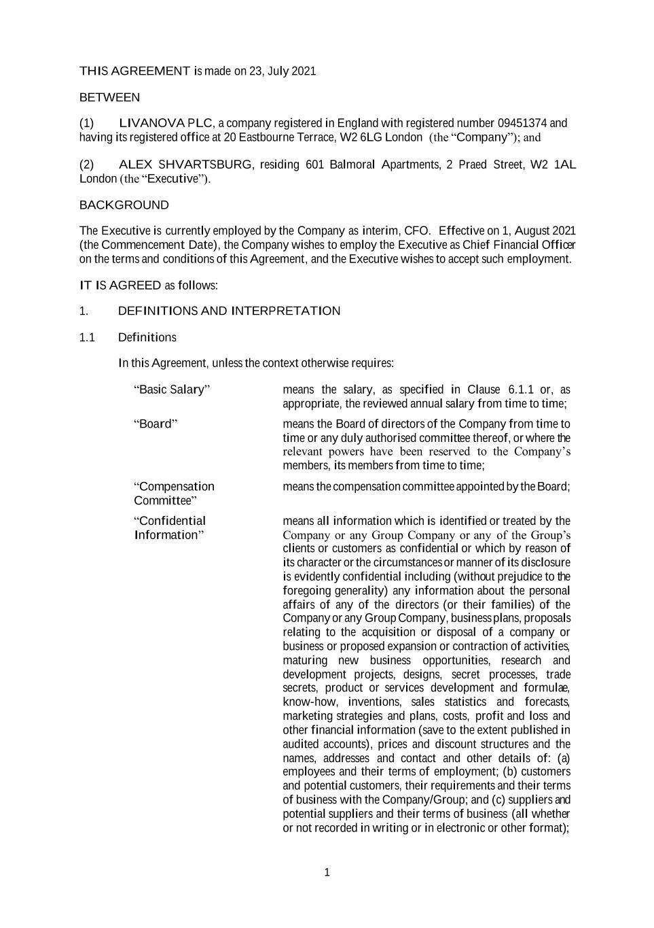

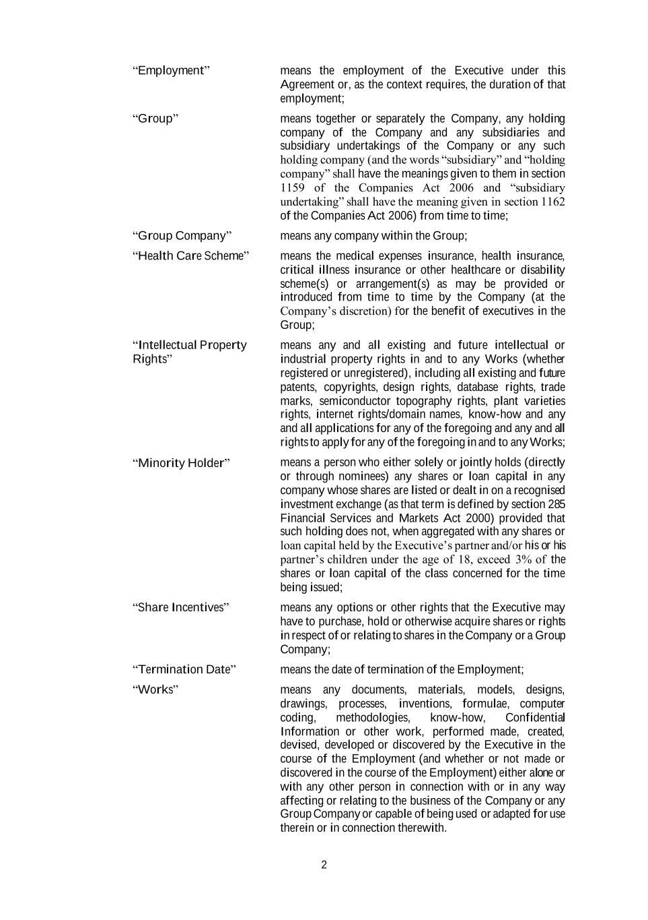

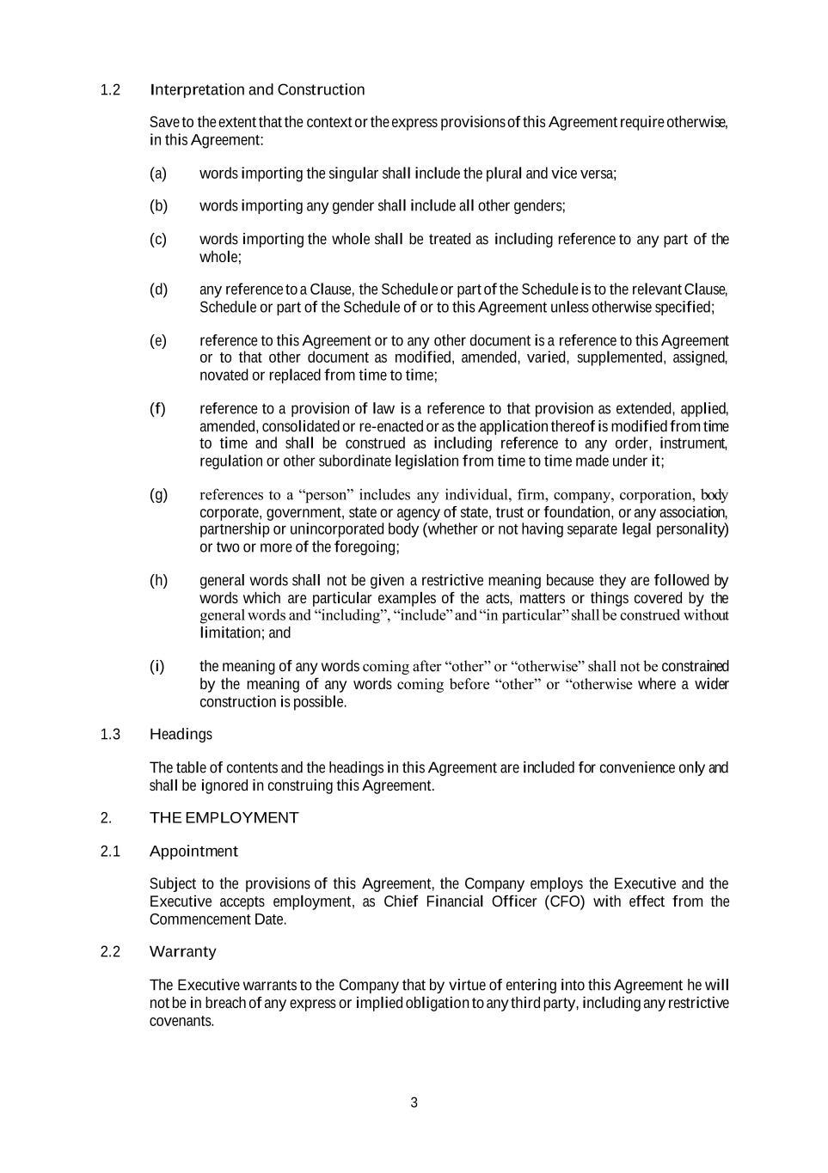

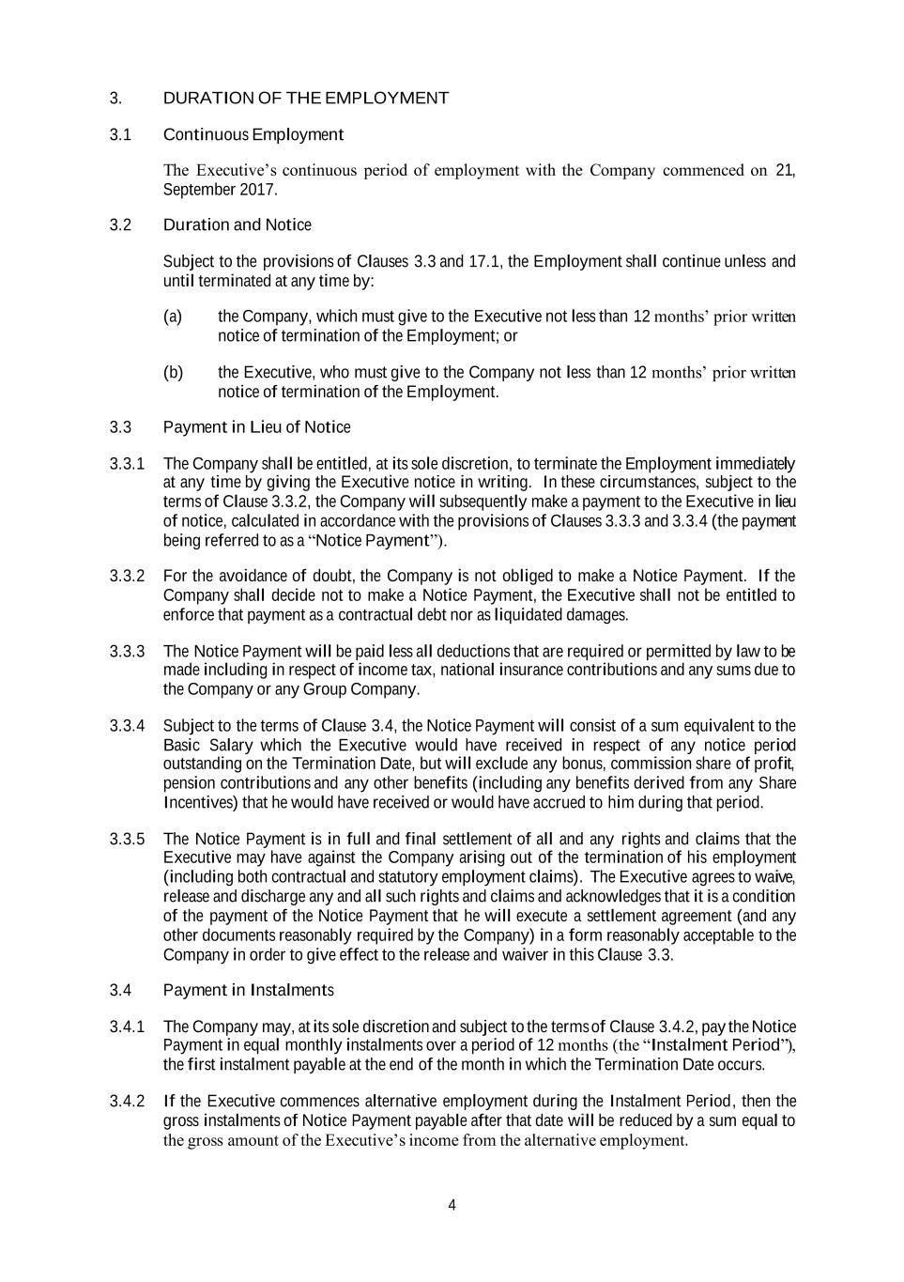



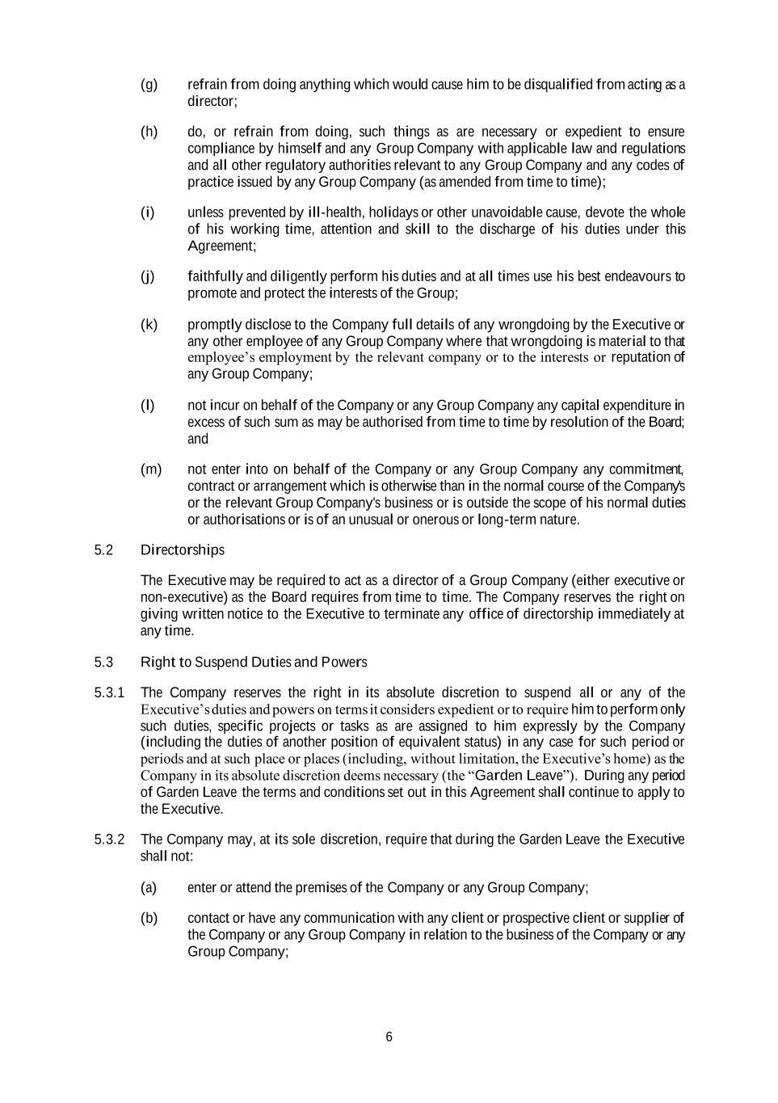

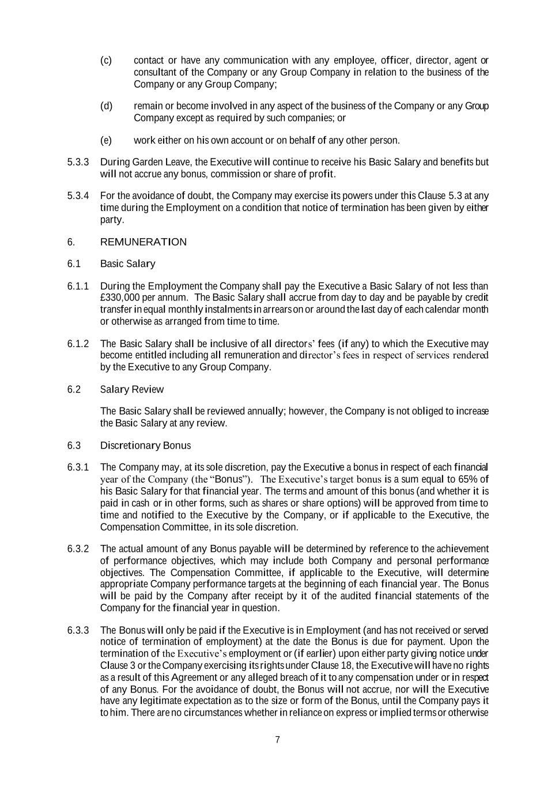

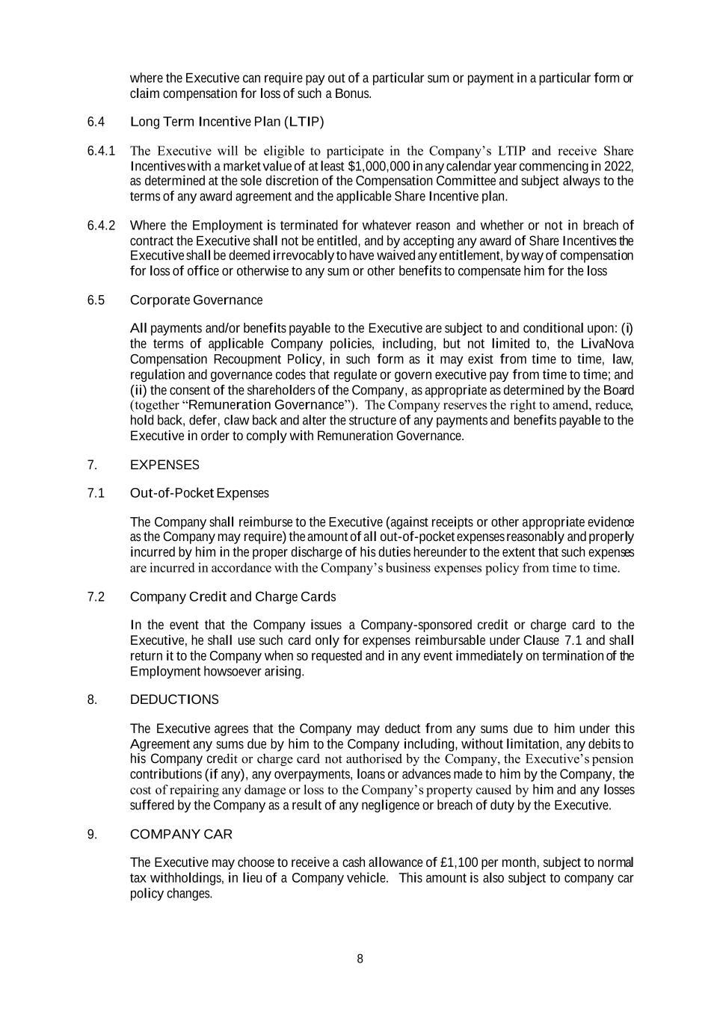

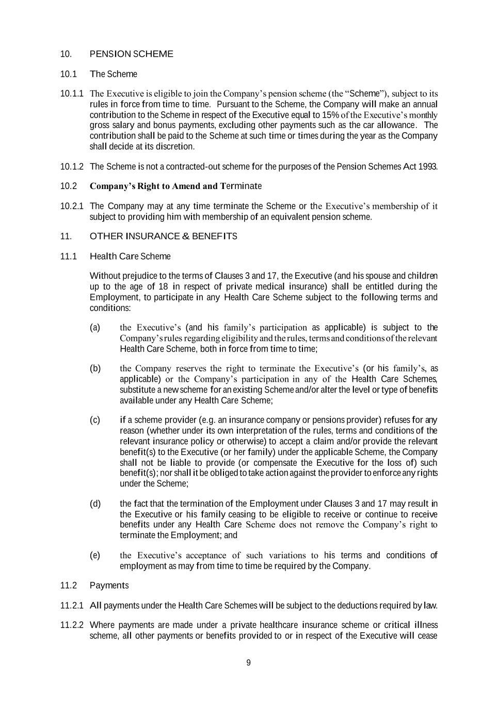

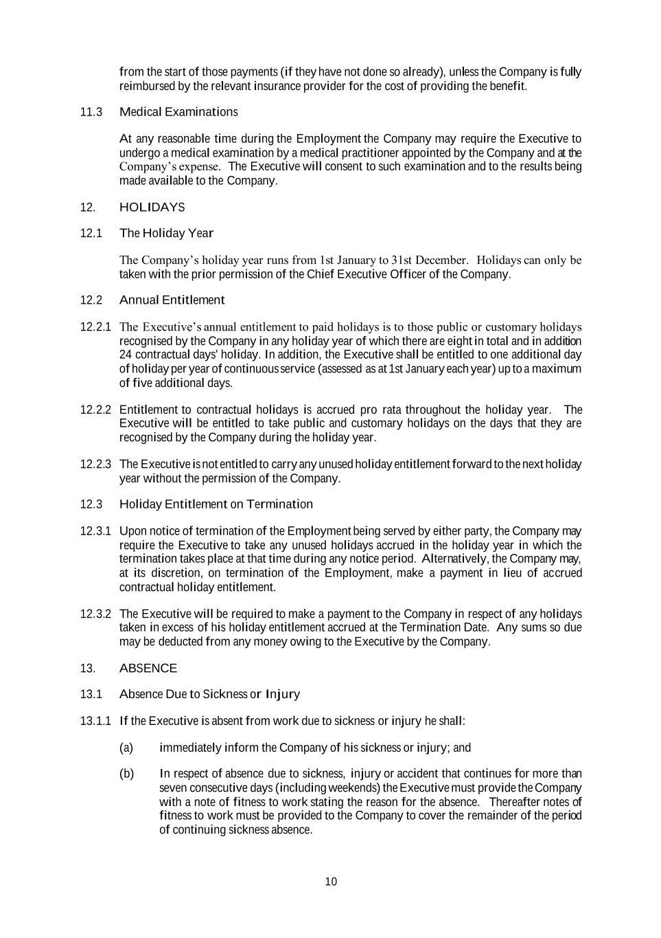

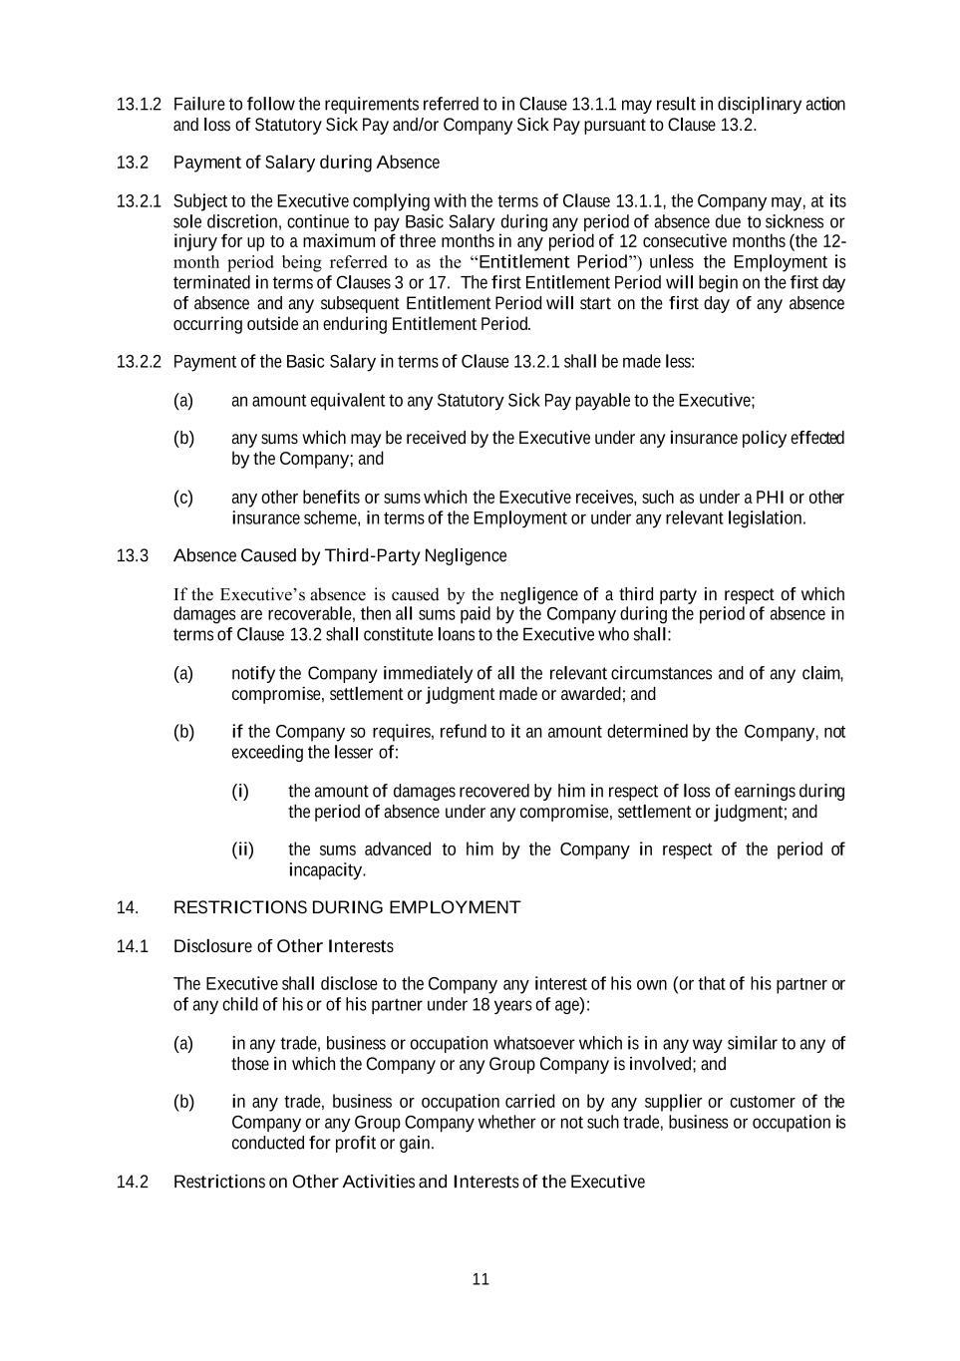

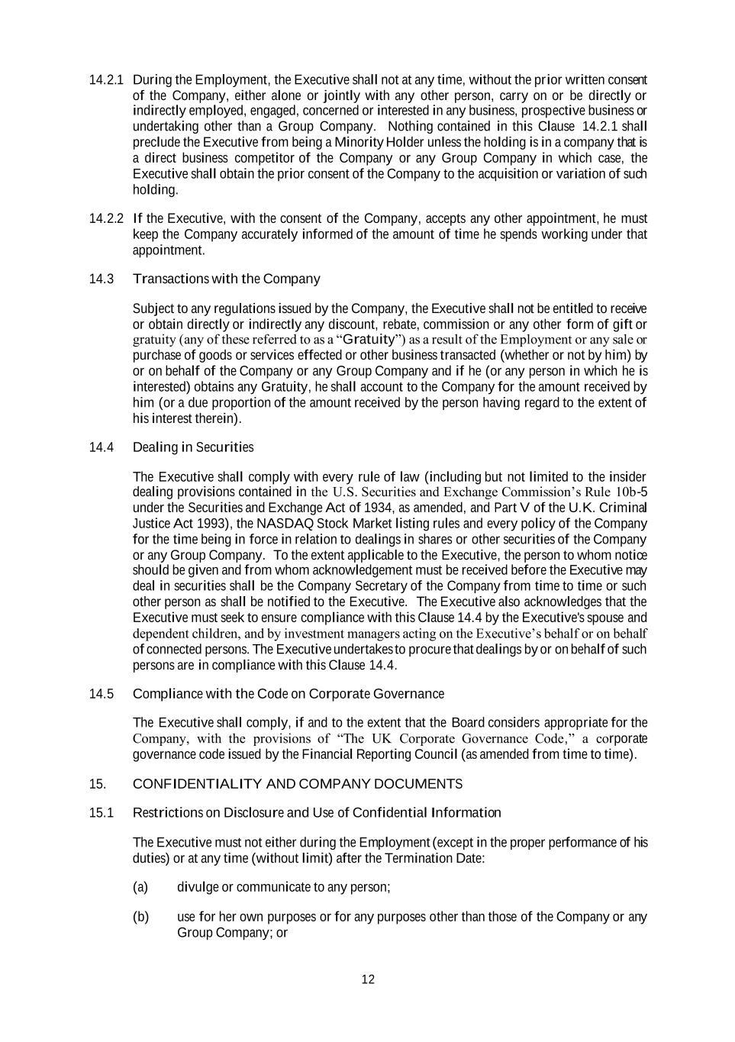

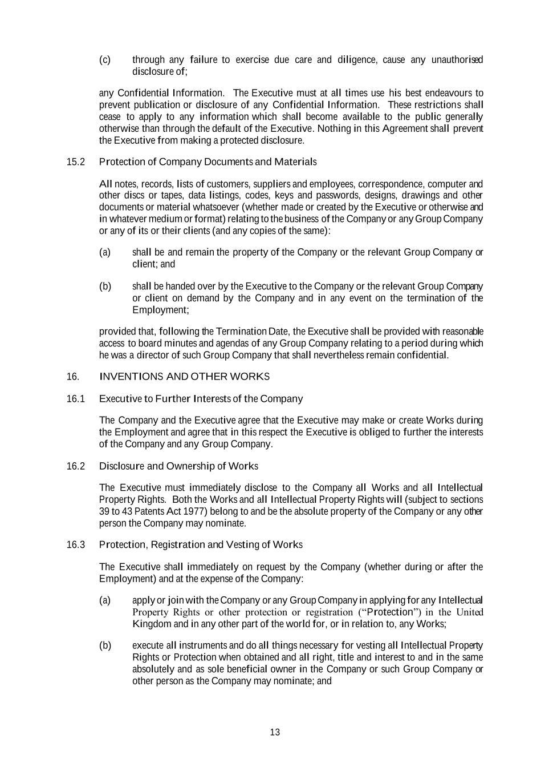

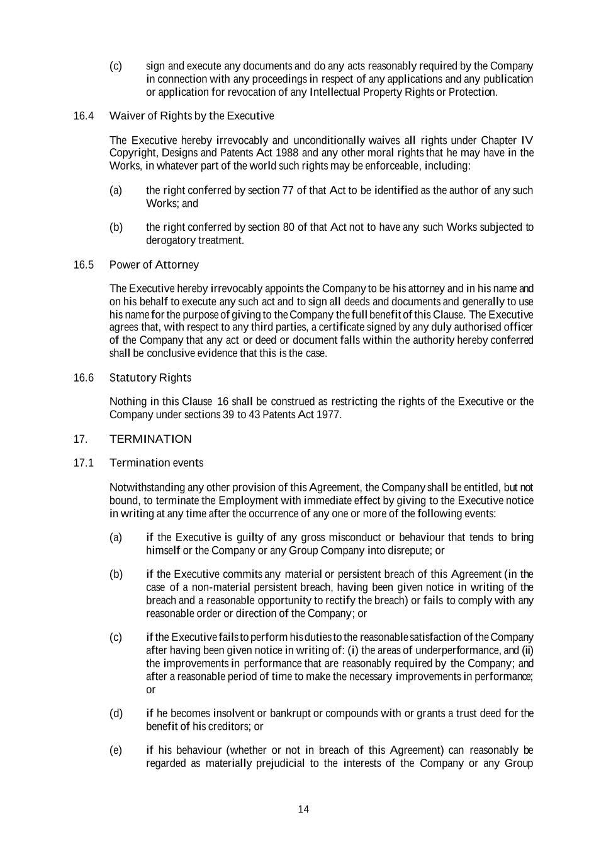

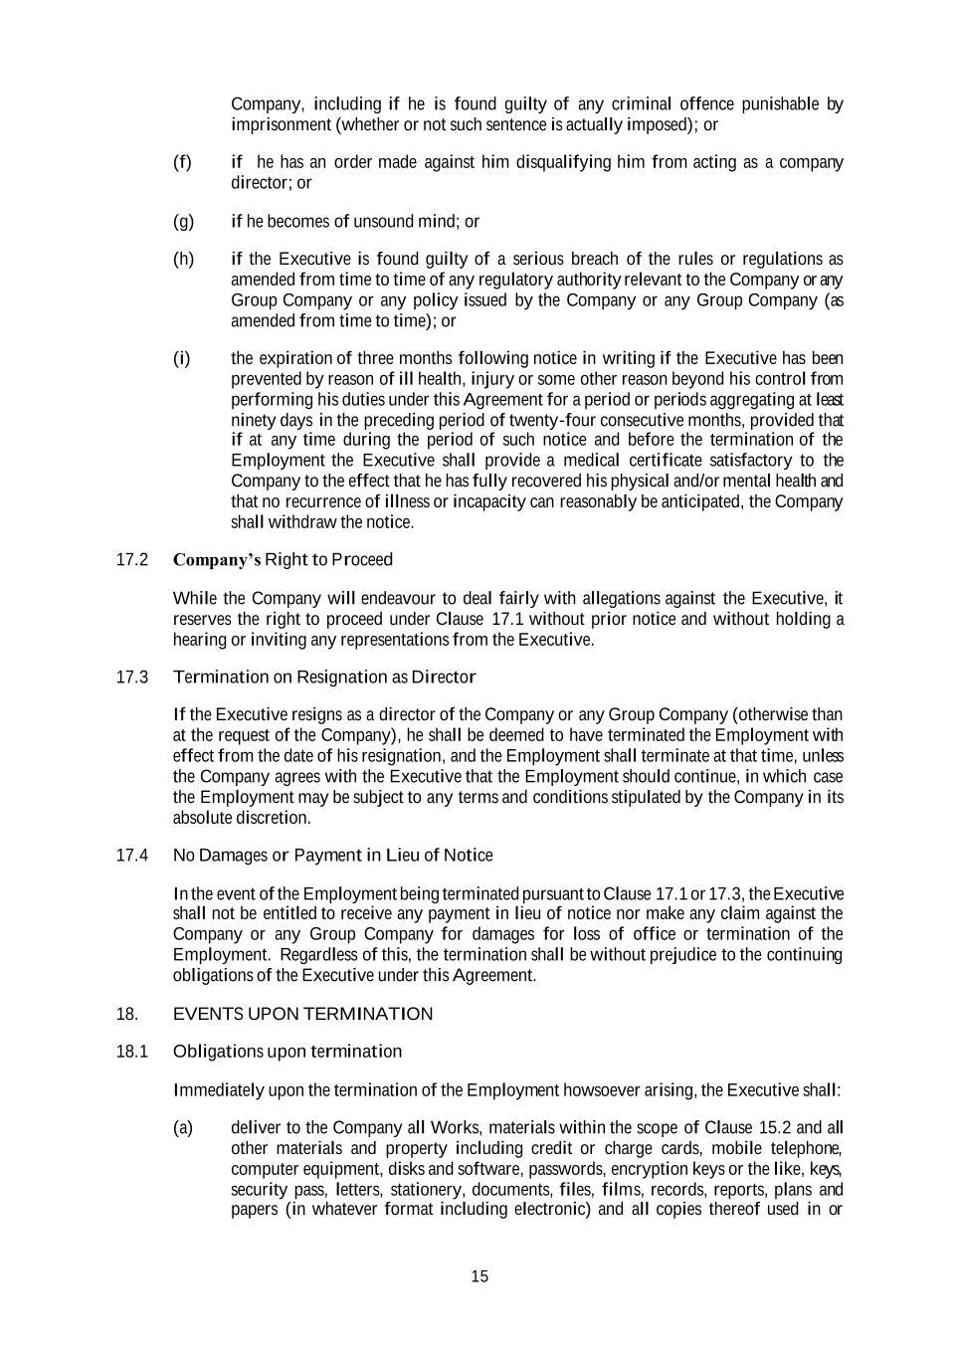

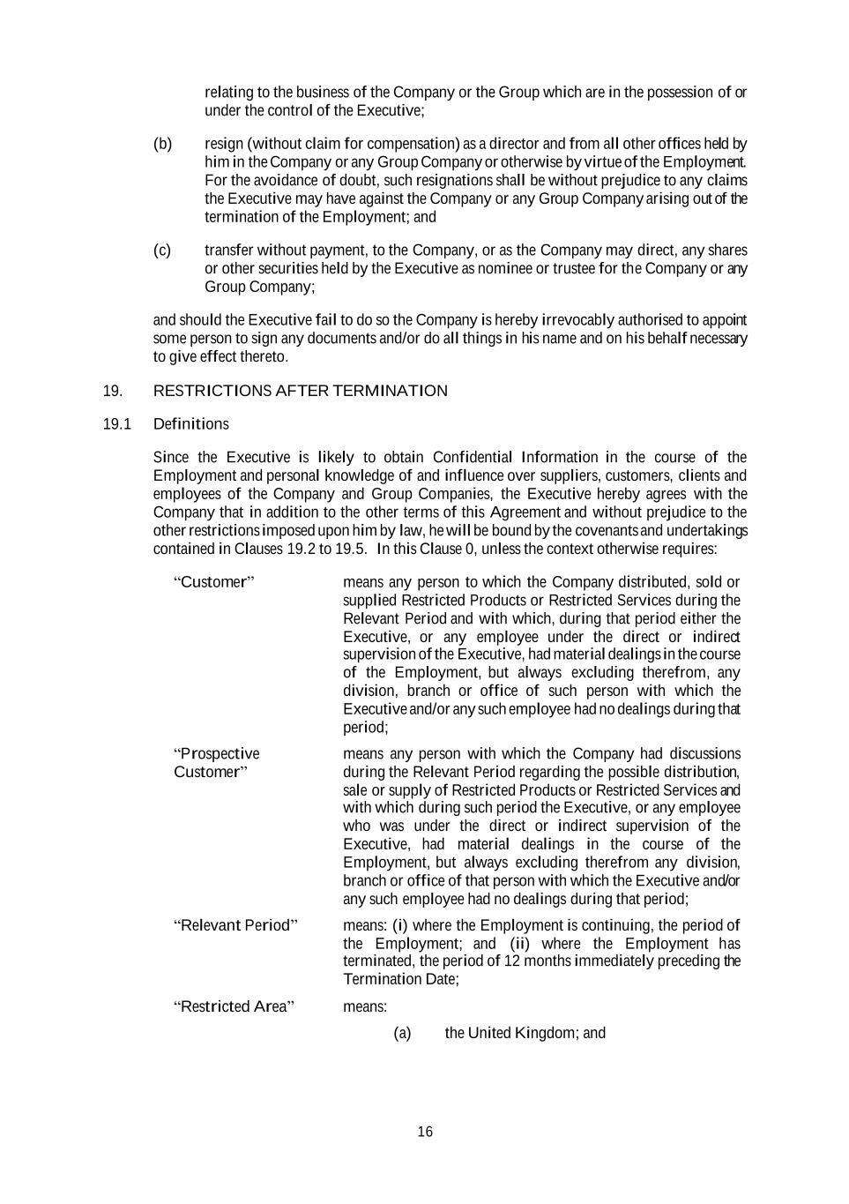

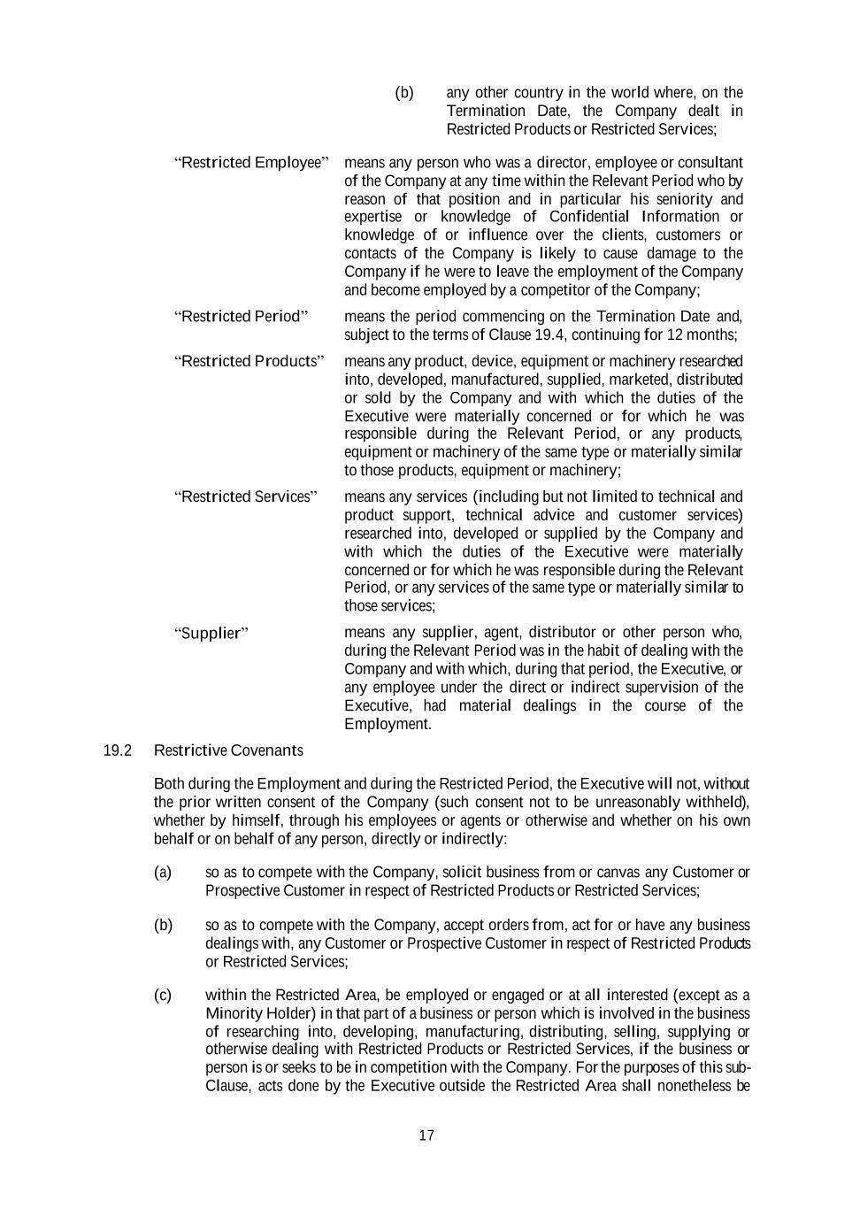

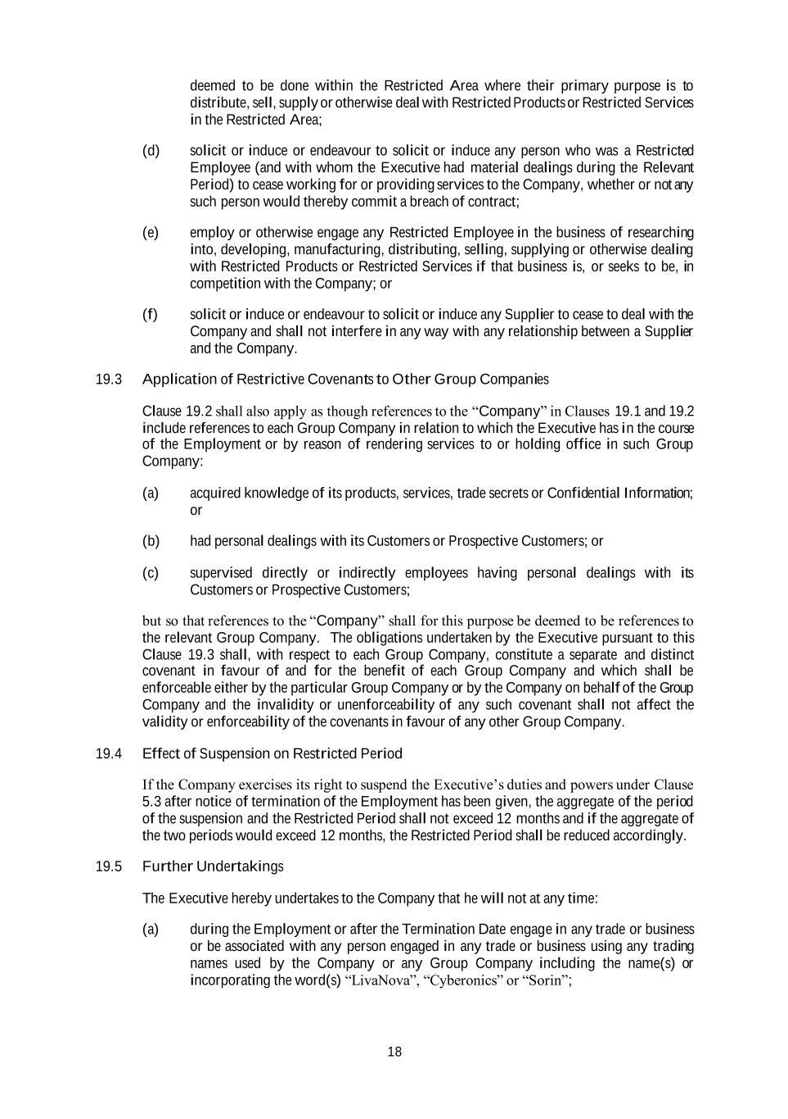



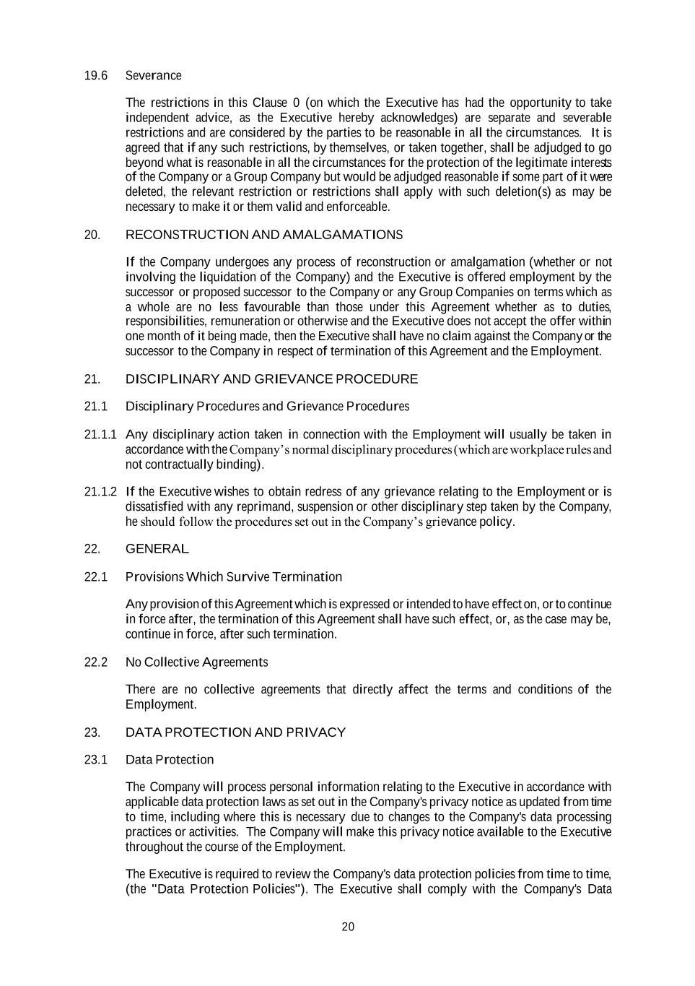

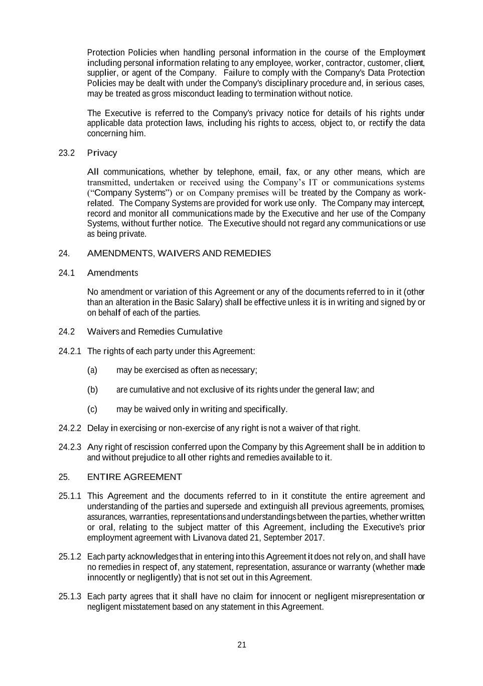

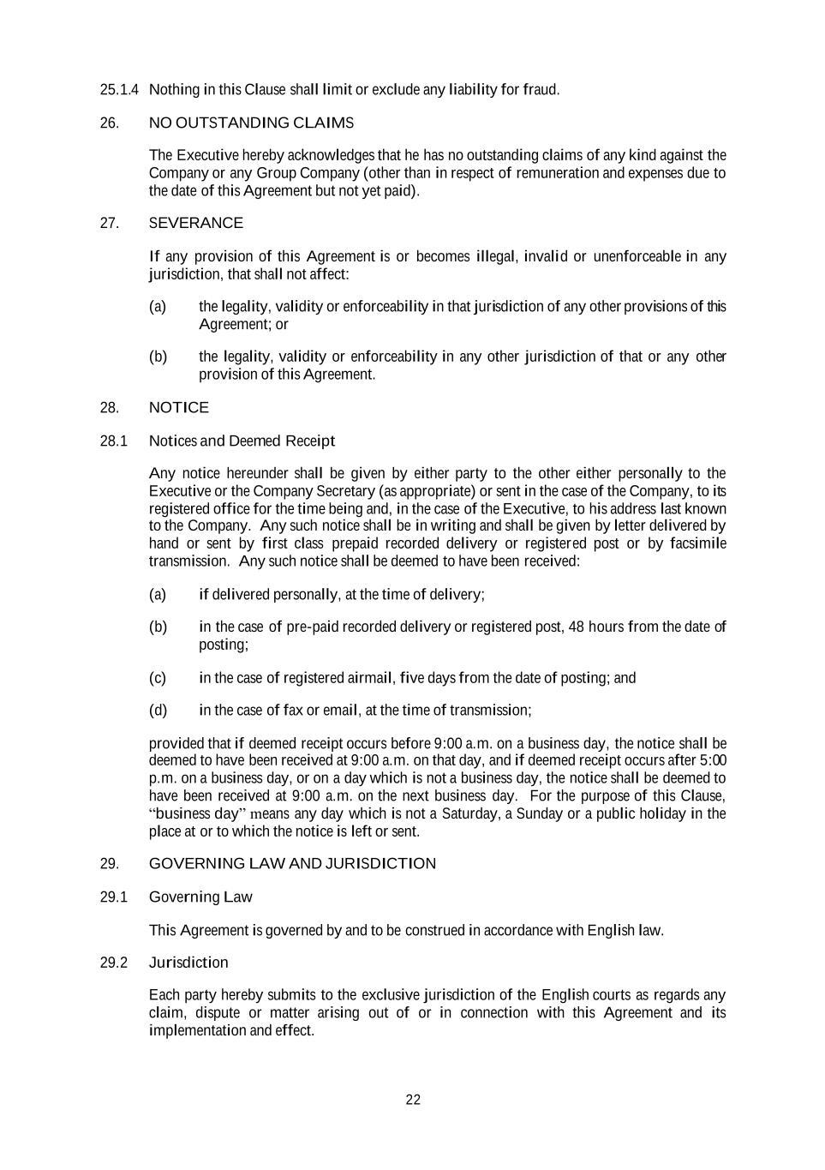

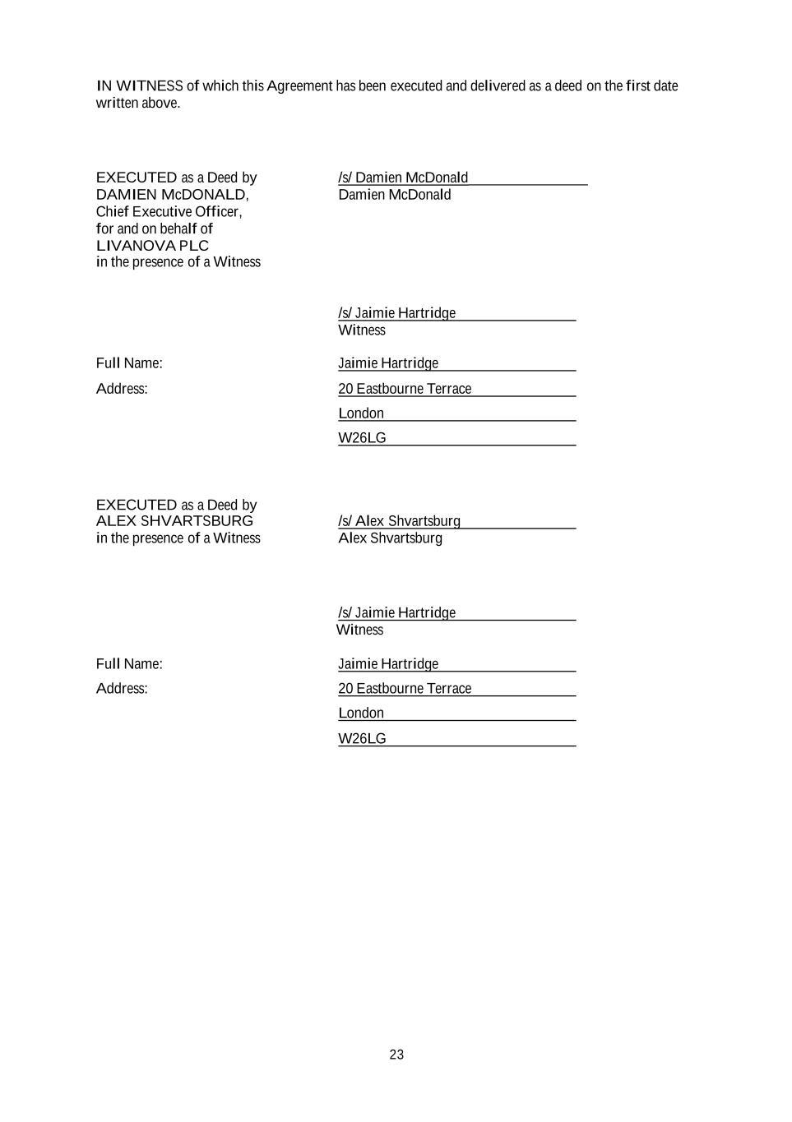

EXHIBIT 31.1

CERTIFICATION OF CHIEF EXECUTIVE OFFICER

PURSUANT TO SECTION 302 OF THE SARBANES-OXLEY ACT OF 2002

I, Damien McDonald, certify that:

- I have reviewed this Quarterly Report on Form 10-Q for the quarterly period ended June 30, 2021 of LivaNova PLC and its consolidated subsidiaries;

- Based on my knowledge, this report does not contain any untrue statement of a material fact or omit to state a material fact necessary to make the statements made, in light of the circumstances under which such statements were made, not misleading with respect to the period covered by this report;

- Based on my knowledge, the financial statements, and other financial information included in this report, fairly present in all material respects the financial condition, results of operations and cash flows of the registrant as of, and for, the periods presented in this report;

- The registrant’s other certifying officer and I are responsible for establishing and maintaining disclosure controls and procedures (as defined in Rules 13a-15(e) and 15d-15(e) of the Securities Exchange Act of 1934 (the "Exchange Act")) and internal control over financial reporting (as defined in Rules 13a-15(f) and 15d-15(f) of the Exchange Act) for the registrant and have:

- Designed such disclosure controls and procedures, or caused such disclosure controls and procedures to be designed under our supervision, to ensure that material information relating to the registrant, including its consolidated subsidiaries, is made known to us by others within those entities, particularly during the period in which this report is being prepared;

- Designed such internal control over financial reporting, or caused such internal control over financial reporting to be designed under our supervision, to provide reasonable assurance regarding the reliability of financial reporting and the preparation of financial statements for external purposes in accordance with generally accepted accounting principles;

- Evaluated the effectiveness of the registrant’s disclosure controls and procedures and presented in this report our conclusions about the effectiveness of the disclosure controls and procedures, as of the end of the period covered by this report based on such evaluation; and

- Disclosed in this report any change in the registrant’s internal control over financial reporting that occurred during the registrant’s most recent fiscal quarter (the registrant’s fourth fiscal quarter in the case of an annual report) that has materially affected, or is reasonably likely to materially affect, the registrant’s internal control over financial reporting; and

- The registrant’s other certifying officer and I have disclosed, based on our most recent evaluation of internal control over financial reporting, to the registrant’s auditors and the audit committee of the registrant’s board of directors (or persons performing the equivalent functions):

- All significant deficiencies and material weaknesses in the design or operation of internal control over financial reporting which are reasonably likely to adversely affect the registrant’s ability to record, process, summarize and report financial information; and

- Any fraud, whether or not material, that involves management or other employees who have a significant role in the registrant’s internal control over financial reporting.

Date: July 28, 2021

/s/ DAMIEN MCDONALD

Damien McDonald

Chief Executive Officer

(Principal Executive Officer)

EXHIBIT 31.2

CERTIFICATION OF CHIEF FINANCIAL OFFICER

PURSUANT TO SECTION 302 OF THE SARBANES-OXLEY ACT OF 2002

I, Alex Shvartsburg, certify that:

- I have reviewed this Quarterly Report on Form 10-Q for the quarterly period ended June 30, 2021 of LivaNova PLC and its consolidated subsidiaries;

- Based on my knowledge, this report does not contain any untrue statement of a material fact or omit to state a material fact necessary to make the statements made, in light of the circumstances under which such statements were made, not misleading with respect to the period covered by this report;

- Based on my knowledge, the financial statements, and other financial information included in this report, fairly present in all material respects the financial condition, results of operations and cash flows of the registrant as of, and for, the periods presented in this report;

- The registrant’s other certifying officer and I are responsible for establishing and maintaining disclosure controls and procedures (as defined in Rules 13a-15(e) and 15d-15(e) of the Securities Exchange Act of 1934 (the "Exchange Act")) and internal control over financial reporting (as defined in Rules 13a-15(f) and 15d-15(f) of the Exchange Act) for the registrant and have:

- Designed such disclosure controls and procedures, or caused such disclosure controls and procedures to be designed under our supervision, to ensure that material information relating to the registrant, including its consolidated subsidiaries, is made known to us by others within those entities, particularly during the period in which this report is being prepared;

- Designed such internal control over financial reporting, or caused such internal control over financial reporting to be designed under our supervision, to provide reasonable assurance regarding the reliability of financial reporting and the preparation of financial statements for external purposes in accordance with generally accepted accounting principles;

- Evaluated the effectiveness of the registrant’s disclosure controls and procedures and presented in this report our conclusions about the effectiveness of the disclosure controls and procedures, as of the end of the period covered by this report based on such evaluation; and

- Disclosed in this report any change in the registrant’s internal control over financial reporting that occurred during the registrant’s most recent fiscal quarter (the registrant’s fourth fiscal quarter in the case of an annual report) that has materially affected, or is reasonably likely to materially affect, the registrant’s internal control over financial reporting; and

- The registrant’s other certifying officer and I have disclosed, based on our most recent evaluation of internal control over financial reporting, to the registrant’s auditors and the audit committee of the registrant’s board of directors (or persons performing the equivalent functions):

- All significant deficiencies and material weaknesses in the design or operation of internal control over financial reporting which are reasonably likely to adversely affect the registrant’s ability to record, process, summarize and report financial information; and

- Any fraud, whether or not material, that involves management or other employees who have a significant role in the registrant’s internal control over financial reporting.

Date: July 28, 2021

/s/ ALEX SHVARTSBURG

Alex Shvartsburg

Chief Financial Officer

(Principal Accounting and Financial Officer)

EXHIBIT 32.1

CERTIFICATION OF THE

CHIEF EXECUTIVE OFFICER AND

CHIEF FINANCIAL OFFICER

OF LIVANOVA PLC

PURSUANT TO 18 U.S.C. SECTION 1350

AS ADOPTED PURSUANT TO SECTION 906 OF THE SARBANES-OXLEY ACT OF 2002

Each of Damien McDonald, Chief Executive Officer of LivaNova PLC (the “Company”), and Alex Shvartsburg, Chief Financial Officer of the Company, each hereby certifies pursuant to 18 U.S.C. Section 1350, as adopted pursuant to Section 906 of the Sarbanes-Oxley Act of 2002, that to the best of his knowledge:

- the Quarterly Report on Form 10-Q of the Company and its consolidated subsidiaries for the quarterly period ended June 30, 2021, as filed with the Securities and Exchange Commission on the date hereof (the “Report”) fully complies with the requirements of Section 13(a) or 15(d) of the Securities Exchange Act of 1934, as amended; and

- the information contained in the Report fairly presents, in all material respects, the financial condition and results of operations of the Company.

Date: July 28, 2021

/s/ DAMIEN MCDONALD

Damien McDonald

Chief Executive Officer

(Principal Executive Officer)

/s/ ALEX SHVARTSBURG

Alex Shvartsburg

Chief Financial Officer

(Principal Accounting and Financial Officer)

A signed original of this written statement required by Section 906 has been provided to the Company and will be retained by the Company and furnished to the Securities and Exchange Commission or its staff upon request.

The foregoing certification is being furnished solely pursuant to 18 U.S.C. Section 1350 and is not being filed as a part of this report or on a separate disclosure document.

