UNITED STATES

SECURITIES AND EXCHANGE COMMISSION

WASHINGTON, D.C. 20549

FORM 8-K

CURRENT REPORT

Pursuant to Section 13 or 15(d) of the Securities Exchange Act of 1934

Date of Report (Date of earliest event reported): April 5, 2019


LivaNova PLC

(Exact Name of Registrant as Specified in its Charter)

England and Wales | 001-37599 | 98-1268150
(State or Other Jurisdiction | (Commission | (IRS Employer
of Incorporation) | File Number) | Identification No.)
 | 20 Eastbourne Terrace
 | London, W2 6LG
 | United Kingdom
 | (Address of Principal Executive Offices)
 | +44 20 33250660
 | (Registrant’s Telephone Number, Including Area Code)
 | N/A
 | (Former Name or Former Address, if Changed Since Last Report)

Check the appropriate box below if the Form 8-K is intended to simultaneously satisfy the filing obligation of the registrant under any of the following provisions (see General Instructions A.2. below):

o Written communications pursuant to Rule 425 under the Securities Act (17 CFR 230.425)

o Soliciting material pursuant to Rule 14a-12 under the Exchange Act (17 CFR 240.14a-12)

o Pre-commencement communications pursuant to Rule 14d-2(b) under the Exchange Act (17 CFR 240.14d-2(b))

o Pre-commencement communications pursuant to Rule 13e-4(c) under the Exchange Act (17 CFR 240.13e-4(c))

Indicate by check mark whether the registrant is an emerging growth company as defined in Rule 405 of the Securities Act of 1933 (§230.405 of this chapter) or Rule 12b-2 of the Securities Exchange Act of 1934 (§240.12b-2 of this chapter).

Emerging growth company o

If an emerging growth company, indicate by check mark if the registrant has elected not to use the extended transition period for complying with any new or revised financial accounting standards provided pursuant to Section 13(a) of the Exchange Act.

o

Item 8.01 Other Events

On April 5, 2019, LivaNova PLC (the “Company”) issued a press release announcing preliminary unaudited revenue results for the quarter ended March 31, 2019.

Item 9.01 Financial Statements and Exhibits

(d) Exhibits.

Exhibit Description

99.1 LivaNova Press Release dated April 5, 2019

2

SIGNATURE

Pursuant to the requirements of the Securities Exchange Act of 1934, the Registrant has duly caused this report to be signed on its behalf by the undersigned hereunto duly authorized.

LivaNova PLC

Date: April 5, 2019 By:/s/ Catherine Moroz

Name: Catherine Moroz

Title: Company Secretary

3

EXHIBIT 99.1


NEWS RELEASE

LivaNova Reports Preliminary Unaudited First Quarter 2019

Revenue Results

London, April 5, 2019 – LivaNova PLC (NASDAQ:LIVN), a market-leading medical technology company, today announced preliminary unaudited revenue results for the quarter ended March 31, 2019.

Preliminary First Quarter 2019 Results

The Company expects worldwide sales from continuing operations for the first quarter 2019 to be approximately $251 million, flat on a reported basis and an increase of 4.0 percent on a constant-currency basis compared to the first quarter of 2018. Neuromodulation sales are anticipated to be $94 million, up 0.6 percent on a reported basis and an increase of 2.1 percent for the first quarter of 2019 compared to the same period last year. Cardiovascular sales are expected to be $155 million, down 0.5 percent on a reported basis and an increase of 5.1 percent for first quarter 2019 as compared to the same period last year. In Cardiovascular, LivaNova ended a previously disclosed third-party distribution agreement on January 1, 2019 that accounted for $8 million in sales in the first quarter of 2018 and is located in Cardiopulmonary within the Rest of World region. The following table highlights expected worldwide sales for the first quarter of 2019 by business:

 |  | Three months ended
$ in millions |  | March 31 |  |  |  | As Reported | Constant Currency
Business/Product Line |  | 2019 |  |  | 2018 | % Change | % Change
Cardiopulmonary | $ | 121.5 | $ |  | 125.1 | (2.9%) | 2.5%
Heart Valves |  | 25.6 |  |  | 31.0 | (17.5%) | (11.4%)
ACS |  | 8.2 |  |  | - | N/A | N/A
Cardiovascular |  | 155.4 |  |  | 156.2 | (0.5%) | 5.1%
Neuromodulation |  | 94.4 |  |  | 93.8 | 0.6% | 2.1%
Other |  | 0.6 |  |  | 0.4 | N/A | N/A
Total Net Sales | $ | 250.5 | $ |  | 250.4 | 0.0% | 4.0%

- Note: Numbers may not add up precisely due to rounding. Constant-currency % change is considered a non-GAAP metric. Constant-currency growth accounts for the impact from fluctuations in the various currencies in which the Company operates as compared to reported growth.

1

The Neuromodulation business experienced unexpected weakness in the U.S. market due to a combination of factors, including competitive dynamics and salesforce turnover. Softness in Perceval sales coupled with continued declines in overall heart valve sales negatively impacted the Cardiovascular business during the quarter.

"While our Europe and Rest of World regions continued to grow above plan, I am disappointed by our execution in the quarter in

light of the changing competitive environment within the U.S. in our Neuromodulation and Heart Valves businesses,” said Damien

McDonald, Chief Executive Officer of LivaNova. “We believe we can address these challenges and remain committed to our

strategy to drive sales, build global capabilities and establish a strong product portfolio. We believe these efforts will serve the

needs of our customers and patients to create quality, long-term value for our shareholders."

2019 Guidance and Financial Outlook

LivaNova is currently reviewing its 2019 guidance and will provide updates and report its full financial results for first quarter 2019 in connection with its earnings call on Wednesday, May 1.

Note Regarding Preliminary Results

The financial results presented in this release are preliminary and may change. This preliminary financial information includes

calculations or figures that have been prepared internally by management and have not been reviewed or audited by our

independent registered public accounting firm. There can be no assurance that the Company’s actual results for the periods

presented herein will not differ from the preliminary financial data presented herein and such changes could be material. This

preliminary financial data should not be viewed as a substitute for full financial statements prepared in accordance with GAAP and

is not necessarily indicative of the results to be achieved for any future periods.

Webcast and Conference Call Instructions

The Company will host a live audio webcast for interested parties commencing at 1 p.m. London time (8 a.m. Eastern Time) on Wednesday, May 1 that will be accessible through the Investor Relations section of the LivaNova corporate website at www.livanova.com. To listen to the

2

conference call live by telephone, dial (844) 601-5111 (if dialing from within the U.S.) or (647) 253-8650 (if dialing from outside the U.S.). The conference ID is 7264769.

Within 24 hours of the webcast, a replay will be available under the "News & Events / Events & Presentations" section of the Investor Relations portion of the LivaNova website, where it will be archived and accessible for approximately 12 months.

About LivaNova

LivaNova PLC is a global medical technology company built on nearly five decades of experience and a relentless commitment to improve the lives of patients around the world. LivaNova’s advanced technologies and breakthrough treatments provide meaningful solutions for the benefit of patients, healthcare professionals and healthcare systems. Headquartered in London, LivaNova has a presence in more than 100 countries worldwide. The Company currently employs approximately 4,000 employees. LivaNova operates as two businesses: Cardiovascular and Neuromodulation, with operating headquarters in Mirandola (Italy) and Houston (U.S.), respectively.

For more information, please visit www.livanova.com.

Use of Non-GAAP Financial Measures

In this press release, management has disclosed financial measurements that present financial information not necessarily in accordance with GAAP. Company management uses these measurements as aids in monitoring the Company’s ongoing financial performance from quarter to quarter and year to year on a regular basis and for benchmarking against other medical technology companies. Non-GAAP financial measures used by the Company may be calculated differently from, and therefore may not be comparable to, similarly titled measures used by other companies. These non-GAAP financial measures should be considered along with, but not as alternatives to, the operating performance measure as prescribed by GAAP.

Unless otherwise noted, all sales growth rates in this release reflect comparable, constant-currency growth. Management believes

that referring to comparable, constant-currency growth is the most useful way to evaluate the sales performance of LivaNova and

to compare the sales performance of current periods to prior periods on a consistent basis. Constant-currency growth, a non-

GAAP financial measure, measures the change in sales between current and prior-year periods using average exchange rates in

effect during the applicable prior-year period.

3

LivaNova calculates forward-looking non-GAAP financial measures based on internal forecasts that omit certain amounts that

would be included in GAAP financial measures. For example, forward-looking net sales growth projections are estimated on a

constant-currency basis and exclude the impact of foreign currency fluctuations. Forward-looking non-GAAP adjusted tax rate and

adjusted diluted earnings per share guidance exclude other items such as, but not limited to, changes in fair value of contingent

consideration arrangements, asset impairment charges and product remediation costs that would be included in comparable

GAAP financial measures. The most directly comparable GAAP measure for constant-currency net sales are net sales.

Furthermore, adjusted financial measures allow investors to evaluate the Company’s core performance for different periods on a

more comparable and consistent basis, and with other entities in the medical technology industry by adjusting for items that are

not related to the ongoing operations of the Company or incurred in the ordinary course of business.

Safe Harbor Statement

This news release contains forward-looking statements within the meaning of Section 27A of the United States Securities Act of 1933, as amended, and Section 21E of the United States Securities Exchange Act of 1934, as amended. Forward-looking statements are not historical facts but are based on certain assumptions of management and describe LivaNova’s future plans, strategies and expectations. Forward-looking statements can generally be identified by the use of forward-looking terminology, including, but not limited to, "may," “could,” “seek,” “guidance,” “predict,” “potential,” “likely,” "believe," "will," "expect," "anticipate," "estimate," "plan," "intend," "forecast," or variations of these terms and similar expressions, or the negative of these terms or similar expressions. Forward-looking statements contained in this news release are based on information presently available to LivaNova and assumptions that LivaNova believes to be reasonable, but are inherently uncertain. As a result, LivaNova’s actual results, performance or achievements may differ materially from those expressed or implied by these forward-looking statements, which are not guarantees of future performance or actions that may be taken by LivaNova and involve known and unknown risks, uncertainties and other factors that may be beyond LivaNova’s control. You should carefully consider the risks and uncertainties that affect LivaNova, including those described in the “Risk Factors” section of LivaNova’s most recent Annual Reports on Form 10-K and other documents filed from time to time with the United States Securities and Exchange Commission.

4

All information in this news release is as of the date of its release. LivaNova does not undertake or assume any obligation to update publicly any of the forward-looking statements in this news release to reflect actual results, new information or future events, changes in assumptions or changes in other factors affecting forward-looking statements, except to the extent required by applicable law. If we update one or more forward-looking statements, no inference should be drawn that we will make additional updates with respect to those or other forward-looking statements. We caution you not to place undue reliance on any forward-looking statements, which are made only as of the date of this news release.

LivaNova PLC Investor Relations and Media

Melissa Farina, +1 (281) 228-7262

Vice President, Investor Relations

InvestorRelations@livanova.com

Deanna Wilke, +1 (281) 727-2764

Director, Corporate Communications

Corporate.Communications@livanova.com

###

5

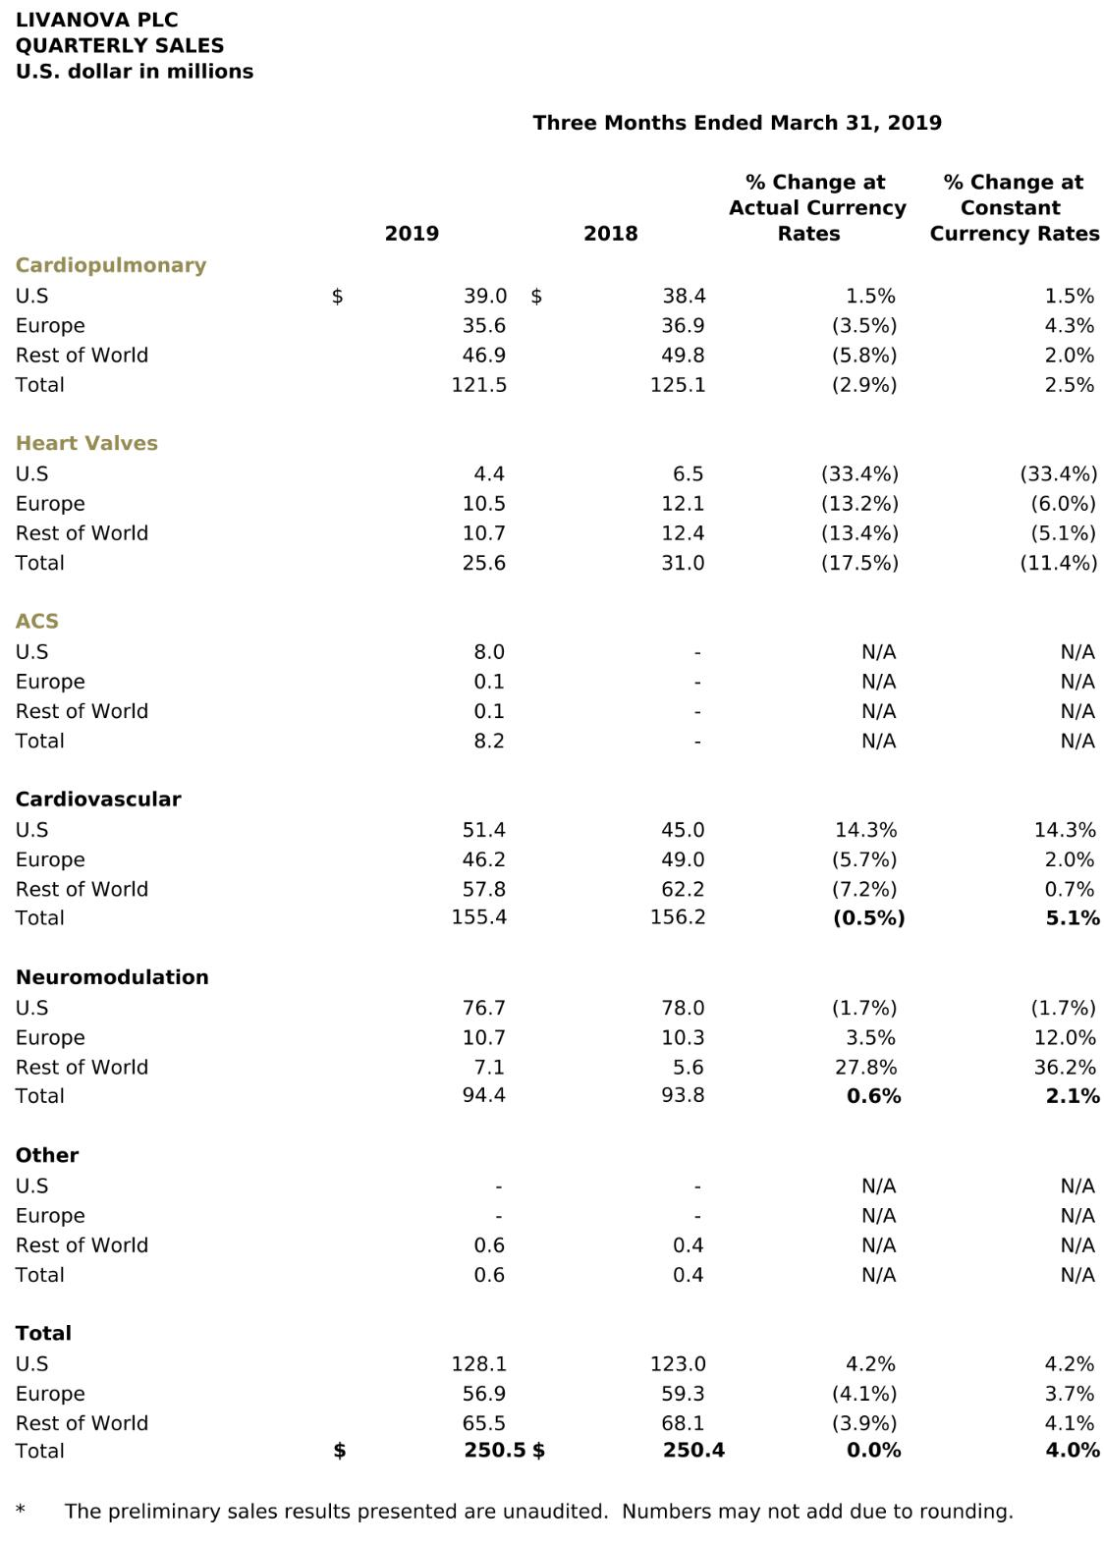

6

