As filed with the Securities and Exchange Commission on July 26, 2023.

Registration No. 333-

UNITED STATES SECURITIES AND EXCHANGE COMMISSION

WASHINGTON, D.C. 20549

FORM S-8

REGISTRATION STATEMENT
UNDER

THE SECURITIES ACT OF 1933

LivaNova PLC

(Exact name of Registrant as specified in its charter)

England and Wales | 98-1268150
(State or other jurisdiction of incorporation or organization) | (I.R.S. Employer Identification Number)
20 Eastbourne Terrace
London, United Kingdom | W2 6LG
(Address of Principal Executive Offices) | (Zip Code)

Amended and Restated LivaNova PLC 2022 Incentive Award Plan

(Full title of the plan)

Company Secretariat

LivaNova Plc

c/o

LivaNova USA, Inc.

100 Cyberonics Blvd.

Houston, Texas 77058

United States

(Name and Address of agent of service)

(281) 228-7200

(Telephone number, including area code, of agent of service)

Indicate by check mark whether the registrant is a large accelerated filer, an accelerated filer, a non-accelerated filer, a smaller reporting company or an emerging growth company.

See the definitions of “large accelerated filer,” “accelerated filer,” “smaller reporting company,” and “emerging growth company” in Rule 12b-2 of the Exchange Act.

Large accelerated filer x

Accelerated filer ☐

Non-accelerated filer ☐

(Do not check if a smaller reporting company)

Smaller reporting company ☐

Emerging growth company ☐

If an emerging growth company, indicate by check mark if the registrant has elected not to use the extended transition period for complying with any new or revised financial accounting standards provided pursuant to Section 7(a)(2)(B) of the Securities Act of 1933 (the “Securities Act”). ☐

EXPLANATORY NOTE

This registration statement on Form S-8 (the “Registration Statement”) is being filed in order to register an additional (i) 650,000 ordinary shares, par value £1.00 per share (the “Ordinary Shares”), of LivaNova PLC (the “Registrant”) that may be issued under the Registrant’s Amended and Restated LivaNova PLC 2022 Incentive Award Plan (the “Plan”) and (ii) 650,000 Ordinary Shares that may become available for issuance under the Plan as a result of outstanding awards under the Plan being (a) forfeited, lapsed, or expired, (b) converted to shares of another company in connection with a takeover, sale, recapitalization, reorganization, merger, consolidation, split-up, spin-off, combination, exchange of shares or other similar event, (c) settled for cash (in whole or in part) or (d) repurchased by the Registrant.

The Ordinary Shares are securities of the same class as those securities registered on the Registrant’s registration statement on Form S-8 previously filed with the Securities and Exchange Commission (the “Commission”) on June 13, 2022 (Registration No. 333-265563), which is hereby incorporated by reference, except to the extent supplemented, amended or superseded by information set forth in this Registration Statement, consistent with General Instruction E to Form S-8.

Part II

INFORMATION REQUIRED IN THE REGISTRATION STATEMENT

Item 3. Incorporation of Documents By Reference.

The following documents filed by the Registrant with the Commission are incorporated into this Registration Statement by reference:

(a)

the Registrant’s Annual Report on Form 10-K for the fiscal year ended December 31, 2022, filed with the Commission on February 27, 2023 (including the information specifically incorporated by reference therein from the Registrant’s definitive proxy statement on Schedule 14A, filed with the Commission on April 28, 2023);

(b)

the Registrant’s Quarterly Report on Form 10-Q for the quarterly period ended March 31, 2023, filed with the Commission on May 3, 2023;

(c)

the Registrant’s Quarterly Report on Form 10-Q for the quarterly period ended June 30, 2023, filed with the Commission on July 26, 2023;

(c)

the Registrant’s Current Reports on Form 8-K filed with the Commission on February 22, 2023 (Item 5.02 only), April 14, 2023 (Item 5.02 only), April 21, 2023 and June 16, 2023; and

(d)

the description of the Registrant’s securities contained in Exhibit 4.1 of the Registrant’s Annual Report on Form 10-K for the fiscal year ended December 31, 2022.

All documents subsequently filed by the Registrant pursuant to Sections 13(a), 13(c), 14 and 15(d) of the Securities Exchange Act of 1934, as amended, after the date of this Registration Statement and prior to the filing of a post-effective amendment to this Registration Statement indicating that all securities offered hereby have been sold or which deregisters all securities then remaining unsold, shall be deemed to be incorporated by reference in this Registration Statement and to be part hereof from the date of the filing of such documents.

Any statement contained in a document incorporated or deemed to be incorporated by reference herein shall be deemed to be modified or superseded for purposes of this Registration Statement to the extent that a statement contained herein or in any other subsequently filed document that also is or is deemed to be incorporated by reference herein modifies or supersedes such statement. Any such statement so modified or superseded shall not be deemed, except as so modified or superseded, to constitute a part of this Registration Statement.

Subject to the foregoing, all information appearing in this Registration Statement is qualified in its entirety by the information appearing in the documents incorporated by reference in this Registration Statement.

Item 8. Exhibits.

The exhibits to this Registration Statement are described below.

Exhibit Number Exhibit

4.1 Amended Articles of Association of LivaNova PLC, effective as from June 29, 2020 (incorporated by reference to Exhibit 3.1 to the Registrant’s Quarterly Report on Form 10-Q, filed on July 29, 2020 (File No. 001-37599))

5.1 Opinion of Cleary Gottlieb Steen & Hamilton LLP

10.1 Amended and Restated LivaNova PLC 2022 Incentive Award Plan (incorporated by reference to Exhibit 10.1 to the Registrant’s Current Report on Form

8-K, filed on June 16, 2023 (File No. 001-37599))

23.1 Consent of Cleary Gottlieb Steen & Hamilton LLP (included in Exhibit 5.1)

23.2 Consent of PricewaterhouseCoopers LLP

24.1 Power of Attorney (included on the signature page hereto)

- Filing Fee Table

SIGNATURES

Pursuant to the requirements of the Securities Act of 1933, the Registrant certifies that it has reasonable grounds to believe that it meets all of the requirements for filing on Form S-8 and has duly caused this Registration Statement to be signed on its behalf by the undersigned, thereunto duly authorized, in London, United Kingdom, on July 26, 2023.

LivaNova PLC

By: /s/ William A. Kozy

William A. Kozy

Interim Chief Executive Officer and Chair of the Board

POWER OF ATTORNEY

KNOW ALL PERSONS BY THESE PRESENTS, that each person whose signature appears below hereby constitutes and appoints Michael Hutchinson as his or her true and lawful attorney-in-fact and agent with full power of substitution, for him or her in any and all capacities, to sign any and all amendments to this registration statement (including post-effective amendments or any abbreviated registration statement and any amendments thereto filed pursuant to Rule 462(b) under the Securities Act of 1933, as amended, increasing the number of securities for which registration is sought), and to file the same, with all exhibits thereto and other documents in connection therewith, with the Commission, granting unto said attorney-in-fact, proxy, and agent full power and authority to do and perform each and every act and thing requisite and necessary to be done in connection therewith, as fully for all intents and purposes as he might or could do in person, hereby ratifying and confirming all that said attorney-in-fact, proxy and agent, or his substitute, may lawfully do or cause to be done by virtue hereof.

Pursuant to the requirements of the Securities Act of 1933, this Registration Statement has been signed by the following persons in the capacities and on the dates indicated.

Signature |  | Title |  | Date
/s/ William A. Kozy |  | Interim Chief Executive Officer and Chair of the Board |  | July 26, 2023
/s/ William A. Kozy |  | (Principal Executive Officer)
William A. Kozy
/s/ Alex Shvartsburg |  | Chief Financial Officer |  | July 26, 2023
/s/ Alex Shvartsburg |  | (Principal Accounting and Financial Officer)
Alex Shvartsburg
/s/ Francesco Bianchi |  | Director |  | July 26, 2023
Francesco Bianchi
/s/ Stacy Enxing Seng |  | Director |  | July 26, 2023
Stacy Enxing Seng
/s/ Daniel J. Moore |  | Director |  | July 26, 2023
Daniel J. Moore
/s/ Sharon O’Kane |  | Director |  | July 26, 2023
Sharon O’Kane
/s/ Andrea L. Saia |  | Director |  | July 26, 2023
Andrea L. Saia
/s/ Todd C. Schermerhorn |  | Director |  | July 26, 2023
Todd C. Schermerhorn
/s/ Brooke Story |  | Director |  | July 26, 2023
Brooke Story
/s/ Peter Wilver |  | Director |  | July 26, 2023
Peter Wilver
/s/ Kevin Smith |  | Authorized Representative in the United States |  | July 26, 2023
Kevin Smith

Exhibit 107

CALCULATION OF FILING FEE TABLES

Form S-8

(Form Type)

LivaNova PLC

(Exact Name of Registrant as Specified in its Charter)

Table 1: Newly Registered Securities

 |  |  |  | Proposed
 |  |  |  | Maximum
 | Security Class | Fee Calculation | Amount to be | Offering Price | Maximum Aggregate Offering |  | Amount of Registration
Security Type | Title | Rule | Registered⁽¹⁾ | Per Unit | Price | Fee Rate | Fee
Equity | Ordinary Shares, | Other⁽²⁾ | 1,300,000 Ordinary | $52.60⁽²⁾ | $68,380,000 ⁽²⁾ | $110.20 per | $7,535.48
 | £1.00 par value |  | Shares |  |  | $1,000,000
Total Offering | Amounts |  |  |  | $68,380,000 |  | $7,535.48
Total Fee Offsets
Net Fee Due |  |  |  |  |  |  | $7,535.48
(1) | Represents 1,300,000 additional ordinary shares par value £1.00 per share of LivaNova PLC (the “Ordinary Shares”) being registered pursuant to the
 | Amended and Restated LivaNova PLC 2022 Incentive Award Plan (the “Plan”) and, pursuant to Rule 416(a) under the Securities Act of 1933, as amended
 | (the “Securities Act”), an indeterminable number of additional Ordinary Shares that may be offered and issued under the Plan to prevent dilution resulting
 | from stock splits, stock distributions or similar transactions.
(2) | Calculated pursuant to Rule 457(c) and Rule 457(h) under the Securities Act based on a price of $52.60 per ordinary share, which is the average of the high
 | and low price per ordinary share as reported by the Nasdaq Global Select Market on July 19, 2023.

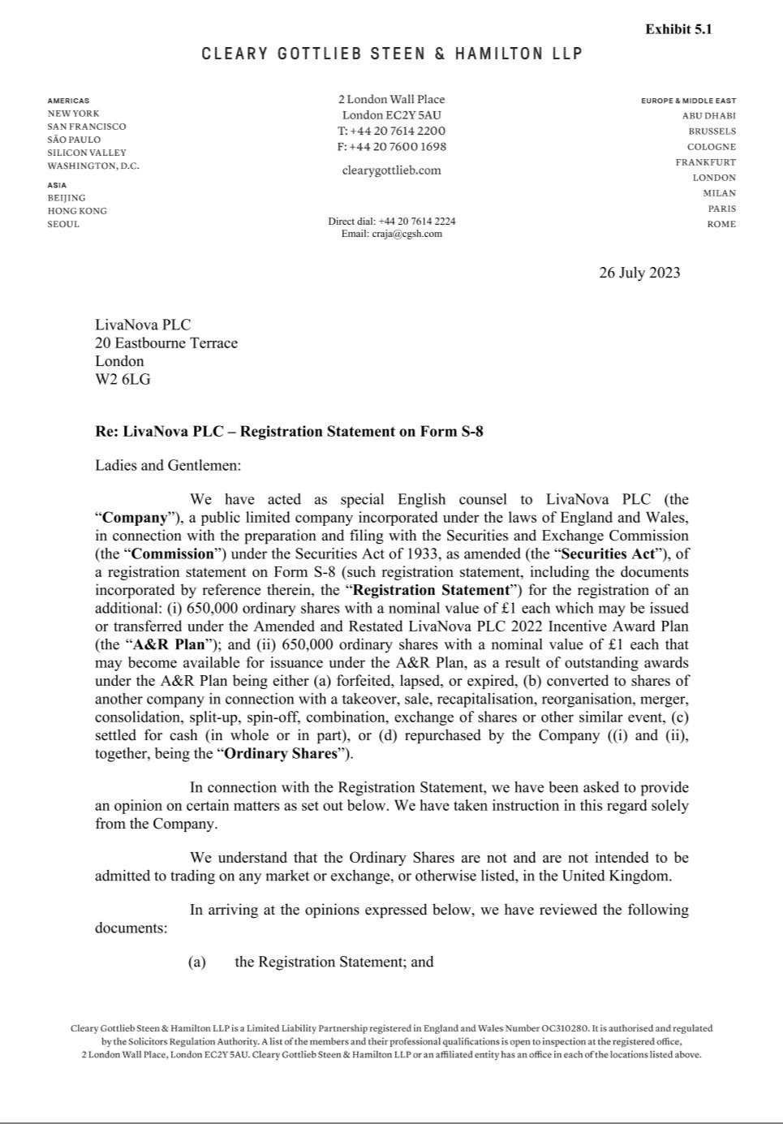

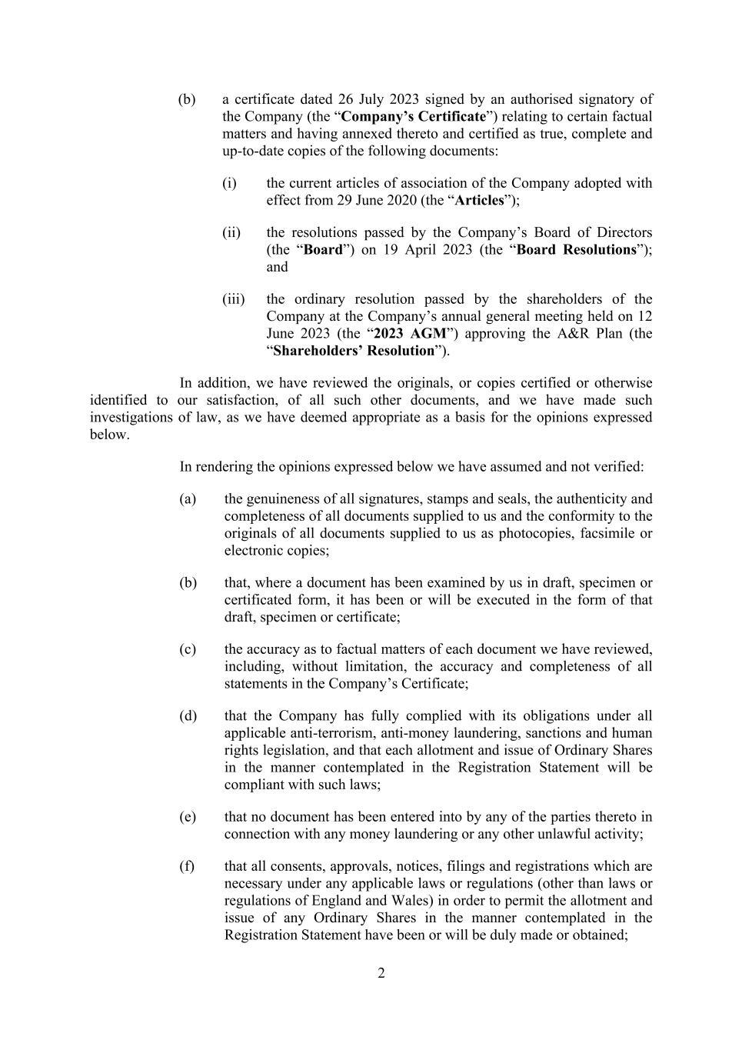

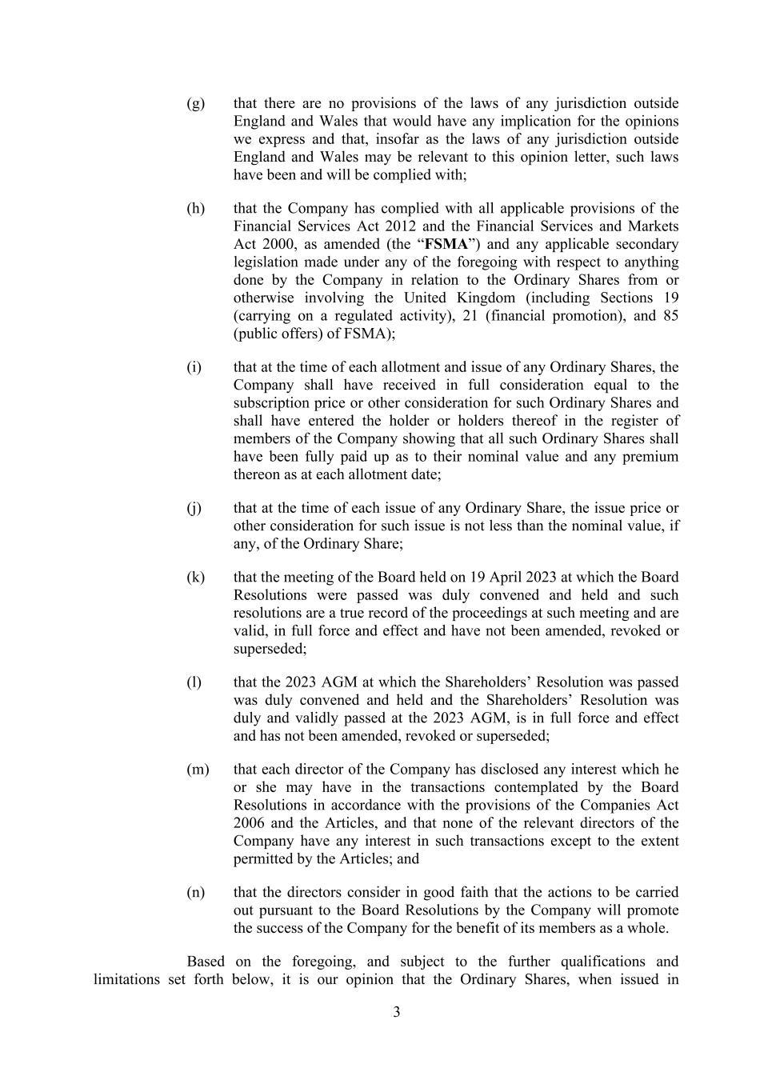

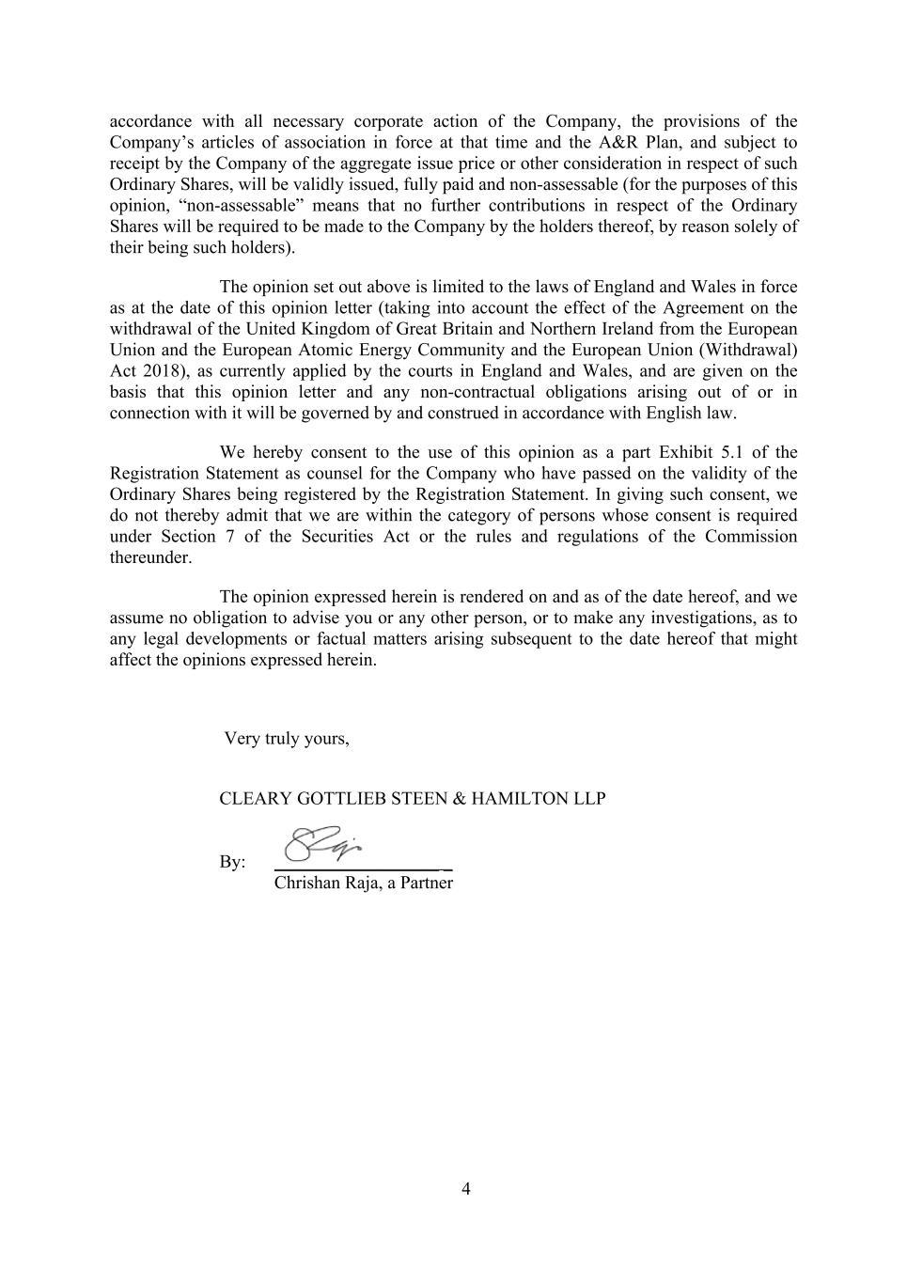

Exhibit 23.2

CONSENT OF INDEPENDENT REGISTERED PUBLIC ACCOUNTING FIRM

We hereby consent to the incorporation by reference in this Registration Statement on Form S-8 of LivaNova PLC of our report dated February 27, 2023 relating to the financial statements and the effectiveness of internal control over financial reporting, which appears in LivaNova PLC’s Annual Report on Form 10-K for the year ended December 31, 2022.

/s/ PricewaterhouseCoopers LLP

Houston, Texas

July 26, 2023

