UNITED STATES

SECURITIES AND EXCHANGE COMMISSION
WASHINGTON, D.C. 20549

FORM 8-K

CURRENT REPORT

Pursuant to Section 13 or 15(d) of the Securities Exchange Act of 1934

Date of Report (Date of earliest event reported): January 5, 2016 (December 31, 2015)


LivaNova PLC

(Exact Name of Registrant as Specified in its Charter)

England and Wales | 333-203510 | N/A
(State or Other Jurisdiction | (Commission | (IRS Employer
of Incorporation) | File Number) | Identification No.)
 | 5 Merchant Square
 | North Wharf Road
 | London, W2 1AY
 | United Kingdom
 | (Address of Principal Executive Offices)
 | +44 20 37865275
 | (Registrant’s Telephone Number, Including Area Code)

N/A

(Former Name or Former Address, if Changed Since Last Report)

Check the appropriate box below if the Form 8-K filing is intended to simultaneously satisfy the filing obligation of the registrant under any of the following provisions:

o Written communications pursuant to Rule 425 under the Securities Act (17 CFR 230.425)

o Soliciting material pursuant to Rule 14a-12 under the Exchange Act (17 CFR 240.14a-12)

o Pre-commencement communications pursuant to Rule 14d-2(b) under the Exchange Act (17 CFR 240.14d-2(b))

o Pre-commencement communications pursuant to Rule 13e-4(c) under the Exchange Act (17 CFR 240.13e-4(c))

|SV\1616837.1||

Item 8.01 Other Events

On December 31, 2015, LivaNova PLC (the “Company”) received a Warning Letter dated December 29, 2015, from the United States Food and Drug Administration ( “FDA”) alleging certain violations of FDA regulations applicable to medical device manufacturers at its Munich, Germany and Arvada, Colorado facilities. A copy of the Warning Letter is provided with this filing as Exhibit 99.1.

The Company currently believes that less than 1% of 2016 consolidated sales could be impacted by this Warning Letter, and that FDA’s concerns can be resolved without a material impact on the Company’s financial results. Further meetings are planned with FDA in order to clarify certain aspects of the Warning Letter.

FDA inspected the Company’s Munich facility from August 24, 2015, to August 27, 2015, and its Arvada facility from August 24, 2015, to September 1, 2015. On August 27, 2015, FDA issued a Form 483 identifying two observed non-conformities with certain regulatory requirements at the Munich facility. The Company did not receive a Form 483 in connection with FDA’s inspection of the Arvada facility.

Following the receipt of the Form 483, the Company provided written responses to FDA describing corrective and preventive actions that were underway or to be taken to address FDA’s observations at the Munich facility. The Warning Letter responded in part to the Company’s responses and identified other alleged violations not previously included in the Form 483. The Company will continue to work diligently to remediate FDA’s inspectional observations for the Munich facility as well as the additional issues identified in the Warning Letter. The Company takes these matters seriously and intends to respond timely and fully to FDA’s requests.

The Warning Letter states that the 3T Heater Cooler devices, and other devices manufactured by the Company’s Munich facility, are subject to refusal of admission into the United States until resolution of the issues set forth in the Warning Letter. FDA has informed the Company that the import alert is, at the present time, limited to the 3T Heater Cooler devices but that the agency reserves the right to expand the scope of the import alert if future circumstances warrant such action. The Warning Letter did not request that existing users cease using the 3T Heater Cooler device, and to help clarify the Warning Letter, the Company has issued an informational Customer Letter, provided with this filing as Exhibit 99.2. The Company is working constructively with FDA to reduce the impact of this decision on existing U. S. customers of 3T Heater Cooler devices, and the Company will promptly communicate to its customers and users of the 3T Heater Cooler any updates agreed upon with FDA in this regard. Manufacturing and shipment of all of the Company’s products other than the 3T Heater Cooler are unaffected by this limitation at the present time and will continue as normal.

Lastly, while the Warning Letter states that premarket approval applications for Class III devices to which the Quality System regulation deviations are reasonably related will not be approved until the violations have been corrected, the Company notes that this Warning Letter only specifically names the Munich and Arvada facilities, which do not manufacture or design devices subject to premarket approval.

Item 9.01 Financial Statements and Exhibits

(d) Exhibits:
Exhibit 99.1 | Department of Health and Human Services, Food and Drug Administration, Warning Letter.
Exhibit 99.2 | Customer Letter dated January 5, 2016.

SIGNATURE

Pursuant to the requirements of the Securities Exchange Act of 1934, the Registrant has duly caused this report to be signed on its behalf by the undersigned hereunto duly authorized.

 | LivaNova PLC
Date: January 5, 2016 | By: | /s/ Brian Sheridan
 | Name: | Brian Sheridan
 | Title | Company Secretary

 | EXHIBIT INDEX
Exhibit No. | Description
99.1 | Department of Health and Human Services, Food and Drug Administration, Warning Letter.
99.2 | Customer Letter dated January 5, 2016.

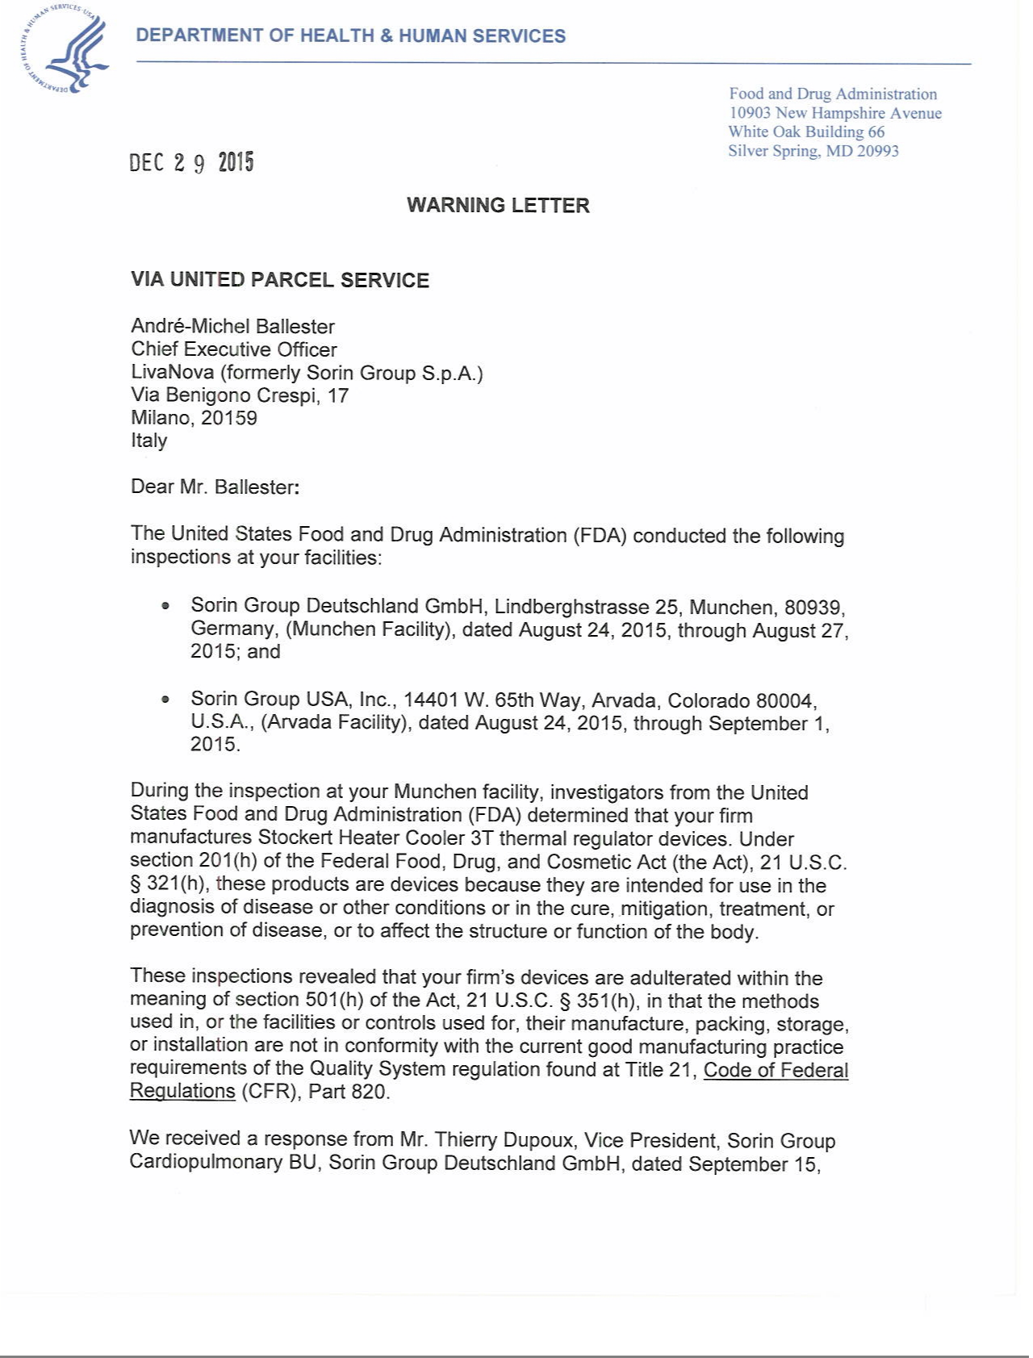

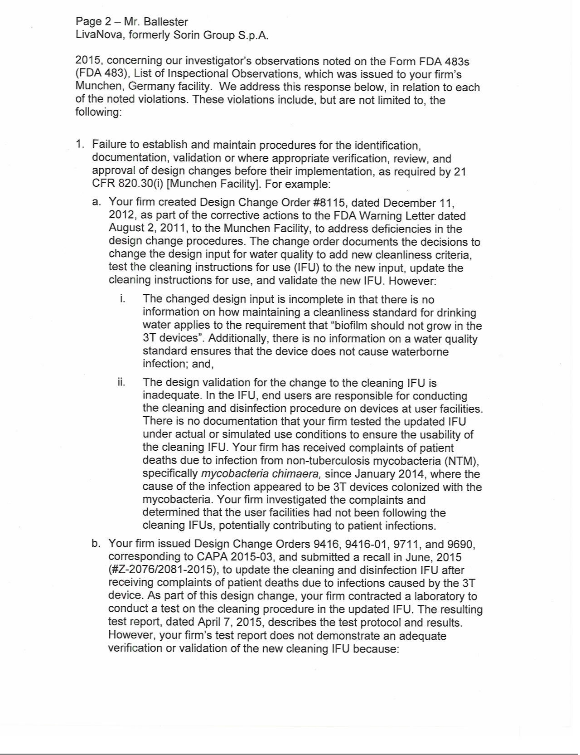

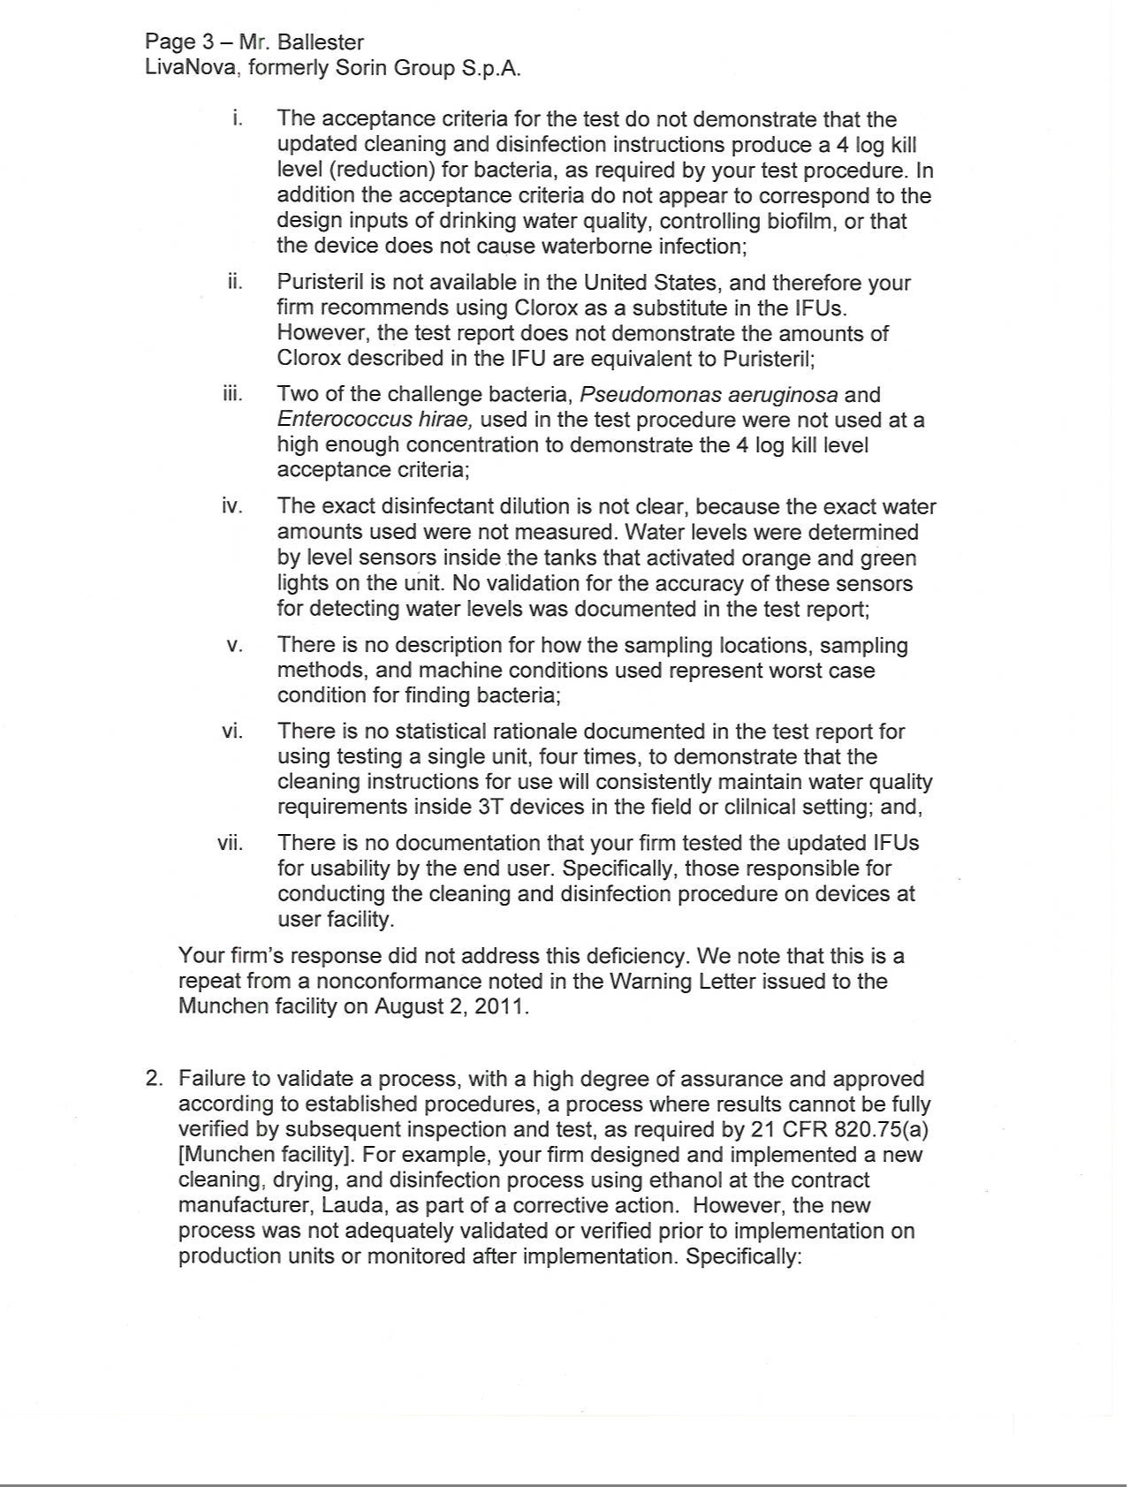

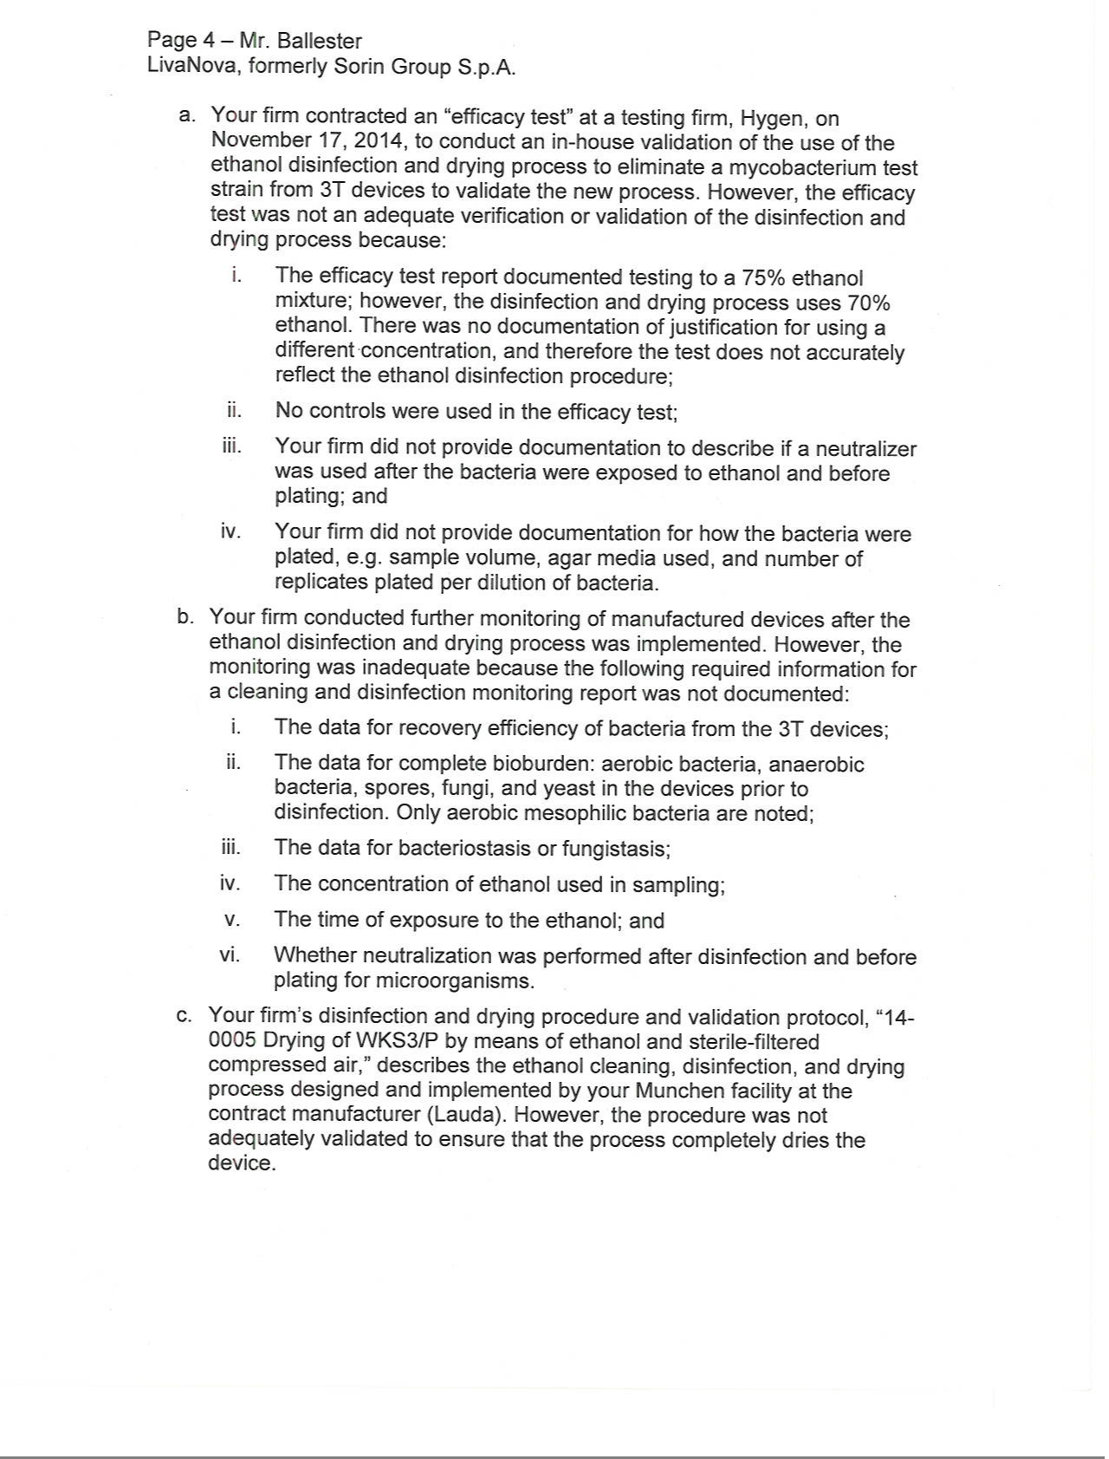

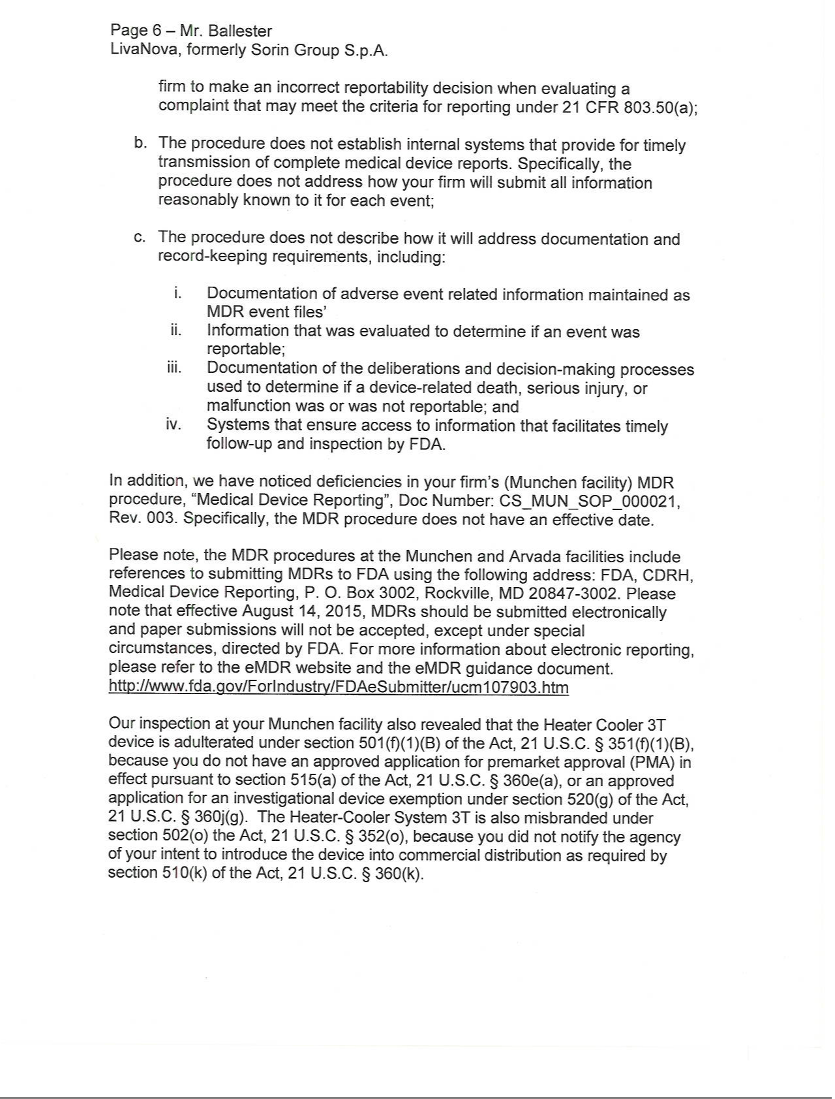

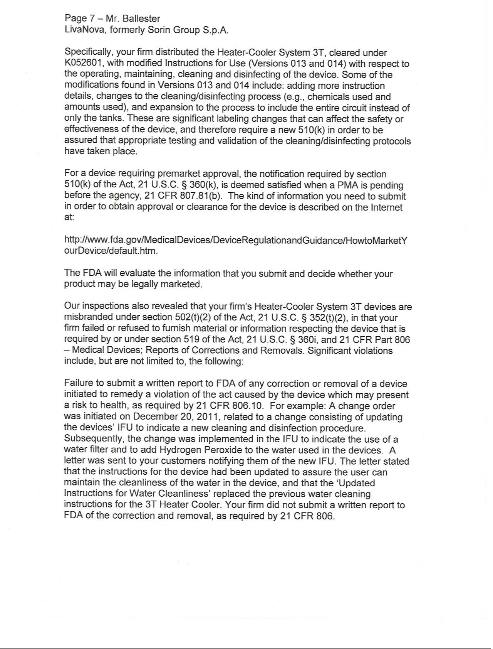

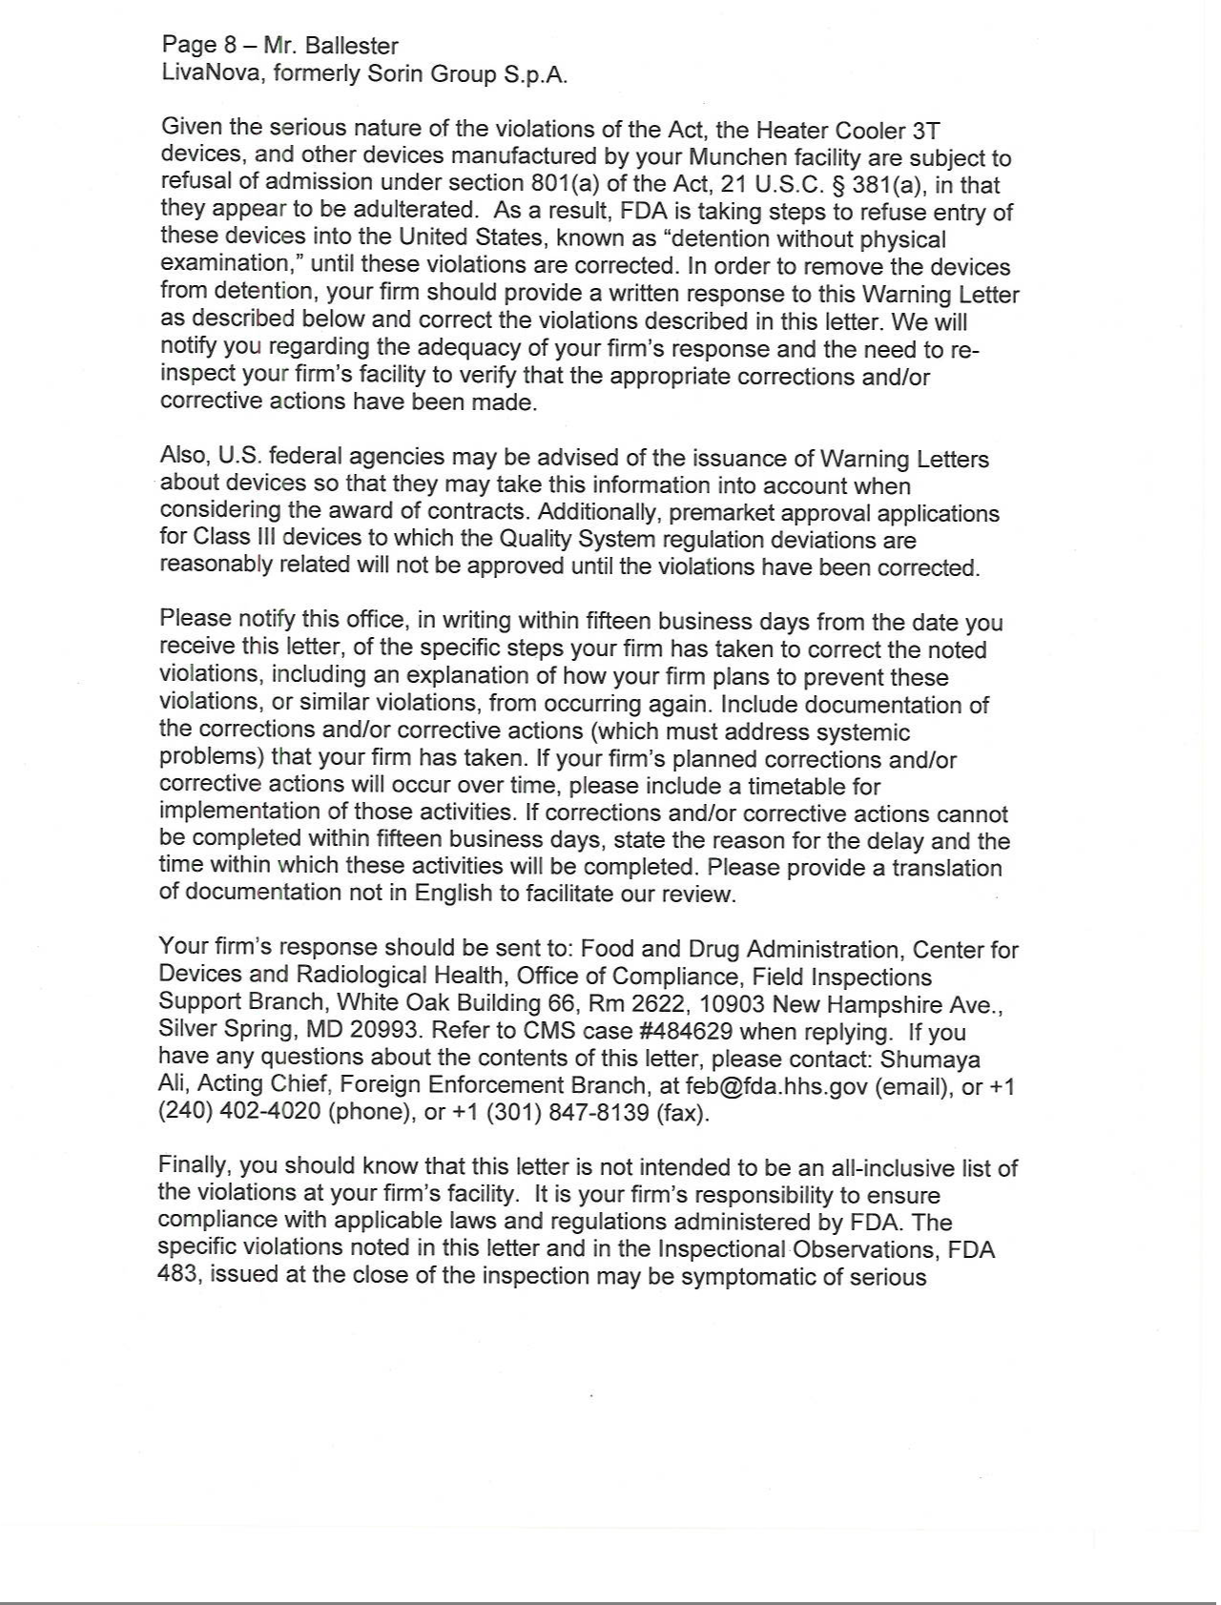

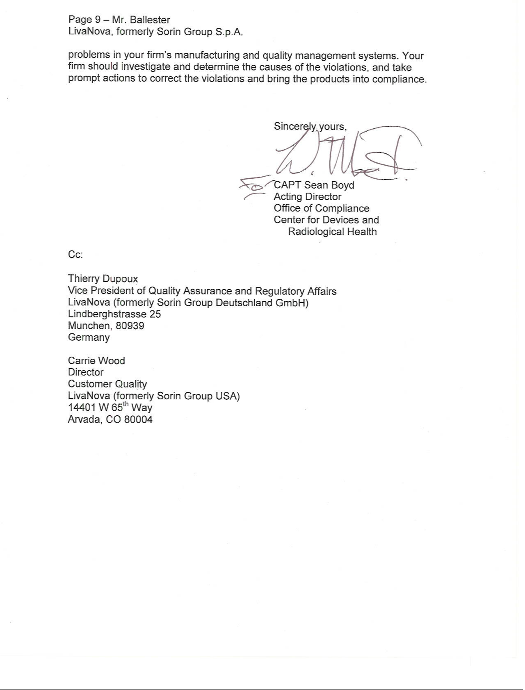

EXHIBIT 99.2

January 5, 2016

Dear Valued Customer,

The purpose of this letter is to inform you about changes in the availability of the 3T Heater-Cooler System (“3T”) in the United States resulting from a Warning Letter issued by the U.S. Food and Drug Administration (“FDA” or “the agency”) dated December 29, 2015. The Warning Letter alleged certain violations of FDA regulations applicable to medical device manufacturers at its Munich, Germany and Arvada, Colorado facilities, to which LivaNova intends to respond in a timely manner. The Warning Letter did not request that existing users cease using the 3T Heater Cooler device. Customers may continue to use the 3T device in accordance with our current Operating Instructions. To this end, we refer you to the Field Safety Notice regarding the Heater-Cooler 3T Devices (Reference #9611109-06/03/15-002-C, dated June 15, 2015 and updated August 6, 2015). Please continue to perform regular maintenance and disinfection of your 3T devices according to the latest Operating Instructions, which can be found at http://www.livanova.sorin.com/3T.

As a result of these issues, FDA has decided to limit the importation of the 3T device into the United States. The Company is working constructively with FDA to reduce the impact of this decision on you, and the Company will promptly communicate to you any updates agreed upon with FDA in this regard. Manufacturing and shipment of all of the Company’s products other than the 3T Heater Cooler are unaffected by this limitation at the present time and will continue as normal.

We are working diligently and in communication with FDA to resolve these issues as quickly as possible. We are committed to providing the highest quality products and service to our customers. We are also collaborating with U.S.

medical societies to ensure that we properly and effectively communicate updates related to the adequate disinfection of our 3T heater-cooler devices. We will continue this practice of rapid and full disclosure in the future.

Contact Information:

Please contact your LivaNova account representative if you have any questions. If further assistance is required, please contact:

Email: 3T.US@LivaNova.com

Technical Services Hotline: 1-800-221-7943, Ext: 6355
3T Voicemail Box: 1-303-467-6601

Thank you for your continued support and cooperation in this matter. We apologize for any inconvenience this situation may have caused for you and your teams.

Sincerely,

