UNITED STATES
SECURITIES AND EXCHANGE COMMISSION
Washington, D.C. 20549

SCHEDULE 14A

Proxy Statement Pursuant to Section 14(a) of
the Securities Exchange Act of 1934 (Amendment No.&numsp;&numsp;&numsp;&numsp;)

Filed by the Registrant ☒
Filed by a Party other than the Registrant ☐
Check the appropriate box:
☐ Preliminary Proxy Statement
☐ Confidential, for Use of the Commission Only (as permitted by Rule 14a-6(e)(2))
☐ Definitive Proxy Statement
☒ Definitive Additional Materials
☐ Soliciting Material under §240.14a-12

LivaNova PLC
(Name of Registrant as Specified In Its Charter)

(Name of Person(s) Filing Proxy Statement, if other than the Registrant)

Payment of Filing Fee (Check the appropriate box):
☒ No fee required.
☐ Fee paid previously with preliminary materials
☐ Fee computed on table in exhibit required by Item 25(b) per Exchange Act Rules 14a-6(i)(1) and 0-11

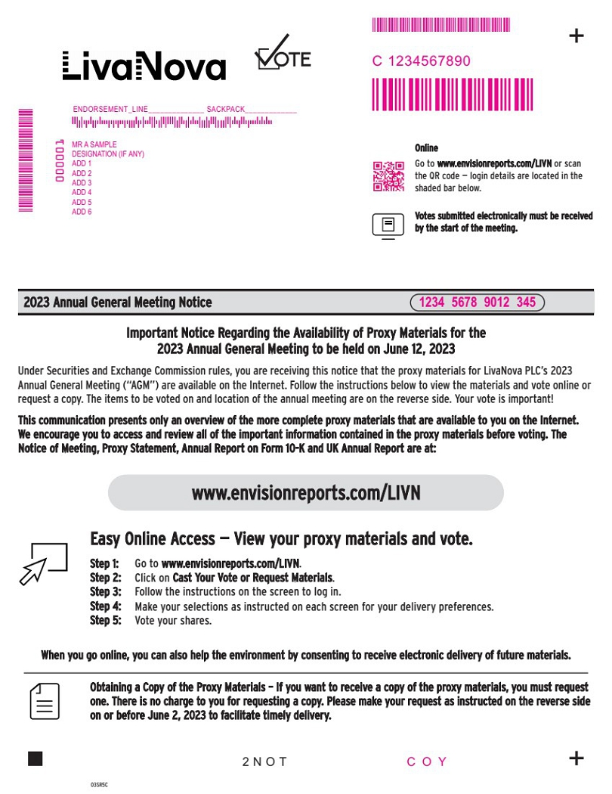 | Step 1: Go to www.envisionreports.com/LIVN. Step 2: Click on Cast Your Vote or Request Materials. Step 3: Follow the instructions on the screen to log in. www.envisionreports.com/LIVN Online Go to www.envisionreports.com/LIVN or scan the QR code — login details are located in the shaded bar below. The Sample Company 2023 Annual General Meeting Notice 03SR5C + + Important Notice Regarding the Availability of Proxy Materials for the 2023 Annual General Meeting to be held on June 12, 2023 Under Securities and Exchange Commission rules, you are receiving this notice that the proxy materials for LivaNova PLC’s 2023 Annual General Meeting (“AGM”) are available on the Internet. Follow the instructions below to view the materials and vote online or request a copy. The items to be voted on and location of the annual meeting are on the reverse side. Your vote is important! This communication presents only an overview of the more complete proxy materials that are available to you on the Internet. We encourage you to access and review all of the important information contained in the proxy materials before voting. The Notice of Meeting, Proxy Statement, Annual Report on Form 10-K and UK Annual Report are at: Obtaining a Copy of the Proxy Materials – If you want to receive a copy of the proxy materials, you must request one. There is no charge to you for requesting a copy. Please make your request as instructed on the reverse side on or before June 2, 2023 to facilitate timely delivery. 2 N O T Easy Online Access — View your proxy materials and vote. When you go online, you can also help the environment by consenting to receive electronic delivery of future materials. Votes submitted electronically must be received by the start of the meeting. Step 4: Make your selections as instructed on each screen for your delivery preferences. Step 5: Vote your shares. MMMMMMMMMMMM M M M M M M M M M 1234 5678 9012 345 C 1234567890 C O Y MMMMMMM MR A SAMPLE DESIGNATION (IF ANY) ADD 1 ADD 2 ADD 3 ADD 4 ADD 5 ADD 6 ENDORSEMENT_LINE______________ SACKPACK_____________ 0 0 0 0 0 1
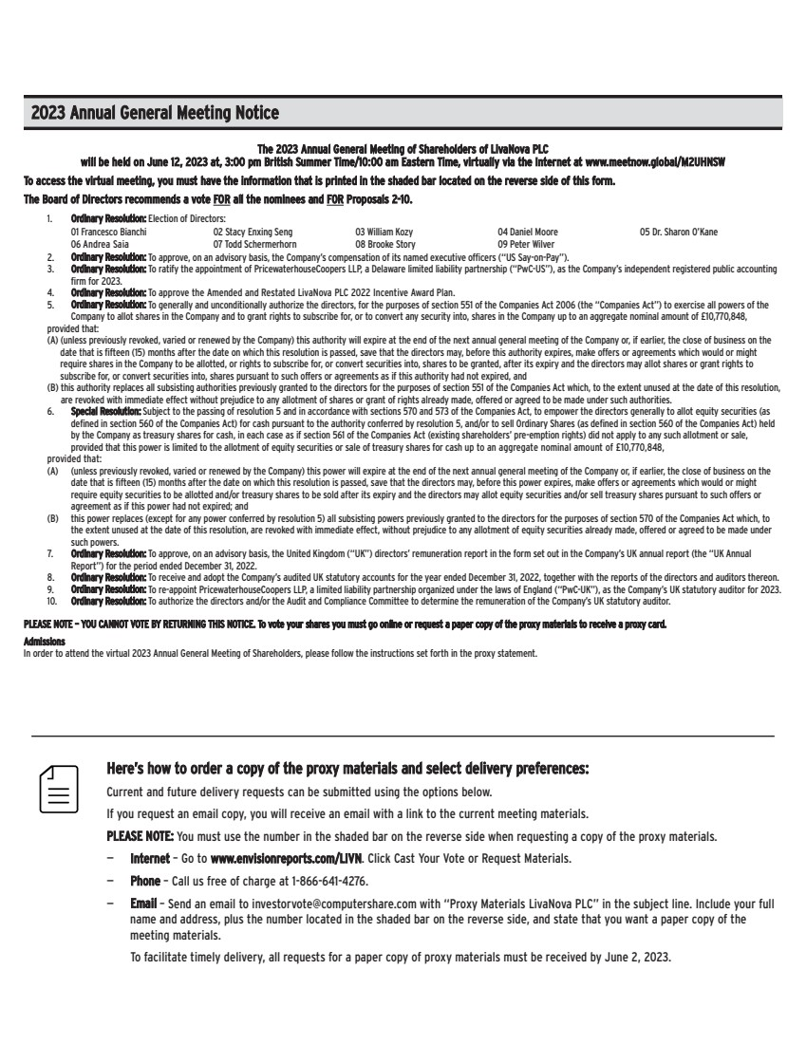 | Here’s how to order a copy of the proxy materials and select delivery preferences: Current and future delivery requests can be submitted using the options below. If you request an email copy, you will receive an email with a link to the current meeting materials. PLEASE NOTE: You must use the number in the shaded bar on the reverse side when requesting a copy of the proxy materials. — Internet – Go to www.envisionreports.com/LIVN. Click Cast Your Vote or Request Materials. — Phone – Call us free of charge at 1-866-641-4276. — Email – Send an email to investorvote@computershare.com with “Proxy Materials LivaNova PLC” in the subject line. Include your full name and address, plus the number located in the shaded bar on the reverse side, and state that you want a paper copy of the meeting materials. To facilitate timely delivery, all requests for a paper copy of proxy materials must be received by June 2, 2023. The 2023 Annual General Meeting of Shareholders of LivaNova PLC will be held on June 12, 2023 at, 3:00 pm British Summer Time/10:00 am Eastern Time, virtually via the Internet at www.meetnow.global/M2UHNSW To access the virtual meeting, you must have the information that is printed in the shaded bar located on the reverse side of this form. The Board of Directors recommends a vote FOR all the nominees and FOR Proposals 2-10. 1. Ordinary Resolution: Election of Directors: 01 Francesco Bianchi 02 Stacy Enxing Seng 03 William Kozy 04 Daniel Moore 05 Dr. Sharon O’Kane 06 Andrea Saia 07 Todd Schermerhorn 08 Brooke Story 09 Peter Wilver 2. Ordinary Resolution: To approve, on an advisory basis, the Company’s compensation of its named executive officers (“US Say-on-Pay”). 3. Ordinary Resolution: To ratify the appointment of PricewaterhouseCoopers LLP, a Delaware limited liability partnership (“PwC-US”), as the Company’s independent registered public accounting firm for 2023. 4. Ordinary Resolution: To approve the Amended and Restated LivaNova PLC 2022 Incentive Award Plan. 5. Ordinary Resolution: To generally and unconditionally authorize the directors, for the purposes of section 551 of the Companies Act 2006 (the “Companies Act”) to exercise all powers of the Company to allot shares in the Company and to grant rights to subscribe for, or to convert any security into, shares in the Company up to an aggregate nominal amount of £10,770,848, provided that: (A) (unless previously revoked, varied or renewed by the Company) this authority will expire at the end of the next annual general meeting of the Company or, if earlier, the close of business on the date that is fifteen (15) months after the date on which this resolution is passed, save that the directors may, before this authority expires, make offers or agreements which would or might require shares in the Company to be allotted, or rights to subscribe for, or convert securities into, shares to be granted, after its expiry and the directors may allot shares or grant rights to subscribe for, or convert securities into, shares pursuant to such offers or agreements as if this authority had not expired, and (B) this authority replaces all subsisting authorities previously granted to the directors for the purposes of section 551 of the Companies Act which, to the extent unused at the date of this resolution, are revoked with immediate effect without prejudice to any allotment of shares or grant of rights already made, offered or agreed to be made under such authorities. 6. Special Resolution: Subject to the passing of resolution 5 and in accordance with sections 570 and 573 of the Companies Act, to empower the directors generally to allot equity securities (as defined in section 560 of the Companies Act) for cash pursuant to the authority conferred by resolution 5, and/or to sell Ordinary Shares (as defined in section 560 of the Companies Act) held by the Company as treasury shares for cash, in each case as if section 561 of the Companies Act (existing shareholders’ pre-emption rights) did not apply to any such allotment or sale, provided that this power is limited to the allotment of equity securities or sale of treasury shares for cash up to an aggregate nominal amount of £10,770,848, provided that: (A) (unless previously revoked, varied or renewed by the Company) this power will expire at the end of the next annual general meeting of the Company or, if earlier, the close of business on the date that is fifteen (15) months after the date on which this resolution is passed, save that the directors may, before this power expires, make offers or agreements which would or might require equity securities to be allotted and/or treasury shares to be sold after its expiry and the directors may allot equity securities and/or sell treasury shares pursuant to such offers or agreement as if this power had not expired; and (B) this power replaces (except for any power conferred by resolution 5) all subsisting powers previously granted to the directors for the purposes of section 570 of the Companies Act which, to the extent unused at the date of this resolution, are revoked with immediate effect, without prejudice to any allotment of equity securities already made, offered or agreed to be made under such powers. 7. Ordinary Resolution: To approve, on an advisory basis, the United Kingdom (“UK”) directors’ remuneration report in the form set out in the Company’s UK annual report (the “UK Annual Report”) for the period ended December 31, 2022. 8. Ordinary Resolution: To receive and adopt the Company’s audited UK statutory accounts for the year ended December 31, 2022, together with the reports of the directors and auditors thereon. 9. Ordinary Resolution: To re-appoint PricewaterhouseCoopers LLP, a limited liability partnership organized under the laws of England (“PwC-UK”), as the Company’s UK statutory auditor for 2023. 10. Ordinary Resolution: To authorize the directors and/or the Audit and Compliance Committee to determine the remuneration of the Company’s UK statutory auditor. PLEASE NOTE – YOU CANNOT VOTE BY RETURNING THIS NOTICE. To vote your shares you must go online or request a paper copy of the proxy materials to receive a proxy card. Admissions In order to attend the virtual 2023 Annual General Meeting of Shareholders, please follow the instructions set forth in the proxy statement. 2023 Annual General Meeting Notice

